YUVA INTERN | LOGISTICS DATA ANALYST INTERNSHIP
Week 3 Task Report
Advanced Data Analysis and Visualization in Logistics
Exploratory analysis of 5,000 simulated shipments using Python (pandas, Matplotlib, Seaborn, SciPy)

Prepared by Aditya
Programme Yuva Intern – Logistics Data Analyst Intern
Task Week 3: Advanced Data Analysis and Visualization in Logistics
Submission date 01 October 2026
Tools Python 3, pandas, NumPy, Matplotlib, Seaborn, SciPy
Dataset Hypothetical logistics dataset, 5,000 shipments, 5 hubs, 4 carriers, 3 transport modes (seed = 42)

Contents
1 Executive Summary
2 Introduction and Objectives
3 Data Simulation
4 Methodology and Data Cleaning
5 Exploratory Data Analysis
6 Visualization Analysis (Figures 1–9)
7 Statistical Validation
8 Analytical Insights
9 How the Visualizations Help Interpret Logistics Performance
10 Recommendations and Impact Estimates
11 Limitations and Future Work
12 Conclusion
A Appendix A – Complete Python Script
B Appendix B – Reproducibility and Project Files

1. Executive Summary
This report documents an end-to-end exploratory analysis of a hypothetical logistics dataset covering 5,000 shipments dispatched from five regional hubs (Delhi, Mumbai, Bengaluru, Kolkata, Nagpur) during 2025. A reproducible Python pipeline simulates the data, cleans it, calculates descriptive statistics, produces nine visualizations, validates the patterns with statistical tests and quantifies four improvement levers. Every number in this report is produced by the script in Appendix A.
Table 1: Headline performance metrics (simulated 2025 network)
Shipments | On-time rate | Mean delivery time | Mean cost / shipment | Total freight spend
5,000 | 75.4% | 42.0 h | $197.74 | $988,699

Key findings
- Delays are concentrated, not evenly spread. The carrier TransGo handles 23% of shipments but causes 45.5% of all late deliveries (delay rate 48.6% versus 17.4% for the other three carriers combined). It is the weakest carrier at every hub.
- Mumbai is the network bottleneck. The hub dispatches 27.4% of shipments yet accounts for 43.9% of delay hours. In the October–December peak its delay rate reaches 60.0%, against 23.9% for the rest of the year.
- Weather is the strongest external driver. The delay rate rises from 13.7% on clear days to 38.3% in rain, 62.8% in fog and 88.1% in storms.
- Distance sets both time and cost, but the modes trade off. Distance correlates strongly with delivery time (Spearman ρ = 0.77) and moderately with cost (r = 0.52). Air costs 3.3× as much per kg as Road; Rail is 14% cheaper per kg than Road but takes 1.9× as long.
- Customers react to lateness, not duration. Customer rating correlates with delay hours (r = −0.31) but not with raw delivery time (r = −0.02). Late shipments average a 4.35 rating versus 4.63 for on-time ones.
- Quantified opportunities. Bringing TransGo to the level of the other carriers would remove about 29% of all delays; weather-aware delivery promises would remove 24% of SLA misses; shifting 30% of eligible long-haul standard freight to rail would save about $51,227 (5.2% of spend) at the price of roughly 24 extra transit hours.
Note on data. The task asks for a hypothetical dataset, so the shipments are simulated. The relationships (for example the carrier and weather effects) were built in deliberately and are documented in Section 3. The value of the report lies in the method: the same pipeline can be pointed at a real shipment export without changes to the analysis code.

2. Introduction and Objectives

2.1 Background
Logistics performance is judged on a small set of measurable outcomes: whether goods arrive on time, how long they take, and what each shipment costs. These outcomes are driven by many interacting factors – distance, shipment size, transport mode, carrier quality, hub congestion, weather and season. Data analysis makes those interactions visible so that managers can decide where to intervene rather than relying on intuition.

2.2 Objectives
The objectives follow the task brief:
- Define a hypothetical logistics dataset with delivery times, shipment volumes and transportation costs, and simulate it in Python.
- Perform a thorough exploratory data analysis (EDA): central tendencies, distributions and correlations.
- Produce multiple visualizations that capture trends, distributions and relationships, and justify each chart type.
- Interpret the visualizations to draw insights on operational efficiency, cost drivers and bottlenecks.
- Document the methodology, Python code excerpts, findings and recommendations in a professional report.

2.3 Where each requirement is covered
Table 2: Mapping of task requirements to report sections
Task requirement | Where it is addressed
Data simulation (structure and key variables) | Section 3 – data dictionary, assumptions, simulation code
EDA: central tendency, distributions, correlations | Sections 5, 6.1, 6.2 and 7
Multiple visualizations (trends, distributions, relationships) | Section 6 – nine figures
Justification of each visualization method | Section 6 – “Why this visualization?” under every figure
Insights on efficiency, cost drivers, bottlenecks | Section 8
How visualizations help interpret performance metrics | Section 9
Methodology, code excerpts, findings, recommendations | Sections 4, 6, 10 and Appendix A

3. Data Simulation

3.1 Design principles
Because no real company data is supplied, a synthetic dataset was designed with three principles: (1) realism – relationships between variables mimic domestic freight (distance, mode, weather, carrier quality); (2) reproducibility – a fixed random seed (42) means anyone running the script gets identical data; (3) messiness – duplicates and missing values are injected on purpose so that the cleaning step is genuine.

3.2 Dataset structure and key variables
The dataset has one row per shipment and 19 columns (5,030 rows before cleaning). The three variables named in the task – delivery times, shipment volumes and transportation costs – are delivery_time_hrs, weight_kg and transport_cost_usd.
Table 3: Data dictionary
Variable | Type | Description
shipment_id | Text | Unique shipment identifier (SH00001 …)
order_date | Date | Dispatch date in 2025
origin_hub | Category | Dispatching hub: Delhi, Mumbai, Bengaluru, Kolkata, Nagpur
destination_region | Category | North, West, South, East or Central
lane | Category | Origin hub → destination region (25 lanes)
carrier | Category | SwiftMove, BlueLine, TransGo, RapidFreight
transport_mode | Category | Road, Rail or Air
priority | Category | Standard or Express service
weather | Category | Weather at dispatch: Clear, Rain, Fog, Storm
weight_kg | Numeric | Shipment weight (shipment volume), kg
distance_km | Numeric | Route distance, km
traffic_index | Numeric | Congestion index from 1 (free flow) to 10
fuel_index | Numeric | Monthly fuel price index (1.00 = base)
delivery_time_hrs | Numeric | Actual delivery time, hours (key outcome)
promised_time_hrs | Numeric | Delivery time promised to the customer, hours
delay_hours | Numeric | Hours late versus promise (0 if on time)
delayed | Binary | 1 if delivered after the promised time
transport_cost_usd | Numeric | Total transport cost, USD (key outcome)
customer_rating | Numeric | Customer rating 1–5 (about 5% missing)
month, is_peak, cost_per_kg, cost_per_kg_km | Derived | Features added during cleaning (Section 4)

3.3 Simulation assumptions
Table 4: Assumptions built into the simulation
Mechanism | Assumption
Distance | Hub-to-hub road distances for the five cities (830–2,150 km) with ±8–15% route variation; shipments within the same region travel 40–350 km.
Shipment weight | Log-normal (median about 220 kg, clipped to 5–6,000 kg) so that most loads are small and a few are very large.
Seasonality | Order volume rises in October–December (festive peak). Weather follows the seasons: monsoon (Jun–Sep) brings rain and storms, winter (Dec–Jan) brings fog.
Transport mode | Road by default; Rail for 32% of Standard shipments over 500 km; Air for 40% of Express shipments over 700 km.
Delivery time | Hub handling time + transit (distance ÷ speed: Road 48 km/h, Rail 36 km/h plus 14 h terminal time, Air 650 km/h plus 12 h ground time) + weather delay + carrier effect + congestion effect on road.
Hidden effects | TransGo adds about 6 h per shipment; RapidFreight removes about 1.5 h. Mumbai hub suffers +6 h handling and higher congestion in the peak season.
Transport cost | Fixed fee + per-km + per-kg charge by mode; Express ×1.20; carrier price multiplier (0.88–1.18); fuel index; 8% storm surcharge; random noise.
Promised time | 1.15 × (hub handling base + nominal transit) + 6 h. A shipment is “delayed” when actual time exceeds the promise.

3.4 Simulation code
The excerpt below is the core of the generator (inside the function simulate_dataset). It draws the categorical variables, builds delivery time and cost from their drivers and adds noise.
Python – data simulation
# --- when, where and what is shipped ---------------------------------
month_w = np.array([.075, .07, .08, .075, .075, .07, .07, .08, .085, .10, .11, .11])
month = rng.choice(np.arange(1, 13), size=n, p=month_w / month_w.sum())
order_date = pd.to_datetime(dict(year=2025, month=month, day=rng.integers(1, 29, size=n)))
peak = np.isin(month, [10, 11, 12]) # Oct-Dec festive peak

hub = rng.choice(HUBS, size=n, p=[.24, .28, .22, .14, .12])
dest = rng.choice(["North", "West", "South", "East", "Central"], size=n,
p=[.22, .25, .24, .17, .12])
dest_hub = np.array([REGION_HUB[r] for r in dest])
same = hub == dest_hub
inter_km = np.array([0 if s else hub_distance(h, d) for h, d, s in zip(hub, dest_hub, same)],
float)
distance = np.where(same, rng.uniform(40, 350, n), inter_km * rng.uniform(0.92, 1.15, n))

weight = np.clip(rng.lognormal(np.log(220), 0.95, n), 5, 6000) # right-skewed
priority = rng.choice(["Standard", "Express"], size=n, p=[.75, .25])
carrier = rng.choice(["SwiftMove", "BlueLine", "TransGo", "RapidFreight"], size=n,
p=[.32, .28, .22, .18])

u = rng.random(n) # choose transport mode
mode = np.where((priority == "Express") & (distance > 700), np.where(u < .40, "Air", "Road"),
np.where((priority == "Standard") & (distance > 500),
np.where(u < .32, "Rail", "Road"), "Road"))

weather = np.empty(n, dtype=object) # seasonal weather
for m in range(1, 13):
idx = month == m
p = [.50, .38, .10, .02] if m in (6, 7, 8, 9) else \
[.72, .05, .01, .22] if m in (12, 1) else [.82, .12, .03, .03]
weather[idx] = rng.choice(["Clear", "Rain", "Storm", "Fog"], size=idx.sum(), p=p)

traffic = np.clip(rng.normal(5, 1.4, n) + 1.0 * peak + 1.2 * (hub == "Mumbai")
+ 0.6 * (hub == "Delhi"), 1, 10) # congestion index 1-10

# --- delivery time (hours) = hub handling + transit + disruptions ----
speed = pd.Series(mode).map({"Road": 48, "Rail": 36, "Air": 650}).to_numpy()
terminal = pd.Series(mode).map({"Road": 0, "Rail": 14, "Air": 12}).to_numpy()
express_road = np.where((priority == "Express") & (mode == "Road"), 0.82, 1.0)
transit = (distance / speed) * express_road + terminal
hub_base = pd.Series(hub).map({"Delhi": 7, "Mumbai": 9, "Bengaluru": 6.5,
"Kolkata": 8, "Nagpur": 5.5}).to_numpy()
handling = (hub_base + weight / 600 + rng.exponential(1.5, n)
+ 6 * ((hub == "Mumbai") & peak) + 2 * ((hub == "Delhi") & peak))
carrier_delay = pd.Series(carrier).map({"SwiftMove": 0.0, "BlueLine": 1.5,
"TransGo": 6.0, "RapidFreight": -1.5}).to_numpy()
weather_delay = np.select(
[weather == "Rain", weather == "Storm", weather == "Fog"],
[np.clip(rng.normal(5, 2, n), 0, None), np.clip(rng.normal(16, 5, n), 0, None),
np.clip(rng.normal(7, 3, n), 0, None)], default=0.0)
traffic_delay = np.where(mode == "Road", 0.9 * (traffic - 5), 0.0)
delivery_time = (handling + transit * rng.lognormal(0, 0.10, n) + weather_delay
+ carrier_delay * rng.uniform(0.6, 1.4, n) + traffic_delay)
delivery_time = np.clip(delivery_time, 3, None)
promised = (hub_base + transit) * 1.15 + 6 # SLA promise
delay_hours = np.clip(delivery_time - promised, 0, None)

# --- transport cost (USD) ---------------------------------------------
fuel_by_month = np.array([98, 99, 101, 103, 104, 102, 101, 103, 105, 108, 110, 111]) / 100
fuel_index = fuel_by_month[month - 1] + rng.normal(0, 0.01, n)
fixed = pd.Series(mode).map({"Road": 12, "Rail": 25, "Air": 40}).to_numpy()
per_km = pd.Series(mode).map({"Road": 0.12, "Rail": 0.07, "Air": 0.10}).to_numpy()
per_kg = pd.Series(mode).map({"Road": 0.06, "Rail": 0.04, "Air": 0.85}).to_numpy()
carrier_mult = pd.Series(carrier).map({"SwiftMove": 1.00, "BlueLine": 0.94,
"TransGo": 0.88, "RapidFreight": 1.18}).to_numpy()
fuel_sens = np.where(mode == "Rail", 0.2, 0.6)
cost = (fixed + per_km * distance + per_kg * weight)
cost = (cost * np.where(priority == "Express", 1.20, 1.0) * carrier_mult
* (1 + fuel_sens * (fuel_index - 1)) * (1 + 0.08 * (weather == "Storm"))
* rng.lognormal(0, 0.08, n))

rating = np.clip(np.round(4.7 - 0.06 * delay_hours + rng.normal(0, 0.55, n)), 1, 5)

4. Methodology and Data Cleaning

4.1 Analytical workflow
Table 5: Workflow, techniques and tools
Step | Technique | Python tools
1. Simulate | Seeded random generation with built-in relationships | NumPy, pandas
2. Clean | De-duplication, imputation, feature engineering, IQR outlier audit | pandas
3. Describe | Mean, median, mode, spread, skewness, grouped summaries | pandas, SciPy
4. Visualize | Histograms, box plots, heatmaps, line/bar charts, scatter, Pareto | Matplotlib, Seaborn
5. Test | Chi-square, Kruskal–Wallis, Spearman/Pearson, Mann–Whitney, normality | SciPy
6. Model | Standardised OLS to rank cost and time drivers | NumPy (least squares)
7. Simulate impact | What-if scenarios on the cleaned data | pandas

4.2 Data cleaning
Four checks were applied before any analysis. The code is shown first, followed by the audit results.
Python – data cleaning and feature engineering
report = {"rows_raw": int(len(raw)), "columns": int(raw.shape[1])}
df = raw.drop_duplicates(subset="shipment_id").copy() # 1) duplicates
report["duplicates_removed"] = int(len(raw) - len(df))
report["missing_weight"] = int(df["weight_kg"].isna().sum()) # 2) missing values
report["missing_rating"] = int(df["customer_rating"].isna().sum())
df["weight_kg"] = df["weight_kg"].fillna(
df.groupby("transport_mode")["weight_kg"].transform("median")) # median impute
df["order_date"] = pd.to_datetime(df["order_date"]) # 3) types + features
df["month"] = df["order_date"].dt.month
df["is_peak"] = df["month"].isin([10, 11, 12])
df["cost_per_kg"] = df["transport_cost_usd"] / df["weight_kg"]
df["cost_per_kg_km"] = df["transport_cost_usd"] / (df["weight_kg"] * df["distance_km"])
for col in ["weight_kg", "transport_cost_usd", "delivery_time_hrs"]: # 4) IQR outlier audit
q1, q3 = df[col].quantile([.25, .75])
iqr = q3 - q1
report[f"outliers_{col}"] = int(((df[col] < q1 - 1.5 * iqr) | (df[col] > q3 + 1.5 *
iqr)).sum())
report["rows_clean"] = int(len(df))

Table 6: Data-quality audit
Check | Finding | Action taken
Duplicate shipments | 30 duplicate rows (5,030 → 5,000) | Dropped on shipment_id
Missing weight_kg | 60 rows (1.2%) | Imputed with the median weight of the same transport mode
Missing customer_rating | 285 rows (5.7%) | Left blank (an unrated delivery is not an error); excluded pairwise
IQR outliers: weight | 376 rows | Kept – genuine heavy consignments (log-normal tail)
IQR outliers: cost | 202 rows | Kept – explained by Air freight and long hauls
IQR outliers: delivery time | 41 rows | Kept – slow Rail and storm-affected shipments

Why keep the outliers? An outlier is only an error if it is impossible. Each flagged value here has a clear operational explanation, and removing them would hide exactly the expensive and slow shipments that logistics managers need to see.

5. Exploratory Data Analysis

5.1 Central tendency and dispersion
For each numeric variable the mean, median and mode describe the centre, while the standard deviation, coefficient of variation (CV) and skewness describe spread and shape. The mode is reported as the centre of the most populated histogram bin (30 bins), because exact repeats are rare in continuous data.
Python – summary statistics
rows = []
for col, label in NUM_LABELS.items():
x = df[col].dropna()
counts, edges = np.histogram(x, bins=30)
k = counts.argmax()
rows.append({
"variable": label, "mean": x.mean(), "median": x.median(),
"mode": (edges[k] + edges[k + 1]) / 2, "std": x.std(),
"min": x.min(), "max": x.max(), "cv_pct": x.std() / x.mean() * 100,
"skew": stats.skew(x),
})
return pd.DataFrame(rows)

Table 7: Descriptive statistics of the cleaned dataset (n = 5,000)
Variable | Mean | Median | Mode | Std | Min | Max | CV | Skew
Shipment weight (kg) | 343.49 | 219.30 | 104.9 | 409.48 | 5.0 | 6,000.0 | 119% | 4.26
Distance (km) | 1,197.41 | 1,119.65 | 1,053.6 | 689.00 | 40.2 | 2,472.3 | 58% | −0.05
Delivery time (hrs) | 41.97 | 39.31 | 30.8 | 20.52 | 5.2 | 123.3 | 49% | 0.65
Transport cost (USD) | 197.74 | 168.60 | 150.4 | 162.88 | 16.7 | 2,690.6 | 82% | 4.47
Cost per kg (USD) | 1.25 | 0.69 | 0.5 | 1.71 | 0.1 | 29.2 | 137% | 5.05
Traffic index (1-10) | 5.76 | 5.75 | 5.7 | 1.53 | 1.0 | 10.0 | 27% | −0.01
Customer rating (1-5) | 4.56 | 5.00 | 5.0 | 0.55 | 2.0 | 5.0 | 12% | −0.76

Reading the table
- Delivery time averages 42.0 h with a median of 39.3 h and a modal bin near 31 h. Mean > median > mode with skewness 0.65 indicates a right-skewed distribution: most shipments arrive within about two days, while a minority take much longer (maximum 123.3 h).
- Shipment weight is strongly skewed (skewness 4.26). The mean (343 kg) overstates the typical load by 57% compared with the median (219 kg), so capacity planning should use the median and percentiles rather than the mean.
- Transport cost and cost per kg are also heavily right-skewed (skewness 4.5 and 5.1). Cost per kg has a CV of 137%: small, expensive air shipments pull the mean ($1.25) far above the median ($0.69).
- Distance and traffic index are close to symmetric (skewness about 0), which is expected from the way they were generated; customer rating is left-skewed with a median of 5.

5.2 Worked example: calculating the core KPIs
The calculations behind every figure in this report are simple. Take shipment SH00458, a Standard consignment sent by TransGo from Mumbai to the South region by Road on 2025-02-07:
- Delay: delivery time 42.28 h − promised 41.73 h = 0.55 h late, so delayed = 1.
- Cost per kg: $170.96 ÷ 440.6 kg = $0.388 per kg.
- Cost per kg-km: $170.96 ÷ (440.6 kg × 1,059.2 km) = $0.000366 – a distance-neutral way to compare Road, Rail and Air.
- A cell of the heatmap (Figure 6): 189 of the 305 shipments that TransGo dispatched from Mumbai were late, so the delay rate is 189 ÷ 305 = 62.0%.

5.3 Segment profiles
Grouping the data by transport mode, carrier and hub gives a first view of where performance differs. These tables are the numerical backbone for the charts in Section 6.
Table 8: Performance by transport mode
Mode | Shipments | Mean time | Median time | Mean cost | Median cost/kg | Delay rate
Road | 3,698 | 36.3 h | 35.6 h | $174.79 | $0.63 | 27.3%
Rail | 928 | 70.2 h | 68.1 h | $146.80 | $0.55 | 14.1%
Air | 374 | 27.8 h | 26.6 h | $551.08 | $2.11 | 23.3%

Table 9: Performance by carrier (sorted by delay rate)
Carrier | Shipments | Delay rate | Mean time | Mean cost | Median cost/kg | Avg rating
RapidFreight | 947 | 11.1% | 38.6 h | $236.56 | $0.80 | 4.61
SwiftMove | 1,561 | 16.7% | 40.6 h | $197.19 | $0.69 | 4.58
BlueLine | 1,342 | 22.7% | 41.9 h | $188.35 | $0.66 | 4.57
TransGo | 1,150 | 48.6% | 46.6 h | $177.48 | $0.65 | 4.47

Table 10: Performance by origin hub
Hub | Shipments | Delay rate | Mean time | Mean cost | Share of delay hours
Delhi | 1,206 | 23.8% | 44.0 h | $209.16 | 22.1%
Mumbai | 1,372 | 35.2% | 42.7 h | $182.93 | 43.9%
Bengaluru | 1,146 | 17.5% | 40.4 h | $195.71 | 15.2%
Kolkata | 683 | 16.7% | 47.4 h | $228.46 | 8.9%
Nagpur | 593 | 24.1% | 33.0 h | $177.31 | 9.8%

5.4 Distribution shape
D’Agostino–Pearson normality tests confirm what the histograms suggest. Delivery time is not normally distributed (statistic = 294.9, p < 0.001), whereas the logarithm of weight is statistically indistinguishable from normal (statistic = 0.21, p = 0.90), i.e. weight is log-normal. This justifies the log scale used in Figures 1(b) and 2(b) and the use of rank-based (non-parametric) tests in Section 7.

6. Visualization Analysis
Nine figures were produced with Matplotlib and Seaborn. For each one this section states why that chart type was chosen, shows the code and interprets what it reveals. A consistent palette is used throughout (navy = Road, teal = Rail, orange = Air where mode is encoded).

6.1 Distributions
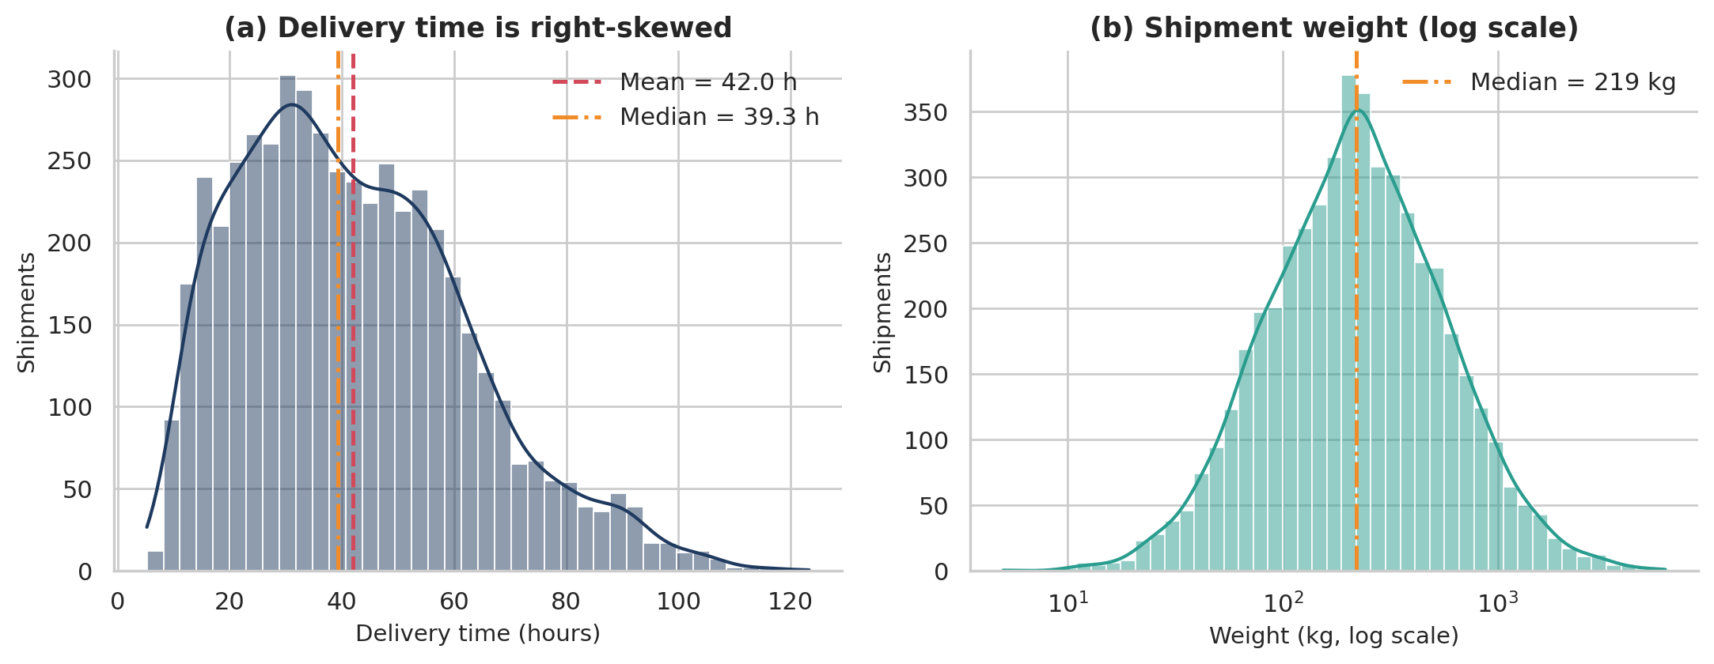
Figure 1: Distribution of delivery time (a) and shipment weight on a log scale (b).

Why this visualization?
A histogram with a kernel-density curve is the standard tool for the shape of one numeric variable: it shows the centre, spread, skew and unusual clusters at a glance. Mean and median lines are overlaid so that the gap between them (a skewness signal) is visible. Weight is drawn on a log axis because a linear axis would crush most of the data into the first few bins.

What it shows
- Delivery time: mean 42.0 h versus median 39.3 h, with a long right tail up to 123 h and a visible shoulder at 60–90 h created by slow Rail shipments.
- Weight: on the log scale the bars form a symmetric bell, confirming a log-normal pattern; the raw mean (343 kg) is 57% above the median.
- Implication: report medians and percentiles for lead time and load size, not just averages.
Python – Figure 1
fig, axes = plt.subplots(1, 2, figsize=(11, 4.4))
t = df["delivery_time_hrs"]
sns.histplot(t, bins=40, kde=True, color=NAVY, ax=axes[0])
axes[0].axvline(t.mean(), color=RED, ls="--", lw=1.8, label=f"Mean = {t.mean():.1f} h")
axes[0].axvline(t.median(), color=ORANGE, ls="-.", lw=1.8, label=f"Median = {t.median():.1f} h")
axes[0].set(title="(a) Delivery time is right-skewed", xlabel="Delivery time (hours)",
ylabel="Shipments")
axes[0].legend(frameon=False)
w = df["weight_kg"]
sns.histplot(w, bins=45, log_scale=True, kde=True, color=TEAL, ax=axes[1])
axes[1].axvline(w.median(), color=ORANGE, ls="-.", lw=1.8, label=f"Median = {w.median():.0f}
kg")
axes[1].set(title="(b) Shipment weight (log scale)", xlabel="Weight (kg, log scale)",
ylabel="Shipments")
axes[1].legend(frameon=False)
save(fig, "fig1_distributions.png")

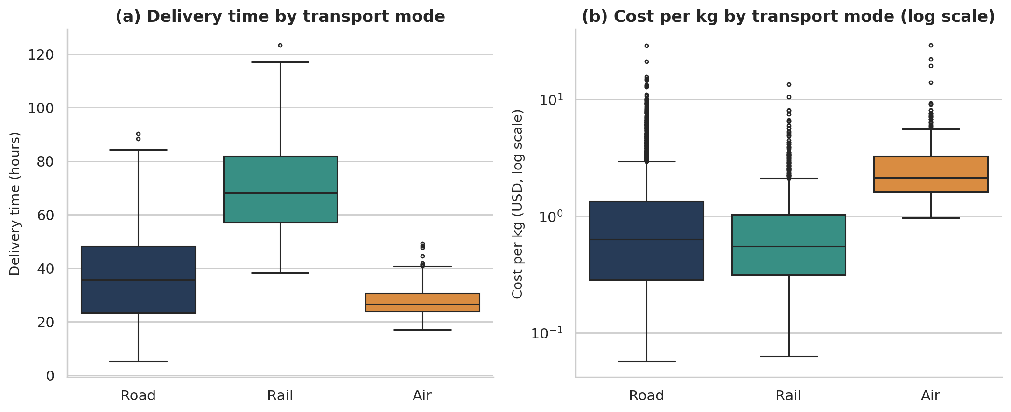
Figure 2: Delivery time (a) and cost per kg (b) by transport mode.

Why this visualization?
A box plot compares the distribution of a numeric variable across categories: median, interquartile range and outliers for each mode side by side. It is more informative than bars of averages because it exposes spread and extremes. A log axis is used for cost per kg since Air is several times more expensive than Road.

What it shows
- Median delivery time: Air 26.6 h, Road 35.6 h, Rail 68.1 h – Rail is about 1.9× slower than Road.
- Median cost per kg: Road $0.63, Rail $0.55, Air $2.11 – Air is 3.3× Road, while Rail saves 14% per kg.
- Implication: mode choice is a cost–speed trade-off; Rail suits non-urgent long hauls, Air only where time is worth a threefold premium.
Python – Figure 2
fig, axes = plt.subplots(1, 2, figsize=(11, 4.6))
sns.boxplot(data=df, x="transport_mode", y="delivery_time_hrs", order=MODES,
hue="transport_mode",
palette=MODE_COLORS, legend=False, fliersize=2.5, linewidth=1.1, ax=axes[0])
axes[0].set(title="(a) Delivery time by transport mode", xlabel="", ylabel="Delivery time
(hours)")
sns.boxplot(data=df, x="transport_mode", y="cost_per_kg", order=MODES, hue="transport_mode",
palette=MODE_COLORS, legend=False, fliersize=2.5, linewidth=1.1, ax=axes[1])
axes[1].set(title="(b) Cost per kg by transport mode (log scale)", xlabel="",
ylabel="Cost per kg (USD, log scale)", yscale="log")
save(fig, "fig2_boxplots_by_mode.png")

6.2 Correlations
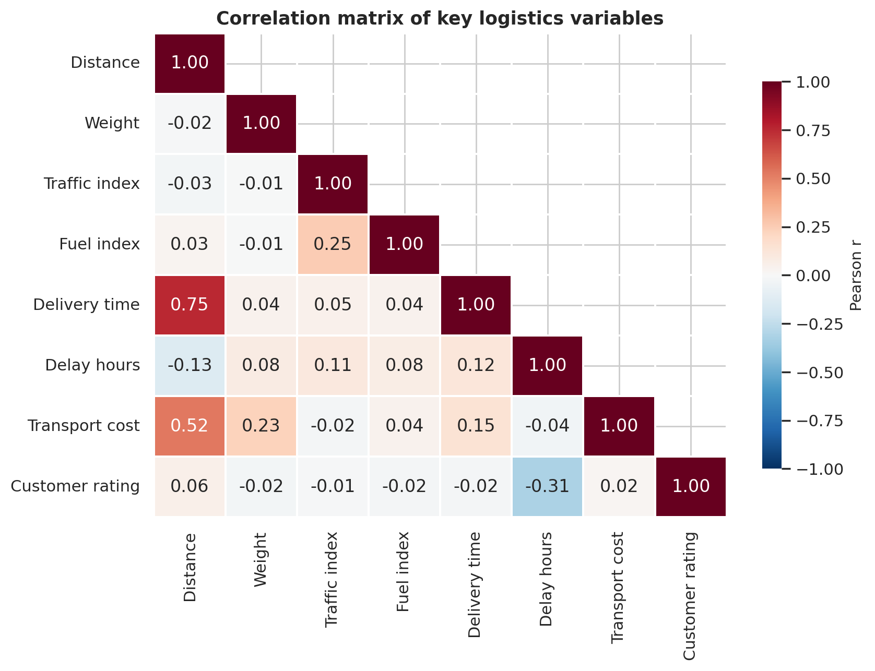
Figure 3: Pearson correlation matrix of key logistics variables.

Why this visualization?
A correlation heatmap summarises every pairwise linear relationship in one picture, so the analyst can spot the strongest links and the surprising non-links quickly. Only the lower triangle is drawn to avoid duplicates; a diverging colour map centred on zero separates positive from negative relationships.

What it shows
- Distance is the dominant factor: r = 0.75 with delivery time and r = 0.52 with cost. Weight matters for cost (r = 0.23) but hardly for time (r = 0.04).
- Traffic and fuel indices show almost no linear link with delivery time or cost (|r| ≤ 0.05) once averaged over all modes.
- Customer rating tracks delay hours (r = −0.31), not delivery time (r = −0.02). Customers judge reliability against the promise, so the service goal should be meeting the promise, not simply being fast.
Python – Figure 3
cols = {"distance_km": "Distance", "weight_kg": "Weight", "traffic_index": "Traffic index",
"fuel_index": "Fuel index", "delivery_time_hrs": "Delivery time",
"delay_hours": "Delay hours", "transport_cost_usd": "Transport cost",
"customer_rating": "Customer rating"}
corr = df[list(cols)].corr().rename(index=cols, columns=cols)
mask = np.triu(np.ones_like(corr, dtype=bool), k=1)
fig, ax = plt.subplots(figsize=(8.6, 6.6))
sns.heatmap(corr, mask=mask, annot=True, fmt=".2f", cmap="RdBu_r", center=0, vmin=-1, vmax=1,
linewidths=.8, linecolor="white", cbar_kws={"label": "Pearson r", "shrink": .8},
ax=ax)
ax.set_title("Correlation matrix of key logistics variables")
save(fig, "fig3_correlation_heatmap.png")

6.3 Trends over time
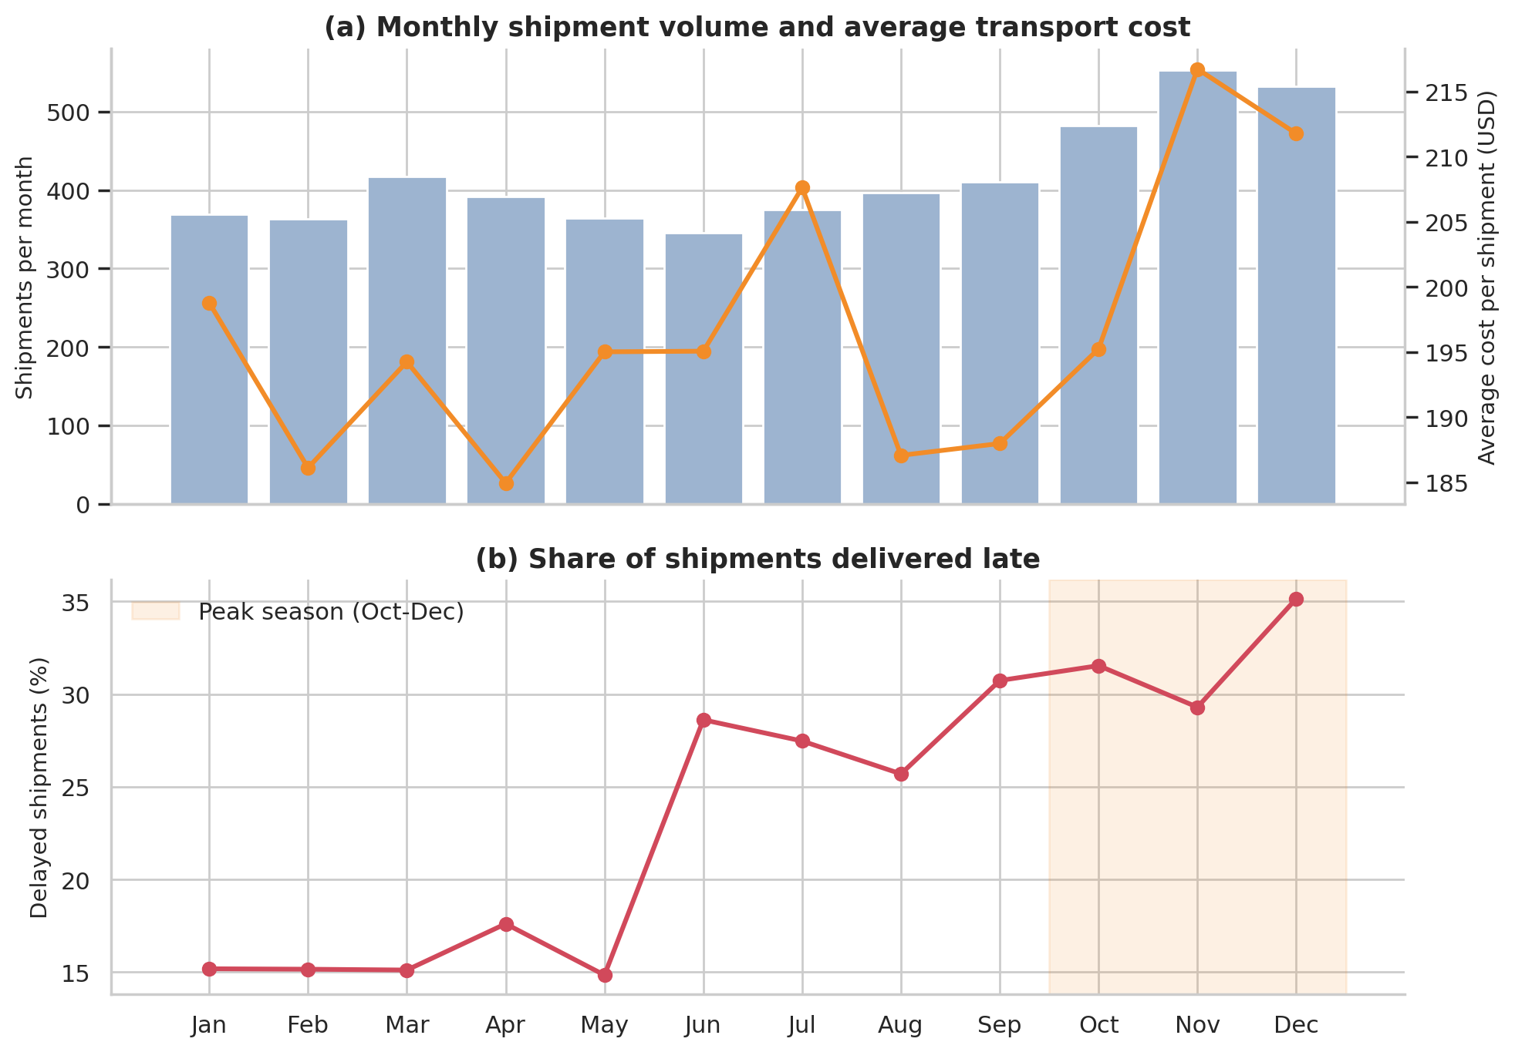
Figure 4: Monthly shipments and average cost (a) and monthly delay rate (b).

Why this visualization?
Line and bar charts are the natural choice for time series. Volume (a count) is drawn as bars and average cost as a line on a secondary axis so both can be read together; the delay rate gets its own panel so its scale is not distorted. A shaded band marks the October–December peak.

What it shows
- Volume stays between 346 and 417 shipments a month from January to September, then climbs to 482 in October and 553 in November. Average cost per shipment is $208.45 in the peak versus $192.85 outside it (+8.1%).
- The delay rate is flat at about 15% from January to May, then jumps to 29% in June when the monsoon starts and reaches 35.2% in December. Peak-season delay is 32.0% versus 21.2% off-peak.
- Implication: two different stresses hit service – weather in June–September and volume congestion in October–December – and each needs its own contingency plan.
Python – Figure 4
m = df.groupby("month").agg(shipments=("shipment_id", "count"), avg_cost=("transport_cost_usd",
"mean"),
delay_rate=("delayed", "mean"))
names = ["Jan", "Feb", "Mar", "Apr", "May", "Jun", "Jul", "Aug", "Sep", "Oct", "Nov", "Dec"]
fig, (a1, a2) = plt.subplots(2, 1, figsize=(10, 7), sharex=True, gridspec_kw={"height_ratios":
[1.1, 1]})
a1.bar(m.index, m["shipments"], color="#9DB4D0", label="Shipments")
a1.set_ylabel("Shipments per month")
b1 = a1.twinx()
b1.plot(m.index, m["avg_cost"], color=ORANGE, marker="o", lw=2.2, label="Average cost (USD)")
b1.set_ylabel("Average cost per shipment (USD)")
b1.grid(False)
b1.spines["right"].set_visible(True)
a1.set_title("(a) Monthly shipment volume and average transport cost")
a2.plot(m.index, m["delay_rate"] * 100, color=RED, marker="o", lw=2.2)
a2.axvspan(9.5, 12.5, color=ORANGE, alpha=.13, label="Peak season (Oct-Dec)")
a2.set(title="(b) Share of shipments delivered late", ylabel="Delayed shipments (%)")
a2.set_xticks(range(1, 13))
a2.set_xticklabels(names)
a2.legend(frameon=False, loc="upper left")
save(fig, "fig4_monthly_trends.png")

6.4 Relationship between distance and delivery time
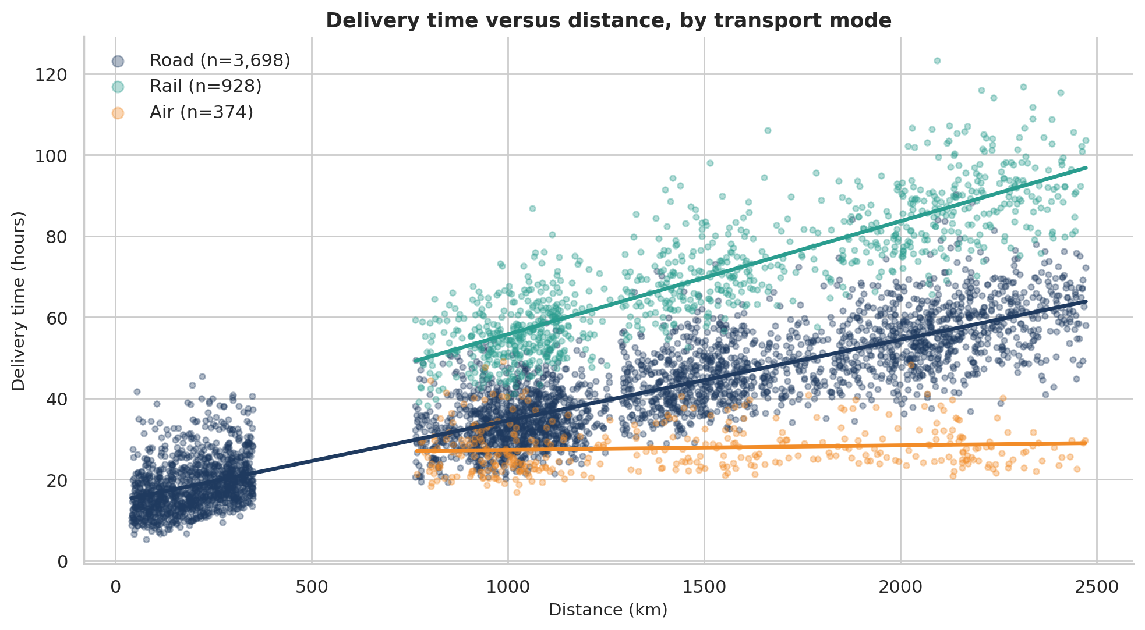
Figure 5: Delivery time versus distance, coloured by transport mode, with fitted trend lines.

Why this visualization?
A scatter plot is the right chart for the relationship between two continuous variables. Colouring by mode and adding a straight-line fit per mode shows that one overall slope would be misleading: each mode has its own speed profile.

What it shows
- Road adds about 2.0 hours per extra 100 km, Rail 2.8 h, while Air adds only 0.11 h – its time is almost independent of distance.
- Rail sits above Road at the same distance because of terminal handling (a fixed offset) and its lower average speed; Air sits lowest on the chart despite covering the longest routes.
- Implication: for distances above about 1,000 km, Air is the only mode whose delivery time barely grows, which explains its premium price.
Python – Figure 5
fig, ax = plt.subplots(figsize=(10, 5.6))
for mode in MODES:
s = df[df["transport_mode"] == mode]
ax.scatter(s["distance_km"], s["delivery_time_hrs"], s=12, alpha=.35,
color=MODE_COLORS[mode],
label=f"{mode} (n={len(s):,})")
slope, icpt = np.polyfit(s["distance_km"], s["delivery_time_hrs"], 1)
xs = np.linspace(s["distance_km"].min(), s["distance_km"].max(), 50)
ax.plot(xs, slope * xs + icpt, color=MODE_COLORS[mode], lw=2.4)
ax.set(title="Delivery time versus distance, by transport mode",
xlabel="Distance (km)", ylabel="Delivery time (hours)")
ax.legend(frameon=False, markerscale=2)
save(fig, "fig5_distance_vs_time.png")

6.5 Bottleneck analysis: hubs, carriers and weather
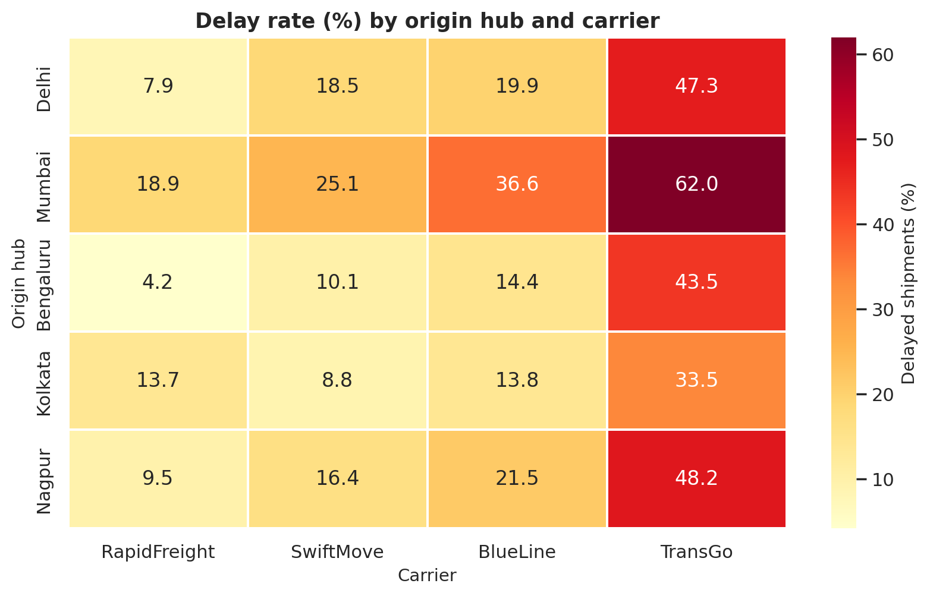
Figure 6: Delay rate (%) by origin hub and carrier.

Why this visualization?
When two categorical factors interact (hub × carrier) and the metric is a rate, an annotated heatmap is the clearest layout: the colour guides the eye to hot spots and the printed value gives the exact number. A bar chart would need 20 bars and be hard to scan.

What it shows
- TransGo is the worst carrier at every hub, from 33.5% in Kolkata to 62.0% in Mumbai. The best cell is RapidFreight from Bengaluru at 4.2%.
- Mumbai is the hottest row for every carrier (for example BlueLine 36.6% versus 14.4% in Bengaluru), so the hub itself adds delay independently of who carries the freight.
- Implication: two separate problems exist – a carrier-quality problem (TransGo) and a hub-capacity problem (Mumbai) – and they compound where they meet (Mumbai × TransGo, 62%).
Python – Figure 6
pv = df.pivot_table(index="origin_hub", columns="carrier", values="delayed", aggfunc="mean") *
100
pv = pv.loc[HUBS, ["RapidFreight", "SwiftMove", "BlueLine", "TransGo"]]
fig, ax = plt.subplots(figsize=(8.4, 5.2))
sns.heatmap(pv, annot=True, fmt=".1f", cmap="YlOrRd", linewidths=.8, linecolor="white",
cbar_kws={"label": "Delayed shipments (%)"}, ax=ax)
ax.set(title="Delay rate (%) by origin hub and carrier", xlabel="Carrier", ylabel="Origin hub")
save(fig, "fig6_hub_carrier_heatmap.png")

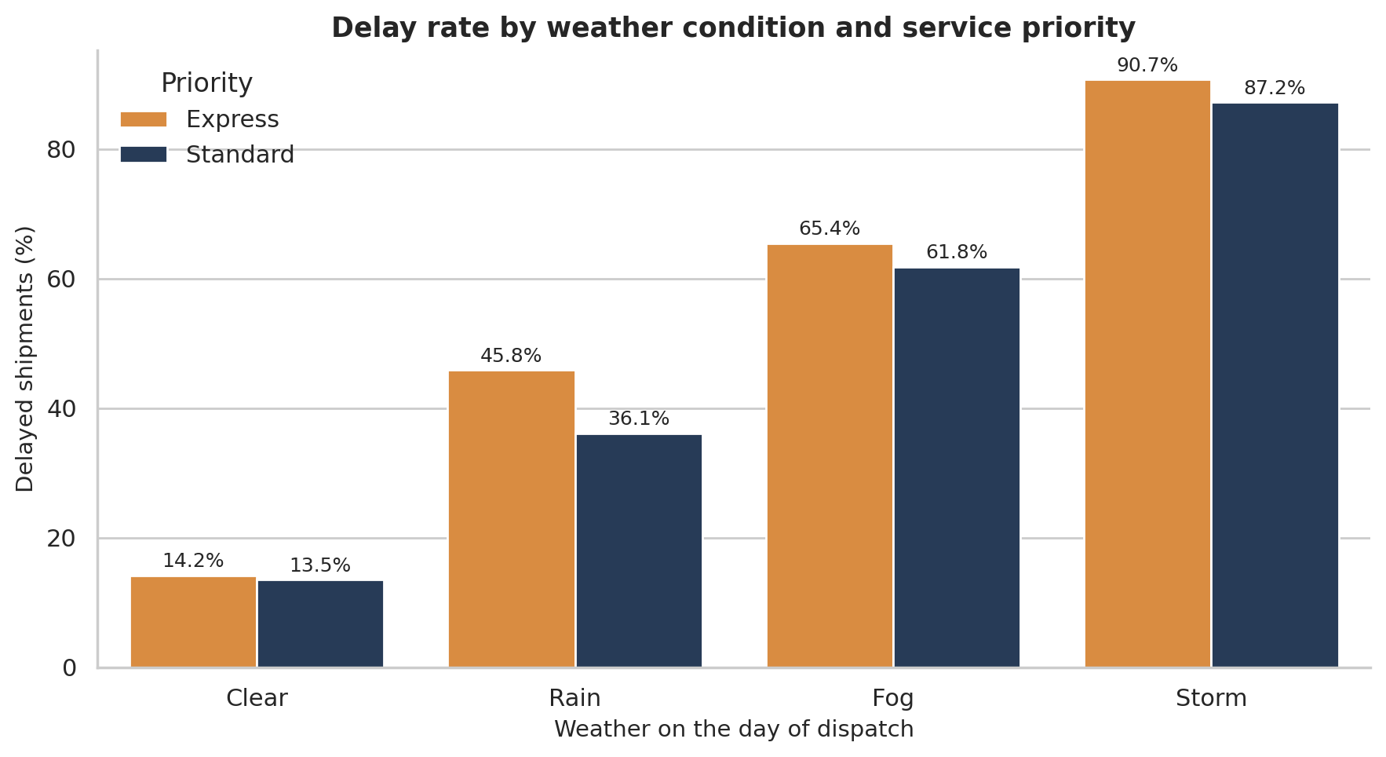
Figure 7: Delay rate by weather condition and service priority.

Why this visualization?
A grouped bar chart compares a rate across one main category (weather) split by a second category (priority). Direct value labels remove the need to read values off the axis.

What it shows
- Delay rates climb steeply with severity: Clear 13.7%, Rain 38.3%, Fog 62.8%, Storm 88.1%. Mean delay per shipment grows from 0.4 h to 9.0 h.
- Express shipments are not more reliable than Standard ones (overall 26.6% versus 23.9%); they are faster (mean 31.3 h versus 45.4 h) but also carry a tighter promise, so disruptions hit them just as often.
- Implication: paying for Express buys speed, not immunity from weather; promises should be weather-aware.
Python – Figure 7
order = ["Clear", "Rain", "Fog", "Storm"]
d = df.groupby(["weather", "priority"])["delayed"].mean().mul(100).reset_index()
fig, ax = plt.subplots(figsize=(9, 5))
sns.barplot(data=d, x="weather", y="delayed", hue="priority", order=order,
palette={"Standard": NAVY, "Express": ORANGE}, ax=ax)
for c in ax.containers:
ax.bar_label(c, fmt="%.1f%%", padding=2, fontsize=9)
ax.set(title="Delay rate by weather condition and service priority",
xlabel="Weather on the day of dispatch", ylabel="Delayed shipments (%)")
ax.legend(title="Priority", frameon=False)
save(fig, "fig7_weather_priority.png")

6.6 Driver analysis: what moves cost and time?
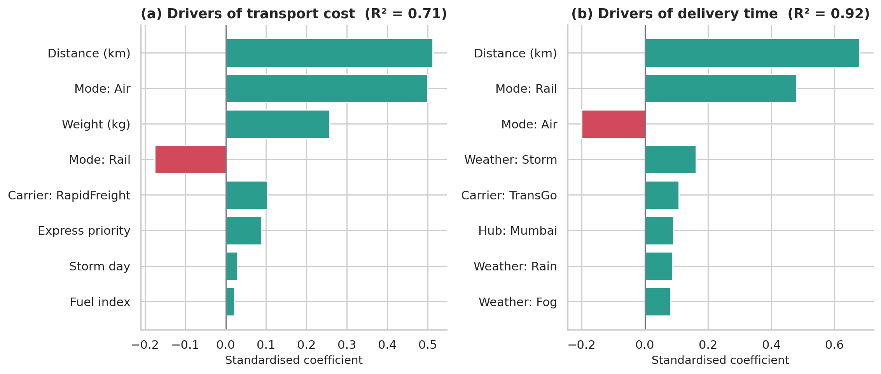
Figure 8: Standardised regression coefficients for transport cost (a) and delivery time (b); top eight drivers shown.

Why this visualization?
Correlations ignore overlap between variables (distance and mode are related, for instance). A multiple regression on z-scored inputs gives each driver a coefficient on a common scale, and horizontal bars sorted by size make the ranking immediate. Teal bars raise the outcome, red bars lower it.
Python – standardised regression (used for Figure 8)
cost_X = pd.DataFrame({
"Distance (km)": df["distance_km"], "Weight (kg)": df["weight_kg"],
"Mode: Air": (df["transport_mode"] == "Air").astype(float),
"Mode: Rail": (df["transport_mode"] == "Rail").astype(float),
"Express priority": (df["priority"] == "Express").astype(float),
"Fuel index": df["fuel_index"], "Storm day": (df["weather"] == "Storm").astype(float),
"Carrier: RapidFreight": (df["carrier"] == "RapidFreight").astype(float),
})
time_X = pd.DataFrame({
"Distance (km)": df["distance_km"], "Weight (kg)": df["weight_kg"],
"Mode: Air": (df["transport_mode"] == "Air").astype(float),
"Mode: Rail": (df["transport_mode"] == "Rail").astype(float),
"Traffic index": df["traffic_index"],
"Weather: Storm": (df["weather"] == "Storm").astype(float),
"Weather: Rain": (df["weather"] == "Rain").astype(float),
"Weather: Fog": (df["weather"] == "Fog").astype(float),
"Carrier: TransGo": (df["carrier"] == "TransGo").astype(float),
"Carrier: RapidFreight": (df["carrier"] == "RapidFreight").astype(float),
"Hub: Mumbai": (df["origin_hub"] == "Mumbai").astype(float),
"Peak season": df["is_peak"].astype(float),
})
cost_beta, cost_r2 = standardized_ols(cost_X, df["transport_cost_usd"])
time_beta, time_r2 = standardized_ols(time_X, df["delivery_time_hrs"])

What it shows
- Cost (R² = 0.71): distance (0.51) and choosing Air (0.50) dominate, followed by weight (0.26). Choosing Rail lowers cost (−0.18). Fuel price and storm surcharge are minor.
- Delivery time (R² = 0.92): distance (0.68) and Rail (0.48) lengthen delivery; Air shortens it (−0.20). Controllable operational factors follow: storms (0.16), TransGo (0.11) and the Mumbai hub (0.09).
- Implication: distance and mode are structural; the levers a manager can actually pull are carrier choice, hub capacity and weather planning.
Python – Figure 8
fig, axes = plt.subplots(1, 2, figsize=(11.5, 5))
for ax, beta, r2, title in [(axes[0], cost_beta, cost_r2, "(a) Drivers of transport cost"),
(axes[1], time_beta, time_r2, "(b) Drivers of delivery time")]:
top = beta.reindex(beta.abs().sort_values(ascending=False).index).head(8)[::-1]
ax.barh(top.index, top.values, color=[TEAL if v > 0 else RED for v in top.values])
ax.axvline(0, color=GREY, lw=1)
ax.set(title=f"{title} (R\u00b2 = {r2:.2f})", xlabel="Standardised coefficient")
save(fig, "fig8_driver_analysis.png")

6.7 Where are the delays? A Pareto view
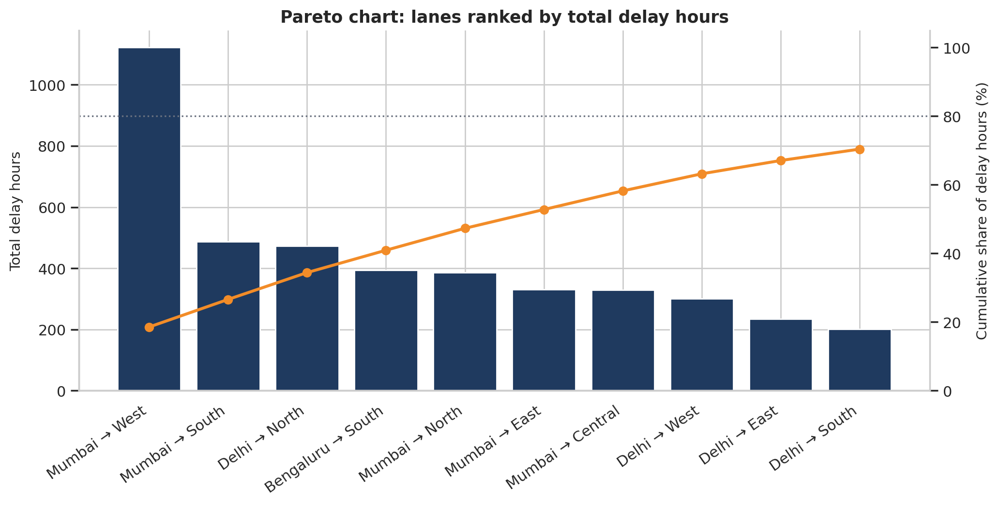
Figure 9: Pareto chart of the ten lanes with the most delay hours.

Why this visualization?
A Pareto chart ranks causes from largest to smallest and adds a cumulative-percentage line, the classic quality-management tool for deciding where to focus first. Here the “causes” are the 25 origin→destination lanes and the measure is total delay hours.

What it shows
- The single lane Mumbai → West (deliveries inside the Mumbai region) produces 18.5% of all delay hours; the top five lanes produce 47.3%, and three of those five start in Mumbai.
- The delay is only moderately concentrated: 14 of the 25 lanes are needed to reach 80% of delay hours, so the fix is a hub-level and carrier-level one rather than a handful of problem routes.
- Implication: start with Mumbai (all outbound lanes) and TransGo (all lanes) before looking at individual routes.
Python – Figure 9
lane = df.groupby("lane")["delay_hours"].sum().sort_values(ascending=False)
cum = lane.cumsum() / lane.sum() * 100
top = lane.head(10)
fig, ax = plt.subplots(figsize=(10.5, 5.4))
ax.bar(range(len(top)), top.values, color=NAVY)
ax.set_xticks(range(len(top)))
ax.set_xticklabels(top.index, rotation=35, ha="right")
ax.set(title="Pareto chart: lanes ranked by total delay hours", ylabel="Total delay hours")
ax2 = ax.twinx()
ax2.plot(range(len(top)), cum.head(10).values, color=ORANGE, marker="o", lw=2.2)
ax2.axhline(80, color=GREY, ls=":", lw=1.2)
ax2.set(ylabel="Cumulative share of delay hours (%)", ylim=(0, 105))
ax2.grid(False)
ax2.spines["right"].set_visible(True)
save(fig, "fig9_pareto_delay_lanes.png")

7. Statistical Validation
A chart can suggest a pattern that is only chance. To check that the patterns are real, the main visual findings were tested formally. Non-parametric tests are used where the data are clearly non-normal.
Table 11: Hypothesis tests on the cleaned dataset
Question | Test | Result | Conclusion
Does delay rate differ across carriers? | Chi-square (df 3) | χ² = 507.0, p < 0.001 | Yes – carrier quality differs significantly
Does delay rate depend on weather? | Chi-square (df 3) | χ² = 1,046.8, p < 0.001 | Yes – very strong effect
Is the delay rate higher in the peak season? | Chi-square (df 1) | χ² = 67.1, p < 0.001 | Yes – peak delay rate is higher
Does cost per kg differ by mode? | Kruskal–Wallis | H = 559.1, p < 0.001 | Yes – modes are priced differently
Distance vs delivery time | Spearman rank | ρ = 0.77, p < 0.001 | Strong positive monotonic link
Distance vs transport cost | Pearson | r = 0.52, p < 0.001 | Moderate positive link
Do late deliveries get lower ratings? | Mann–Whitney U | U = 1.56×10⁶, p < 0.001 | Yes – 4.35 (late) vs 4.63 (on time)

Every relationship highlighted in the visual analysis is statistically significant. With 5,000 observations even small effects reach significance, so effect sizes (delay rates, hours, dollars) rather than p-values alone are used to prioritise actions in Sections 8 and 10.
Python – hypothesis tests
out = {}
out["chi_carrier"] = stats.chi2_contingency(pd.crosstab(df["carrier"], df["delayed"]))[:3]
out["chi_weather"] = stats.chi2_contingency(pd.crosstab(df["weather"], df["delayed"]))[:3]
out["chi_peak"] = stats.chi2_contingency(pd.crosstab(df["is_peak"], df["delayed"]))[:3]
out["kruskal_cpk"] = stats.kruskal(*[g["cost_per_kg"] for _, g in df.groupby("transport_mode")])
out["spearman_dist_time"] = stats.spearmanr(df["distance_km"], df["delivery_time_hrs"])
out["pearson_dist_cost"] = stats.pearsonr(df["distance_km"], df["transport_cost_usd"])
rated = df.dropna(subset=["customer_rating"])
out["mwu_rating"] = stats.mannwhitneyu(rated.loc[rated["delayed"] == 1, "customer_rating"],
rated.loc[rated["delayed"] == 0, "customer_rating"])
out["normal_time"] = stats.normaltest(df["delivery_time_hrs"])
out["normal_logw"] = stats.normaltest(np.log(df["weight_kg"]))

8. Analytical Insights

8.1 Operational efficiency
- Overall on-time performance is 75.4%, but it hides a wide spread: 88.9% for RapidFreight versus 51.4% for TransGo. A single network-wide average is a poor management metric.
- Late shipments are late by a modest amount (4.9 h on average) but frequently; the damage is to the reliability promise, and ratings fall from 4.63 to 4.35.
- Rail is the most reliable mode (delay rate 14.1% versus 27.3% for Road) because its promised time scales with its long transit, leaving more slack in absolute hours, but it is the slowest. Road is the most delay-prone because it is exposed to congestion and weather.

8.2 Cost drivers
- Distance, mode and weight explain most of the cost: a standardised regression with eight inputs reaches R² = 0.71, and the top three coefficients are distance, Air and weight.
- Air freight averages $551 per shipment against $175 for Road and $147 for Rail, even though Air is only 7.5% of volume.
- Peak season raises average cost per shipment by 8.1% ($193 → $208), driven by volume mix and fuel prices that peak in November–December.
- TransGo is the cheapest carrier per kg ($0.65) and RapidFreight the most expensive ($0.80); the price gap is the cost of reliability and must be weighed against the 38%-point reliability gap.

8.3 Bottlenecks
- Carrier bottleneck: TransGo – 45.5% of delays from 23% of volume.
- Hub bottleneck: Mumbai – 43.9% of delay hours from 27.4% of shipments, deteriorating to a 60% delay rate in the Oct–Dec peak.
- Environmental bottleneck: storms and fog account for 383 late shipments from only 519 dispatches (10.4% of volume).
- Seasonal bottleneck: the network has no spare capacity in Q4 – volume rises 52% from May to November while the delay rate roughly doubles (14.8% in May, 29.3% in November and 35.2% in December).

9. How the Visualizations Help Interpret Logistics Performance
Each logistics KPI answers a different management question, and each needs a different visual form to be read correctly. The table links the metrics used in this report to the visualization that interprets them best.
Table 12: Performance metrics and the visualizations that interpret them
Logistics metric | Visualization | What the picture adds beyond the number
Delivery time (lead time) | Histogram + KDE (Fig. 1a), box plot (Fig. 2a) | Shows skew, the long tail of slow shipments and differences in spread between modes – an average alone hides all three.
Shipment volume / load size | Log-scale histogram (Fig. 1b) | Reveals the log-normal shape, so planners use medians and percentiles.
Cost per kg | Box plot, log axis (Fig. 2b) | Compares price levels and variability across modes on one scale.
Cost and time drivers | Standardised coefficient bars (Fig. 8) | Ranks causes on a common scale and separates structural from controllable drivers.
On-time delivery rate | Monthly line (Fig. 4b), heatmap (Fig. 6), grouped bars (Fig. 7) | Locates when, where and under what conditions reliability fails.
Volume and cost trend | Bar + line combination (Fig. 4a) | Links demand peaks to cost pressure and capacity strain.
Speed per distance | Scatter with trend lines (Fig. 5) | Shows the time penalty of every extra 100 km by mode.
Delay concentration | Pareto chart (Fig. 9) | Shows how much of the problem a few lanes explain and what to fix first.
Interdependence of KPIs | Correlation heatmap (Fig. 3) | Reveals which KPIs move together (distance, time, cost) and which do not (rating vs duration).

Three general lessons emerge. First, distribution plots protect against misleading averages – mean delivery time (42.0 h) describes almost nobody once skew and the Rail cluster are visible. Second, comparison plots turn a KPI into a decision: the hub × carrier heatmap converts a 24.6% delay rate into “fix TransGo and Mumbai”. Third, trend plots separate causes by timing: the June jump points to weather, the Q4 rise to volume.

10. Recommendations and Impact Estimates
Four what-if scenarios were run on the cleaned data to size the opportunity before recommending action. They are estimates on simulated data and should be re-run on real shipments.
Python – what-if scenarios
res = {}
total_delays = int(df["delayed"].sum())
# 1) carrier: bring the weakest carrier to the average rate of the other carriers
rate = df.groupby("carrier")["delayed"].mean()
worst = rate.idxmax()
others = df.loc[df["carrier"] != worst, "delayed"].mean()
n_worst = int((df["carrier"] == worst).sum())
avoided = n_worst * (rate[worst] - others)
res["carrier"] = {"worst": worst, "rate_worst": rate[worst], "rate_others": others,
"shipments": n_worst, "avoided": avoided, "share_of_all": avoided /
total_delays}
# 2) weather buffer: add 12 h to the promised time on Storm / Fog days
risky = df["weather"].isin(["Storm", "Fog"])
still = (df["delivery_time_hrs"] > df["promised_time_hrs"] + 12)
avoided_w = int(df.loc[risky, "delayed"].sum() - still[risky].sum())
res["weather"] = {"risky_shipments": int(risky.sum()), "delays_before": int(df.loc[risky,
"delayed"].sum()),
"avoided": avoided_w, "share_of_all": avoided_w / total_delays}
# 3) mode shift: 30% of Standard road shipments >= 800 km move to rail
band = df[(df["priority"] == "Standard") & (df["distance_km"] >= 800)]
kgkm = band["weight_kg"] * band["distance_km"]
ckk = band.groupby("transport_mode")["transport_cost_usd"].sum() /
kgkm.groupby(band["transport_mode"]).sum()
road = band[band["transport_mode"] == "Road"]
saving = 0.30 * (ckk["Road"] - ckk["Rail"]) * (road["weight_kg"] * road["distance_km"]).sum()
t = band.groupby("transport_mode")["delivery_time_hrs"].median()
res["mode_shift"] = {"road_ckk": ckk["Road"], "rail_ckk": ckk["Rail"], "eligible":
int(len(road)),
"saving": saving, "saving_pct": saving / df["transport_cost_usd"].sum(),
"road_time": t["Road"], "rail_time": t["Rail"]}
# 4) peak-season capacity at Mumbai hub
mum = df[df["origin_hub"] == "Mumbai"]
res["mumbai"] = {"peak_rate": mum.loc[mum["is_peak"], "delayed"].mean(),
"off_rate": mum.loc[~mum["is_peak"], "delayed"].mean(),
"peak_shipments": int(mum["is_peak"].sum())}

Table 13: What-if scenario results
Lever | Assumption | Estimated impact
1. Fix the weakest carrier | Bring TransGo (48.6% delay rate, 1,150 shipments) to the 17.4% of the other carriers | About 359 fewer late shipments (29.2% of all delays)
2. Weather-aware promises | Add 12 h to the promised time on Storm/Fog days (519 shipments) | 289 fewer SLA misses (23.5% of all delays); expectation management, not faster delivery
3. Selective Road → Rail shift | 30% of the 1,966 Standard Road shipments of 800 km or more switch to Rail | Saving about $51,227 (5.2% of spend); median transit rises from 45 h to 68 h
4. Mumbai peak capacity | 428 Mumbai shipments in Oct–Dec currently see a 60% delay rate versus 24% off-peak | Bringing the peak to off-peak levels would remove roughly 155 delays (illustrative: 428 × (60% − 24%))

Table 14: Prioritised recommendations
# | Recommendation | Evidence | KPI to track | Priority
1 | Put TransGo on a performance plan with SLA penalties; shift volume to RapidFreight/SwiftMove on Mumbai lanes until delay rate falls below 25% | Fig. 6; chi-square on carrier; scenario 1 | Delay rate by carrier and hub | High
2 | Add temporary handling capacity (labour shifts, cross-docking, dock-slot booking) at Mumbai from September | Figs. 4 and 9; Mumbai peak delay rate 60% | Mumbai handling time, peak delay rate | High
3 | Introduce weather-linked dynamic ETAs and a contingency routing playbook for Storm/Fog | Fig. 7; scenario 2 | SLA miss rate on Storm/Fog days | Medium
4 | Move non-urgent long-haul Standard freight to Rail where customers can accept an extra day | Figs. 2 and 5; scenario 3 | Cost per kg-km, Rail share | Medium
5 | Reserve Express/Air for shipments whose urgency justifies a 3× cost per kg; do not assume Express is more reliable | Fig. 2b; Express delay rate 26.6% | Express SLA hit rate | Medium
6 | Monitor lane-level delay hours (Pareto) and carrier × hub heatmap monthly in a dashboard | Figs. 6 and 9 | Delay hours by lane | Ongoing

11. Limitations and Future Work
- Simulated data. Effects such as TransGo’s delay or the Mumbai peak were built in, so the analysis demonstrates the method rather than discovering facts about a real network. Absolute figures (costs, delay rates) must not be quoted as real-world benchmarks.
- Linear models on skewed outcomes. The cost model explains 71% of the variance; a log-transformed or gradient-boosted model would fit better. Regression coefficients show association, not proven causation.
- Single year and simplified operations. Inventory levels, warehouse capacity, vehicle utilisation, returns and driver availability are not modelled.
- Future work. (1) Replace the simulated file with a real shipment export; (2) build a predictive model for late delivery (logistic regression or random forest) and use it for proactive alerts; (3) turn the figures into an interactive Plotly or Power BI dashboard; (4) add a cost–service optimisation of the carrier mix.

12. Conclusion
The analysis shows how a structured sequence of simulation, cleaning, descriptive statistics, targeted visualization and statistical testing converts raw shipment records into specific, defensible management actions. In the simulated network, 75.4% of shipments arrive on time, but reliability is dominated by a few controllable factors: one underperforming carrier, one congested hub, and weather exposure. Distance and transport mode set the structural cost and time, while customers judge the service on whether the promise is kept.
Nine figures, seven statistical tests, two driver models and four what-if scenarios support six prioritised recommendations. Together, fixing the weakest carrier, adding peak capacity in Mumbai and making delivery promises weather-aware address the largest share of late deliveries, while selective rail use trims about 5% from freight spend. The complete, reproducible code is given in Appendix A.

Appendix A – Complete Python Script
File: logistics_eda.py. Running it regenerates the dataset, all nine figures and every number quoted in this report.
#!/usr/bin/env python3
"""
Advanced Data Analysis and Visualization in Logistics
=====================================================
Yuva Intern - Logistics Data Analyst Intern - Week 3 Task

Pipeline
1. Simulate a hypothetical logistics dataset (5,000 shipments, seed = 42)
2. Inject realistic data-quality problems, then clean the data
3. Exploratory Data Analysis (central tendency, distributions, correlations)
4. Nine visualizations saved to ./figures
5. Statistical tests, driver (regression) analysis and what-if scenarios
6. Save cleaned data to ./data and all numbers to results.json

Run: python logistics_eda.py
Requires: numpy, pandas, matplotlib, seaborn, scipy
"""
import json
import os
import warnings

import matplotlib
matplotlib.use("Agg")
import matplotlib.pyplot as plt
import numpy as np
import pandas as pd
import seaborn as sns
from scipy import stats

warnings.filterwarnings("ignore")

BASE = os.path.dirname(os.path.abspath(__file__))
FIG_DIR = os.path.join(BASE, "figures")
DATA_DIR = os.path.join(BASE, "data")
os.makedirs(FIG_DIR, exist_ok=True)
os.makedirs(DATA_DIR, exist_ok=True)

SEED = 42
N_SHIPMENTS = 5000

NAVY, ORANGE, TEAL, RED, GREY = "#1F3A5F", "#F28C28", "#2A9D8F", "#D1495B", "#6B7280"
MODE_COLORS = {"Road": NAVY, "Rail": TEAL, "Air": ORANGE}
MODES = ["Road", "Rail", "Air"]

sns.set_theme(style="whitegrid", context="notebook")
plt.rcParams.update({
"savefig.dpi": 200, "axes.titleweight": "bold", "axes.titlesize": 12.5,
"axes.labelsize": 10.5, "axes.spines.top": False, "axes.spines.right": False,
})

# ----------------------------------------------------------------------------
# 1. DATA SIMULATION
# ----------------------------------------------------------------------------
HUBS = ["Delhi", "Mumbai", "Bengaluru", "Kolkata", "Nagpur"]
HUB_REGION = {"Delhi": "North", "Mumbai": "West", "Bengaluru": "South",
"Kolkata": "East", "Nagpur": "Central"}
REGION_HUB = {v: k for k, v in HUB_REGION.items()}
ROAD_KM = {("Delhi", "Mumbai"): 1400, ("Delhi", "Bengaluru"): 2150,
("Delhi", "Kolkata"): 1500, ("Delhi", "Nagpur"): 1050,
("Mumbai", "Bengaluru"): 980, ("Mumbai", "Kolkata"): 2000,
("Mumbai", "Nagpur"): 830, ("Bengaluru", "Kolkata"): 1870,
("Bengaluru", "Nagpur"): 1000, ("Kolkata", "Nagpur"): 1100}

def hub_distance(a, b):
return ROAD_KM.get((a, b), ROAD_KM.get((b, a)))

def simulate_dataset(n=N_SHIPMENTS, seed=SEED):
"""Generate a hypothetical shipment-level logistics dataset."""
rng = np.random.default_rng(seed)
# --- when, where and what is shipped ---------------------------------
month_w = np.array([.075, .07, .08, .075, .075, .07, .07, .08, .085, .10, .11, .11])
month = rng.choice(np.arange(1, 13), size=n, p=month_w / month_w.sum())
order_date = pd.to_datetime(dict(year=2025, month=month, day=rng.integers(1, 29, size=n)))
peak = np.isin(month, [10, 11, 12]) # Oct-Dec festive peak

hub = rng.choice(HUBS, size=n, p=[.24, .28, .22, .14, .12])
dest = rng.choice(["North", "West", "South", "East", "Central"], size=n,
p=[.22, .25, .24, .17, .12])
dest_hub = np.array([REGION_HUB[r] for r in dest])
same = hub == dest_hub
inter_km = np.array([0 if s else hub_distance(h, d) for h, d, s in zip(hub, dest_hub,
same)], float)
distance = np.where(same, rng.uniform(40, 350, n), inter_km * rng.uniform(0.92, 1.15, n))

weight = np.clip(rng.lognormal(np.log(220), 0.95, n), 5, 6000) # right-skewed
priority = rng.choice(["Standard", "Express"], size=n, p=[.75, .25])
carrier = rng.choice(["SwiftMove", "BlueLine", "TransGo", "RapidFreight"], size=n,
p=[.32, .28, .22, .18])

u = rng.random(n) # choose transport
mode
mode = np.where((priority == "Express") & (distance > 700), np.where(u < .40, "Air",
"Road"),
np.where((priority == "Standard") & (distance > 500),
np.where(u < .32, "Rail", "Road"), "Road"))

weather = np.empty(n, dtype=object) # seasonal weather
for m in range(1, 13):
idx = month == m
p = [.50, .38, .10, .02] if m in (6, 7, 8, 9) else \
[.72, .05, .01, .22] if m in (12, 1) else [.82, .12, .03, .03]
weather[idx] = rng.choice(["Clear", "Rain", "Storm", "Fog"], size=idx.sum(), p=p)

traffic = np.clip(rng.normal(5, 1.4, n) + 1.0 * peak + 1.2 * (hub == "Mumbai")
+ 0.6 * (hub == "Delhi"), 1, 10) # congestion index
1-10

# --- delivery time (hours) = hub handling + transit + disruptions ----
speed = pd.Series(mode).map({"Road": 48, "Rail": 36, "Air": 650}).to_numpy()
terminal = pd.Series(mode).map({"Road": 0, "Rail": 14, "Air": 12}).to_numpy()
express_road = np.where((priority == "Express") & (mode == "Road"), 0.82, 1.0)
transit = (distance / speed) * express_road + terminal
hub_base = pd.Series(hub).map({"Delhi": 7, "Mumbai": 9, "Bengaluru": 6.5,
"Kolkata": 8, "Nagpur": 5.5}).to_numpy()
handling = (hub_base + weight / 600 + rng.exponential(1.5, n)
+ 6 * ((hub == "Mumbai") & peak) + 2 * ((hub == "Delhi") & peak))
carrier_delay = pd.Series(carrier).map({"SwiftMove": 0.0, "BlueLine": 1.5,
"TransGo": 6.0, "RapidFreight": -1.5}).to_numpy()
weather_delay = np.select(
[weather == "Rain", weather == "Storm", weather == "Fog"],
[np.clip(rng.normal(5, 2, n), 0, None), np.clip(rng.normal(16, 5, n), 0, None),
np.clip(rng.normal(7, 3, n), 0, None)], default=0.0)
traffic_delay = np.where(mode == "Road", 0.9 * (traffic - 5), 0.0)
delivery_time = (handling + transit * rng.lognormal(0, 0.10, n) + weather_delay
+ carrier_delay * rng.uniform(0.6, 1.4, n) + traffic_delay)
delivery_time = np.clip(delivery_time, 3, None)
promised = (hub_base + transit) * 1.15 + 6 # SLA promise
delay_hours = np.clip(delivery_time - promised, 0, None)

# --- transport cost (USD) ---------------------------------------------
fuel_by_month = np.array([98, 99, 101, 103, 104, 102, 101, 103, 105, 108, 110, 111]) / 100
fuel_index = fuel_by_month[month - 1] + rng.normal(0, 0.01, n)
fixed = pd.Series(mode).map({"Road": 12, "Rail": 25, "Air": 40}).to_numpy()
per_km = pd.Series(mode).map({"Road": 0.12, "Rail": 0.07, "Air": 0.10}).to_numpy()
per_kg = pd.Series(mode).map({"Road": 0.06, "Rail": 0.04, "Air": 0.85}).to_numpy()
carrier_mult = pd.Series(carrier).map({"SwiftMove": 1.00, "BlueLine": 0.94,
"TransGo": 0.88, "RapidFreight": 1.18}).to_numpy()
fuel_sens = np.where(mode == "Rail", 0.2, 0.6)
cost = (fixed + per_km * distance + per_kg * weight)
cost = (cost * np.where(priority == "Express", 1.20, 1.0) * carrier_mult
* (1 + fuel_sens * (fuel_index - 1)) * (1 + 0.08 * (weather == "Storm"))
* rng.lognormal(0, 0.08, n))

rating = np.clip(np.round(4.7 - 0.06 * delay_hours + rng.normal(0, 0.55, n)), 1, 5)
df = pd.DataFrame({
"shipment_id": [f"SH{i:05d}" for i in range(1, n + 1)],
"order_date": order_date, "origin_hub": hub, "destination_region": dest,
"lane": [f"{h} \u2192 {d}" for h, d in zip(hub, dest)],
"carrier": carrier, "transport_mode": mode, "priority": priority, "weather": weather,
"weight_kg": weight.round(1), "distance_km": distance.round(1),
"traffic_index": traffic.round(2), "fuel_index": fuel_index.round(3),
"delivery_time_hrs": delivery_time.round(2), "promised_time_hrs": promised.round(2),
"delay_hours": delay_hours.round(2), "delayed": (delay_hours > 0).astype(int),
"transport_cost_usd": cost.round(2), "customer_rating": rating,
})
return df.sort_values("order_date").reset_index(drop=True).assign(
shipment_id=lambda d: [f"SH{i:05d}" for i in range(1, len(d) + 1)])

def inject_data_issues(df, seed=SEED):
"""Add realistic quality problems (missing values, duplicates) to practise cleaning."""
rng = np.random.default_rng(seed + 1)
df = df.copy()
df.loc[rng.choice(df.index, 60, replace=False), "weight_kg"] = np.nan # missing
weights
df.loc[rng.random(len(df)) < 0.05, "customer_rating"] = np.nan # unrated
deliveries
dup = df.sample(30, random_state=seed) # double-posted
rows
return pd.concat([df, dup], ignore_index=True)

# ----------------------------------------------------------------------------
# 2. DATA CLEANING
# ----------------------------------------------------------------------------
def clean_dataset(raw):
report = {"rows_raw": int(len(raw)), "columns": int(raw.shape[1])}
df = raw.drop_duplicates(subset="shipment_id").copy() # 1) duplicates
report["duplicates_removed"] = int(len(raw) - len(df))
report["missing_weight"] = int(df["weight_kg"].isna().sum()) # 2) missing values
report["missing_rating"] = int(df["customer_rating"].isna().sum())
df["weight_kg"] = df["weight_kg"].fillna(
df.groupby("transport_mode")["weight_kg"].transform("median")) # median impute
df["order_date"] = pd.to_datetime(df["order_date"]) # 3) types + features
df["month"] = df["order_date"].dt.month
df["is_peak"] = df["month"].isin([10, 11, 12])
df["cost_per_kg"] = df["transport_cost_usd"] / df["weight_kg"]
df["cost_per_kg_km"] = df["transport_cost_usd"] / (df["weight_kg"] * df["distance_km"])
for col in ["weight_kg", "transport_cost_usd", "delivery_time_hrs"]: # 4) IQR outlier audit
q1, q3 = df[col].quantile([.25, .75])
iqr = q3 - q1
report[f"outliers_{col}"] = int(((df[col] < q1 - 1.5 * iqr) | (df[col] > q3 + 1.5 *
iqr)).sum())
report["rows_clean"] = int(len(df))
return df.reset_index(drop=True), report

# ----------------------------------------------------------------------------
# 3. EXPLORATORY DATA ANALYSIS
# ----------------------------------------------------------------------------
NUM_LABELS = {
"weight_kg": "Shipment weight (kg)", "distance_km": "Distance (km)",
"delivery_time_hrs": "Delivery time (hrs)", "transport_cost_usd": "Transport cost (USD)",
"cost_per_kg": "Cost per kg (USD)", "traffic_index": "Traffic index (1-10)",
"customer_rating": "Customer rating (1-5)",
}

def summary_statistics(df):
rows = []
for col, label in NUM_LABELS.items():
x = df[col].dropna()
counts, edges = np.histogram(x, bins=30)
k = counts.argmax()
rows.append({
"variable": label, "mean": x.mean(), "median": x.median(),
"mode": (edges[k] + edges[k + 1]) / 2, "std": x.std(),
"min": x.min(), "max": x.max(), "cv_pct": x.std() / x.mean() * 100,
"skew": stats.skew(x),
})
return pd.DataFrame(rows)

# ----------------------------------------------------------------------------
# 4. VISUALIZATIONS
# ----------------------------------------------------------------------------
def save(fig, name):
fig.tight_layout()
fig.savefig(os.path.join(FIG_DIR, name), bbox_inches="tight", facecolor="white")
plt.close(fig)

def fig1_distributions(df):
fig, axes = plt.subplots(1, 2, figsize=(11, 4.4))
t = df["delivery_time_hrs"]
sns.histplot(t, bins=40, kde=True, color=NAVY, ax=axes[0])
axes[0].axvline(t.mean(), color=RED, ls="--", lw=1.8, label=f"Mean = {t.mean():.1f} h")
axes[0].axvline(t.median(), color=ORANGE, ls="-.", lw=1.8, label=f"Median = {t.median():.1f}
h")
axes[0].set(title="(a) Delivery time is right-skewed", xlabel="Delivery time (hours)",
ylabel="Shipments")
axes[0].legend(frameon=False)
w = df["weight_kg"]
sns.histplot(w, bins=45, log_scale=True, kde=True, color=TEAL, ax=axes[1])
axes[1].axvline(w.median(), color=ORANGE, ls="-.", lw=1.8, label=f"Median = {w.median():.0f}
kg")
axes[1].set(title="(b) Shipment weight (log scale)", xlabel="Weight (kg, log scale)",
ylabel="Shipments")
axes[1].legend(frameon=False)
save(fig, "fig1_distributions.png")

def fig2_boxplots(df):
fig, axes = plt.subplots(1, 2, figsize=(11, 4.6))
sns.boxplot(data=df, x="transport_mode", y="delivery_time_hrs", order=MODES,
hue="transport_mode",
palette=MODE_COLORS, legend=False, fliersize=2.5, linewidth=1.1, ax=axes[0])
axes[0].set(title="(a) Delivery time by transport mode", xlabel="", ylabel="Delivery time
(hours)")
sns.boxplot(data=df, x="transport_mode", y="cost_per_kg", order=MODES, hue="transport_mode",
palette=MODE_COLORS, legend=False, fliersize=2.5, linewidth=1.1, ax=axes[1])
axes[1].set(title="(b) Cost per kg by transport mode (log scale)", xlabel="",
ylabel="Cost per kg (USD, log scale)", yscale="log")
save(fig, "fig2_boxplots_by_mode.png")

def fig3_correlation(df):
cols = {"distance_km": "Distance", "weight_kg": "Weight", "traffic_index": "Traffic index",
"fuel_index": "Fuel index", "delivery_time_hrs": "Delivery time",
"delay_hours": "Delay hours", "transport_cost_usd": "Transport cost",
"customer_rating": "Customer rating"}
corr = df[list(cols)].corr().rename(index=cols, columns=cols)
mask = np.triu(np.ones_like(corr, dtype=bool), k=1)
fig, ax = plt.subplots(figsize=(8.6, 6.6))
sns.heatmap(corr, mask=mask, annot=True, fmt=".2f", cmap="RdBu_r", center=0, vmin=-1,
vmax=1,
linewidths=.8, linecolor="white", cbar_kws={"label": "Pearson r", "shrink": .8},
ax=ax)
ax.set_title("Correlation matrix of key logistics variables")
save(fig, "fig3_correlation_heatmap.png")
return corr

def fig4_monthly_trend(df):
m = df.groupby("month").agg(shipments=("shipment_id", "count"),
avg_cost=("transport_cost_usd", "mean"),
delay_rate=("delayed", "mean"))
names = ["Jan", "Feb", "Mar", "Apr", "May", "Jun", "Jul", "Aug", "Sep", "Oct", "Nov", "Dec"]
fig, (a1, a2) = plt.subplots(2, 1, figsize=(10, 7), sharex=True,
gridspec_kw={"height_ratios": [1.1, 1]})
a1.bar(m.index, m["shipments"], color="#9DB4D0", label="Shipments")
a1.set_ylabel("Shipments per month")
b1 = a1.twinx()
b1.plot(m.index, m["avg_cost"], color=ORANGE, marker="o", lw=2.2, label="Average cost
(USD)")
b1.set_ylabel("Average cost per shipment (USD)")
b1.grid(False)
b1.spines["right"].set_visible(True)
a1.set_title("(a) Monthly shipment volume and average transport cost")
a2.plot(m.index, m["delay_rate"] * 100, color=RED, marker="o", lw=2.2)
a2.axvspan(9.5, 12.5, color=ORANGE, alpha=.13, label="Peak season (Oct-Dec)")
a2.set(title="(b) Share of shipments delivered late", ylabel="Delayed shipments (%)")
a2.set_xticks(range(1, 13))
a2.set_xticklabels(names)
a2.legend(frameon=False, loc="upper left")
save(fig, "fig4_monthly_trends.png")
return m

def fig5_distance_vs_time(df):
fig, ax = plt.subplots(figsize=(10, 5.6))
for mode in MODES:
s = df[df["transport_mode"] == mode]
ax.scatter(s["distance_km"], s["delivery_time_hrs"], s=12, alpha=.35,
color=MODE_COLORS[mode],
label=f"{mode} (n={len(s):,})")
slope, icpt = np.polyfit(s["distance_km"], s["delivery_time_hrs"], 1)
xs = np.linspace(s["distance_km"].min(), s["distance_km"].max(), 50)
ax.plot(xs, slope * xs + icpt, color=MODE_COLORS[mode], lw=2.4)
ax.set(title="Delivery time versus distance, by transport mode",
xlabel="Distance (km)", ylabel="Delivery time (hours)")
ax.legend(frameon=False, markerscale=2)
save(fig, "fig5_distance_vs_time.png")

def fig6_hub_carrier_heatmap(df):
pv = df.pivot_table(index="origin_hub", columns="carrier", values="delayed", aggfunc="mean")
* 100
pv = pv.loc[HUBS, ["RapidFreight", "SwiftMove", "BlueLine", "TransGo"]]
fig, ax = plt.subplots(figsize=(8.4, 5.2))
sns.heatmap(pv, annot=True, fmt=".1f", cmap="YlOrRd", linewidths=.8, linecolor="white",
cbar_kws={"label": "Delayed shipments (%)"}, ax=ax)
ax.set(title="Delay rate (%) by origin hub and carrier", xlabel="Carrier", ylabel="Origin
hub")
save(fig, "fig6_hub_carrier_heatmap.png")
return pv

def fig7_weather_priority(df):
order = ["Clear", "Rain", "Fog", "Storm"]
d = df.groupby(["weather", "priority"])["delayed"].mean().mul(100).reset_index()
fig, ax = plt.subplots(figsize=(9, 5))
sns.barplot(data=d, x="weather", y="delayed", hue="priority", order=order,
palette={"Standard": NAVY, "Express": ORANGE}, ax=ax)
for c in ax.containers:
ax.bar_label(c, fmt="%.1f%%", padding=2, fontsize=9)
ax.set(title="Delay rate by weather condition and service priority",
xlabel="Weather on the day of dispatch", ylabel="Delayed shipments (%)")
ax.legend(title="Priority", frameon=False)
save(fig, "fig7_weather_priority.png")
return d

def standardized_ols(X, y):
"""OLS on z-scored predictors so coefficients are comparable (effect of +1 SD, in SD of
y)."""
Xz = (X - X.mean()) / X.std()
yz = (y - y.mean()) / y.std()
A = np.column_stack([np.ones(len(Xz)), Xz.to_numpy(float)])
beta, *_ = np.linalg.lstsq(A, yz.to_numpy(float), rcond=None)
resid = yz.to_numpy(float) - A @ beta
r2 = 1 - (resid ** 2).sum() / ((yz - yz.mean()) ** 2).sum()
return pd.Series(beta[1:], index=X.columns), float(r2)

def driver_models(df):
cost_X = pd.DataFrame({
"Distance (km)": df["distance_km"], "Weight (kg)": df["weight_kg"],
"Mode: Air": (df["transport_mode"] == "Air").astype(float),
"Mode: Rail": (df["transport_mode"] == "Rail").astype(float),
"Express priority": (df["priority"] == "Express").astype(float),
"Fuel index": df["fuel_index"], "Storm day": (df["weather"] == "Storm").astype(float),
"Carrier: RapidFreight": (df["carrier"] == "RapidFreight").astype(float),
})
time_X = pd.DataFrame({
"Distance (km)": df["distance_km"], "Weight (kg)": df["weight_kg"],
"Mode: Air": (df["transport_mode"] == "Air").astype(float),
"Mode: Rail": (df["transport_mode"] == "Rail").astype(float),
"Traffic index": df["traffic_index"],
"Weather: Storm": (df["weather"] == "Storm").astype(float),
"Weather: Rain": (df["weather"] == "Rain").astype(float),
"Weather: Fog": (df["weather"] == "Fog").astype(float),
"Carrier: TransGo": (df["carrier"] == "TransGo").astype(float),
"Carrier: RapidFreight": (df["carrier"] == "RapidFreight").astype(float),
"Hub: Mumbai": (df["origin_hub"] == "Mumbai").astype(float),
"Peak season": df["is_peak"].astype(float),
})
cost_beta, cost_r2 = standardized_ols(cost_X, df["transport_cost_usd"])
time_beta, time_r2 = standardized_ols(time_X, df["delivery_time_hrs"])
return cost_beta, cost_r2, time_beta, time_r2

def fig8_drivers(cost_beta, cost_r2, time_beta, time_r2):
fig, axes = plt.subplots(1, 2, figsize=(11.5, 5))
for ax, beta, r2, title in [(axes[0], cost_beta, cost_r2, "(a) Drivers of transport cost"),
(axes[1], time_beta, time_r2, "(b) Drivers of delivery time")]:
top = beta.reindex(beta.abs().sort_values(ascending=False).index).head(8)[::-1]
ax.barh(top.index, top.values, color=[TEAL if v > 0 else RED for v in top.values])
ax.axvline(0, color=GREY, lw=1)
ax.set(title=f"{title} (R\u00b2 = {r2:.2f})", xlabel="Standardised coefficient")
save(fig, "fig8_driver_analysis.png")

def fig9_pareto(df):
lane = df.groupby("lane")["delay_hours"].sum().sort_values(ascending=False)
cum = lane.cumsum() / lane.sum() * 100
top = lane.head(10)
fig, ax = plt.subplots(figsize=(10.5, 5.4))
ax.bar(range(len(top)), top.values, color=NAVY)
ax.set_xticks(range(len(top)))
ax.set_xticklabels(top.index, rotation=35, ha="right")
ax.set(title="Pareto chart: lanes ranked by total delay hours", ylabel="Total delay hours")
ax2 = ax.twinx()
ax2.plot(range(len(top)), cum.head(10).values, color=ORANGE, marker="o", lw=2.2)
ax2.axhline(80, color=GREY, ls=":", lw=1.2)
ax2.set(ylabel="Cumulative share of delay hours (%)", ylim=(0, 105))
ax2.grid(False)
ax2.spines["right"].set_visible(True)
save(fig, "fig9_pareto_delay_lanes.png")
return lane, cum

# ----------------------------------------------------------------------------
# 5. STATISTICAL TESTS AND WHAT-IF SCENARIOS
# ----------------------------------------------------------------------------
def run_tests(df):
out = {}
out["chi_carrier"] = stats.chi2_contingency(pd.crosstab(df["carrier"], df["delayed"]))[:3]
out["chi_weather"] = stats.chi2_contingency(pd.crosstab(df["weather"], df["delayed"]))[:3]
out["chi_peak"] = stats.chi2_contingency(pd.crosstab(df["is_peak"], df["delayed"]))[:3]
out["kruskal_cpk"] = stats.kruskal(*[g["cost_per_kg"] for _, g in
df.groupby("transport_mode")])
out["spearman_dist_time"] = stats.spearmanr(df["distance_km"], df["delivery_time_hrs"])
out["pearson_dist_cost"] = stats.pearsonr(df["distance_km"], df["transport_cost_usd"])
rated = df.dropna(subset=["customer_rating"])
out["mwu_rating"] = stats.mannwhitneyu(rated.loc[rated["delayed"] == 1, "customer_rating"],
rated.loc[rated["delayed"] == 0, "customer_rating"])
out["normal_time"] = stats.normaltest(df["delivery_time_hrs"])
out["normal_logw"] = stats.normaltest(np.log(df["weight_kg"]))
return out

def scenarios(df):
"""Quantify four what-if improvement levers on the simulated data."""
res = {}
total_delays = int(df["delayed"].sum())
# 1) carrier: bring the weakest carrier to the average rate of the other carriers
rate = df.groupby("carrier")["delayed"].mean()
worst = rate.idxmax()
others = df.loc[df["carrier"] != worst, "delayed"].mean()
n_worst = int((df["carrier"] == worst).sum())
avoided = n_worst * (rate[worst] - others)
res["carrier"] = {"worst": worst, "rate_worst": rate[worst], "rate_others": others,
"shipments": n_worst, "avoided": avoided, "share_of_all": avoided /
total_delays}
# 2) weather buffer: add 12 h to the promised time on Storm / Fog days
risky = df["weather"].isin(["Storm", "Fog"])
still = (df["delivery_time_hrs"] > df["promised_time_hrs"] + 12)
avoided_w = int(df.loc[risky, "delayed"].sum() - still[risky].sum())
res["weather"] = {"risky_shipments": int(risky.sum()), "delays_before": int(df.loc[risky,
"delayed"].sum()),
"avoided": avoided_w, "share_of_all": avoided_w / total_delays}
# 3) mode shift: 30% of Standard road shipments >= 800 km move to rail
band = df[(df["priority"] == "Standard") & (df["distance_km"] >= 800)]
kgkm = band["weight_kg"] * band["distance_km"]
ckk = band.groupby("transport_mode")["transport_cost_usd"].sum() /
kgkm.groupby(band["transport_mode"]).sum()
road = band[band["transport_mode"] == "Road"]
saving = 0.30 * (ckk["Road"] - ckk["Rail"]) * (road["weight_kg"] *
road["distance_km"]).sum()
t = band.groupby("transport_mode")["delivery_time_hrs"].median()
res["mode_shift"] = {"road_ckk": ckk["Road"], "rail_ckk": ckk["Rail"], "eligible":
int(len(road)),
"saving": saving, "saving_pct": saving /
df["transport_cost_usd"].sum(),
"road_time": t["Road"], "rail_time": t["Rail"]}
# 4) peak-season capacity at Mumbai hub
mum = df[df["origin_hub"] == "Mumbai"]
res["mumbai"] = {"peak_rate": mum.loc[mum["is_peak"], "delayed"].mean(),
"off_rate": mum.loc[~mum["is_peak"], "delayed"].mean(),
"peak_shipments": int(mum["is_peak"].sum())}
return res

def to_py(o):
if isinstance(o, dict):
return {str(k): to_py(v) for k, v in o.items()}
if isinstance(o, (list, tuple)):
return [to_py(v) for v in o]
if isinstance(o, (np.floating, np.integer)):
o = o.item()
if isinstance(o, float) and np.isnan(o):
return None
if isinstance(o, (np.bool_,)):
return bool(o)
if isinstance(o, pd.DataFrame):
return to_py(o.to_dict(orient="index"))
if isinstance(o, pd.Series):
return to_py(o.to_dict())
return o

# ----------------------------------------------------------------------------
# MAIN
# ----------------------------------------------------------------------------
def main():
raw_clean = simulate_dataset()
raw = inject_data_issues(raw_clean)
raw.to_csv(os.path.join(DATA_DIR, "logistics_shipments_raw.csv"), index=False)
df, report = clean_dataset(raw)
df.to_csv(os.path.join(DATA_DIR, "logistics_shipments_clean.csv"), index=False)

R = {"cleaning": report}
R["summary"] = summary_statistics(df)
R["overall"] = {
"shipments": len(df), "delay_rate": df["delayed"].mean(), "mean_time":
df["delivery_time_hrs"].mean(),
"mean_cost": df["transport_cost_usd"].mean(), "total_cost":
df["transport_cost_usd"].sum(),
"mean_delay_when_late": df.loc[df["delayed"] == 1, "delay_hours"].mean(),
"mean_rating": df["customer_rating"].mean(),
"rating_late": df.loc[df["delayed"] == 1, "customer_rating"].mean(),
"rating_ontime": df.loc[df["delayed"] == 0, "customer_rating"].mean(),
}
R["by_mode"] = df.groupby("transport_mode").agg(
shipments=("shipment_id", "count"), mean_time=("delivery_time_hrs", "mean"),
median_time=("delivery_time_hrs", "median"), mean_cost=("transport_cost_usd", "mean"),
cost_per_kg=("cost_per_kg", "median"), delay_rate=("delayed", "mean"),
avg_distance=("distance_km", "mean")).reindex(MODES)
R["by_carrier"] = df.groupby("carrier").agg(
shipments=("shipment_id", "count"), delay_rate=("delayed", "mean"),
mean_time=("delivery_time_hrs", "mean"), mean_cost=("transport_cost_usd", "mean"),
cost_per_kg=("cost_per_kg", "median"), rating=("customer_rating", "mean"))
R["by_hub"] = df.groupby("origin_hub").agg(
shipments=("shipment_id", "count"), delay_rate=("delayed", "mean"),
mean_time=("delivery_time_hrs", "mean"), mean_cost=("transport_cost_usd",
"mean")).reindex(HUBS)
R["by_weather"] = df.groupby("weather").agg(
shipments=("shipment_id", "count"), delay_rate=("delayed", "mean"),
mean_delay=("delay_hours", "mean"))
R["by_priority"] = df.groupby("priority").agg(
shipments=("shipment_id", "count"), delay_rate=("delayed", "mean"),
mean_time=("delivery_time_hrs", "mean"), mean_cost=("transport_cost_usd", "mean"))

fig1_distributions(df)
fig2_boxplots(df)
corr = fig3_correlation(df)
monthly = fig4_monthly_trend(df)
fig5_distance_vs_time(df)
pv = fig6_hub_carrier_heatmap(df)
wp = fig7_weather_priority(df)
cost_beta, cost_r2, time_beta, time_r2 = driver_models(df)
fig8_drivers(cost_beta, cost_r2, time_beta, time_r2)
lane, cum = fig9_pareto(df)

R["slopes"] = {m: float(np.polyfit(g["distance_km"], g["delivery_time_hrs"], 1)[0] * 100)
for m, g in df.groupby("transport_mode")} # extra hours per +100
km
ex = df[(df["origin_hub"] == "Mumbai") & (df["destination_region"] == "South") &
(df["carrier"] == "TransGo")
& (df["transport_mode"] == "Road") & (df["delayed"] == 1) &
df["customer_rating"].notna()].iloc[0]
cell = df[(df["origin_hub"] == "Mumbai") & (df["carrier"] == "TransGo")]
R["worked_row"] = ex.to_dict()
R["worked_cell"] = {"n": len(cell), "late": int(cell["delayed"].sum())}
R["corr"] = corr
R["monthly"] = monthly
R["hub_carrier"] = pv
R["weather_priority"] = wp
R["cost_beta"], R["cost_r2"] = cost_beta, cost_r2
R["time_beta"], R["time_r2"] = time_beta, time_r2
R["pareto"] = {"top10": lane.head(10), "cum10": cum.head(10),
"lanes_for_80pct": int((cum < 80).sum() + 1), "n_lanes": int(len(lane))}
R["tests"] = {k: [float(x) for x in v] for k, v in run_tests(df).items()}
R["scenarios"] = scenarios(df)
hub_delay = df.groupby("origin_hub")["delay_hours"].sum()
R["hub_delay_share"] = hub_delay / hub_delay.sum()
R["peak"] = {"peak_delay": df.loc[df["is_peak"], "delayed"].mean(),
"off_delay": df.loc[~df["is_peak"], "delayed"].mean(),
"peak_cost": df.loc[df["is_peak"], "transport_cost_usd"].mean(),
"off_cost": df.loc[~df["is_peak"], "transport_cost_usd"].mean()}

with open(os.path.join(BASE, "results.json"), "w") as f:
json.dump(to_py(R), f, indent=2, default=str)
print("Done. Shipments analysed:", len(df), "| overall delay rate: %.1f%%" % (100 *
df["delayed"].mean()))

if __name__ == "__main__":
main()

Appendix B – Reproducibility and Project Files
Table 15: Project files
File | Content
logistics_eda.py | Complete analysis script (simulation → cleaning → EDA → figures → tests → scenarios)
data/logistics_shipments_raw.csv | Simulated dataset with injected quality issues (5,030 rows)
data/logistics_shipments_clean.csv | Cleaned dataset used for all analysis (5,000 rows)
figures/fig1 … fig9 (.png) | The nine visualizations used in this report
results.json | All computed statistics quoted in the report

How to run
pip install numpy pandas matplotlib seaborn scipy
python logistics_eda.py

Python 3.9 or later is recommended. The random seed is fixed (42), so the output is identical on every run.

