AI-Driven Metadata Management for Modern Data Warehouse and Lakehouse Architectures
A governed architecture and reproducible evaluation using public NYC TLC metadata
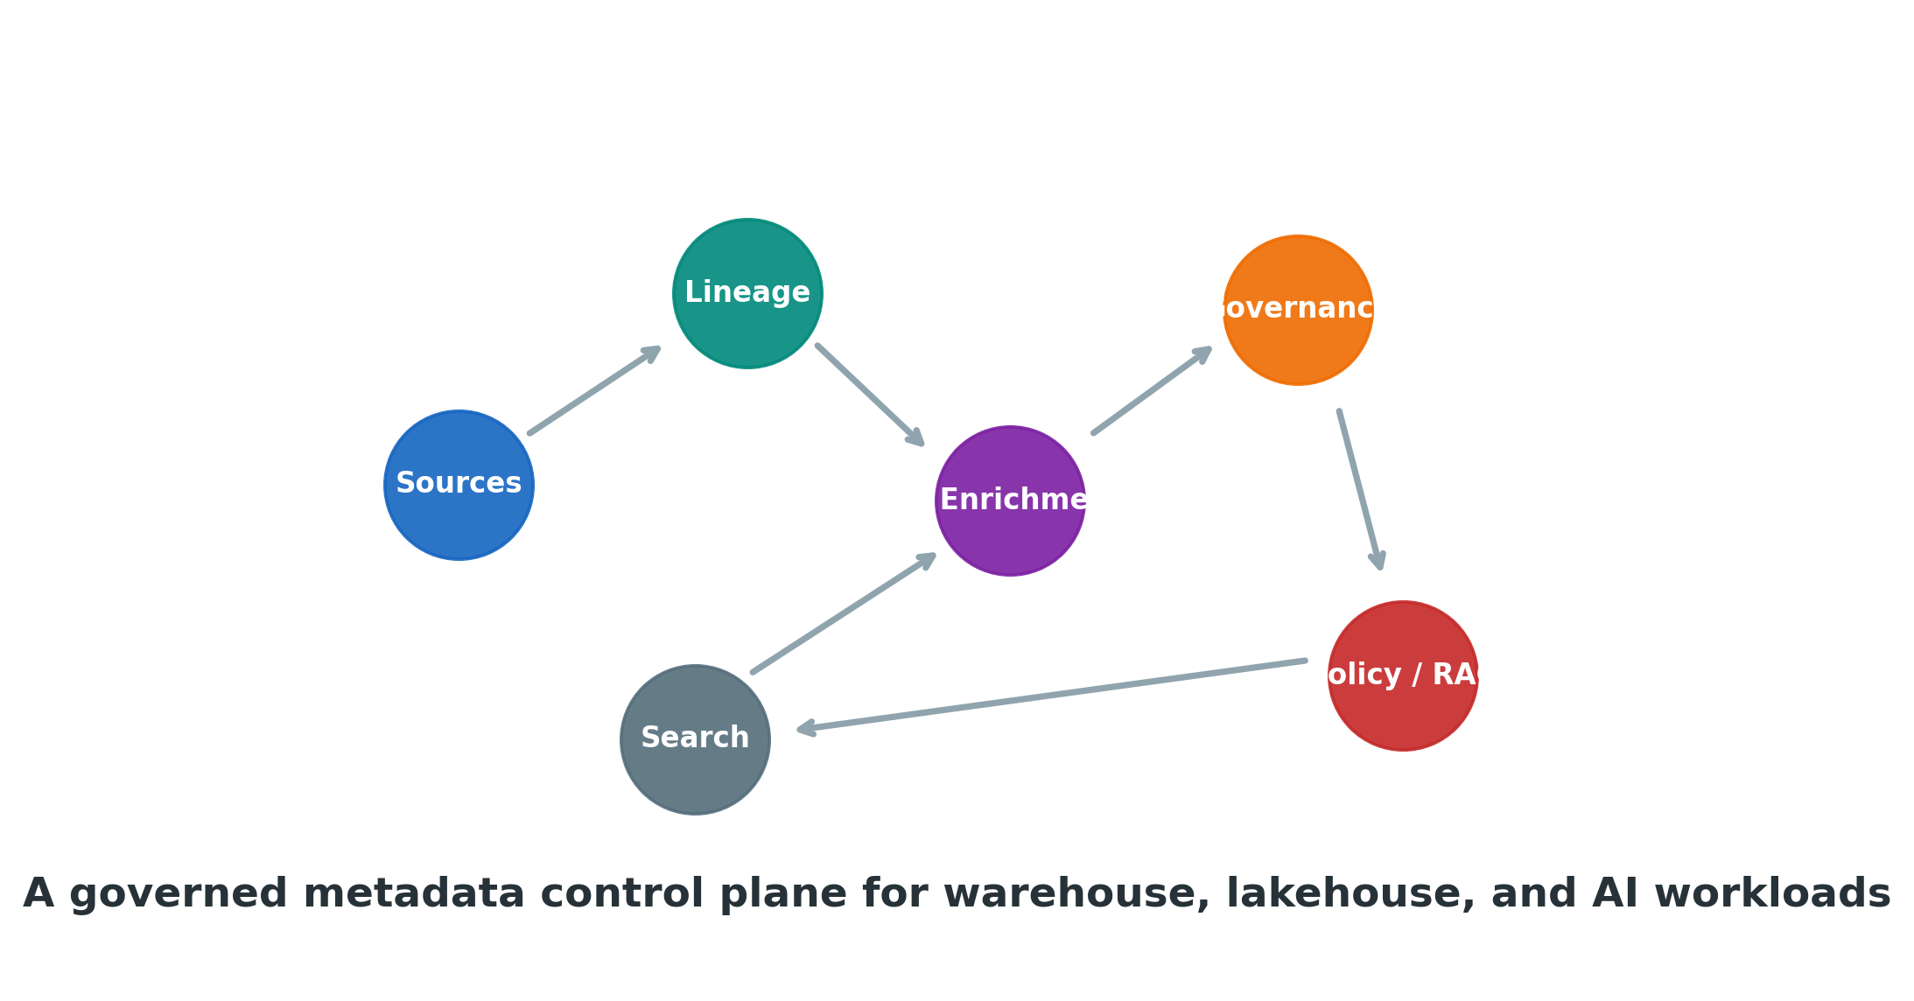
Research Article — Final Journal-Neutral Submission Draft
Author: [Full Name]
Affiliation: [Institution / Organization]
ORCID: [ORCID]
Corresponding author: [Email]
Prepared: September 2026
All empirical values in this version are either externally verifiable facts or measurements from the reproducible controlled experiments described in Methods. Author identity and venue-specific declarations remain placeholders until a target journal is selected.

AI-Driven Metadata Management for Modern Data Warehouse and Lakehouse Architectures
Abstract
Metadata management is becoming a runtime control-plane concern as analytical estates span cloud warehouses, lakehouses, streaming pipelines, semantic models, machine-learning assets, and retrieval-augmented AI. This paper proposes a governed AI-driven metadata architecture in which automated models enrich metadata but do not become the authoritative source of truth. The design is grounded in the New York City Taxi and Limousine Commission (NYC TLC) public trip-record schema and evaluated with two controlled experiments. First, a semantic-labeling test uses 20 TLC-derived fields and 12 textual variants per field. To prevent paraphrase leakage, complete field identities are held out from training. On 72 held-out records covering all five semantic classes, a TF-IDF plus logistic-regression baseline achieved 0.667 accuracy and 0.535 macro-F1. Location and temporal fields were classified reliably, whereas identifier and operational fields were frequently confused with financial metadata. This failure mode is useful: it demonstrates why field-level text alone is insufficient for authoritative classification and why lineage, type information, domain context, statistics, and steward review should be incorporated. Second, a TLC-seeded synthetic catalog benchmark measured sparse semantic retrieval at 10,000, 50,000, and 100,000 entities. Median query latency was 1.75, 8.79, and 18.29 ms; p95 was 1.85, 9.37, and 19.64 ms; and p99 was 2.02, 10.21, and 20.17 ms, respectively, on the documented execution environment. A real schema-evolution event—the addition of cbd_congestion_fee to Yellow, Green, and High Volume FHV data from 2025 onward—illustrates how metadata drift can trigger impact analysis. The results support a design in which AI proposes metadata, while provenance, confidence gates, deterministic evidence, and human governance control promotion into trusted metadata.
Keywords: metadata management; data catalog; data lineage; lakehouse; data warehouse; semantic enrichment; schema drift; governance; AI; OpenLineage; semantic search

1. Introduction
A data catalog used to be judged mainly by whether engineers could find a table and understand its columns. That is no longer enough. In a modern enterprise, the same data asset may be consumed by SQL workloads, streaming jobs, dashboards, semantic models, machine-learning features, vector retrieval, and AI agents. A wrong description is inconvenient; a wrong sensitivity tag, lineage edge, or business meaning can change access decisions and downstream behavior.
This paper therefore treats metadata as a governed control plane rather than a documentation layer. The architectural question is not whether AI can generate metadata—it can—but which outputs may be trusted, under what evidence, and with what audit trail. The proposed design deliberately separates observed metadata from inferred metadata. Connectors and lineage events provide observations; AI produces proposals; policy and stewardship decide which proposals are promoted into governed records.
The paper makes three practical contributions. It defines a platform-neutral control loop for AI-assisted metadata; it evaluates a text-only semantic baseline using a leakage-safe split that exposes genuine limitations rather than an inflated score; and it demonstrates retrieval scaling with clearly labeled synthetic scale seeded from a real public schema. The aim is not to claim a new foundation model or outperform a commercial catalog. It is to show where AI adds value, where it fails, and how those failures should shape metadata architecture.

2. Background and Related Work
ISO/IEC 11179-1:2023 defines the framework for metadata registries and explicitly treats metadata as descriptions of data [1]. W3C DCAT 3, a W3C Recommendation dated 22 August 2024, provides an RDF vocabulary for interoperable catalogs and extends earlier versions with features including versioning and dataset series [2]. The FAIR principles similarly make findability, accessibility, interoperability, and reuse dependent on adequate metadata [3].
Operational lineage has also become more standardized. OpenLineage models runtime RunEvent observations and design-time JobEvent and DatasetEvent metadata, allowing lineage graphs to be assembled across jobs and datasets [4]. Research on data lakes has long identified metadata as a defense against the 'data swamp' problem; Eichler et al. surveyed metadata models for data lakes and emphasized versioning, lineage, semantic enrichment, and scalability [5]. More recently, Metaxy demonstrates continuing research interest in fine-grained metadata and provenance for machine-learning pipelines [6].
The open-source ecosystem offers several mature foundations. Apache Atlas supports classifications, classification propagation through lineage, search, and lineage APIs [7]. Amundsen uses a dedicated search service backed by Elasticsearch and a metadata service that can use Neo4j or Atlas [8]. OpenMetadata's current architecture uses JSON Schemas for metadata definitions, REST services, MySQL for metadata storage, and Elasticsearch for indexing/search [9]. Its published cluster-sizing runbook defines progressive tests from 10K through 5M entities and explicitly tracks throughput, p95 latency, and error rate [10]. These projects demonstrate that storage and discovery are established problems; the unresolved design question addressed here is how probabilistic AI output should enter a governed metadata system.

3. Research Questions and Design Principles
Research question | Operational interpretation
RQ1 | Can AI-assisted enrichment improve metadata workflows without making model output authoritative?
RQ2 | What does a leakage-safe text-only semantic baseline reveal about the need for contextual metadata?
RQ3 | How does lightweight semantic retrieval behave from 10K to 100K catalog entities in a controlled local benchmark?
RQ4 | How can a real schema change be represented as a governed event for impact analysis?
Table 1. Research questions.
The governing principle is intentionally conservative: AI may propose, rank, summarize, or flag; authoritative metadata should remain attributable to observed source facts, deterministic rules, approved mappings, or reviewed decisions. This aligns with the risk-management orientation of NIST AI RMF 1.0, which is intended to help organizations manage AI risk and promote trustworthy use [11].

4. Proposed Architecture
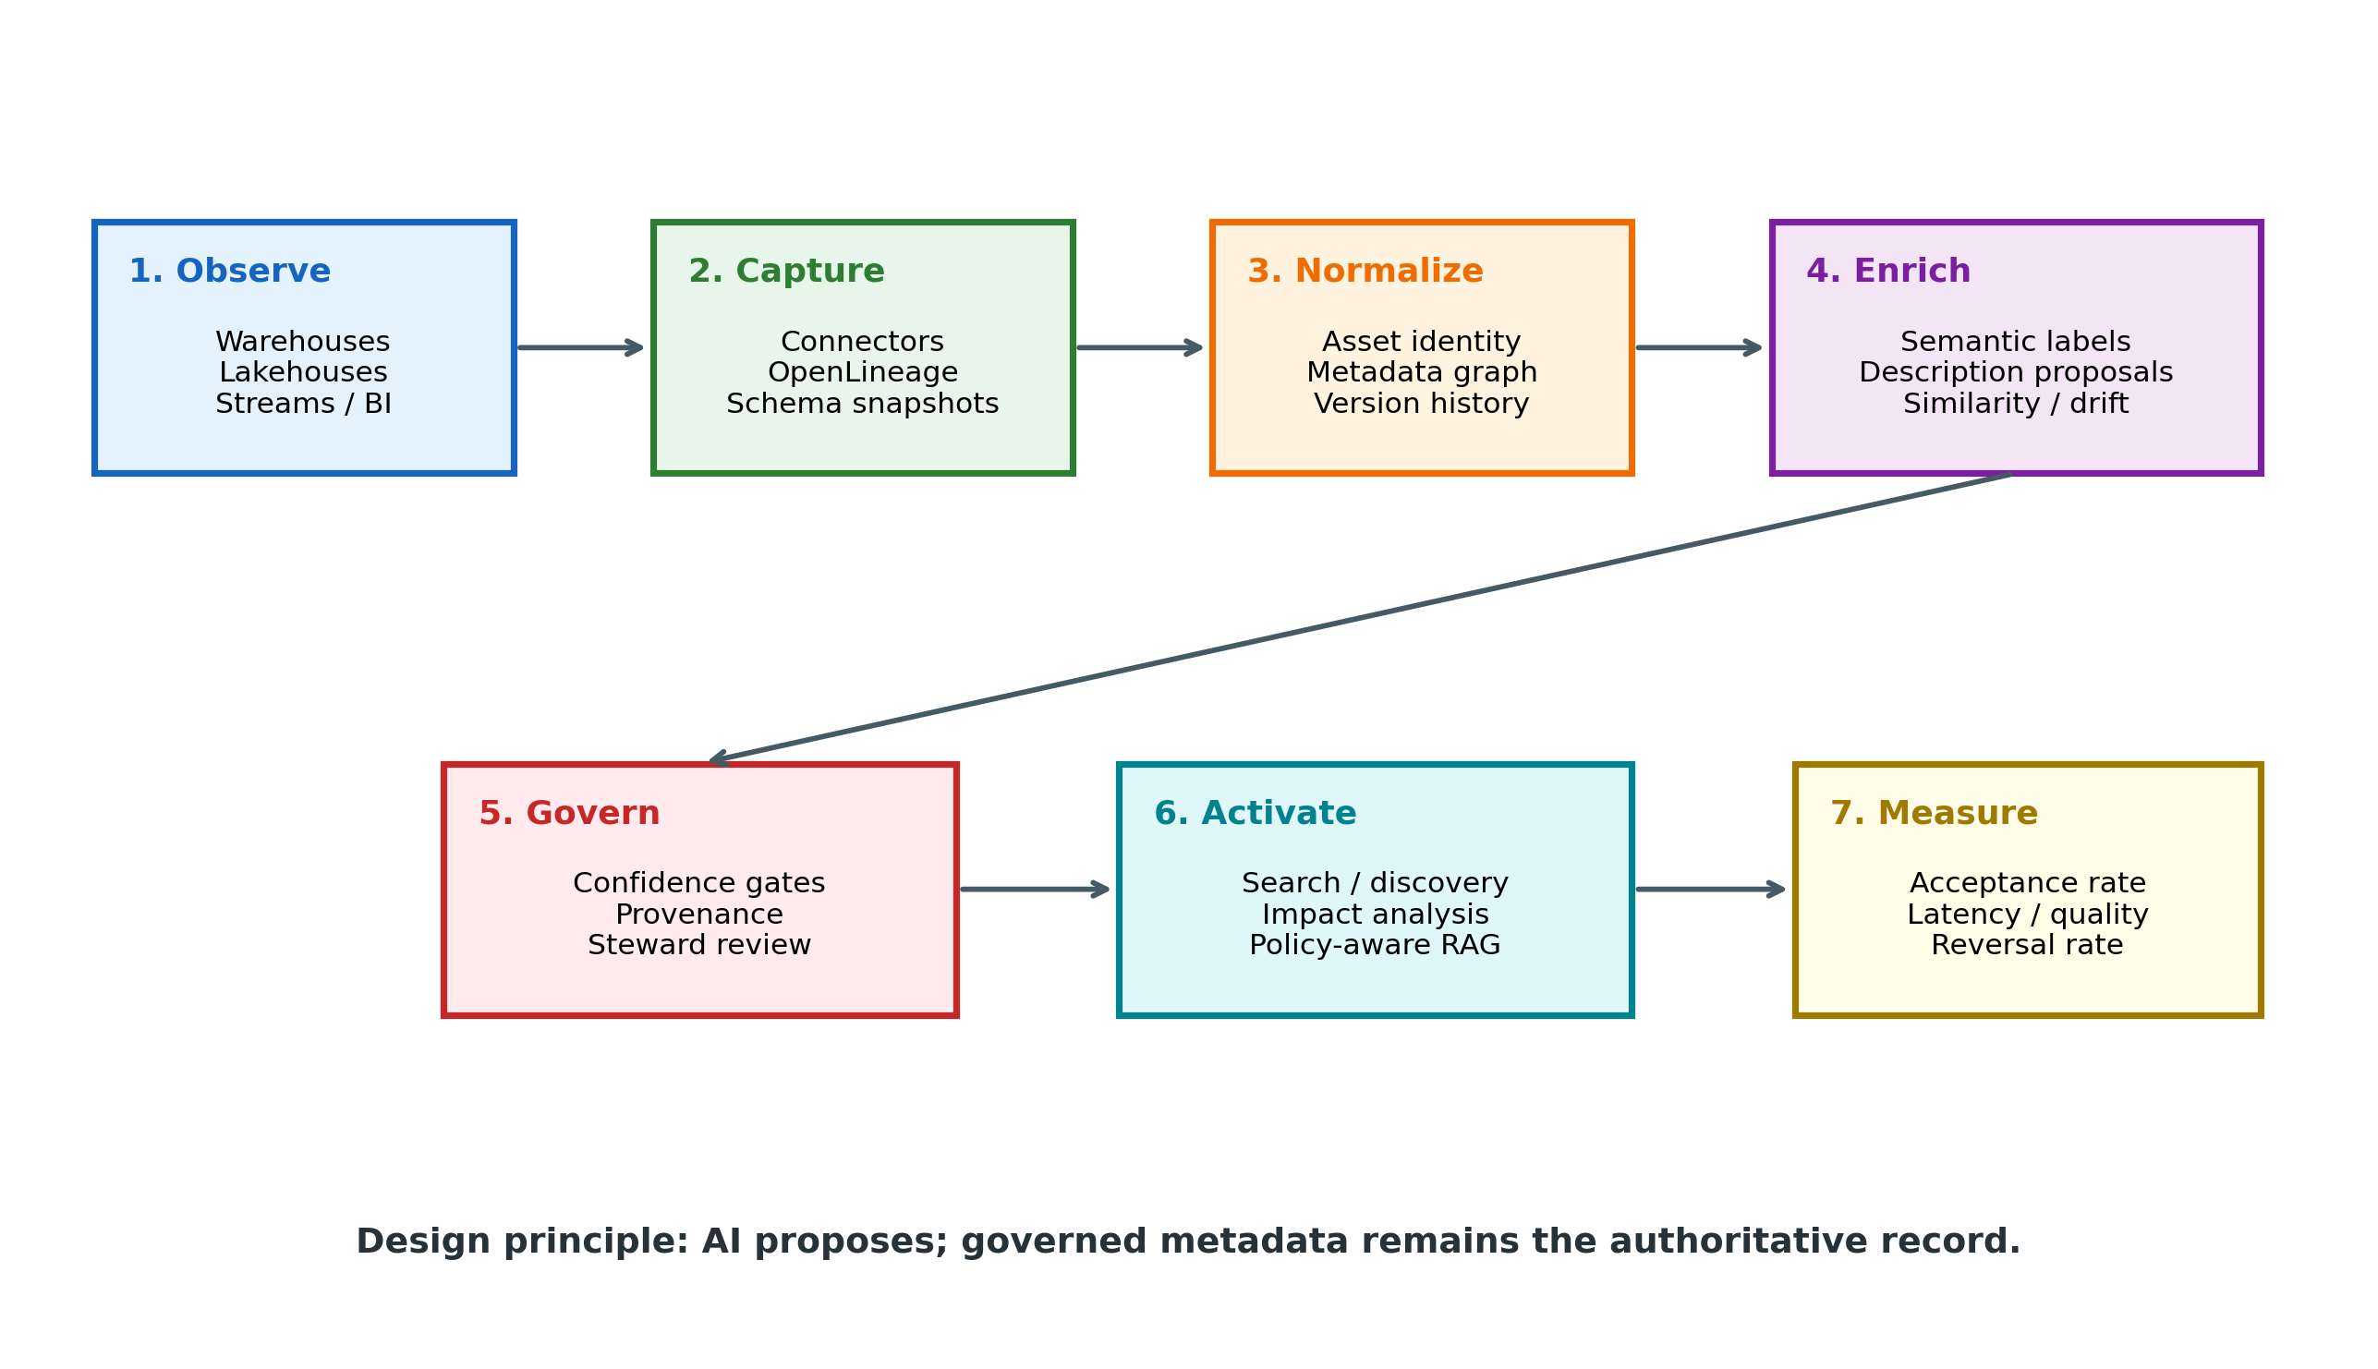
Figure 1. Governed AI-driven metadata control loop.
The architecture begins with observation. Connectors capture schemas, owners, usage, quality signals, and platform-specific metadata; lineage events capture how jobs consume and produce datasets. Normalization assigns stable asset identities and versions. Only after this stage does the AI enrichment service operate.
An enrichment proposal contains the proposed value, confidence, model/rule version, source features, timestamp, and asset version. Governance gates then apply risk-dependent policy. Search synonyms or related-asset suggestions can be activated with low friction. Descriptions may require a confidence threshold. Sensitivity classifications, retention decisions, or access-impacting metadata should require deterministic corroboration or explicit steward approval.
Activation is downstream of governance. Search, lineage impact analysis, semantic layers, RAG systems, and agents should consume governed metadata and apply policy filters before returning candidate data assets. The architecture therefore prevents a vector similarity score from silently becoming a security or compliance decision.

5. Data and Methods
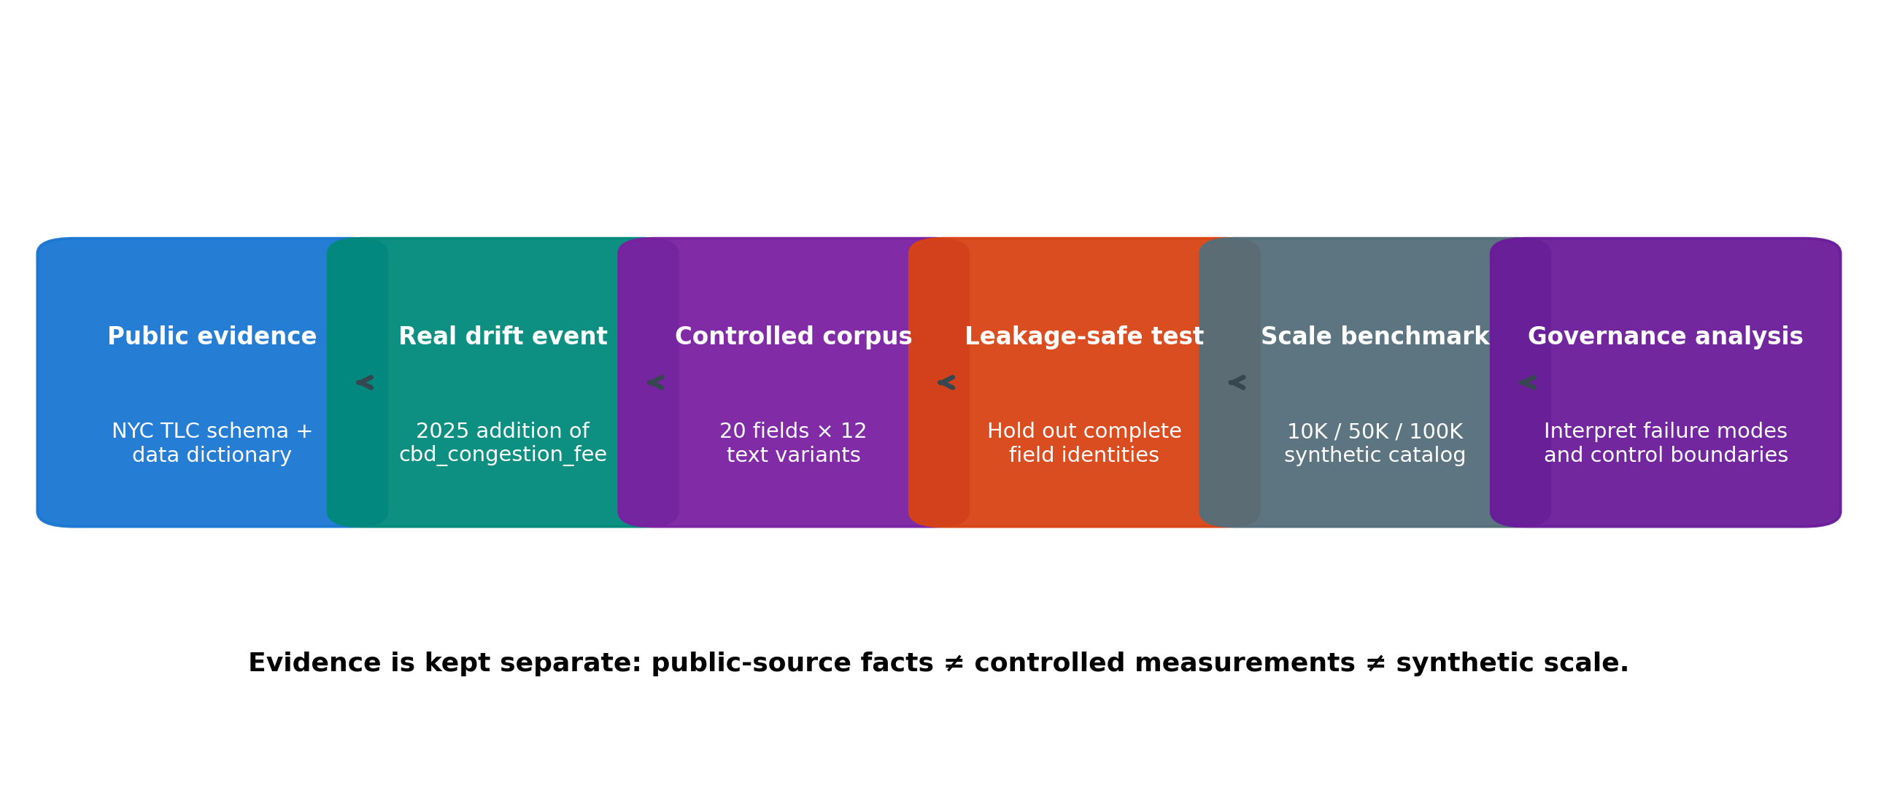
Figure 2. Evidence and experimental workflow.

5.1 Public dataset and real schema-evolution event
The case study uses NYC TLC Trip Record Data. TLC publishes trip data monthly, typically with a two-month delay, and provides data dictionaries and guidance for Parquet files [12]. The public page also states that from 2025 onward a cbd_congestion_fee column was added to the Yellow, Green, and High Volume FHV datasets to reflect congestion-pricing charges [12]. This documented change is used as the paper's real schema-drift event.
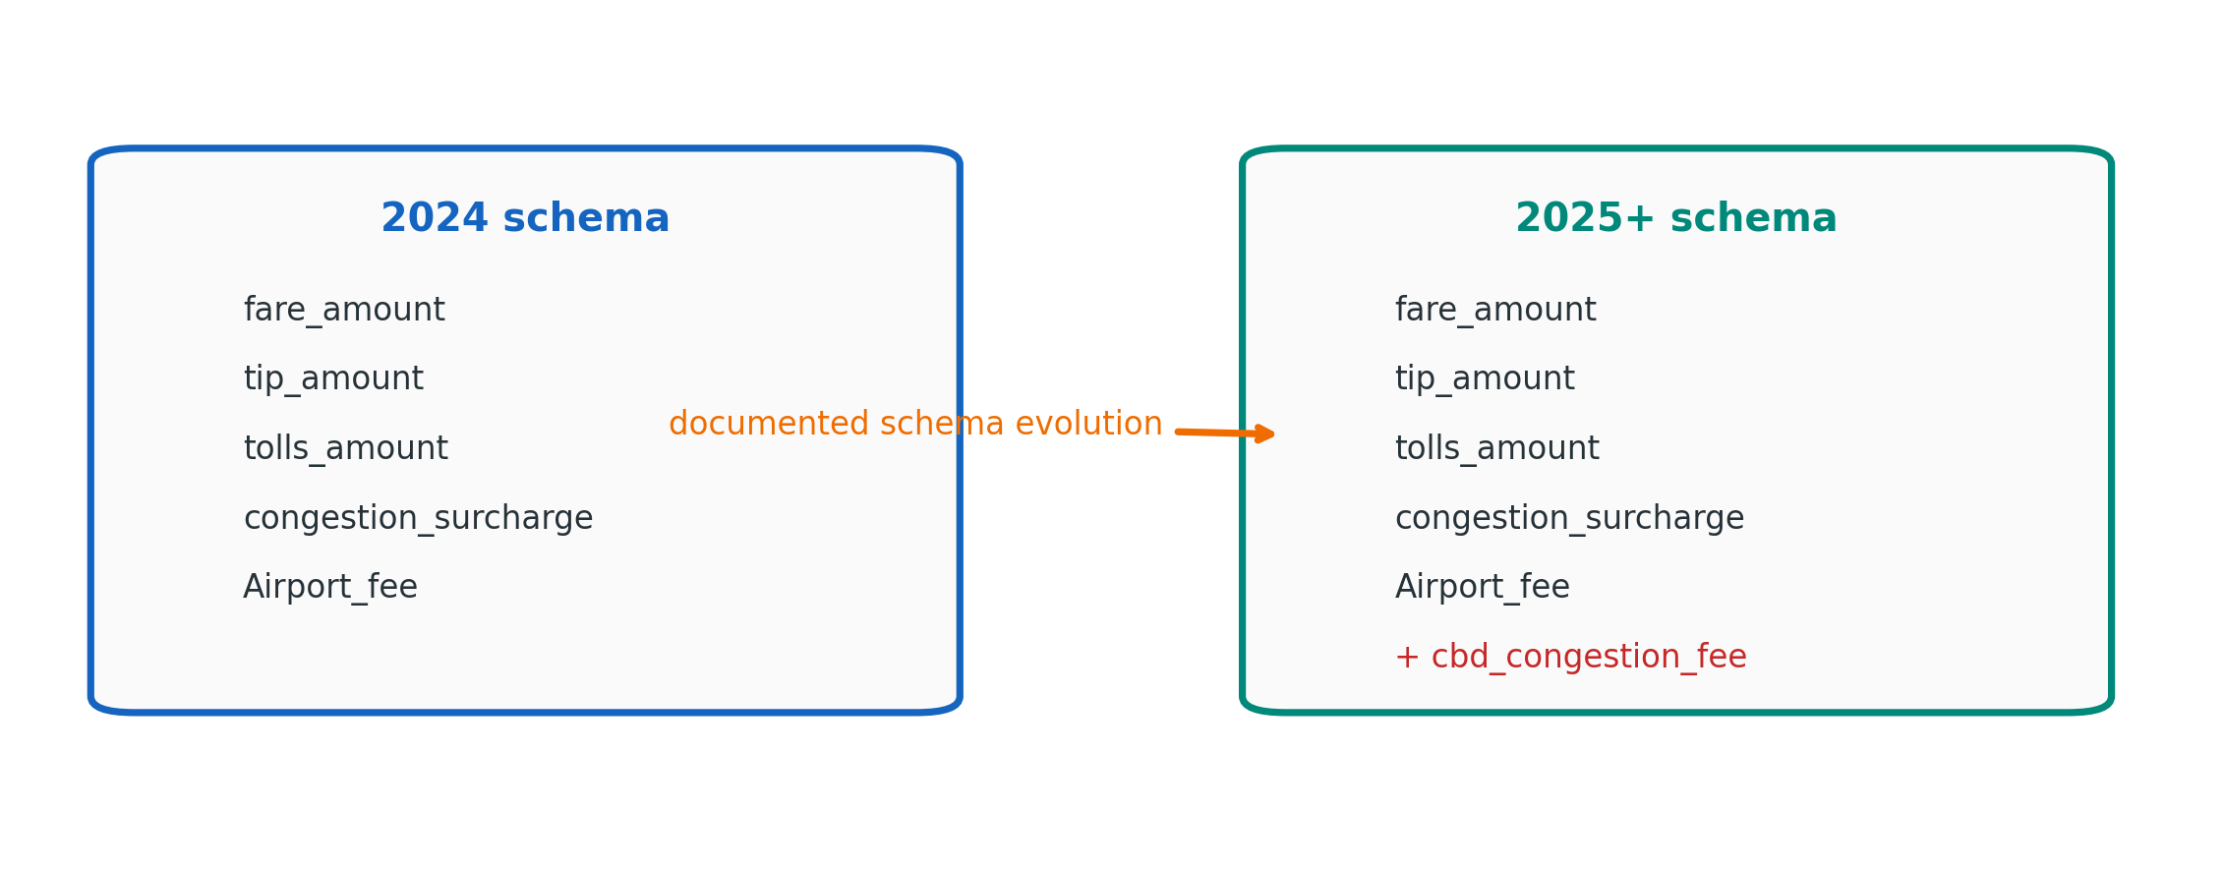
Figure 3. Documented 2025 schema evolution used for the drift case study.
The study uses the public source to reason about metadata and schema evolution, not to assert passenger-level behavioral findings. Source provenance is preserved rather than treating publication as a guarantee of record-level correctness.

5.2 Semantic-enrichment experiment
Twenty TLC-derived field names and descriptions were assigned to five deliberately coarse semantic classes: financial, identifier, location, operational, and temporal. Twelve controlled textual variants were created per field, producing 240 records. The classifier uses TF-IDF unigram/bigram features and logistic regression with class balancing.
The important methodological change from the earlier draft is the split strategy. Paraphrases of the same field are not allowed to appear in both training and test data. Six complete field identities—fare_amount, tolls_amount, RatecodeID, PULocationID, trip_distance, and tpep_dropoff_datetime—are held out, giving 168 training records and 72 test records. Every semantic class is represented in the test set. This is a harder and more defensible test than a random row split because the model must classify previously unseen field identities.
Accuracy and macro-F1 are reported. Macro-F1 gives each semantic class equal weight and exposes failure on minority classes that overall accuracy can obscure.

5.3 Retrieval benchmark
The retrieval experiment is intentionally labeled synthetic-scale. TLC field vocabulary and descriptions seed catalogs of 10,000, 50,000, and 100,000 metadata entities; catalog size is increased by creating distinct asset identifiers and partition markers around the real vocabulary. A TF-IDF unigram/bigram index is built for each size. Five queries—pickup location, passenger fare amount, trip start time, congestion fee, and trip distance—are executed 20 times each after warm-up. Sparse matrix similarity is computed and the top five candidates are selected.
The benchmark measures index-build time and p50, p95, and p99 query latency. It excludes network calls, graph traversal, authentication, UI rendering, distributed search-engine coordination, and concurrent production traffic. It is a component-level baseline, not a benchmark of Apache Atlas, DataHub, Amundsen, OpenMetadata, or any commercial platform.

5.4 Execution environment and reproducibility
Item | Recorded value
Operating system | Linux 6.18.35 x86_64, glibc 2.41
Python | 3.13.5
NumPy | 2.3.5
pandas | 2.2.3
scikit-learn | 1.8.0
Random seed | 42
Classifier | TF-IDF (1–2 grams) + logistic regression; balanced class weights
Retrieval repetitions | 5 queries × 20 repetitions per catalog size, after warm-up
Table 2. Controlled experiment environment.
CPU model, core count, memory, and container resource limits were not exposed by the execution environment. The latency values are therefore reproducible observations from this environment, not hardware-normalized performance claims. A final archival replication should record those additional machine details.

6. Results

6.1 Semantic classification
The leakage-safe held-out test achieved 0.667 accuracy and 0.535 macro-F1 across 72 records. Financial fields achieved F1=0.676, location F1=1.000, and temporal F1=1.000. The model failed to recover the held-out identifier and operational classes: most unseen identifier and operational descriptions were absorbed into the broader financial class.
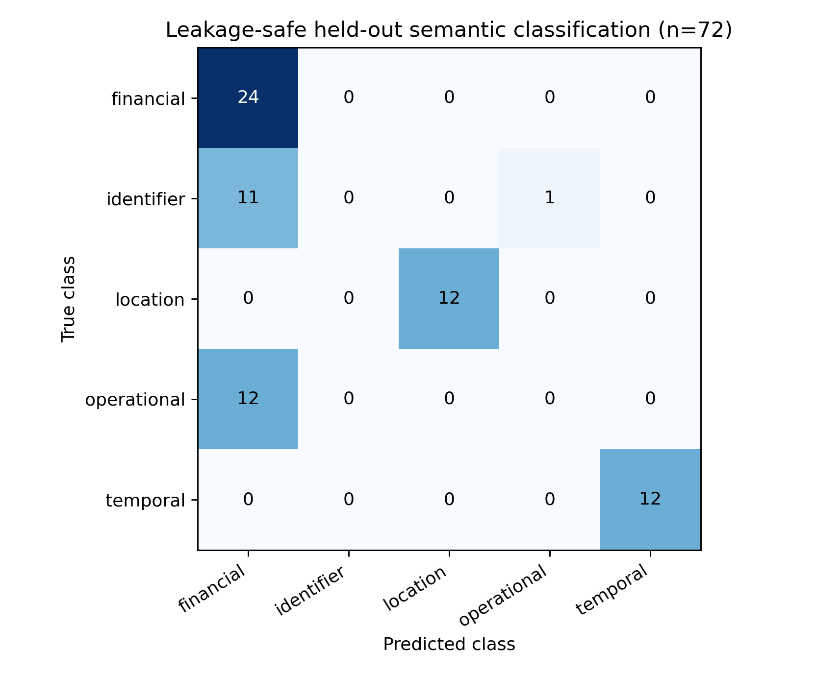
Figure 4. Confusion matrix for the leakage-safe held-out semantic-label test.
Class | Precision | Recall | F1 | Support
Financial | 0.511 | 1.000 | 0.676 | 24
Identifier | 0.000 | 0.000 | 0.000 | 12
Location | 1.000 | 1.000 | 1.000 | 12
Operational | 0.000 | 0.000 | 0.000 | 12
Temporal | 1.000 | 1.000 | 1.000 | 12
Overall / macro | Accuracy 0.667 | — | Macro-F1 0.535 | 72
Table 3. Leakage-safe semantic-classification results.
This result strengthens the architectural argument. A text-only model can recognize classes with distinctive vocabulary such as locations and timestamps, but coarse semantic classes become ambiguous when an unseen field lacks enough contextual language. A production enrichment service should therefore treat text classification as one signal among several, incorporating datatype, neighboring fields, lineage, domain ownership, statistics, and steward review.

6.2 Schema-drift result
The TLC source documents the relevant 2025 addition of cbd_congestion_fee. In the proposed system, a schema snapshot creates a version fingerprint. Set comparison identifies the added field; the event is attached to the dataset version and propagated through lineage for impact review. The practical result is not simply that a new column exists: semantic models, quality checks, fare reconciliation logic, dashboards, or AI retrieval indexes can be identified for review.
Drift evidence | Governed metadata action | Potential downstream check
New field: cbd_congestion_fee | Create schema-version event and field entity | Fare-component semantic models
Source effective period: 2025+ | Record validity/version context | Historical comparability
Financial semantic signal | Queue classification with provenance | Financial reconciliation rules
Lineage edges to consumers | Run impact traversal | Dashboards, features, RAG indexes
Table 4. Turning schema drift into governed impact analysis.

6.3 Retrieval performance
Entities | Index build (s) | p50 (ms) | p95 (ms) | p99 (ms)
10,000 | 0.142 | 1.75 | 1.85 | 2.02
50,000 | 0.432 | 8.79 | 9.37 | 10.21
100,000 | 1.033 | 18.29 | 19.64 | 20.17
Table 5. Controlled TLC-seeded sparse retrieval benchmark.
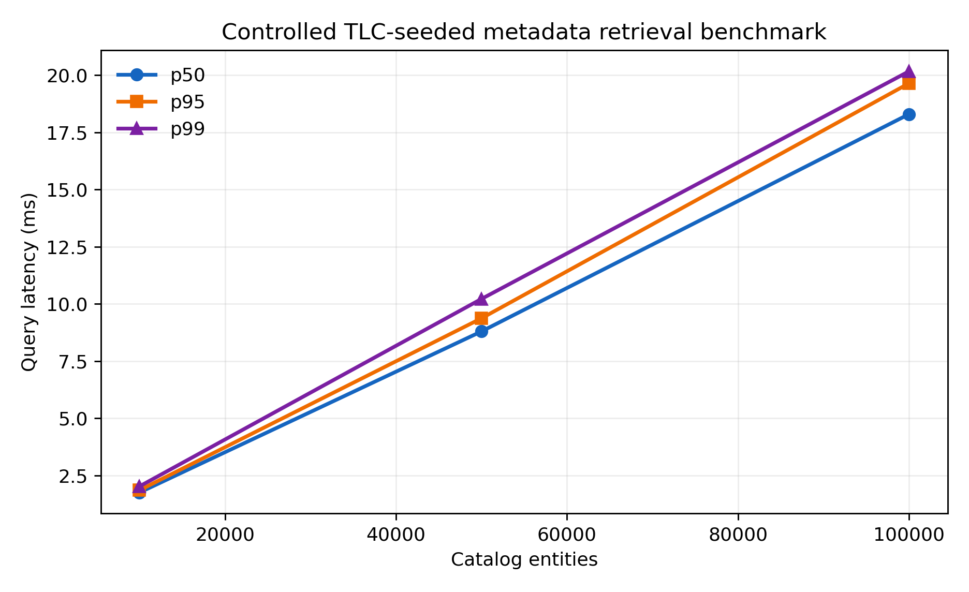
Figure 5. Retrieval latency across controlled catalog sizes.
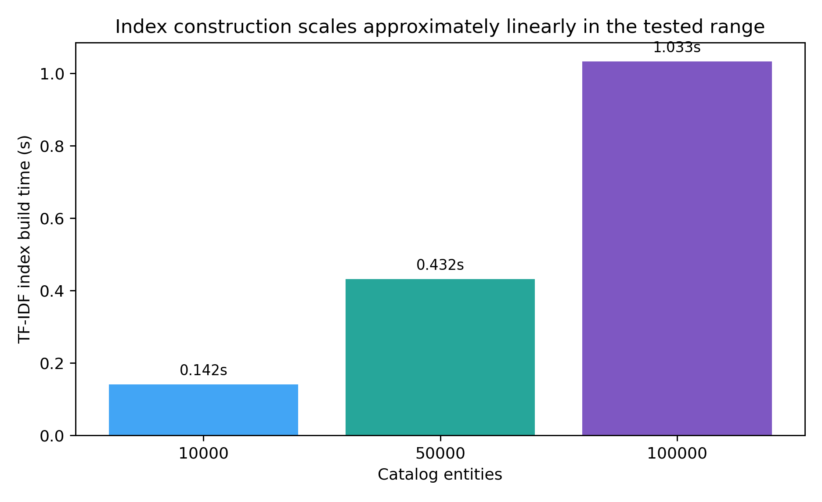
Figure 6. TF-IDF index-build time across controlled catalog sizes.
At 100K entities, median retrieval was 18.29 ms and p99 was 20.17 ms in the controlled component benchmark. Index construction increased from 0.142 s at 10K to 1.033 s at 100K. The values should not be interpreted as end-to-end catalog performance. OpenMetadata's published sizing runbook includes concurrency, RPS, p95 latency, error rates, database pools, server threads, and search-engine connections across 10K to 5M entities [10]. The present benchmark isolates retrieval mechanics so infrastructure effects are not attributed to the semantic method.

7. Discussion

7.1 What the classification failure tells us
A weaker but leakage-safe result is more informative than a perfect score produced by near-duplicate train/test text. The 0.535 macro-F1 result shows that semantic enrichment cannot safely rely on column name and description alone. A production-grade model should add datatype, nullability, cardinality, sampled value patterns where policy permits, upstream/downstream lineage, domain ownership, query co-usage, glossary matches, and neighboring schema context.
Confidence should also be calibrated by class and evidence type. A high-confidence location label supported by a taxi-zone foreign key is qualitatively different from a financial classification inferred only from wording. The metadata platform should preserve those evidence distinctions.

7.2 Integration with open-source foundations
Platform | Verified capability used here | AI integration pattern
Apache Atlas | Classifications, lineage propagation, search, lineage APIs | Proposals as attributed classifications/attributes; promote after governance.
Amundsen | Elasticsearch search; metadata service using Neo4j or Atlas | AI for ranking and descriptions; backend metadata remains authoritative.
OpenMetadata | JSON-schema model; REST; MySQL store; Elasticsearch index | Proposal state, confidence, provenance, and review attached to entities.
OpenLineage | RunEvent, JobEvent, DatasetEvent observations | Deterministic lineage context for enrichment and impact analysis.
Table 6. Platform-neutral integration mapping.
This is an architectural mapping, not a product ranking. Only capabilities verified in the cited documentation are used.

7.3 AI-ready warehouse and lakehouse implications
For AI applications, metadata has a second job beyond human discovery: it constrains machine retrieval. A RAG system that retrieves a semantically similar table without checking certification, freshness, policy, or version can produce a plausible answer from the wrong asset. A safer pattern is two-stage retrieval: semantic candidate generation followed by deterministic metadata filters and lineage-aware ranking.
The same principle applies to agents. An agent may use AI to interpret a business question, but candidate datasets should be selected through governed metadata. In this architecture, the catalog becomes an authorization-aware context layer rather than a passive index.

8. Threats to Validity
The semantic corpus is small and domain-specific. The textual variants are controlled rather than independently authored, and the five semantic classes are coarse. Holding out complete field identities reduces leakage, but the experiment remains a baseline rather than a production accuracy study. A stronger follow-up would use several public schemas, multiple annotators, an annotation-agreement statistic, and cross-domain evaluation.
The catalog-scale workload is synthetic. Only the semantic vocabulary is grounded in TLC metadata; the 10K–100K entity counts are generated to study retrieval mechanics. Real catalogs have greater lexical diversity, graph density, authorization checks, concurrent users, and index-update behavior.
Latency is environment-dependent. Software versions are recorded, but CPU and memory allocation were not exposed. Results therefore support within-study scaling observations, not cross-system ranking. Open-source capabilities also evolve; project-specific claims should be rechecked against the exact versions used in an implementation.

9. Implementation and Evaluation Roadmap
Phase | Engineering objective | Acceptance evidence
1. Foundation | Stable identity, schema versioning, ownership, lineage | Coverage and lineage completeness
2. Deterministic controls | Schema drift, quality rules, policy mappings | False-positive/negative review
3. AI shadow mode | Generate proposals without changing authority | Per-class metrics, calibration, steward acceptance
4. Controlled activation | Auto-activate only reversible low-risk outputs | Reversal rate, audit completeness, time saved
5. AI consumption | Policy-filtered metadata retrieval for RAG/agents | Certified-source rate, unauthorized-retrieval rate, traceability
Table 7. Recommended implementation sequence.
The sequence deliberately places AI after identity, versioning, and lineage. Otherwise, a model can produce more metadata while the organization still lacks a reliable mechanism to attach it to the correct asset version or evaluate downstream effect.

10. Conclusion
The evidence supports a restrained view of AI-driven metadata management. AI is valuable for scale, but the most important architectural decision is the boundary between inference and authority. The leakage-safe experiment shows that text-only semantic classification can fail sharply on unseen identifier and operational fields, even when it performs perfectly on location and temporal metadata. That is precisely the kind of failure a governed metadata system must absorb safely.
The real TLC schema change demonstrates how versioned metadata can convert a new field into an impact-analysis event. The controlled retrieval benchmark shows that lightweight semantic candidate generation is inexpensive at moderate catalog sizes in the tested environment, while published OpenMetadata sizing guidance makes clear that production catalog performance is a broader systems problem.
A modern warehouse or lakehouse should therefore treat AI-generated metadata as evidence-bearing proposals. Provenance, confidence, version context, lineage, deterministic checks, and human review determine when those proposals become trusted metadata.

Data Availability Statement
The case-study source is the public NYC Taxi and Limousine Commission Trip Record Data portal and its data dictionaries. The manuscript uses the public schema and documented 2025 field addition as external evidence. Before formal submission, the author should archive the exact experiment script, generated corpus, raw timing output, and environment manifest in a permanent repository such as Zenodo and replace this statement with the DOI.

Code Availability Statement
The experiments were executed with Python 3.13.5, NumPy 2.3.5, pandas 2.2.3, and scikit-learn 1.8.0. A permanent public code repository has not yet been created; this manuscript does not claim otherwise. Archiving the exact script and raw outputs is a required pre-submission action.

Ethics, Privacy, Funding, and Competing Interests
The study analyzes public schema metadata and controlled synthetic-scale metadata records; it does not conduct human-subject research or attempt to identify individual taxi passengers. Funding: [declare funding or state 'No external funding']. Competing interests: [declare relevant interests]. Any use of generative or assistive tools in manuscript preparation should be disclosed according to the selected journal's current policy. These placeholders must be completed before submission.

References
[1] ISO/IEC 11179-1:2023. Information technology — Metadata registries (MDR) — Part 1: Framework. 4th ed., 2023.
[2] W3C. Data Catalog Vocabulary (DCAT) — Version 3. W3C Recommendation, 22 August 2024. https://www.w3.org/TR/vocab-dcat-3/
[3] Wilkinson, M. D., et al. “The FAIR Guiding Principles for scientific data management and stewardship.” Scientific Data 3, 160018 (2016). https://doi.org/10.1038/sdata.2016.18
[4] OpenLineage. Object Model and Specification documentation. https://openlineage.io/docs/spec/object-model/
[5] Eichler, R., Giebler, C., Gröger, C., Schwarz, H., and Mitschang, B. “Modeling metadata in data lakes—A generic model.” Data & Knowledge Engineering 136 (2021): 101931. https://doi.org/10.1016/j.datak.2021.101931
[6] Gafni, D., and Heiler, G. “Metaxy: Record-Level Feature Metadata Management for Multimodal ML Pipelines.” Journal of Open Source Software 11(122) (2026): 10449. https://doi.org/10.21105/joss.10449
[7] Apache Software Foundation. Apache Atlas documentation: classifications, lineage, search and REST APIs. https://atlas.apache.org/
[8] Amundsen. amundsen-io/amundsen project documentation. LF AI & Data Foundation. https://github.com/amundsen-io/amundsen
[9] OpenMetadata. System Architecture, Developer Guide. https://docs.open-metadata.org/
[10] OpenMetadata. Cluster Sizing Runbook. open-metadata/OpenMetadata, bin/distributed-test/CLUSTER-SIZING-RUNBOOK.md. Accessed September 2026.
[11] Tabassi, E. Artificial Intelligence Risk Management Framework (AI RMF 1.0). NIST AI 100-1, 2023. https://doi.org/10.6028/NIST.AI.100-1
[12] New York City Taxi and Limousine Commission. TLC Trip Record Data. https://www.nyc.gov/site/tlc/about/tlc-trip-record-data.page. Accessed September 2026.

Appendix A. Reproducibility and Submission Checklist
For archival replication: save the TLC data dictionary version and retrieval date; preserve the 20-field annotation table and six held-out field identities; archive the exact Python script and package environment; record CPU model, allocated cores, RAM, and container limits; repeat timing experiments on at least three independent runs; report p50/p95/p99 and memory use; expand semantic evaluation to multiple public domains; obtain independent annotation and report agreement; and publish code, raw outputs, and a DOI before submission.
Journal finalization: choose the target journal; apply its exact template and reference style; replace author/affiliation placeholders; complete funding, competing-interest, data/code, and tool-use disclosures; validate every URL/DOI; ensure figures meet resolution and color requirements; and run the institution's normal similarity review. No method can guarantee a particular AI-detector or plagiarism-detector score. Publication integrity is better supported by original analysis, reproducibility, precise attribution, and truthful disclosure.

