SUPREME COURT OF THE STATE OF NEW YORK COUNTY OF NEW YORK

- x

OPEHLLC,

Plaintiff, Index No.

-against- SUMMONS

MICHAEL E. BLEICH and ALEXIS K. BLEICH,

Defendants.
- x

TO THE ABOVE NAMED DEFENDANTS:

You are hereby summoned and required to submit to Plaintiffs attorney your answering papers on this motion within the time provided in the notice of motion annexed hereto. In case of your failure to submit answering papers, summary judgment will be taken against you by default for the relief demanded in the notice of motion.
The basis of venue is Plaintiffs choice pursuant to CPLR §503.

PLEASE TAKE FURTHER NOTICE that answering papers, if any, must be served on the undersigned so that they are received no later than seven (7) days before the return date.
Dated: New York, New York September 27, 2018

TARTER KRINSKY & DROGIN LLP

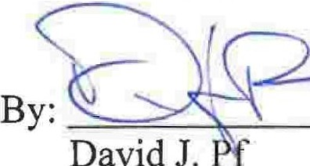
Attorneys for Plaintiff

effer, Esq.
Cathleen P. Cassidy, Esq. 1350 Broadway
New York, New York 10018
(212) 216-8000

To: Michael E. Bleich
13 Harrison Street, Unit 1 New York, New York 10013

Alexis K. Bleich
13 Harrison Street, Unit 1 New York, New York 10013

2

