List of required items:

1-Sparkfun board

1-Breadboard

1-Moisture Sensor

1-USB cable

3-Jumper Wires

1-LED

1-Resistor

1-Photoresistor

Activity two:

Goal- Teaching about the makings of a circuit. No coding required.

**Basic LED circuit:**

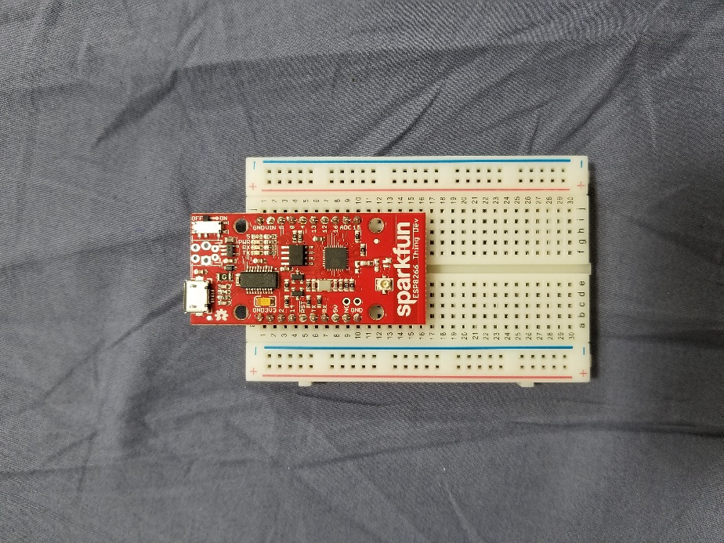

1. Plug one jumper wire from **GND** (1) to the negative power pins (along the blue side).

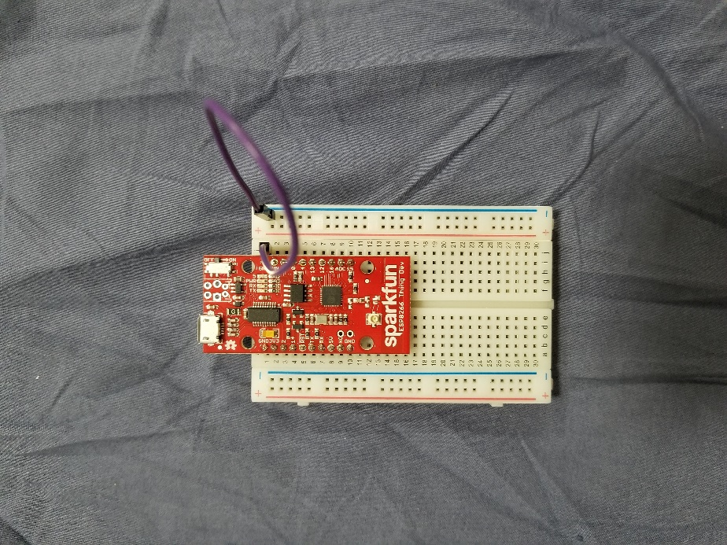

1. Plug one jumper wire from **VIN** (2) to the positive power pins (along the red side)

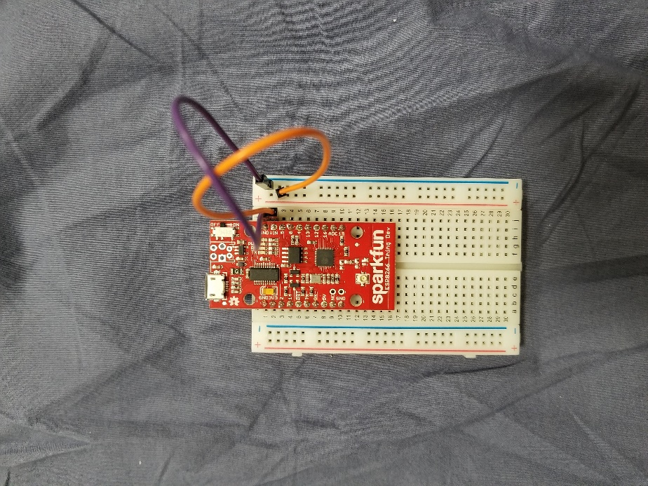

1. Plug one end of the resistor into the positive (red) power terminal beside (20), plug the other end, on (20) near the middle of the board.
   1. **Note:** resistors do not have polarity and therefore can be put into a circuit either direction.

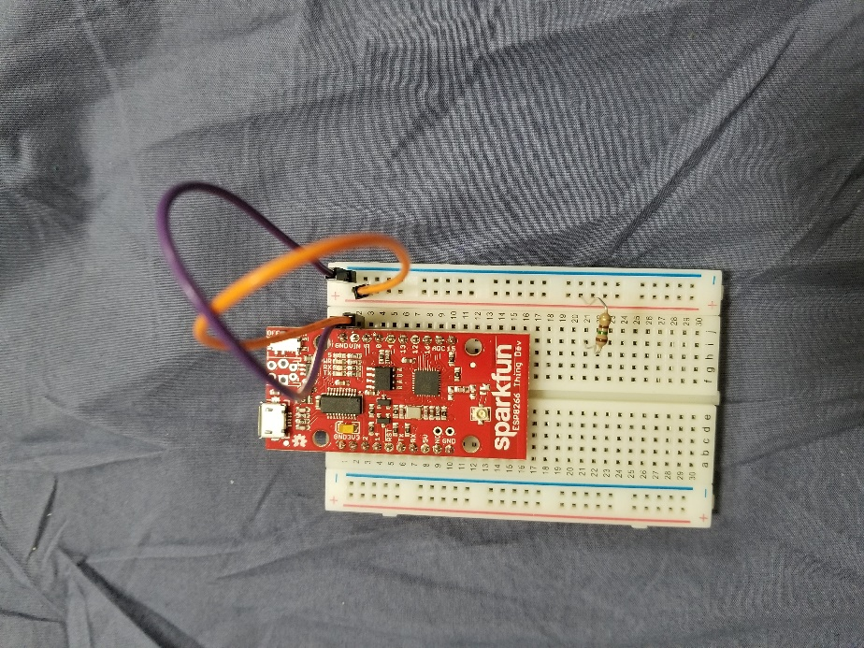

1. Plug the positive lead of the LED (the longer side) in the same row (20) as the resistor, plug the negative lead at (25).
   1. **Note:** LED’s do have polarity. The longer lead is positive, the shorter lead is negative.

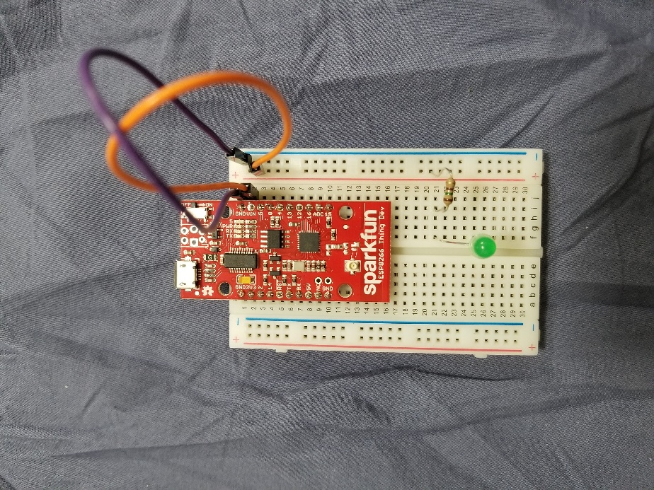

1. Plug one jumper wire from (25) to the negative (blue) power terminal.

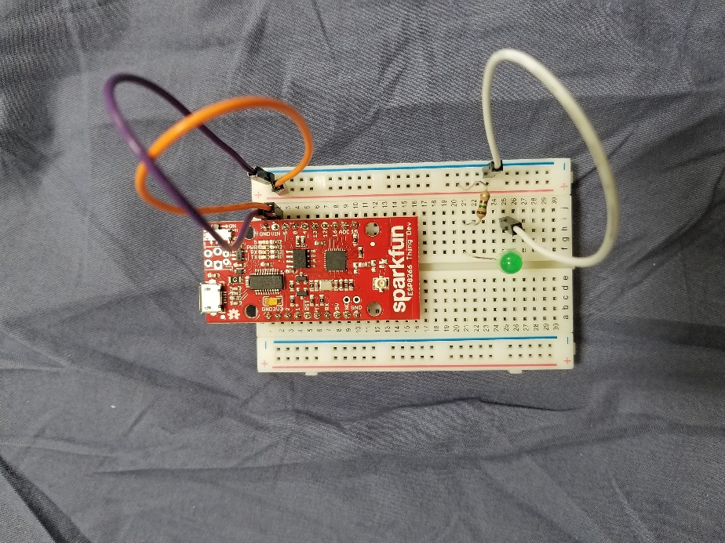

1. Plug USB cable to power, and LED will light up.

**Troubleshooting:**

1. Notice the LED direction.
2. See if the pins are in the proper rows.
3. See if the jumper cables are connected to GND-Negative, and VIN-Positive.
4. Check to make sure the cable from LED is connected to negative.
5. The LED might have burnt out, change LED and check circuit.

**Basic LED circuit with Photoresistor:**

1. Plug one jumper wire from **GND** (1) to the negative power pins (along the blue side)
2. Plug one jumper wire from **VIN** (2) to the positive power pins (along the red side)
3. Plug one end of the photoresistor into the positive (red) power terminal beside (20), plug the other end, on (20) near the middle of the board.
   1. **Note:** resistors do not have polarity and therefore can be put into a circuit either direction.

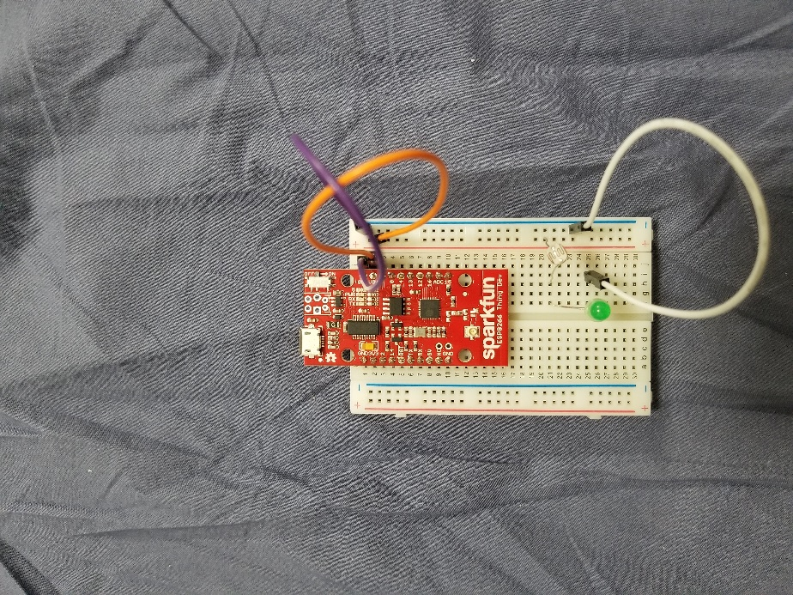

1. Plug the positive lead of the LED (the longer side) in the same row (20) as the resistor, plug the negative lead at (25).
   1. **Note:** LED’s do have polarity. The longer lead is positive, the shorter lead is negative.
2. Plug one jumper wire from (25) to the negative (blue) power terminal.
3. Plug USB cable to power, and LED will light up.

**Troubleshooting:**

1. Notice the LED direction.
2. See if the pins are in the proper rows.
3. See if the jumper cables are connected to GND-Negative, and VIN-Positive.
4. Check to make sure the cable from LED is connected to negative.
5. The LED might have burnt out, change LED and check circuit.

**Moisture Sensor:**

1. Plug Yellow Wire to **ADC** (9).

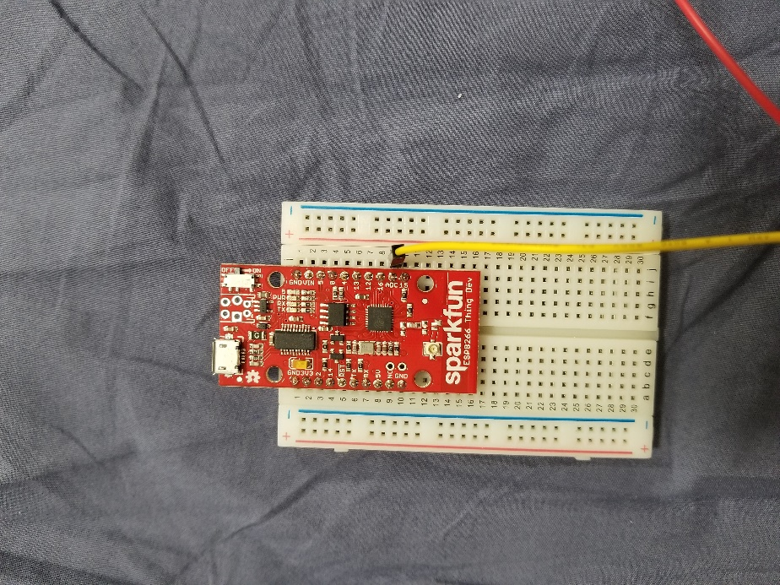

1. Plug Red Wire to Pin **5** (3).

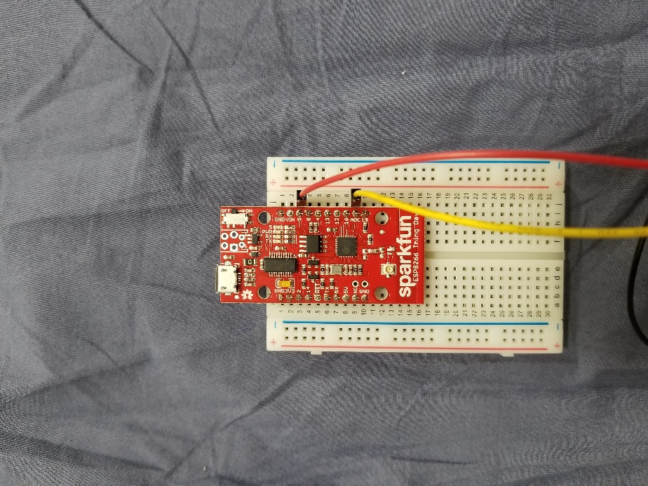

1. Plug Black Wire to **GND** (1).

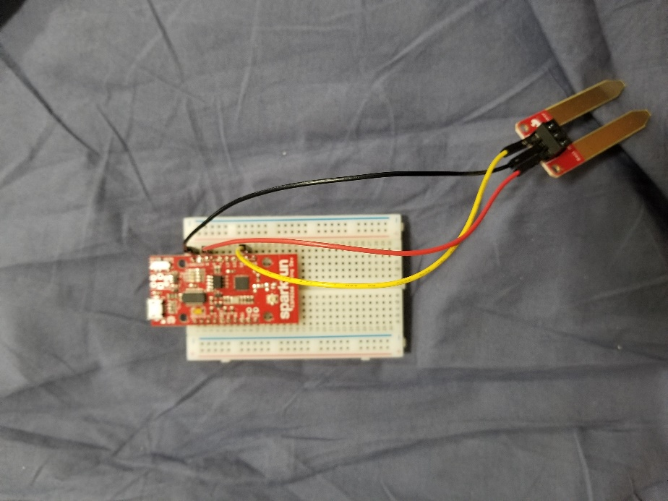

1. Plug USB cable to power.
2. Access io.adafruit.com.
3. Login: canadagoose , password: Essential Skills!
4. Click on dashboards.
5. Check the number on the back of the breadboard and access the same analog[number] link.
6. Experiment with the moisture sensor both in and out of the water and notice the change in the graphs.

**Troubleshooting:**

1. Check all the connections, Yellow-ADC, Red-5, Black-GND.
2. Check the USB Connection and if the board-switch is turned on.
3. Check to make sure they are accessing the appropriate dashboard, 15 = analog15
4. If none of the above work, on io.adafruit, click feeds. Go to the appropriate feed. See if any data shows up there. If not, the board cannot connect to the internet, change board.