**Practical 8: Database backup and restore using Workbench**

**(Aditya Pulikal / DSAI – L022)**

**1. Backup**

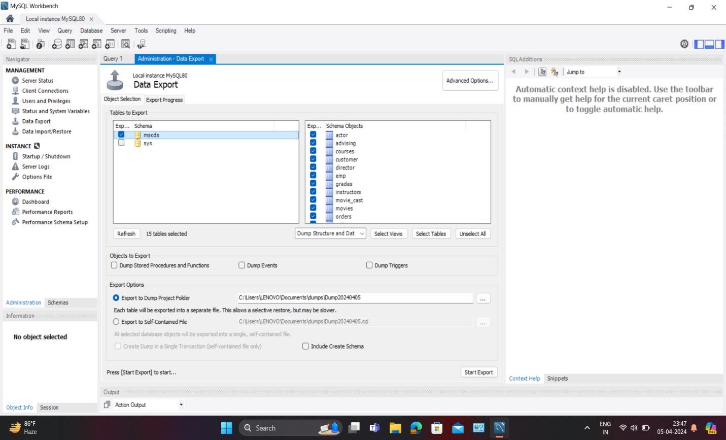

Go to the Administration tab, on the Navigation panel (on the left by default)

1. Select Data Export
2. From the Data Export tab in the Tables To Export section, select the databases and tables that will be added to the backup file
3. From the Export Option section, select the format for the exported data. Either each table will be exported to a separate .sql file, or one common .sql file will be created.
4. Press the Export button to create a backup file.

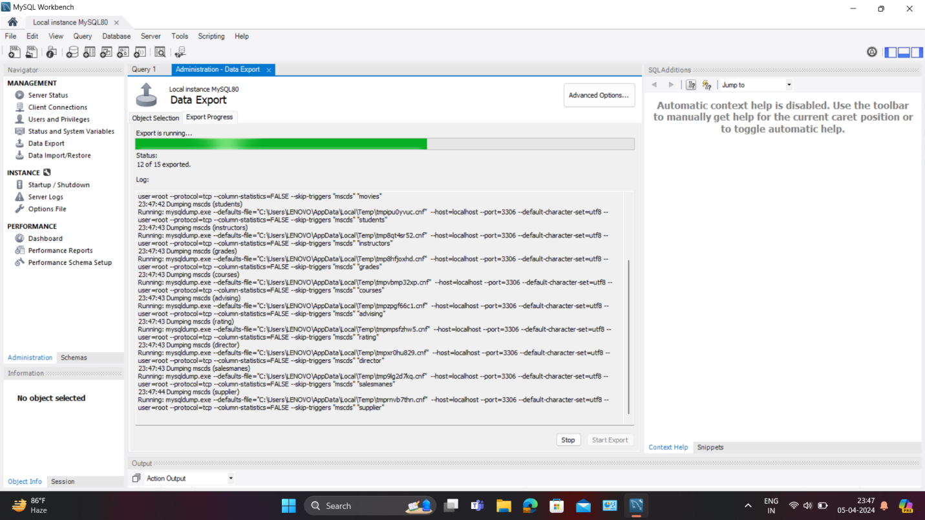

When you click the Export button, a log of the export execution will be displayed, in which there will be a mysqldump command with the parameters specified in the interface.

**2. Restore**

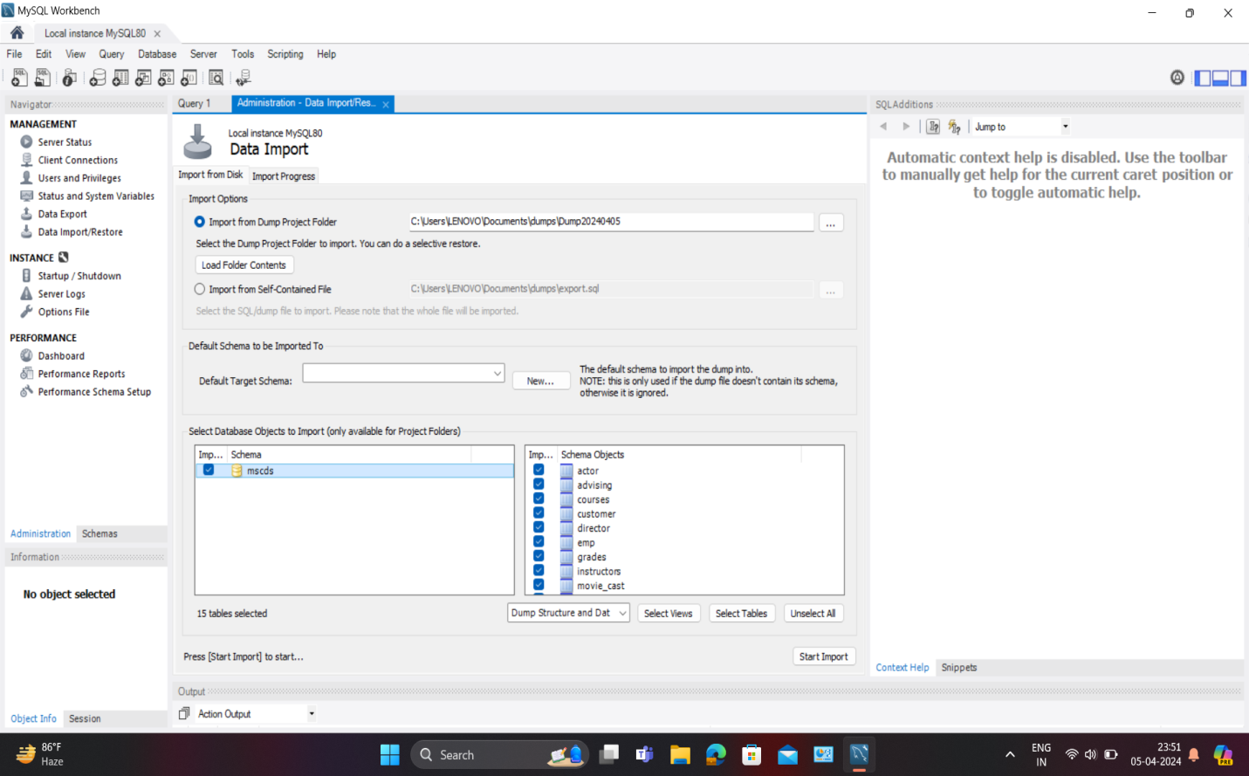

1. Go to the Administration tab, on the Navigation panel (on the left by default)
2. Select Data Import\Restore
3. Select the source of the recovery Dump Project Folder or Self-Contained File, depending on what you selected at the backup stage
4. If you used a Dump Project Folder, then you can select the databases and tables that need to be restored.
5. If you use a Self-Contained File, then before restoring, you must select the schema into which you want to restore the dump. If you restore a dump to a server where the required schema does not exist, you can create it by clicking the New button.
6. Press the Start Import button.