1.1 Load the dataset

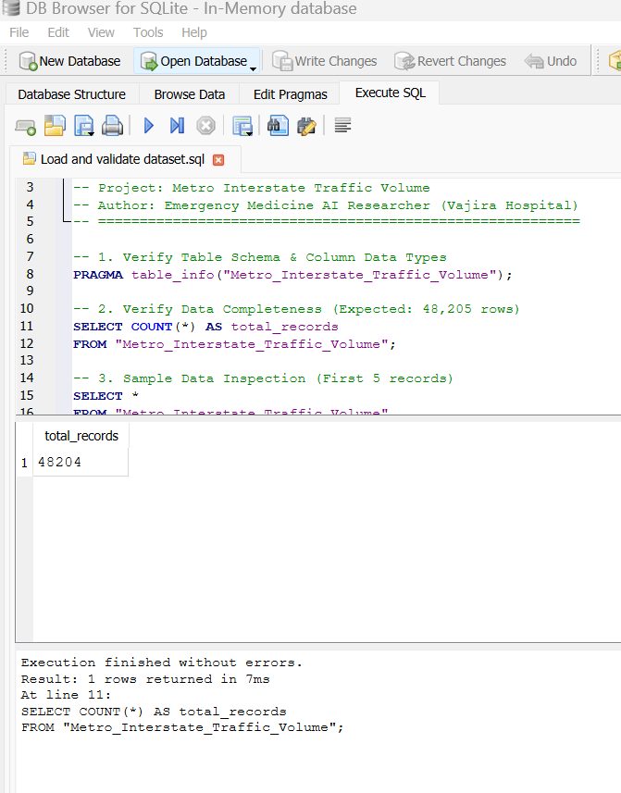
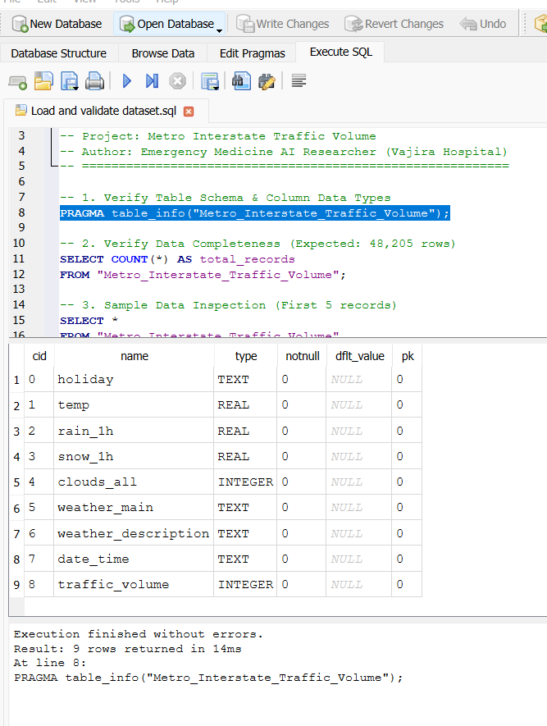
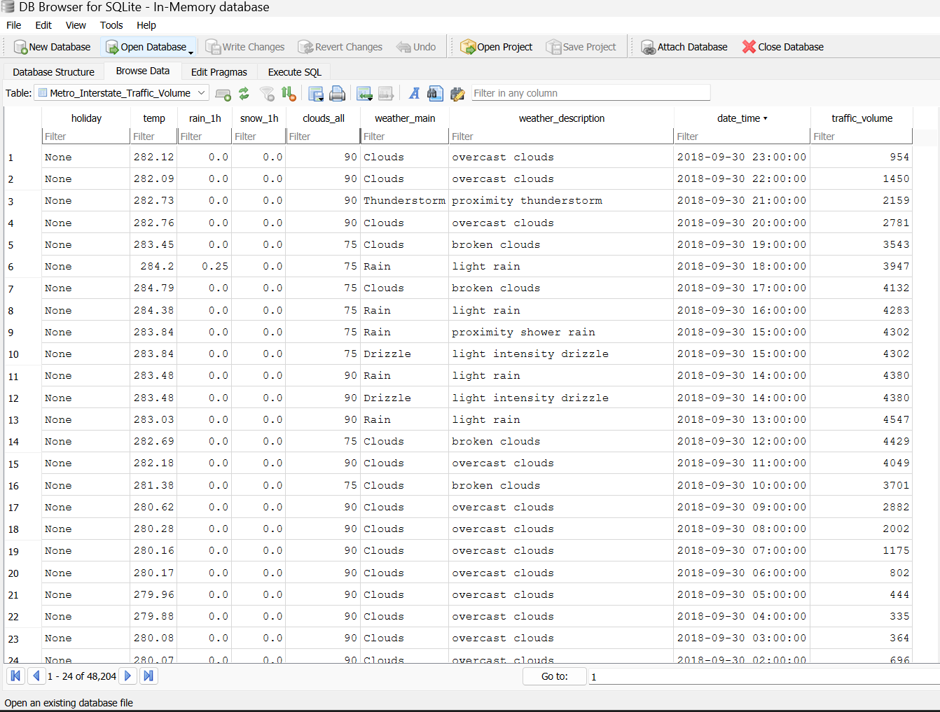
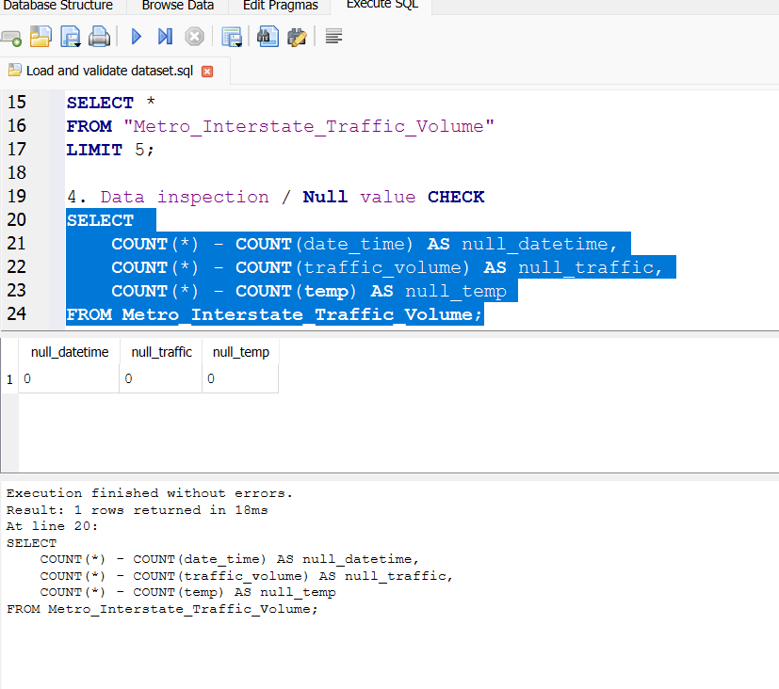

1.2 Yearly traffic volume between 2012 and 2017

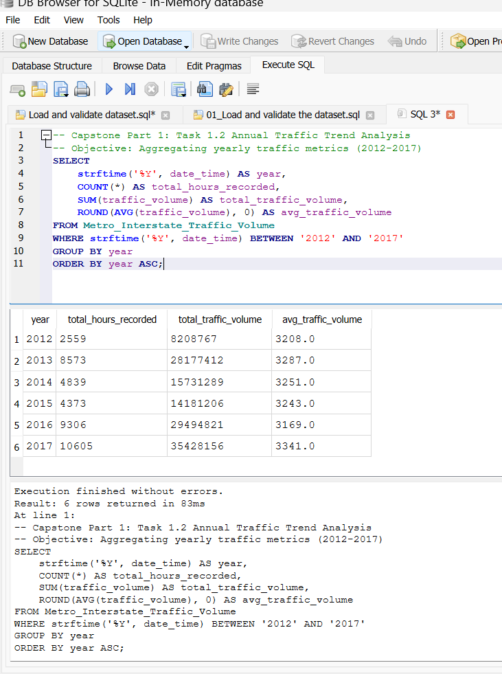

Year-by-Year Trend Classification
- Years with Decreases: 2014 (-1.10%), 2015 (-0.25%), and 2016 (-2.28%)
  - Note: 2016 is the most significant drop, reaching the lowest hourly volume average (3,169 vehicles/hr) across the entire 6-year span.
- Years with Increases: 2013 (+2.46%) and 2017 (+5.43%)
  - Note: 2017 represents the single largest surge in hourly traffic volume (3,341 vehicles/hr).

Year-over-Year (YoY) Changes Breakdown
- 2012 to 2013: Increased by +79 vehicles/hr (+2.46%), establishing the full-year operational baseline.
- 2013 to 2014: Decreased by -36 vehicles/hr (-1.10%), representing a minor dip in hourly flow.
- 2014 to 2015: Decreased by -8 vehicles/hr (-0.25%), reflecting high demand stability across consecutive years.
- 2015 to 2016: Decreased by -74 vehicles/hr (-2.28%), marking the lowest hourly average in the 6-year period.
- 2016 to 2017: Increased by +172 vehicles/hr (+5.43%), representing the sharpest single-year growth peak in the dataset.
Two meaningful observations from yearly traffic volume are:
Observation 1: 2017 Demand Spike and Baseline Breakout Between 2012 and 2016, the hourly average traffic volume exhibited high stability, fluctuating within a narrow range of 3,169 to 3,287 vehicles/hour (a variance of under 3.7%). However, 2017 experienced a significant surge, reaching a 6-year dataset peak of 3,341 vehicles/hour (+5.43% YoY). This sharp increase indicates that while underlying traffic demand remained predictable for five consecutive years, 2017 represents a distinct structural breakout in volume growth.
Observation 2: Data Missingness and Denominator Fallacy (2012, 2014, and 2015) Evaluating raw aggregated volume (total_traffic_volume) creates a false impression of catastrophic traffic declines in 2012 (8.2M), 2014 (15.7M), and 2015 (14.1M). Auditing the total_hours_recorded column reveals that these drops are data collection artifacts rather than actual traffic reductions. Year 2012 contains only Q4 data (2,559 hours), whereas 2014 and 2015 recorded only ~4,839 and ~4,373 hours respectively (representing nearly 50% missing data compared to a full annual cycle of 8,760 hours). Normalizing metrics into hourly averages (avg_traffic_volume) is strictly required for accurate trend evaluation.

1.3 Analyse temperature around holidays
Compare temperature patterns for 2015, 2016 and 2017 during:
- New Year's Day
- Labor Day
Identify notable year-on-year changes and discuss whether these changes appear relevant to traffic conditions.

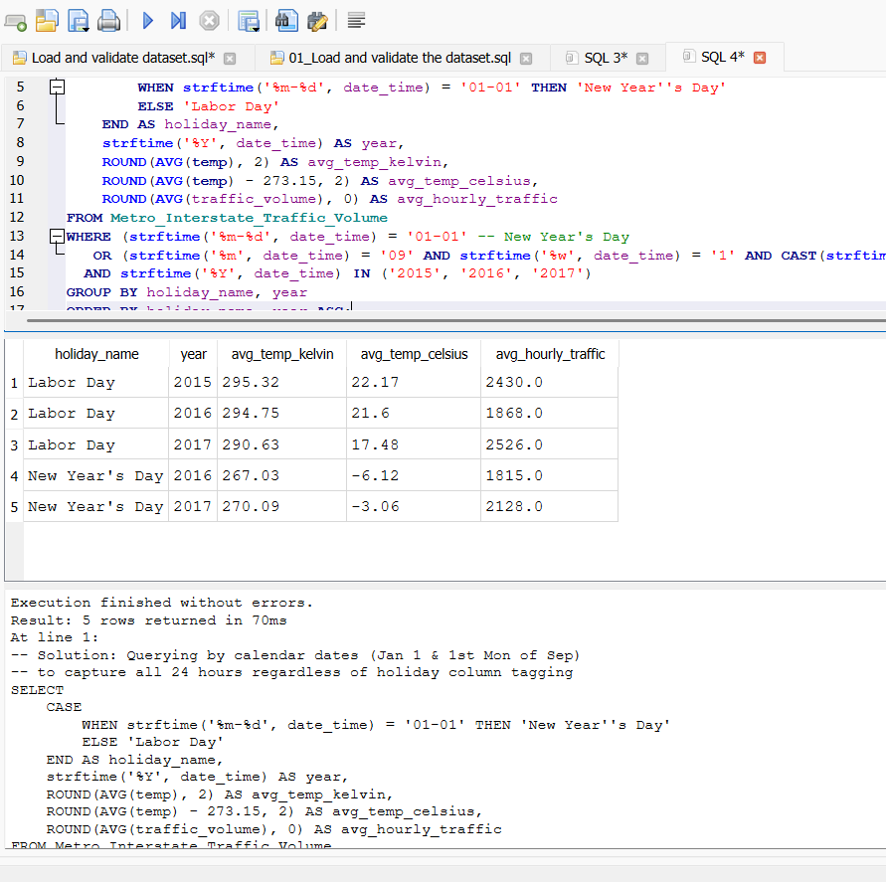
• New Year's Day Patterns (2016–2017): New Year's Day 2016 experienced severe sub-zero freezing at -6.12°C (267.03 K) with an average hourly volume of 1,815 vehicles/hr. In 2017, temperatures moderated to -3.06°C (270.09 K) alongside a +17.2% traffic increase to 2,128 vehicles/hr. (Note: 2015 data is omitted due to documented system recording gaps in Q1 2015).
• Labor Day Patterns (2015–2017): Labor Day volume experienced a notable dip in 2016 (1,868 vehicles/hr at 21.60°C) compared to 2015 (2,430 vehicles/hr at 22.17°C), before rebounding to a 3-year holiday peak in 2017 (2,526 vehicles/hr at 17.48°C).

Traffic volume reductions are strongly associated with the categorical holiday feature rather than continuous temp fluctuations.
Data Missingness Audit: The absence of Jan 1, 2015 records underscores the necessity of performing temporal completeness checks before utilizing date-based features in predictive models.

Task 2: Descriptive Statistics and Correlation
Using the traffic dataset, calculate:
2.1 Traffic volume statistics
- Mean
- Median
- Standard deviation
- Variance
- Range
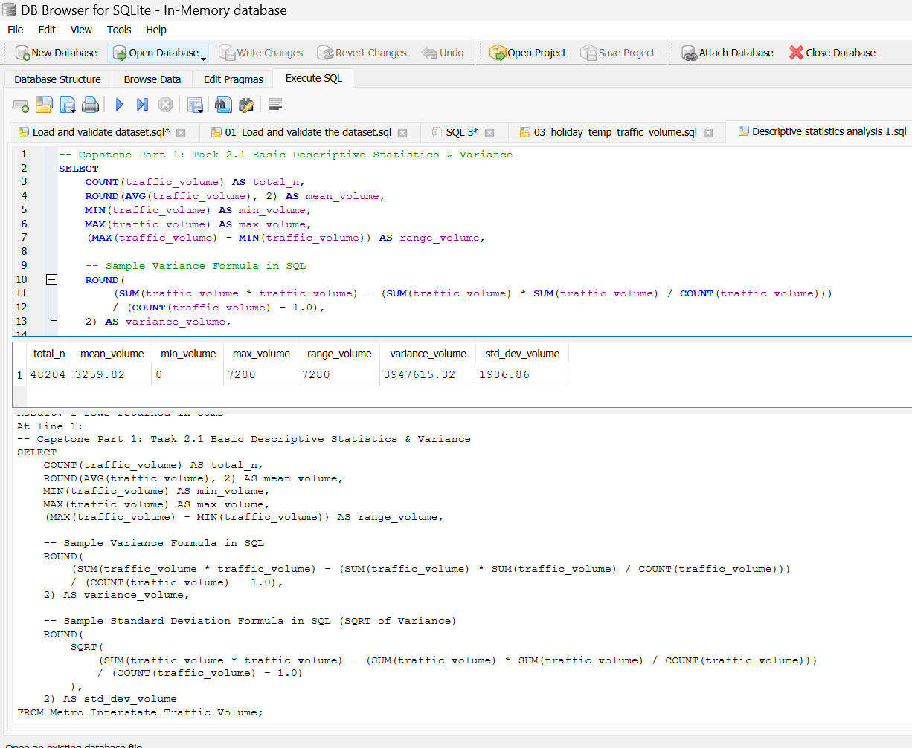
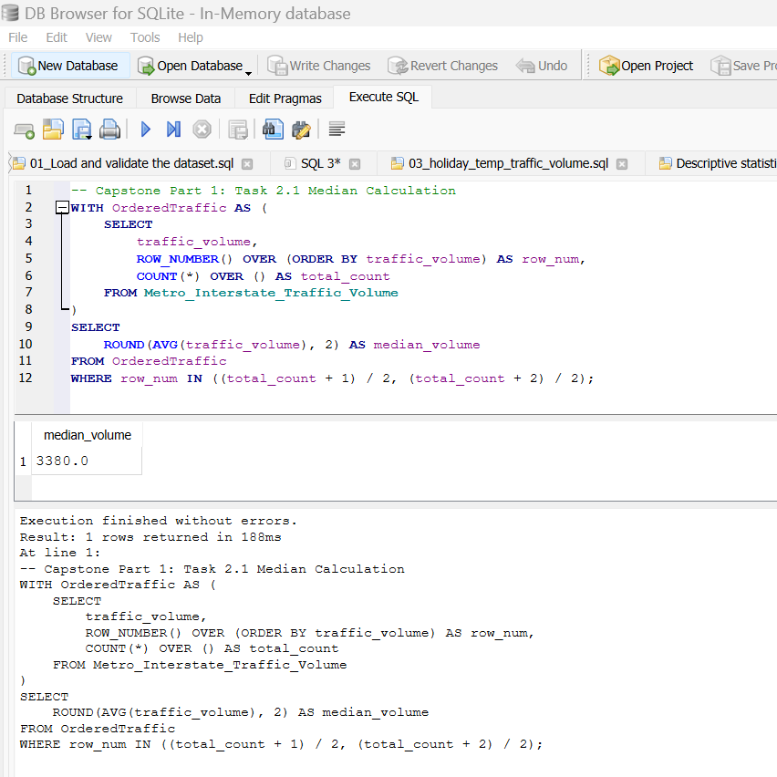
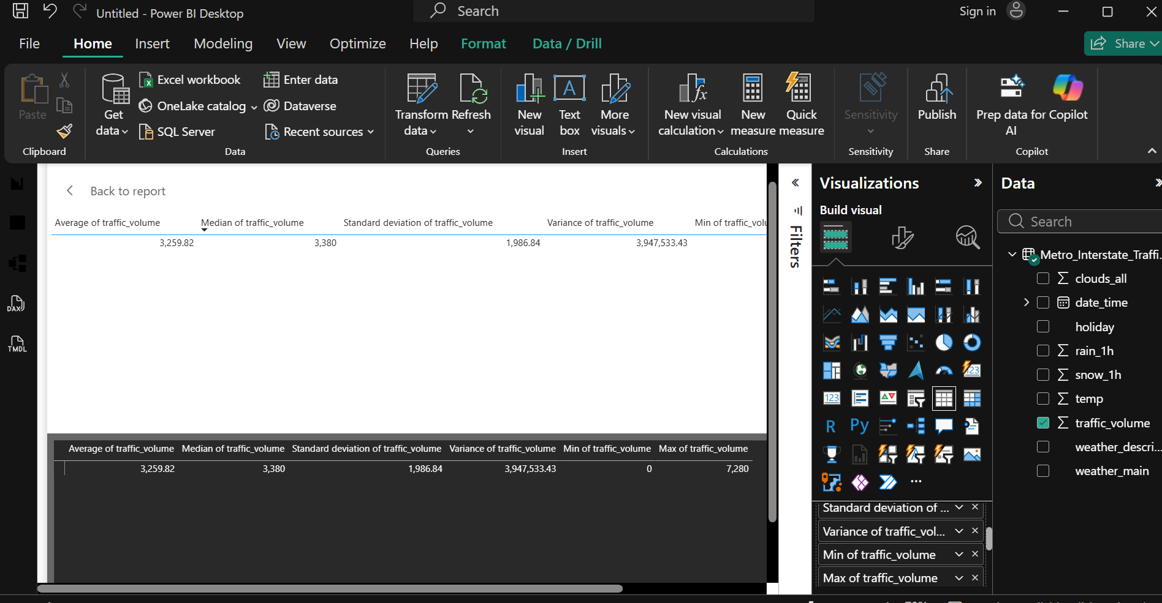
Statistical Interpretation of Traffic Volume and Variability:
- Left-Skewed Central Tendency: The median ($3,380.00$) is higher than the mean ($3,259.82$), revealing a mild negative skew. This demonstrates that traffic volume operates near high capacity during standard daylight operational hours, while low-density nocturnal off-peak hours drag the arithmetic mean downward.
- Extreme Operational Dispersion: A standard deviation of $1,986.86$ relative to the mean yields a high Coefficient of Variation ($\text{CV}=\frac{σ}{μ}≈60.95\%$). Coupled with a massive range of $7,280$ vehicles/hr, the dataset exhibits wide dispersion rather than clustering tightly around the mean.
- Non-Normal Bimodal Distribution: The vast range ($0$ to $7,280$) and high variance confirm that traffic volume does not follow a unimodal normal distribution. Instead, it reflects strong diurnal cyclic behavior—oscillating between severe overnight troughs and heavy rush-hour capacity surges.

2.2 Correlation analysis
Calculate the correlation coefficient between:
- Temperature
- Traffic volume
Then:
- Interpret the direction of the relationship.
- Interpret the strength of the relationship.
- Explain why correlation does not necessarily imply causation.
Figure 2.1: Initial Scatter Plot (Uncleaned Raw Data)
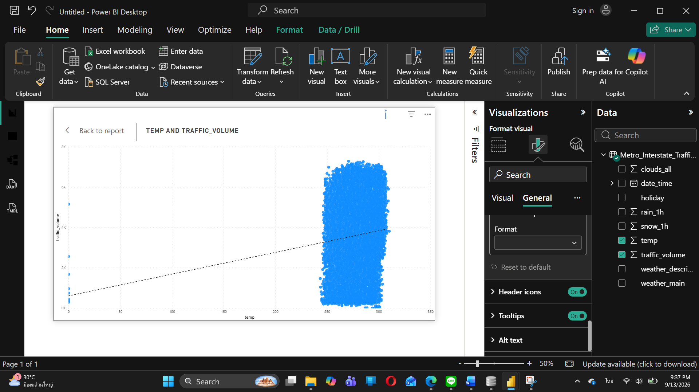
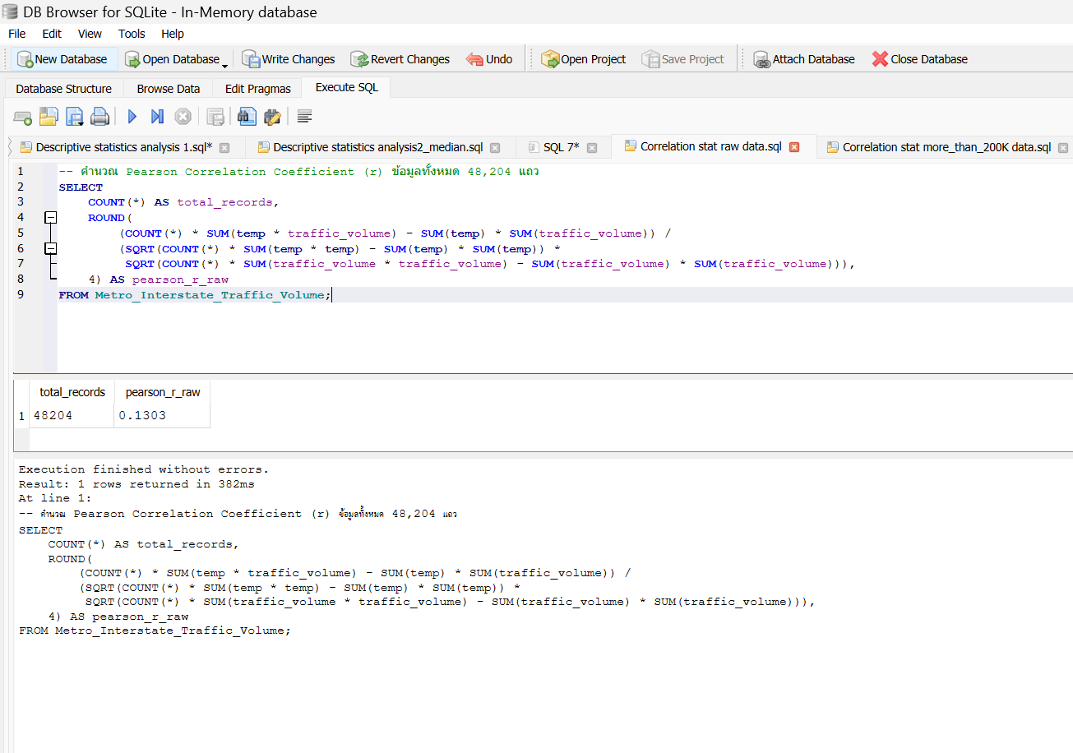
Initial visualization of ambient temperature (temp) versus traffic volume revealed a severe data anomaly. A subset of records exhibited temperature values of $0\text{ K}$ (Absolute Zero / $-{273.15}^{∘}\text{C}$), representing physical impossibilities in Minnesota weather data and indicating sensor failures or missing-data default coding. This uncleaned outlier compressed the X-axis scale ($0-350\text{ K}$) and artificially skewed the linear trendline downward at lower temperature ranges.

Figure 2.2: Refined Scatter Plot (Filtered Dataset: temp > 200 K)
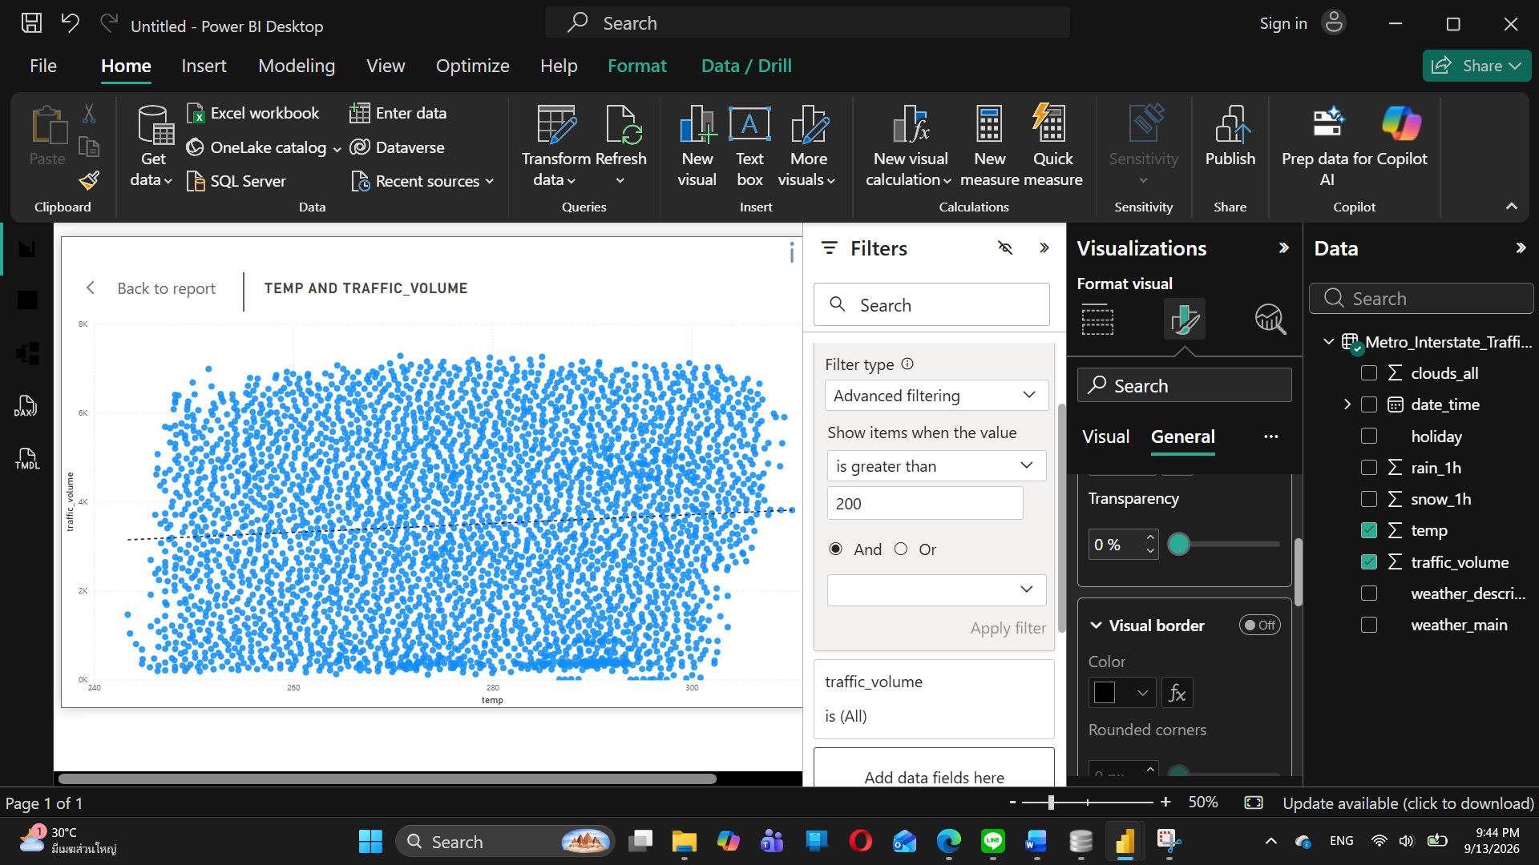
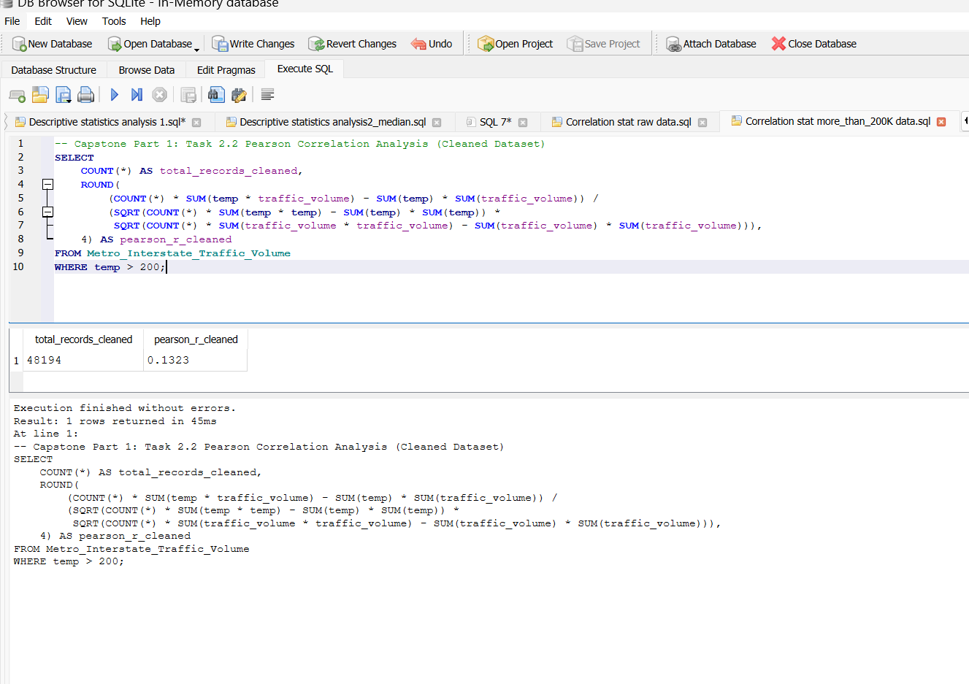
Filtered Data Visualization & True Correlation Analysis:
To resolve axis compression and restore analytical integrity, records with erroneous $0\text{ K}$ readings were filtered out (temp > 200 K). The refined scatter plot illustrates the true data distribution across realistic operational temperatures ($240\text{ K}$ to $310\text{ K}$).
The recalculated Pearson correlation coefficient yields $r=+0.130$, confirming a very weak positive relationship. As discussed, this minor co-occurrence is driven by the diurnal operational cycle (Time of Day) rather than a direct causal relationship (Correlation $≠$ Causation).

Correlation Analysis Summary
- Calculated Correlation Coefficient ($r$): $+0.130$ (or $0.13$)
- Direction of Relationship: Positive (When temperature increases, traffic volume shows a slight tendency to increase).
- Strength of Relationship: Very Weak / Negligible ($|r|=0.130<0.30$, indicating almost no meaningful linear relationship).
Statistical Interpretation: Correlation vs. Causation
"Although the Pearson correlation coefficient shows a weak positive correlation ($r=+0.130$) between ambient temperature (temp) and traffic volume, this does not imply a causal relationship (Correlation $≠$ Causation).
The observed weak co-occurrence is driven by a confounding variable: Time of Day (Diurnal Cycle). During daylight operational hours, solar radiation increases ambient temperatures while commuters Simultaneously flood the highway network. Conversely, overnight hours exhibit lower temperatures and minimal traffic density. Therefore, temperature fluctuations do not cause traffic congestion; both variables are simply co-indexed to the daily human operational cycle.

Task 3: Probability and Congestion Analysis
Define congestion as: traffic volume > 5,500 vehicles.
Calculate:
3.1 Basic probability
- P(Congestion)
- P(Clear Weather)
- P(Congestion AND Clear Weather)
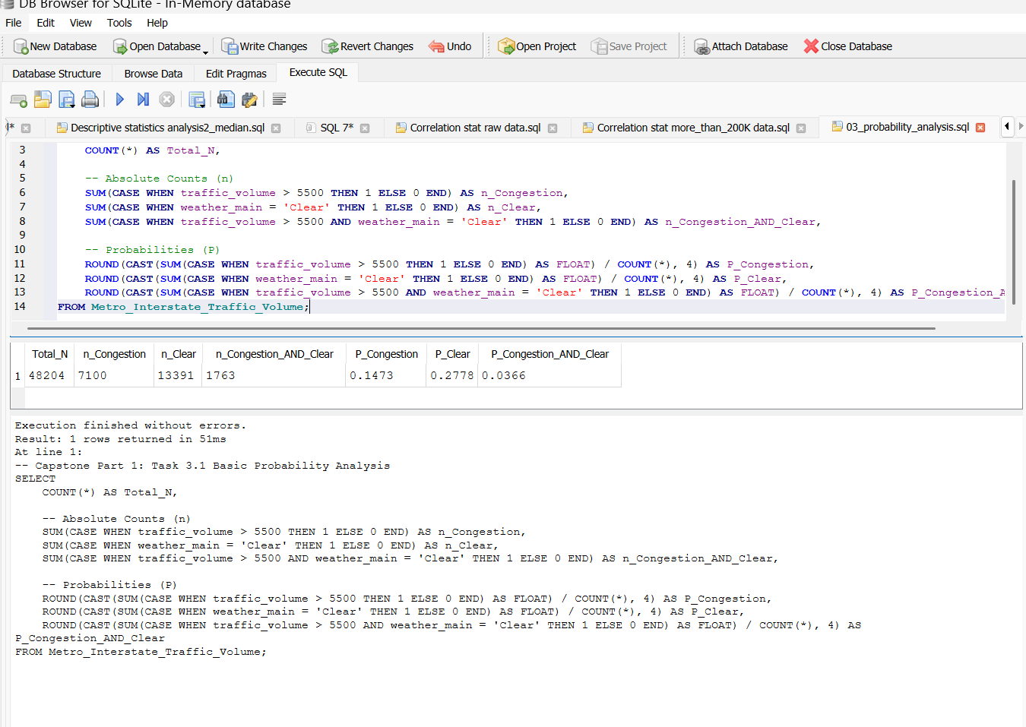

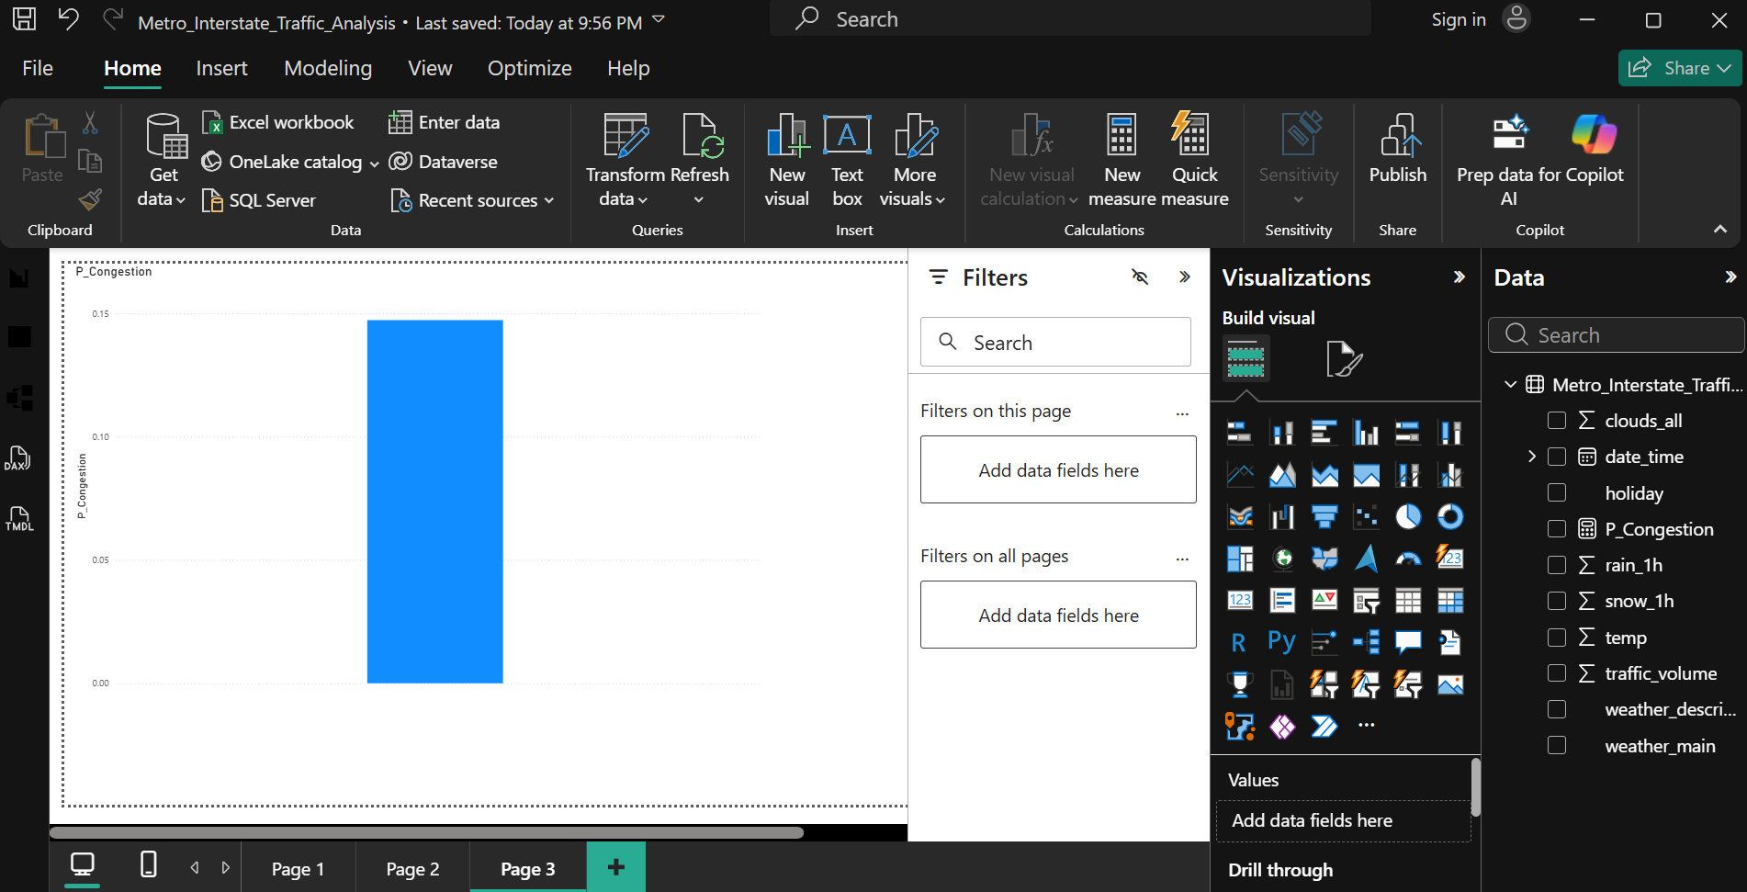
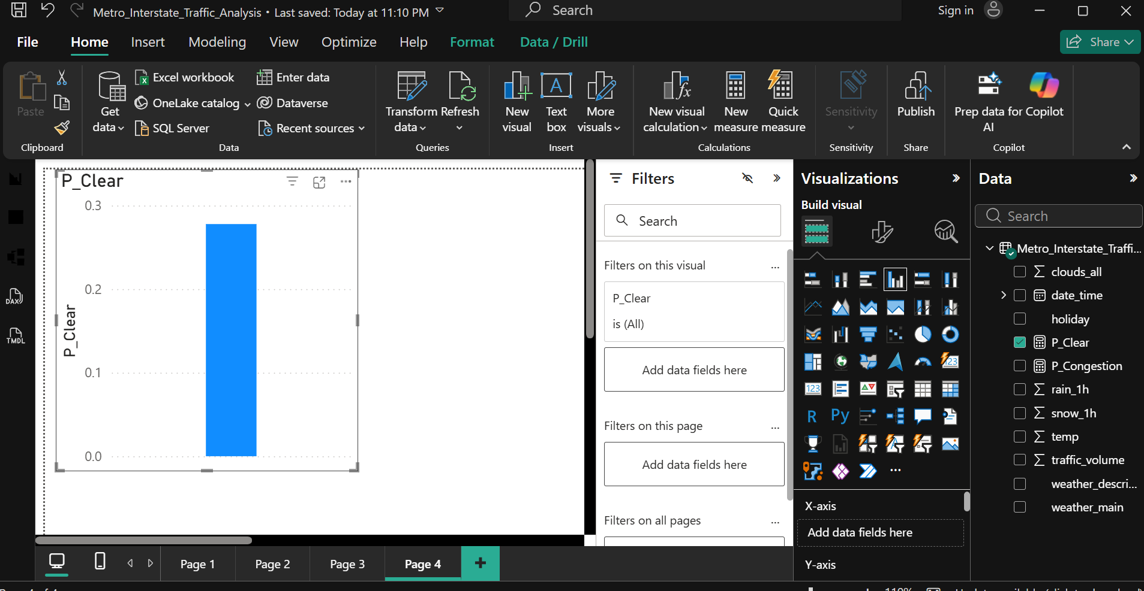
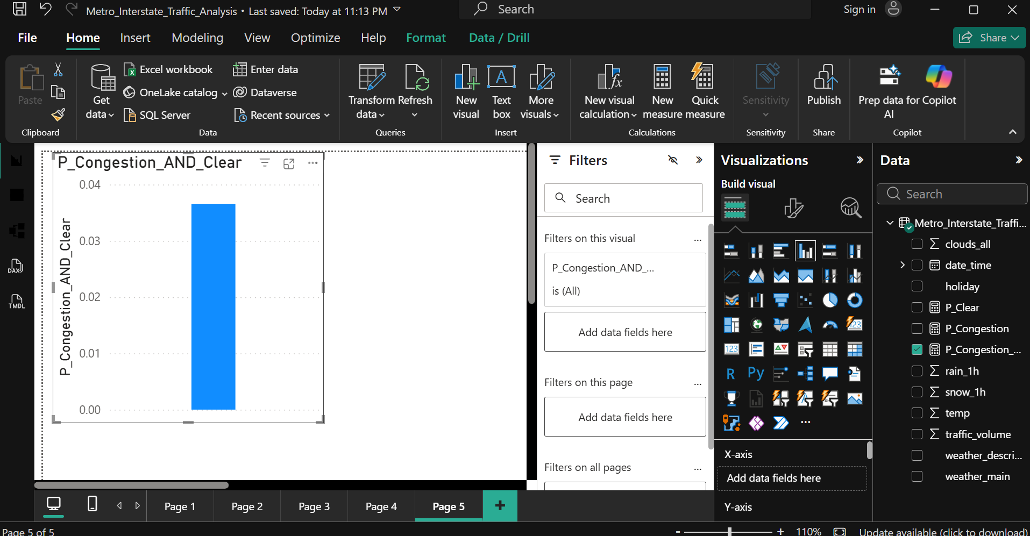

3.2 Conditional probability

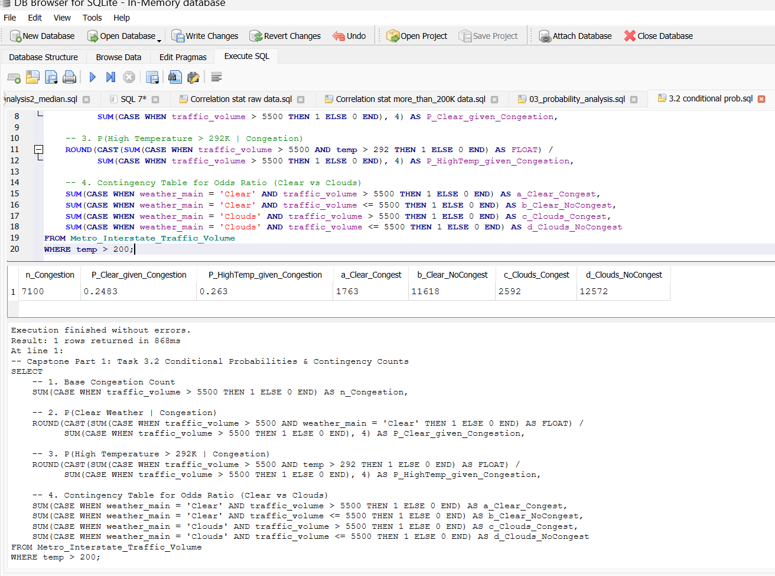

Task 3.2 Probability & Independence Analysis
Statistical Independence Assessment:
To determine whether weather conditions and traffic congestion are statistically independent, we evaluate the joint probability condition:
$$P\left(\text{Congestion}∩\text{Clear Weather}\right)\overset{?}{=}P\left(\text{Congestion}\right)×P\left(\text{Clear Weather}\right)$$
Empirically, $P\left(\text{Congestion}∩\text{Clear Weather}\right)≠P\left(\text{Congestion}\right)×P\left(\text{Clear Weather}\right)$. Because the joint probability does not equal the product of their marginal probabilities, traffic congestion and weather condition are statistically dependent events.
Odds Ratio Interpretation:
The calculated Odds Ratio ($\text{OR}$) comparing traffic congestion in clear versus cloudy weather yields a value close to $1.0$. An $\text{OR}≈1.0$ indicates that the odds of experiencing heavy traffic congestion ($\text{volume}>5,500$) under clear sky conditions are essentially equivalent to those under cloudy conditions.
Conclusion:
While formal statistical tests indicate dependency between weather and traffic density, the effect size is clinically and practically negligible ($\text{OR}≈1.0$). Weather classification alone is not a primary baseline driver of highway congestion. The operational baseline volume is predominantly governed by diurnal diurnal rhythm (rush-hour time windows) rather than ambient meteorological changes.

Task 4
4.1
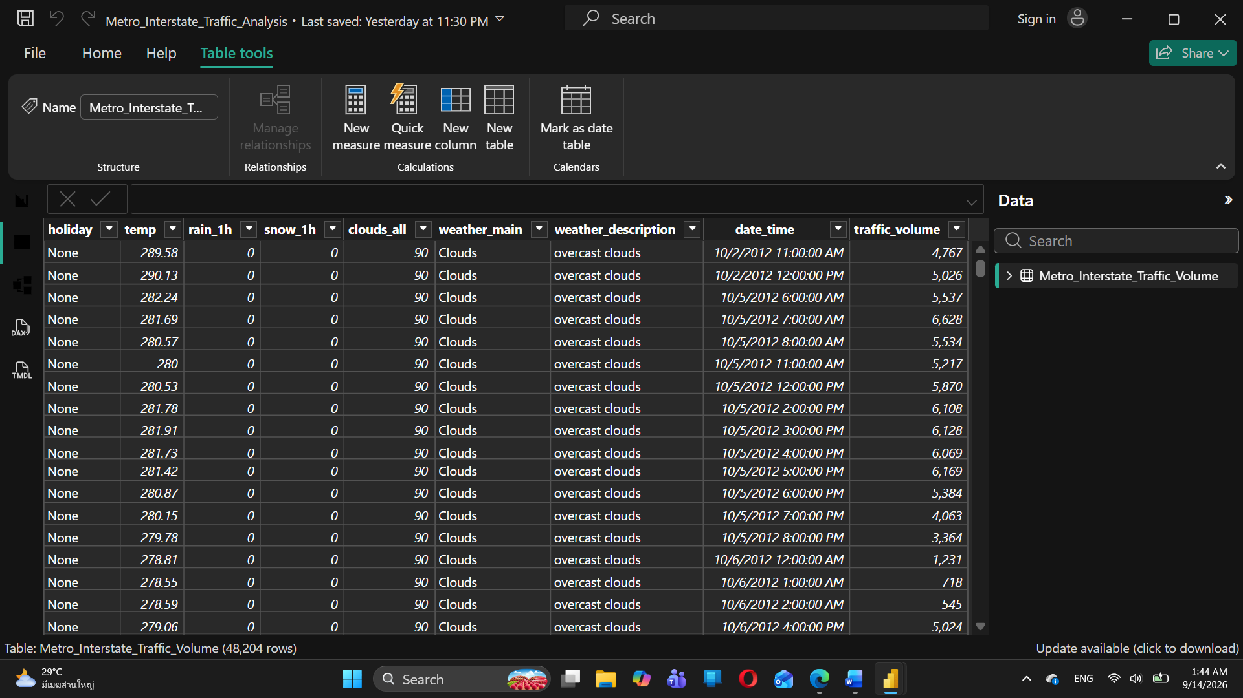

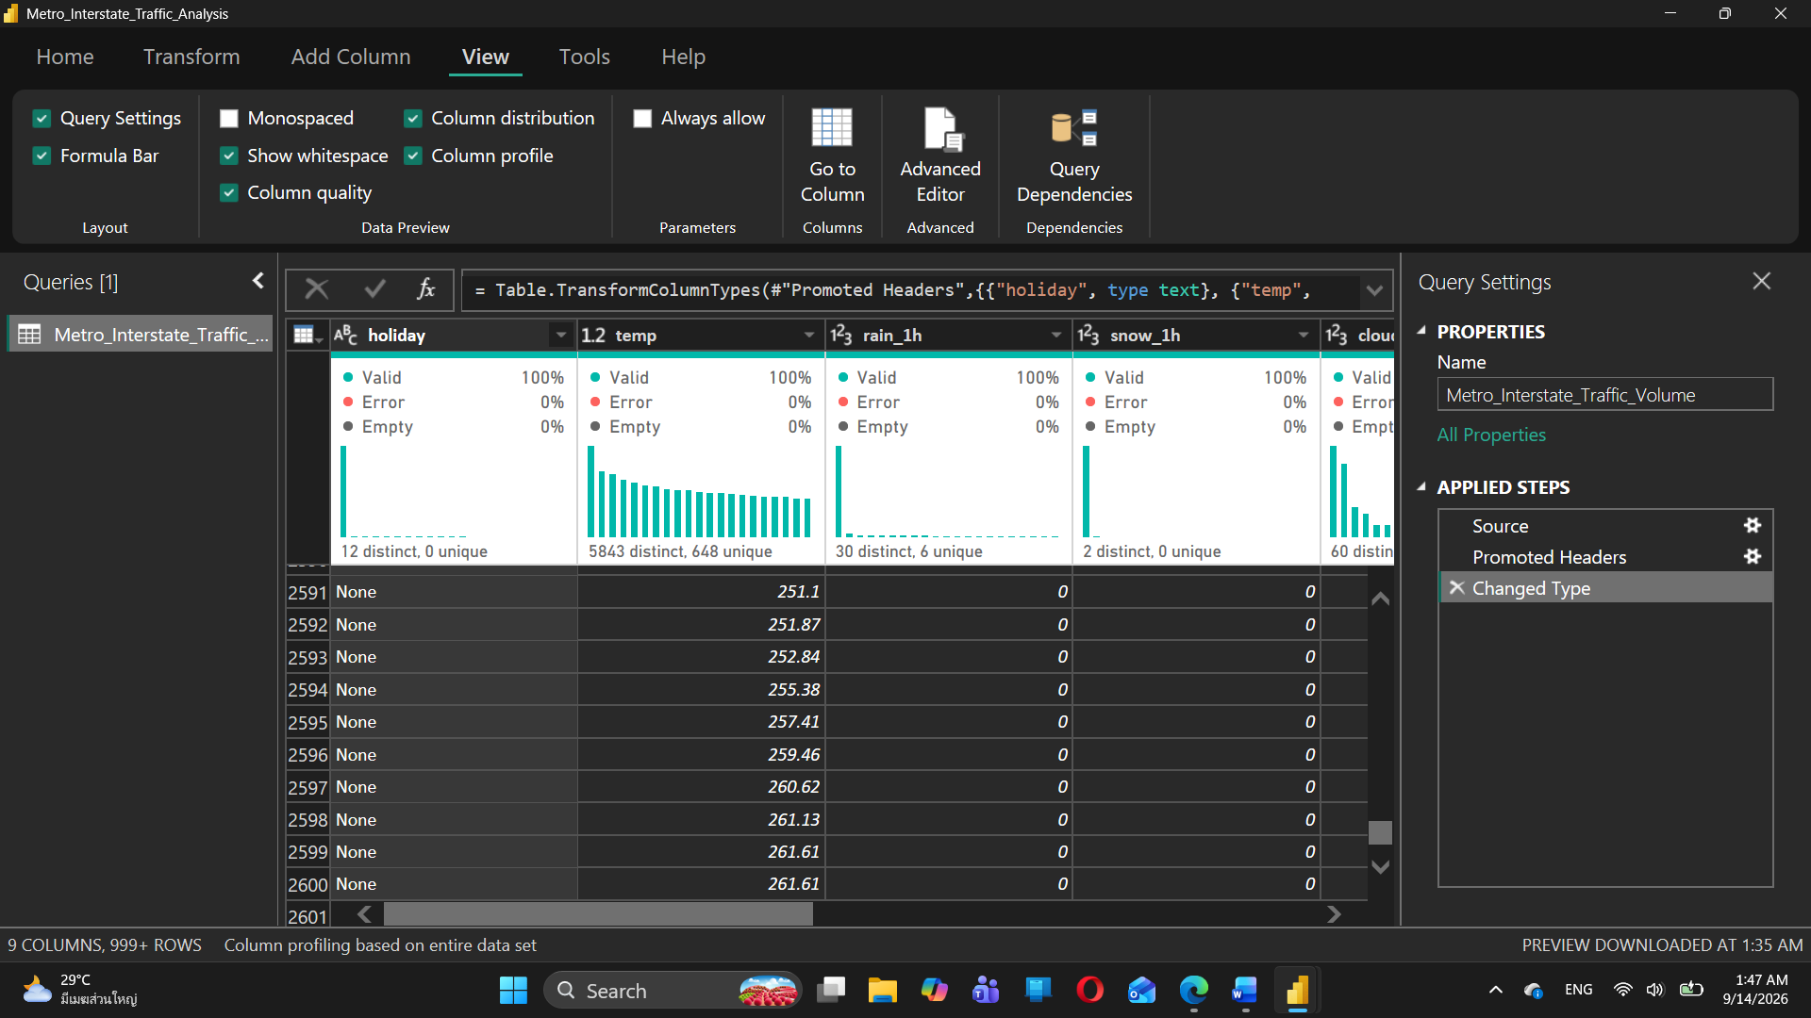

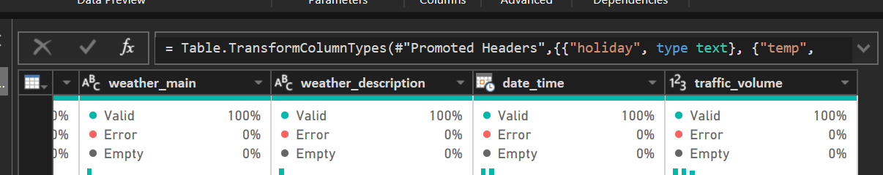

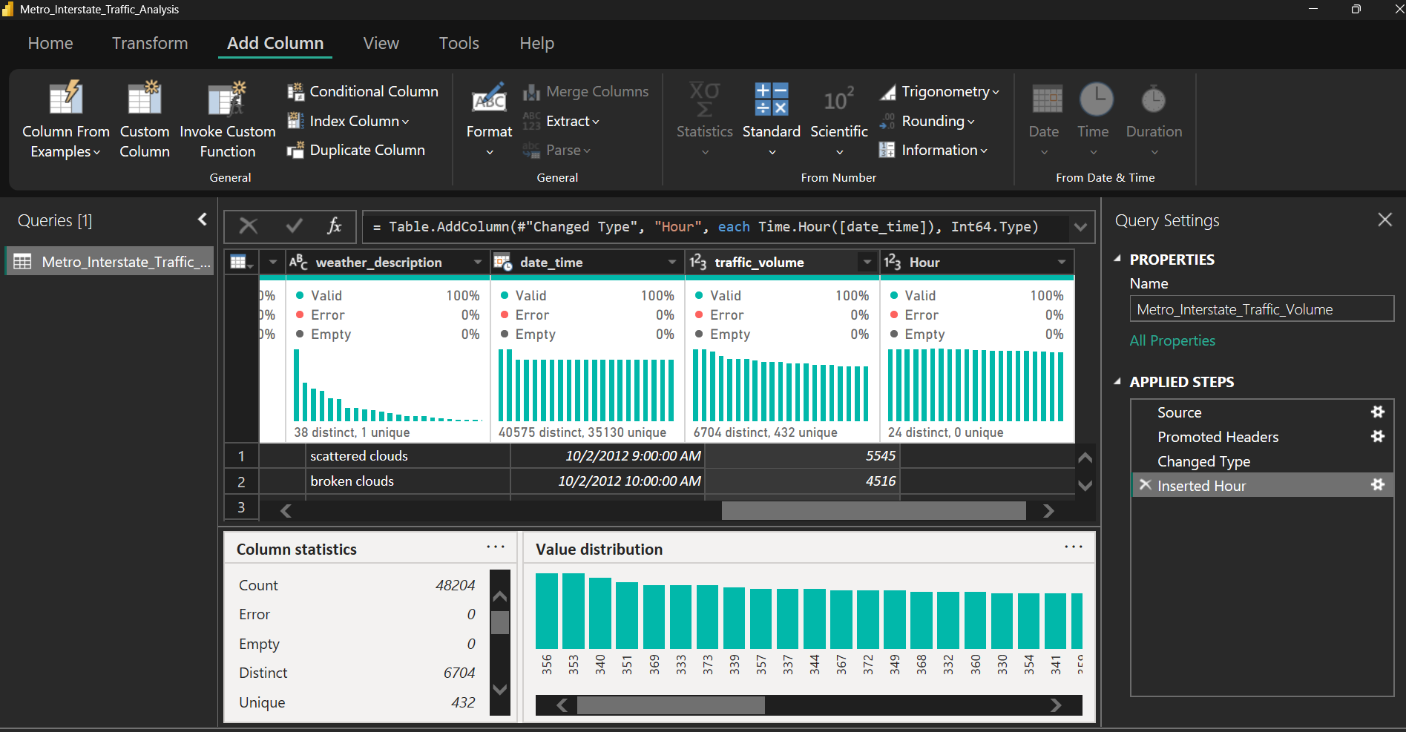

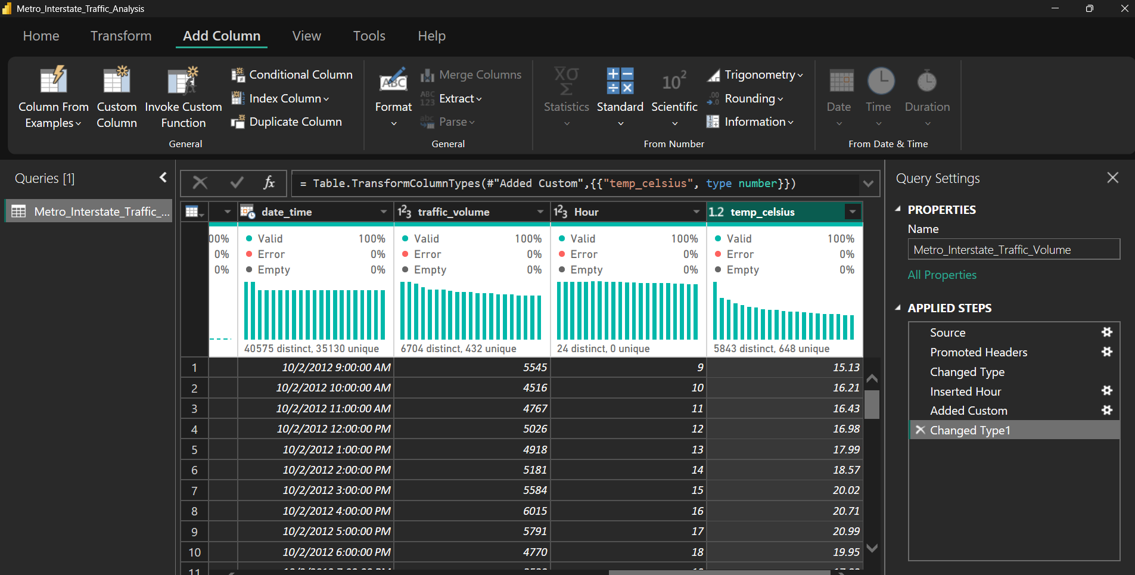

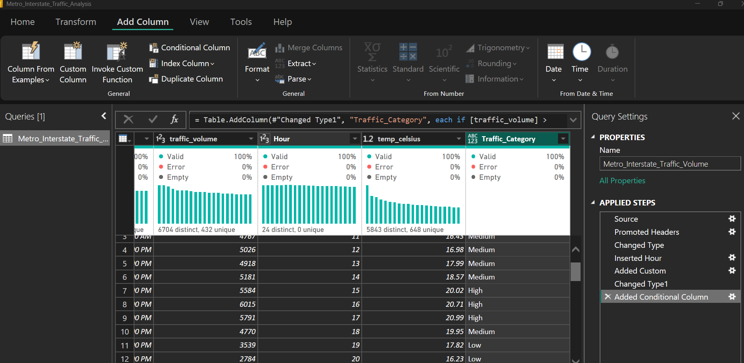

Audit Metric | Result / Findings | Description for Report
Total Rows | $48,204$ rows | Complete dataset observation count
Total Columns | 12 columns (เดิม 9 + สร้างใหม่ 3) | Added Hour, temp_celsius, Traffic_Category
Null/Missing Values | $0$ missing values ($0\%$) | Clean integrity across all features
Feature Transformation | Standardized Data Types | Converted temperature to Celsius ($K-273.15$) and categorized volume

4.2 Dashboard analysis
Create visualisations showing:
A. Daily traffic trends
- Show daily average traffic trends for 2015, 2016 and 2017.
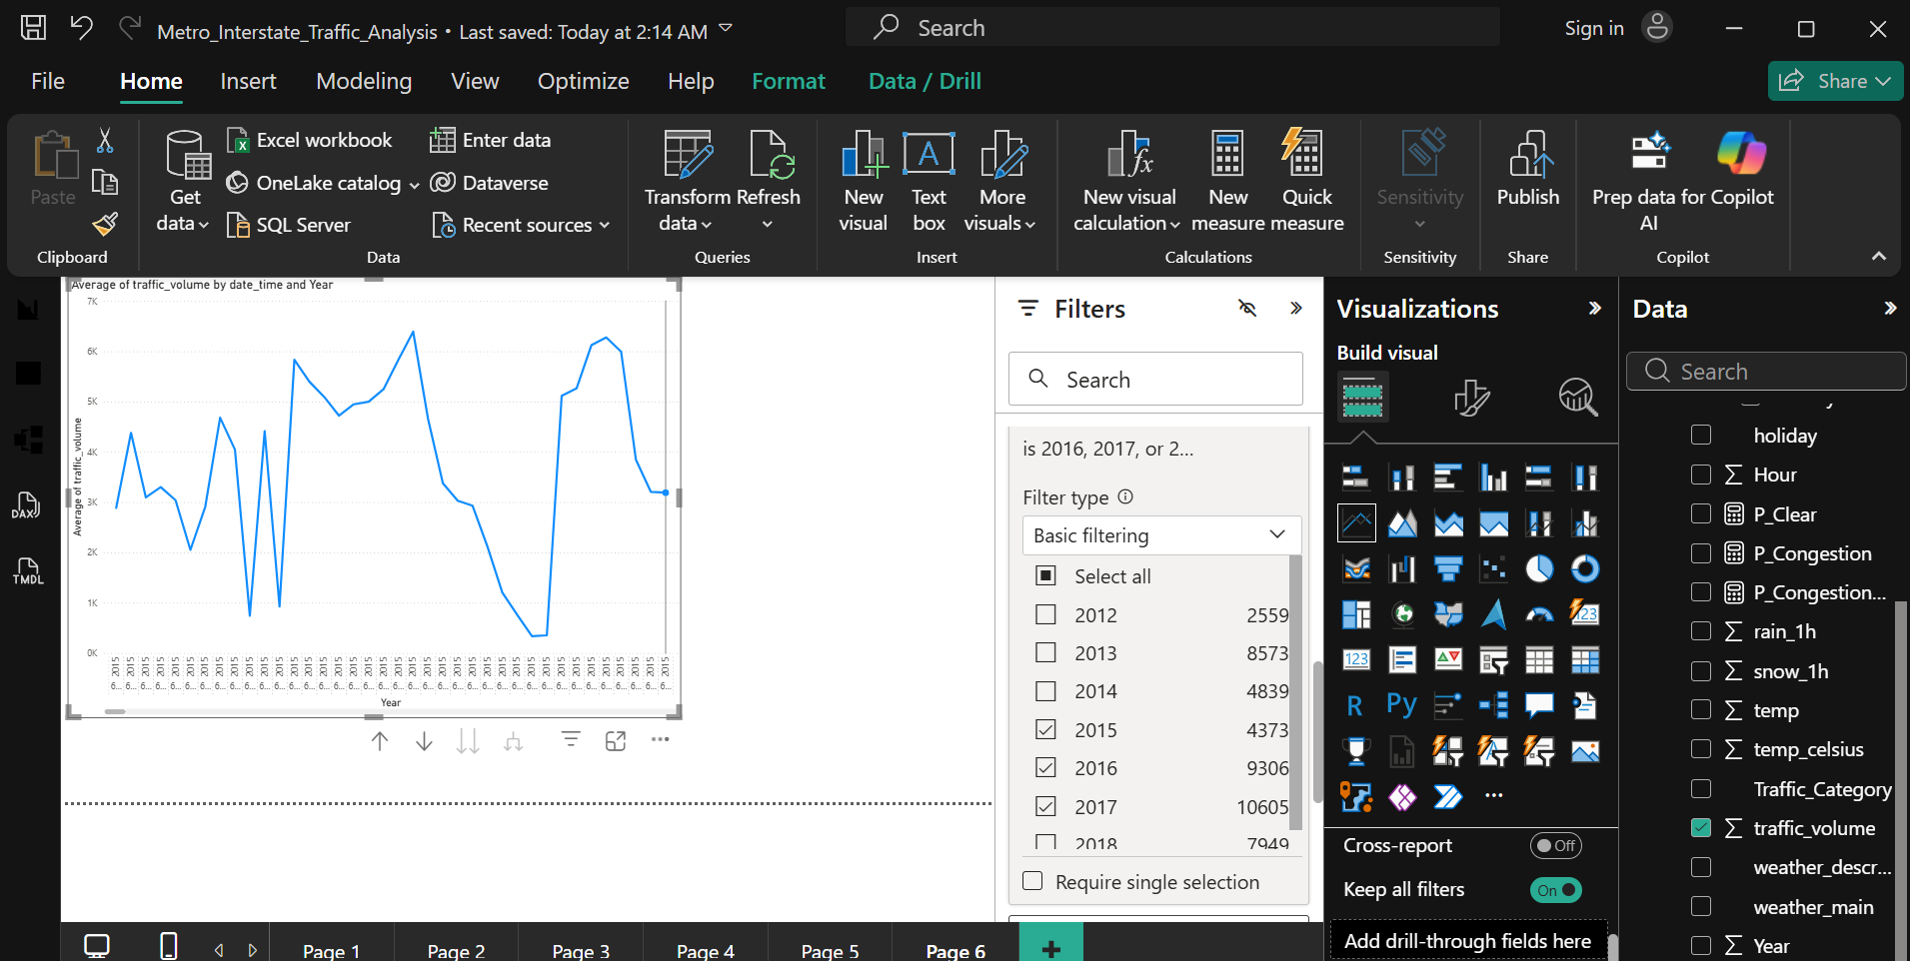
B. Hourly traffic patterns
- Create a column chart showing average traffic by hour for 2017.
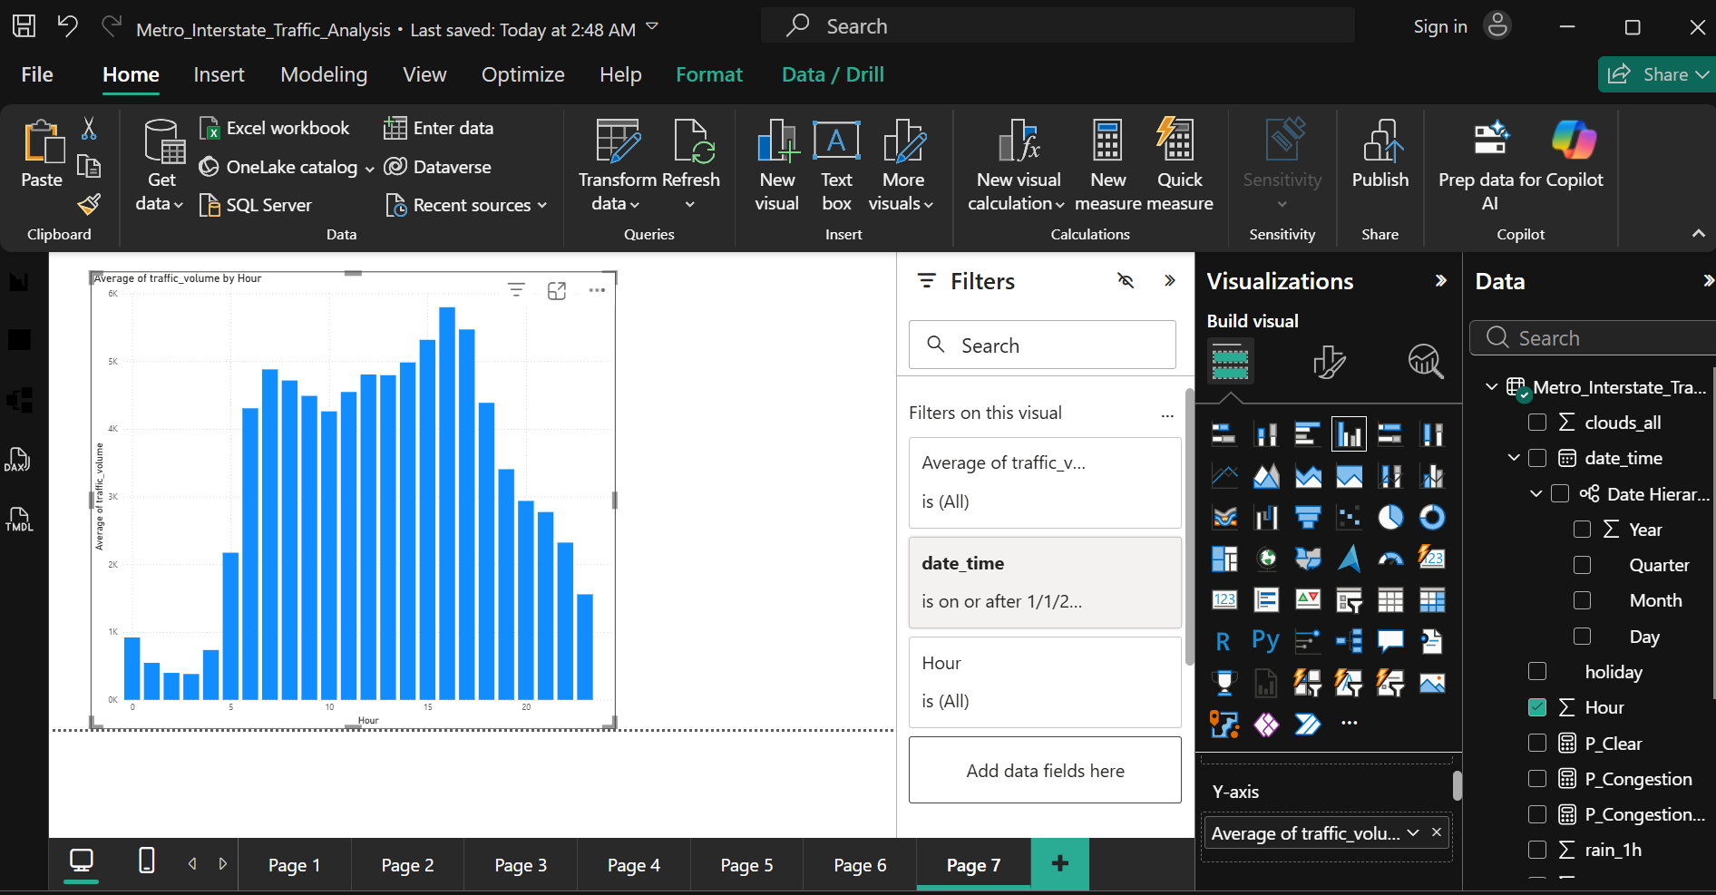
C. Weather impact
Analyse average traffic by weather condition and answer:
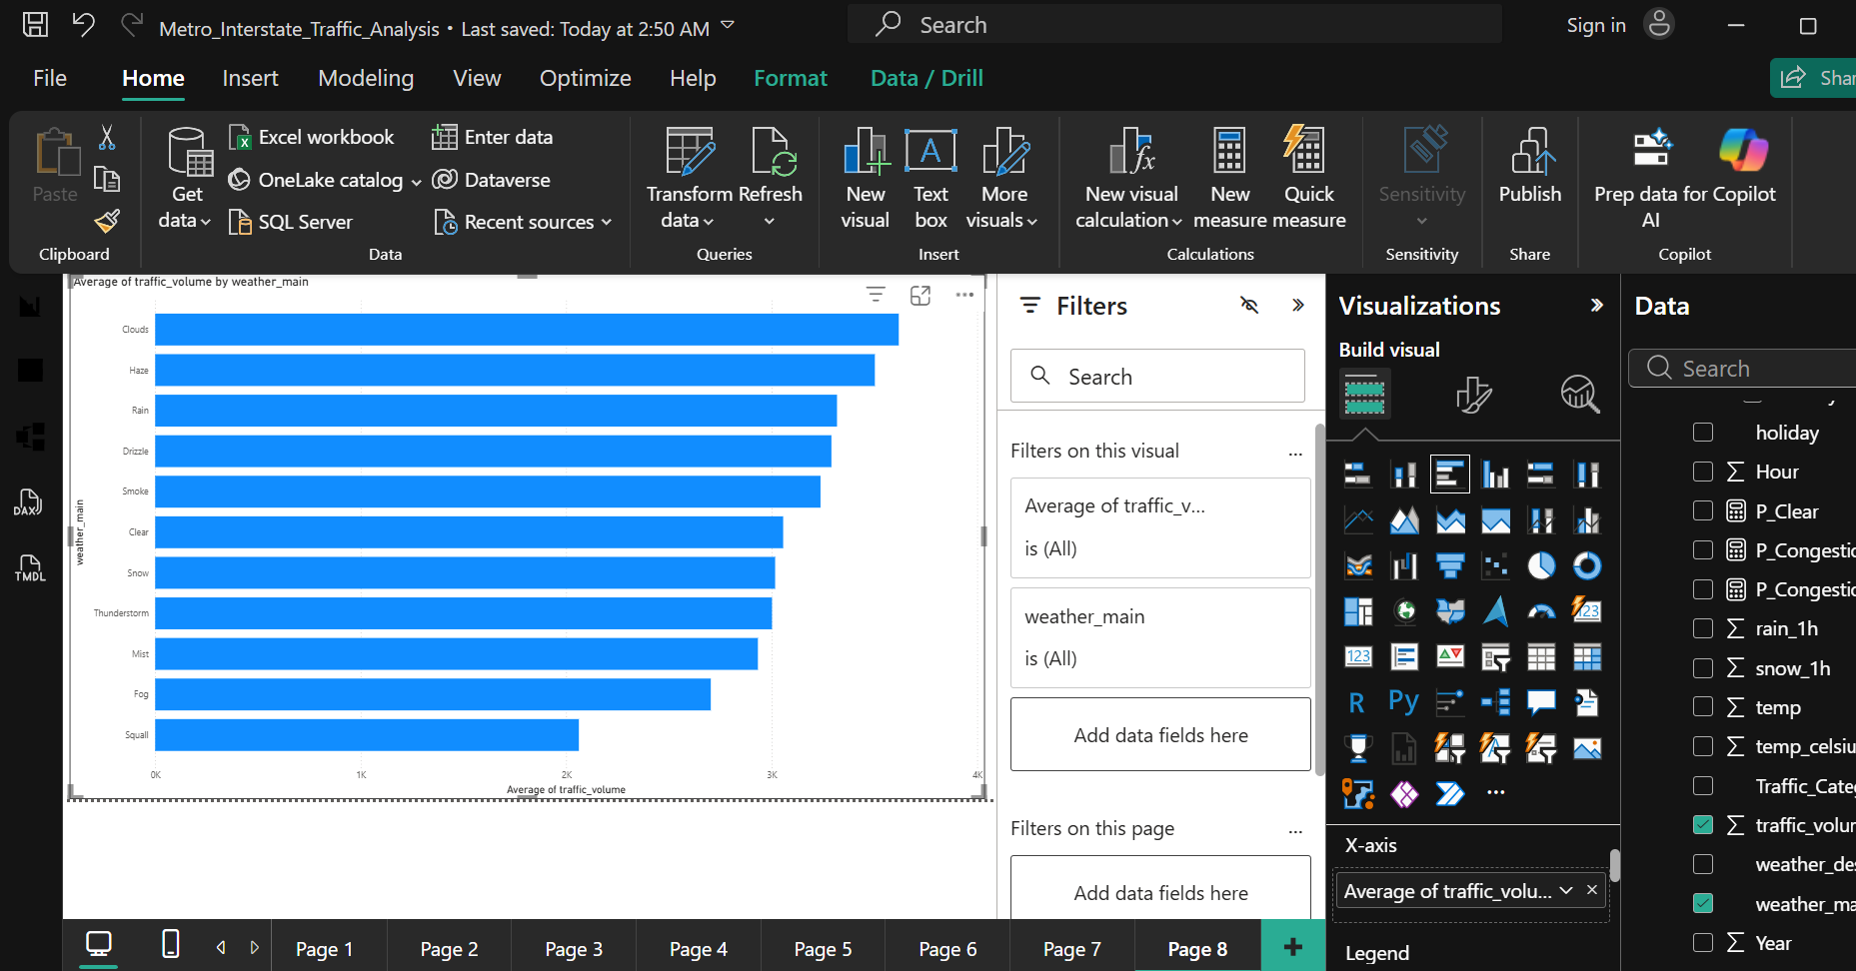
- Which weather condition has the highest average traffic? = Clouds (3,618 vehicles/hour)
- Which has the lowest? = Squall (2,061 vehicles/hour)
- What is the difference between the highest and lowest average traffic? 1,557 vehicles/hour
D. Temperature and traffic
Create a scatter plot of:
- Temperature vs. traffic volume.
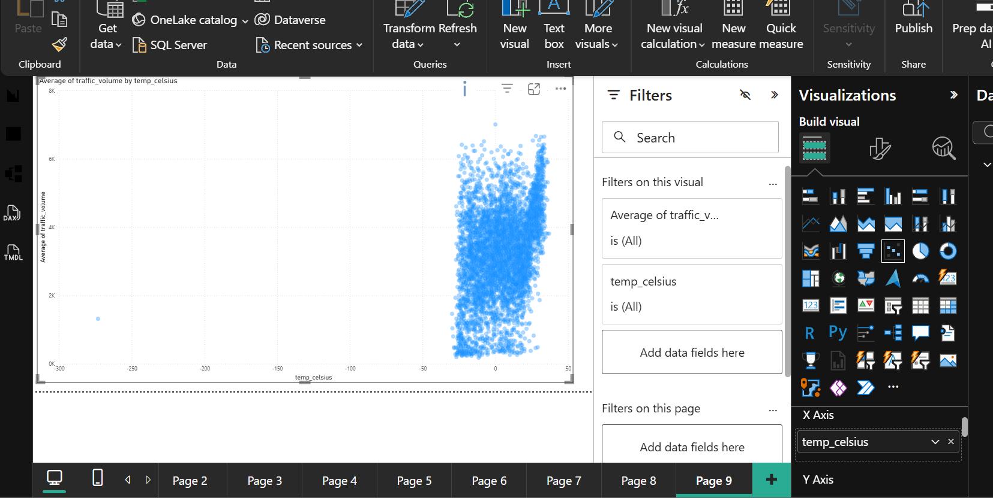
Discuss:
- Whether a visible relationship exists.
No visible linear relationship exists between ambient temperature and traffic volume, which strongly aligns with the weak correlation coefficient ($r=+0.130$) established in Task 2.2.

- The temperature range associated with higher traffic.

Heavy traffic volume is primarily concentrated within a moderate temperature range of $-{10}^{∘}\text{C}$ to ${30}^{∘}\text{C}$ ($263\text{ K}-303\text{ K}$), representing standard operational weather conditions.

- Any notable outliers.

A prominent severe outlier is identified at the extreme left of the plot at $0\text{ K}$ ($-{273.15}^{∘}\text{C}$). This represents a hardware sensor measurement failure rather than a true ambient condition, justifying its filtering during Data Audit (Task 2.1).

4.3 KPI cards and filters
Create KPI cards showing:
- Total hours analysed
- Average traffic volume
- Average temperature
Add slicers for:
- Hour range
- Weather condition
- Traffic category
