Why x3 cannot be packed in the disk?

x1 and x2 are continuous functions of a and b when a and b lie in [0,0.4]. X and x3 are also continuous as a result.

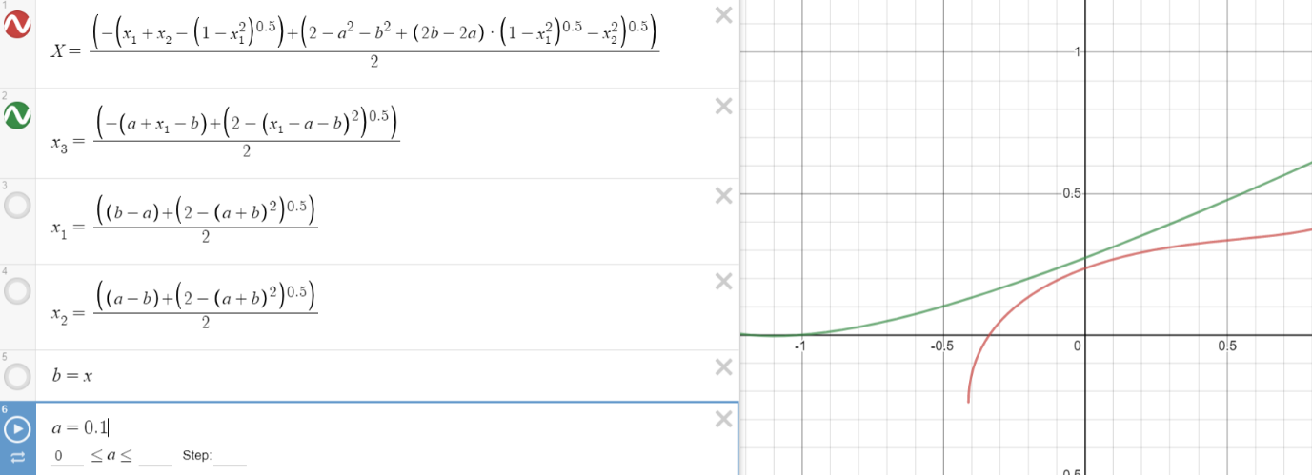

When a=0.1 and b is varying

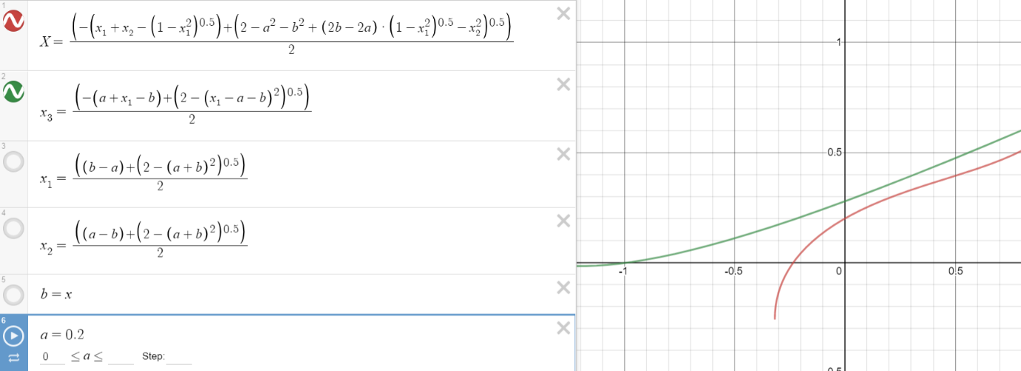

When a=0.2 and b is varying

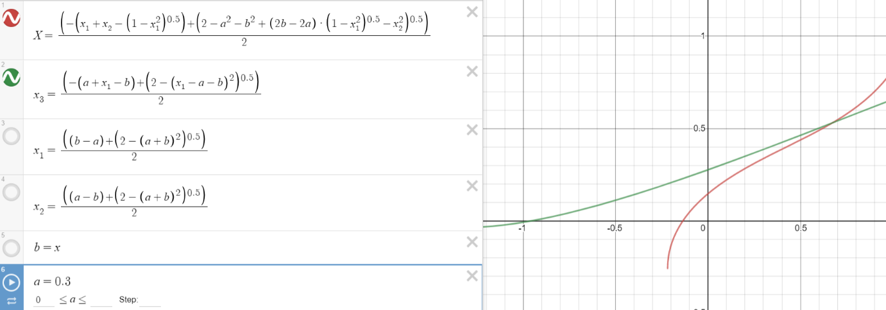

When a=0.3 and b is varying

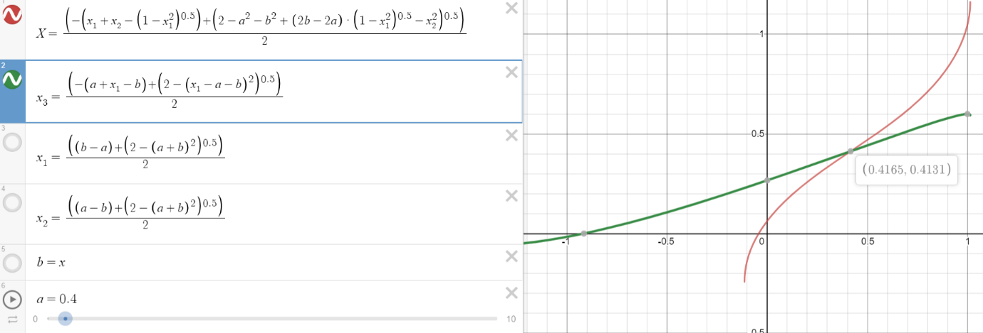

When a=0.4 and b is varying

x3(in green)is always greater X(in red) when a and b lie in [0,0.4] in all graphs. Thus, a square with side x3 cannot be packed in disc in the following fashion.

