Versions:

Date | Version | Author | Comments
4 Nov. 2021 | V0.1 | Yours truly | Initial analisys&design
10 Nov. 2021 | V1.0 | Yours truly | Complete analisys&design
26 Nov. 2021 | V1.1 | Yours truly | Added and changed a few things
16 Dec. 2021 | V1.2 | Yours truly | Updated diagrams, final touches

Analisys&Design for Python Webscraper

Content:
- General Presentation

- Theoretical Fundamentals

- IT Technology (which will be implemented)

- Functionalities

- Actors and related access rights

- Use Case Diagrams

- System Architecture

- Design (UML Diagrams)

- Operation Mode (Operation Guide, including screen-shots)

- Portability

- Competing Softwares

1. General Presentation

This program will search on the web for the price of cryptocurrencies on Dex markets in real-time and store any changes in the database.
With the collected information it will create a graph that updates live and, depending on what the client wants, it will give him personalized information. For example, if you want to buy more, the price per coin is higher than the base one, or if you bought at a given time, you will be interested only in the change of price since then.

- Theoretical Fundamentals

Web scraping, web harvesting, or web data extraction is data scraping used for extracting data from websites. The web scraping software may directly access the World Wide Web using the Hypertext Transfer Protocol or a web browser. While web scraping can be done manually by a software user, the term typically refers to automated processes implemented using a bot or web crawler. It is a form of copying in which specific data is gathered and copied from the web, typically into a central local database or spreadsheet, for later retrieval or analysis.
Web scraping a web page involves fetching it and extracting from it. Fetching is the downloading of a page (which a browser does when a user views a page). Therefore, web crawling is a main component of web scraping, to fetch pages for later processing. Once fetched, then extraction can take place. The content of a page may be parsed, searched, reformatted, its data copied into a spreadsheet or loaded into a database. Web scrapers typically take something out of a page, to make use of it for another purpose somewhere else. An example would be to find and copy names and telephone numbers, or companies and their URLs, or e-mail addresses to a list (contact scraping).

- IT Technology

For the back-end, Python using the Selenium, BeautifulSoup and (if needed) Pandas libraries. For the front-end, Flask web framework for Python. For the database, MySQL or (if it is good enough) SQLite.

Selenium is an open-source tool that automates web browsers.
Beautiful Soup is a Python package for parsing HTML and XML documents (including having malformed markup, i.e. non-closed tags, so named after tag soup). It creates a parse tree for parsed pages that can be used to extract data from HTML, which is useful for web scraping.
Pandas, if you don’t know what it is, I refuse to associate myself with you.
Flask is a web framework, it’s a Python module that lets you develop web applications easily. It’s has a small and easy-to-extend core: it’s a microframework that doesn’t include an ORM (Object Relational Manager) or such features.
MySQL Database Service is a fully managed database service to deploy cloud-native applications.

- Functionalities

This program will search on the web for the price of cryptocurrencies on Dex markets in real-time and store any changes in the database.
With the collected information it will create a graph that updates live and, depending on what the client wants, it will give him personalized information. For example, if you want to buy more, the price per coin is higher than the base one, or if you bought at a given time, you will be interested only in the change of price since then.
The user is able to visualize the information (graphs and real time price). Also, they can see personalized information, regarding prices for different amounts or statistics for chosen intervals of time. The administrator can choose which pairs will be tracked. They can also import a pair history to update the database and graphs with the untracked past prices. Also, all functions of the user are available to them.

- Actors and related access rights

There are 2 types of actors:
- Administrator – has admin and user rights, for visualizing and modifying the data
- User – only has user rights, only for visualizing the data

- Use Case Diagrams

User: is able to visualize the information (graphs and real time price). Also, they can see personalized information, regarding prices for different amounts or statistics for chosen intervals of time.

Administrator: can choose which pairs will be tracked. They can also import a pair history to update the database and graphs with the untracked past prices. Also, all functions of the user are available to them.

- System Architecture

Server – the backbone of the application. This part does the data scrapping and maintains the communication with the client and the database, sending the new data to both of them, for viewing and storing. It also works as an intermediary between the database and the client when information about the token or the price history is required by the client.

Client – a web client written in javascript containing a login page, a main page and one page for each tracked pair of tokens. It communicates with the server in order to update it’s graphs and the live prices. Formulas, graph manipulation and any light data processing that dosen’t need access to the database is done here, using the resources of the user instead of the server’s.

Database – a simple database which is handled entirely by the server. It stores the tokens and pairs information, and for each pair it has a table of prices that is constantly updated by the server process.

- Design (aprox 12 UML Diagrams!!!)

Use Case
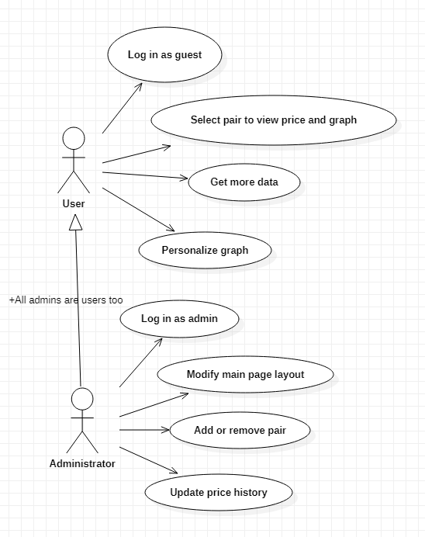

System architecture
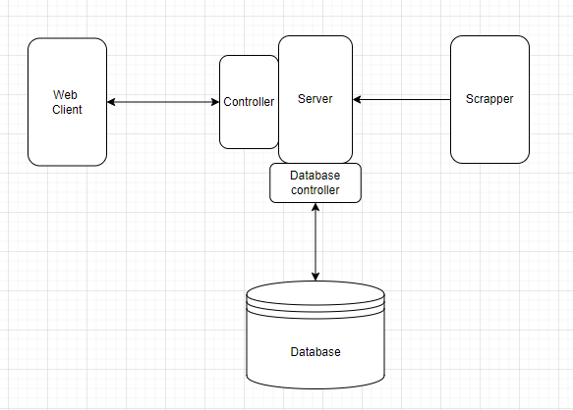

Class diagram
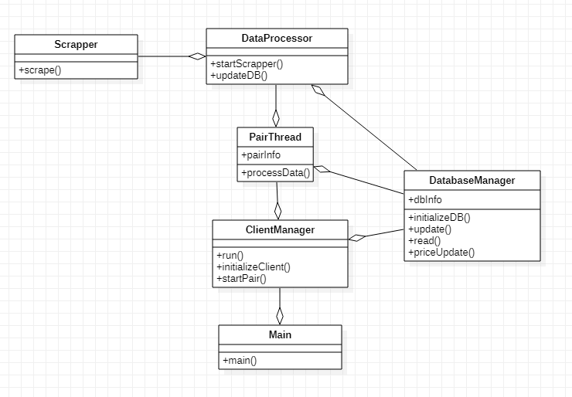

Object Diagram
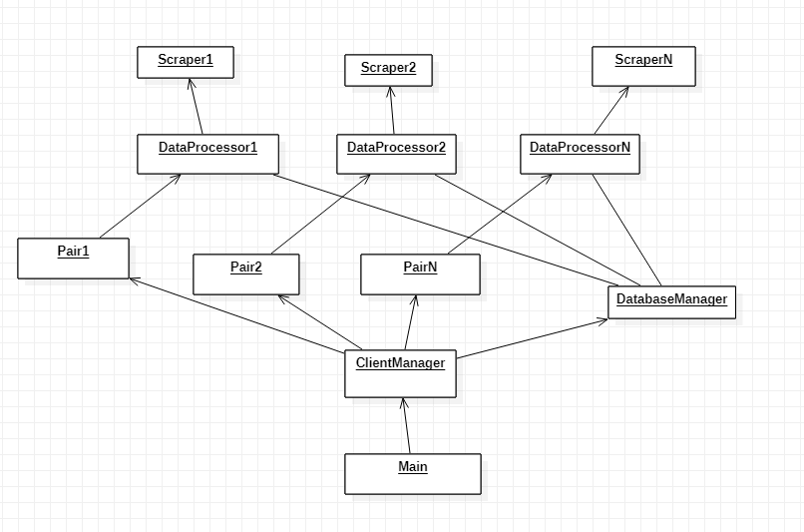

Flowchart
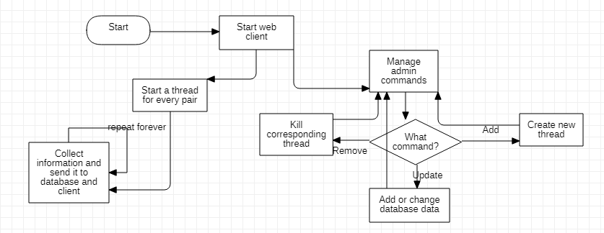

Sequence diagram
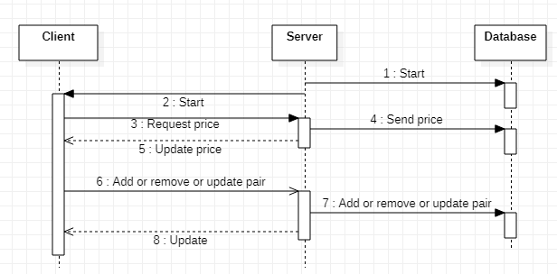

Activity
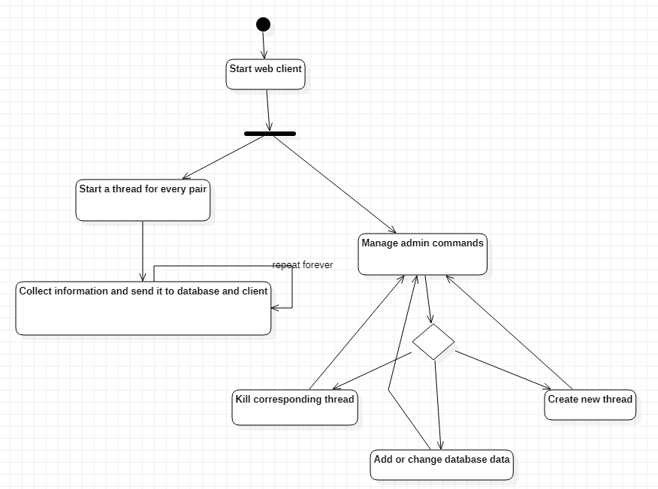

State transition
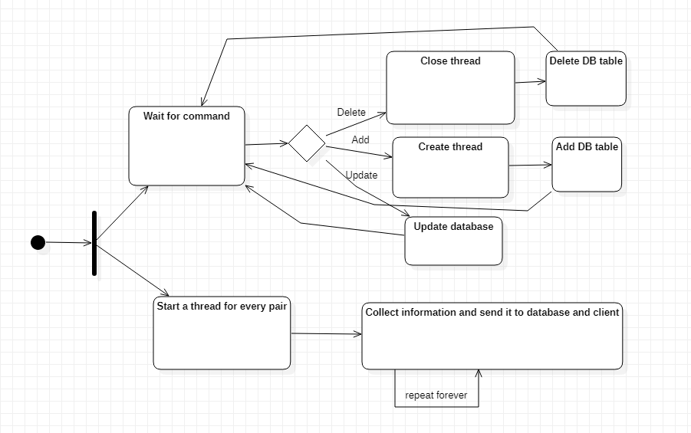

Communication
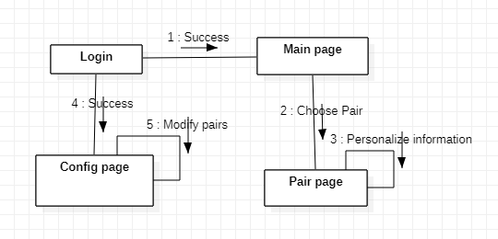

Package
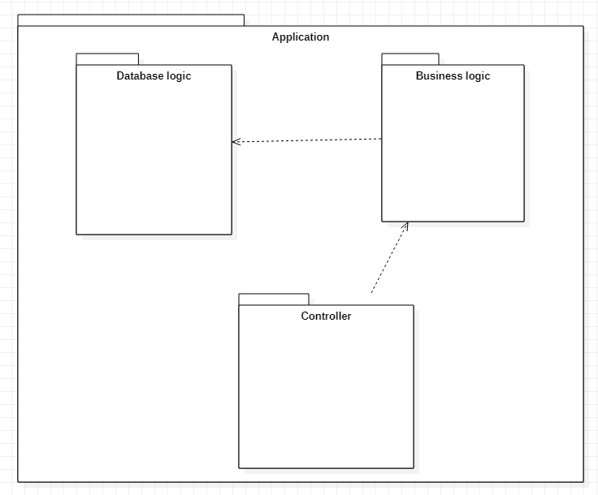

Deployment

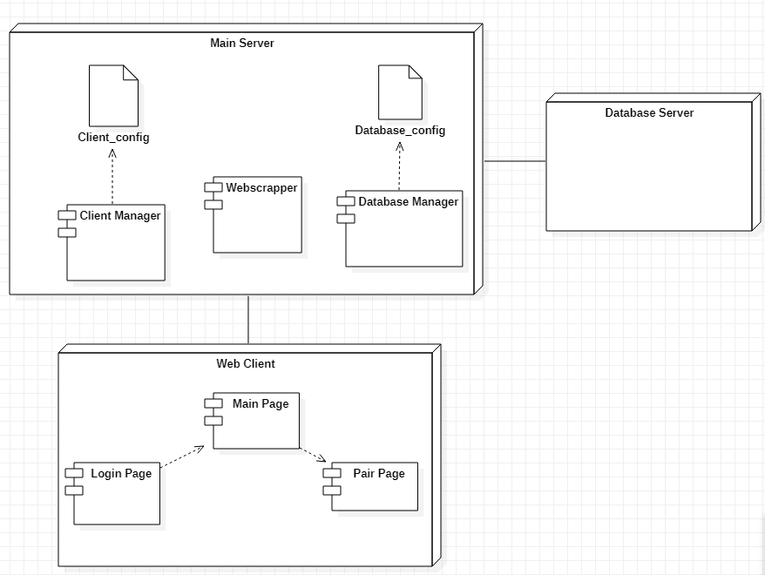

Database
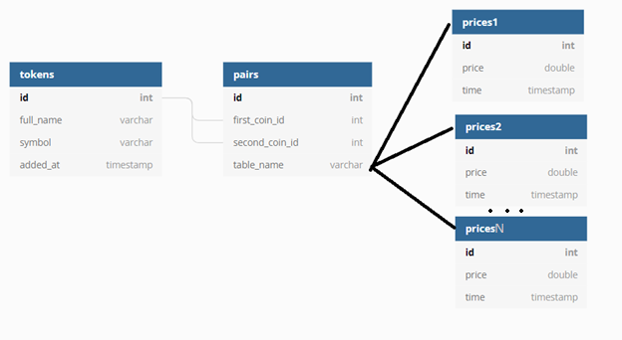

- Operation Mode (Interactivity presentation) + screen shots (UI design)

There are 4 pages in total (kind of), out of which one of them is a template reused multiple times to display different pages. The clients have access to only 3 of them, while the admins also have access to an additional one.

The Login page – a simple login page with username and password fields. This is required only for administrators, normal users will have an option to visit as guests, which doesn’t require an account.

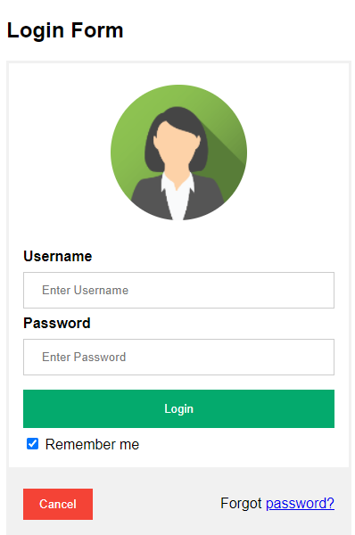

The main page –it mainly contains a list or table of tracked token pairs with brief information, from which you can access their own pages.

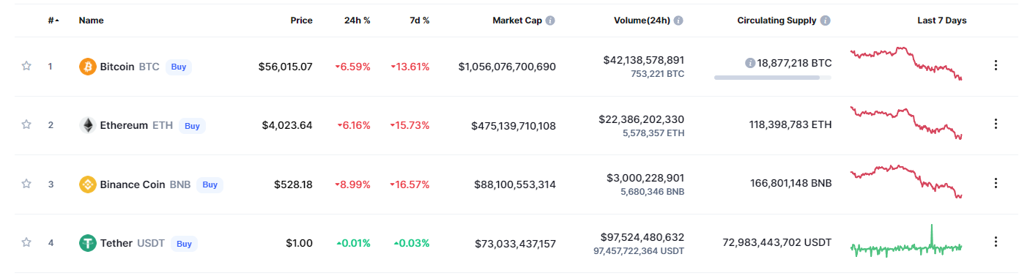

The token pair page – this is the page where you can see detailed information about a pair, and the price history chart. Every pair has it’s own version of this page. Addittionally to the example picture, it will also have textboxes, checkboxes, buttons and other inputs that will allow to get detailed personalised information on the pair.

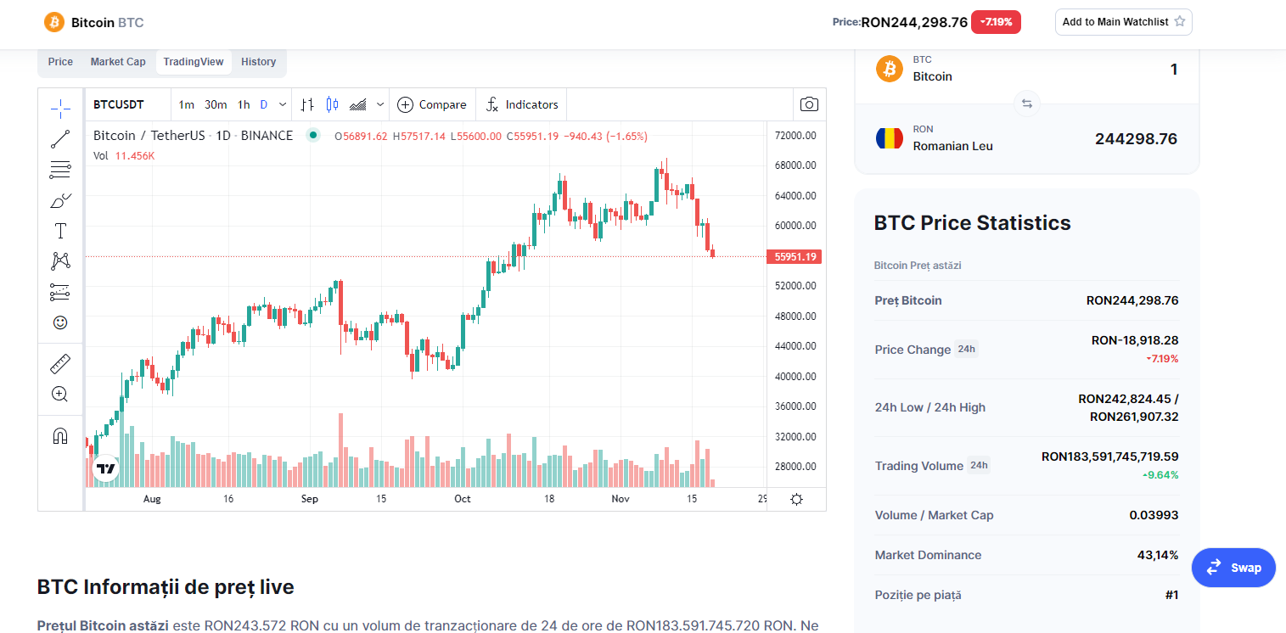

The admin/configuration page – the page where the admins can send commands to the server. From here they can add or remove tokens to the tracked list, or import/update price histories for tracked pairs. Addittionally, they can change the layout of the other pages, but these are only cosmetical changes.

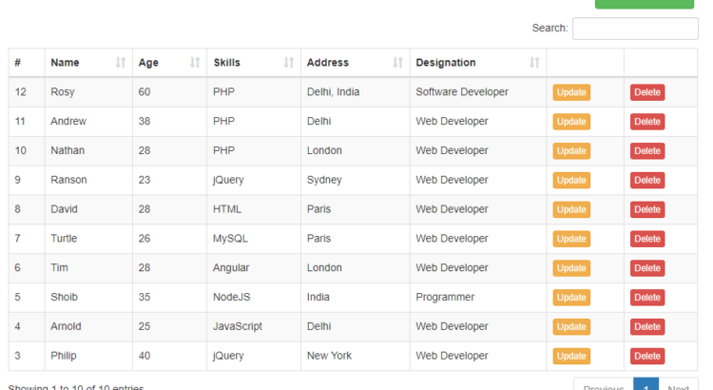

- Portability

Web application for the users (so no client) that gets data from the server. Usable by any device with an internet connection, on any device capable of running a browser (a normal browser).
The server’s portability may be a bit more limited, however, (apart from this being a small problem) most devices that run on Windows or Linux and are able to install and use python 3 are good. For the moment, I am not planning on packing the server into a full application, making it somewhat more portable, but only through the direct transfer of the source files/code, something that you would want to do in the case of servers anyway.
The database is local, so same story as the server.

- Competing software

Countless websites that provide graphs and past (or live) prices for Dex crypto. Anything from coinmarketcap, coingeko to binance, revolut and all the way to pancakeswap, poocoin.
It is not about the competition, which track a very broad range of pairs and sacrifices speed, it is about the small-scale, focused approach which is guaranteed to be faster and more precise, but useful only to a select few.

