This readme document is for the code exercise submission by Anne DiSciullo.

Once the code is downloaded and imported (to either Eclipse or IntelliJ), it should look like this:

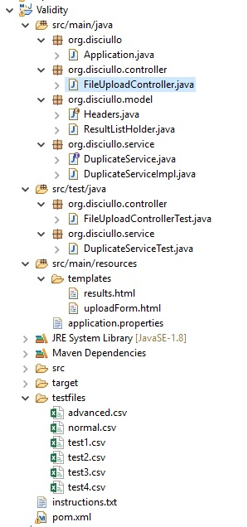

I used SpringBoot with ThymeLeaf to display the results. I was not sure exactly how to meet the requirement for the JSON object, so I created two outputs. One that looks like this:

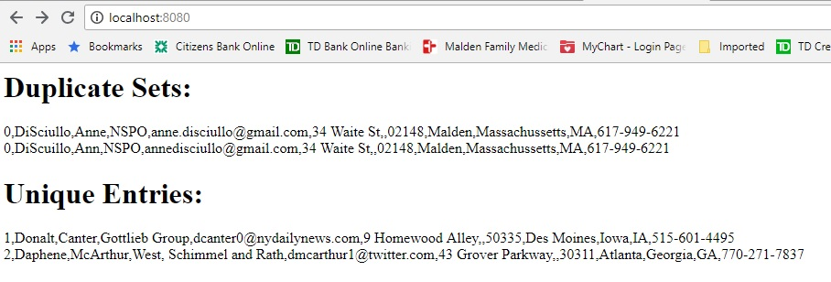

And the other like this:

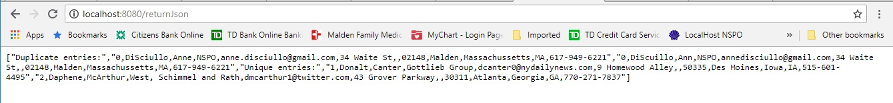

To Build and Run

Prerequisite: you need to have maven installed.

* Open a command window or PowerShell at the location of the project.
* To get the dependencies, run:
  + mvn dependency:tree
* To run:
  + mvn spring-boot:run
* To build a jar:
  + mvn package
* To run the jar, in folder where jar has been placed, run:
  + java -jar AnneDiSciullo-ValidityExercise-0.0.1-SNAPSHOT
* Go to the browser of your choice and type “localhost:8080” and you should see this:
  + 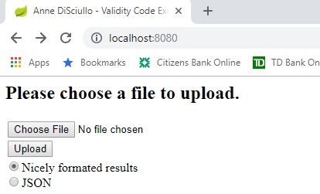
* Once you have selected a file to process, you should see the name of the file shown next to the “Choose File” button.
  + 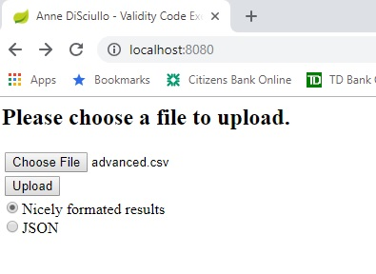
* Select the radio button for the type of display you would like, then click “Upload".