Database Assignment

 | Name: |  | Adish Jain
 | Email ID: | adish.jain@tothenew.com
1. | Create Database
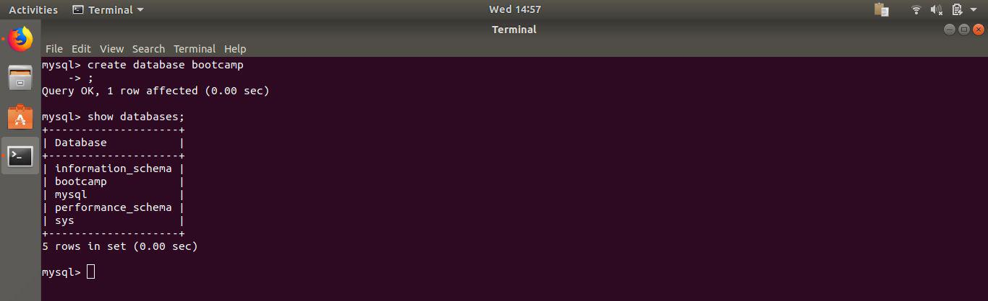

- Design Schema
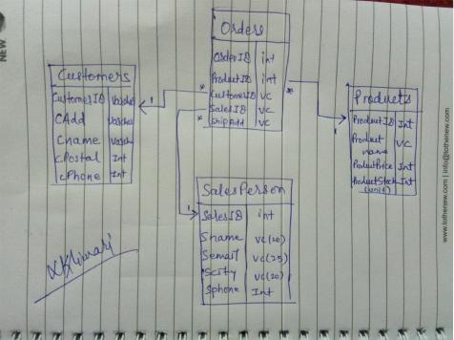
- Create tables

Customer table
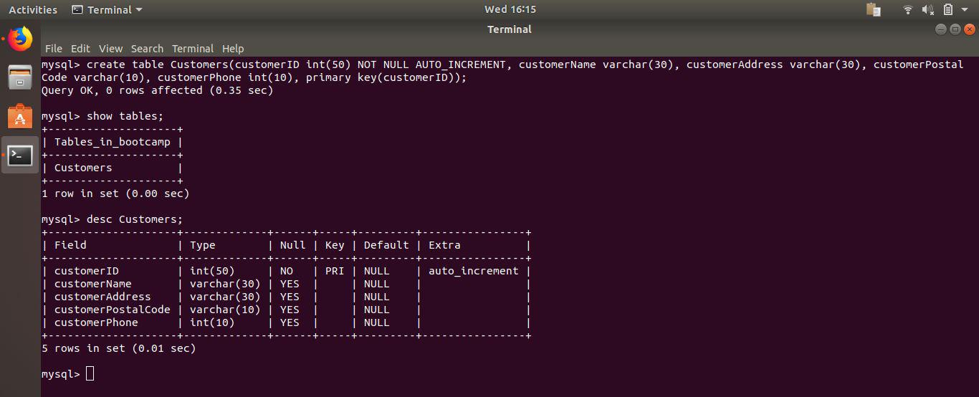

SalesPerson table
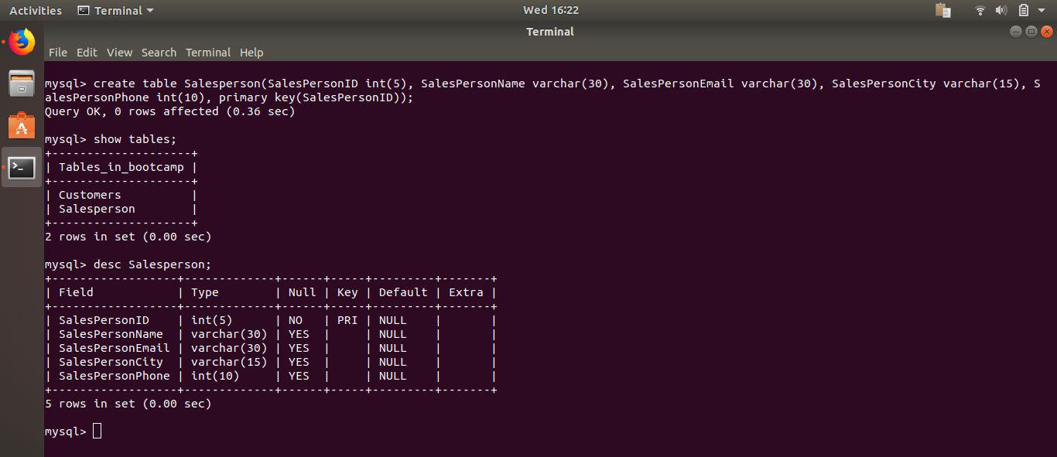
Product table
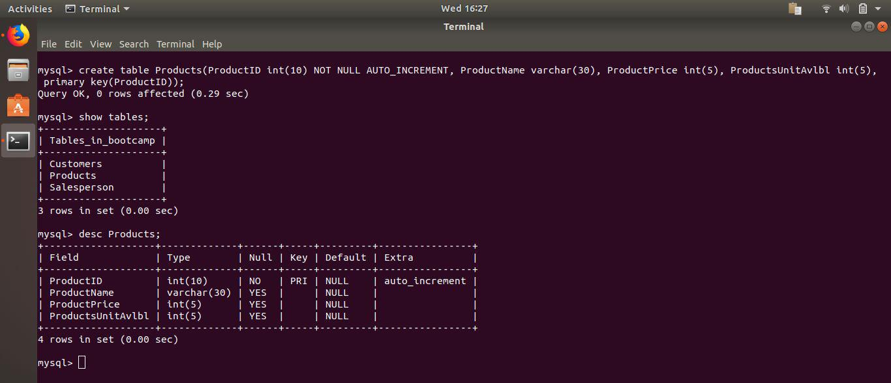

Order table
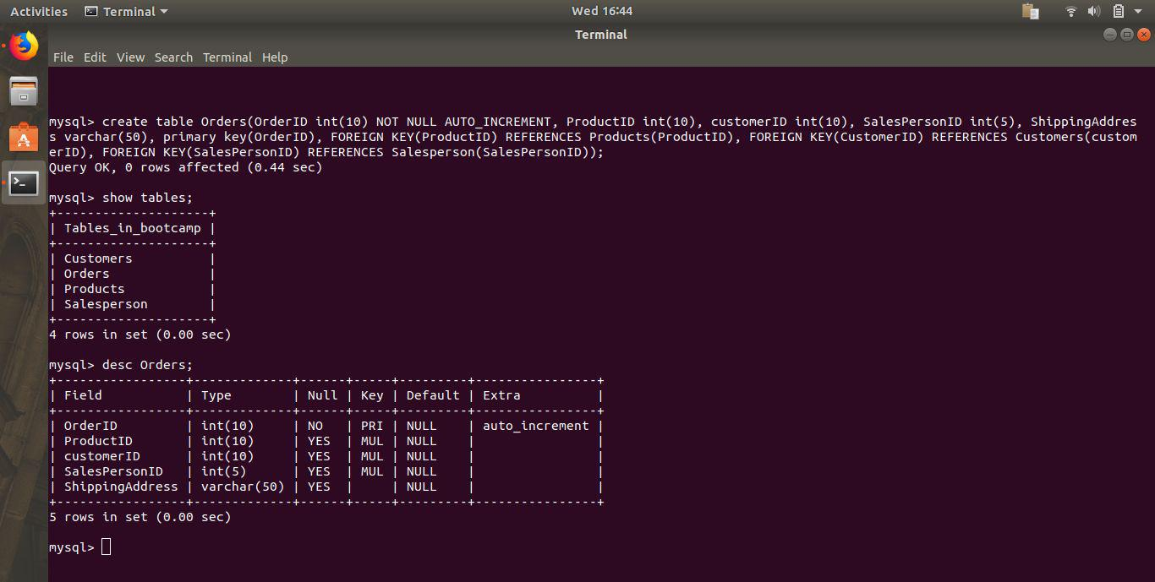
- Insert sample data
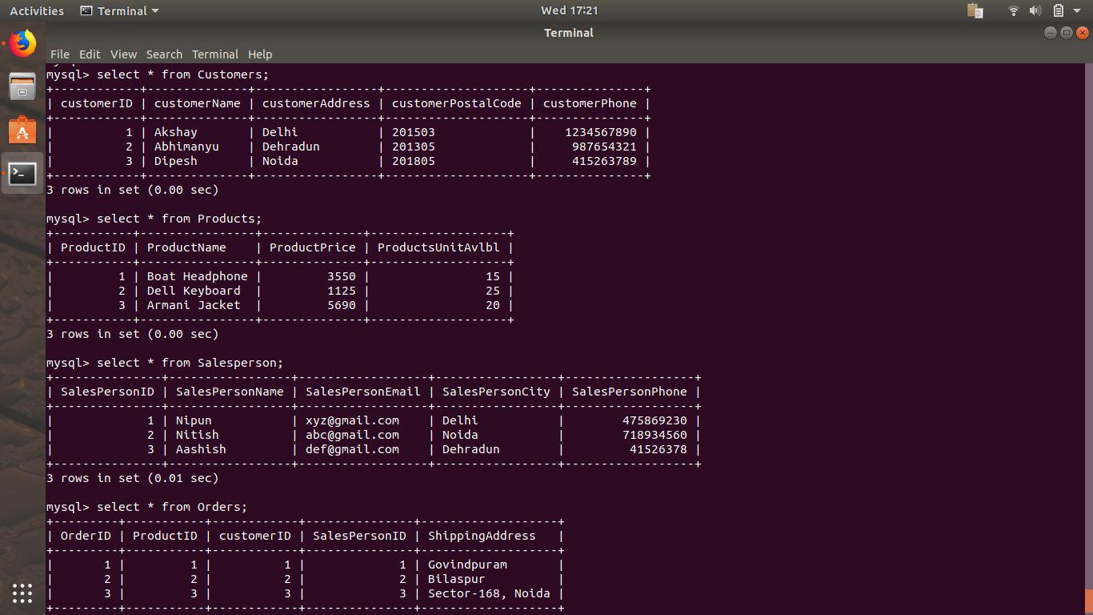

- Find the sales person have multiple orders.
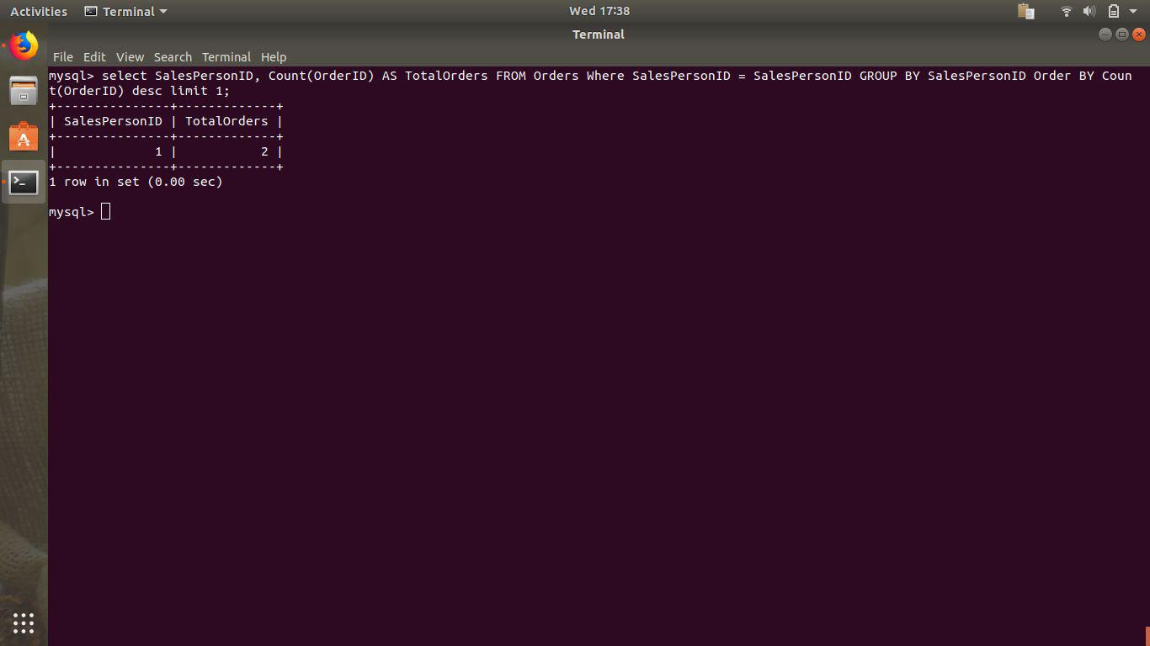
- Find the all sales person details along with order details.
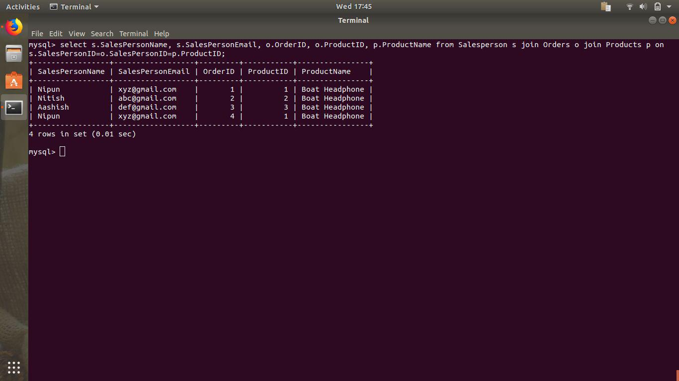

- Create index.
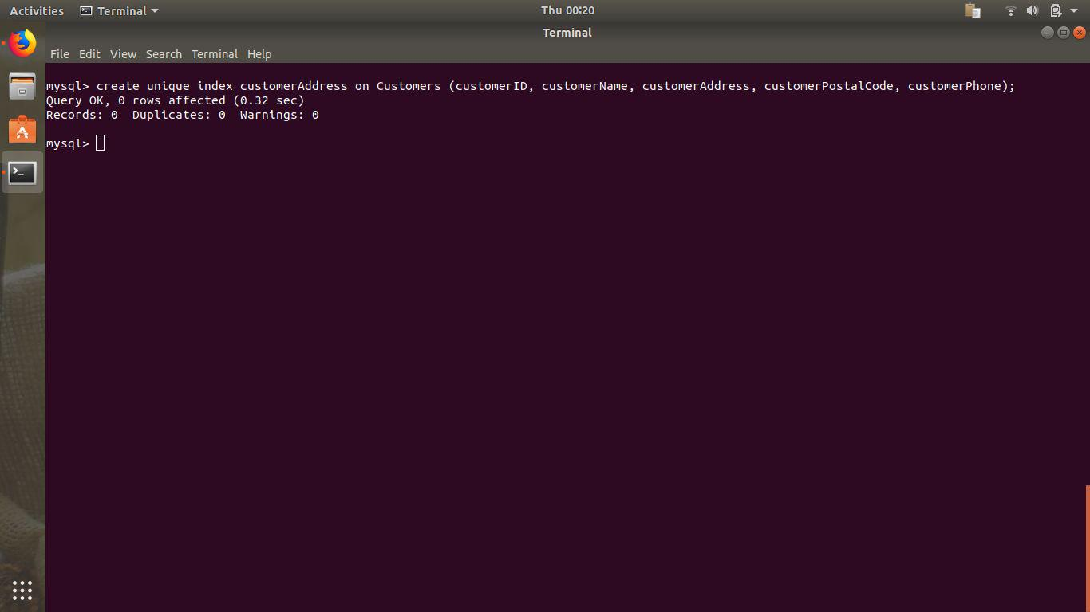
- How to show index on a table.
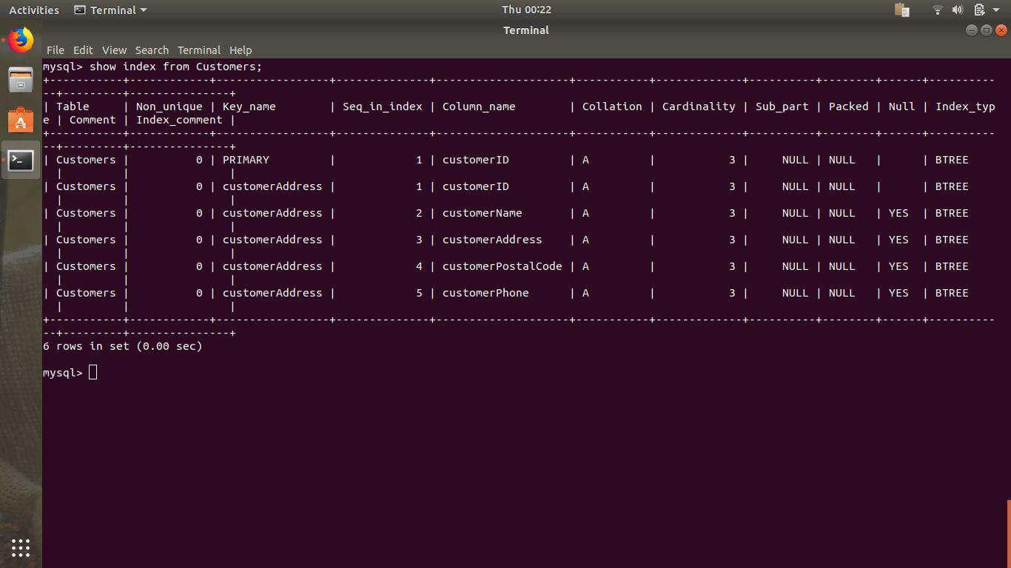

- Find the order number, sales person name, along with the customer to whom that order belongs to.
