**AN INTRODUCTION TO ALL SECTIONS WITH PICTURES**

**1. LITERARY SECTION**

The world is full of people, and they can be segregated in groups of two, the dreamers and the followers. For those who dare to dream, imagination acts as the flying carpet that takes them through their kingdom of fantasy. The Literary section of Pratibimb gives you a small view of the vast ideas of some of the dreamers. So sit back, relax, AND wander through someone’s paradise and explore life through their kaleidoscope.

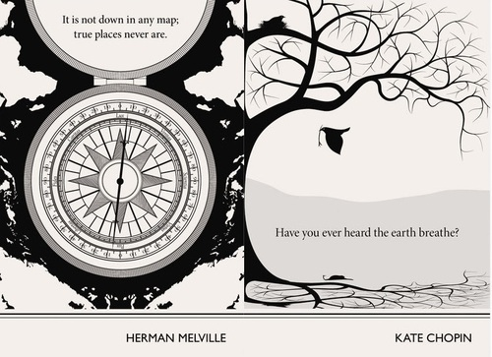

**2. MANAGERIAL SECTION**

As Paul Hawken once said, good management is the art of making problems so interesting and their solutions so constructive that everyone wants to get to work and deal with them. The Managerial Section of Pratibimb gives you a glimpse into what our audience thinks is effective management, what challenges does this sphere pose and the current scenario of this ever changing world.



**3. TECH SECTION**

Over many years, human life has gradually been transformed by technology and our dependence as well as fascination for all things technical has increased at an exponential rate. This has plunged us into an era of technology making our lives simple, our work more effective and raising our creativity to a scale unimaginable before. The Tech Section shows that insight into this world is both a necessity and a thing of passion, intrigue and excitement for the masses. We have endeavoured to bring you a culmination of beautifully pieced together articles from the world of cyber security to money pads to gaming.



**4. WOMEN-IN-ENGINEERING SECTION**

The WIE section aims to capture the essence of engineering with both men and women working collectively to innovate for the benefit of humanity. Women-in-Engineering, an affinity group of IEEE, paves the path for girls to take up a career in the field of technology and enlightens them about the future prospects.



**5. POPULAR SCIENCE**

Popular Science is an amalgamation of every sphere of science and technology. Cyborgs, Black Holes, Drones, Nanotechnology, Oculus Rift, it is all Popular Science. This section contains contributions from our readers on various attractive topics in this field, making it very interesting for the editors to compile.

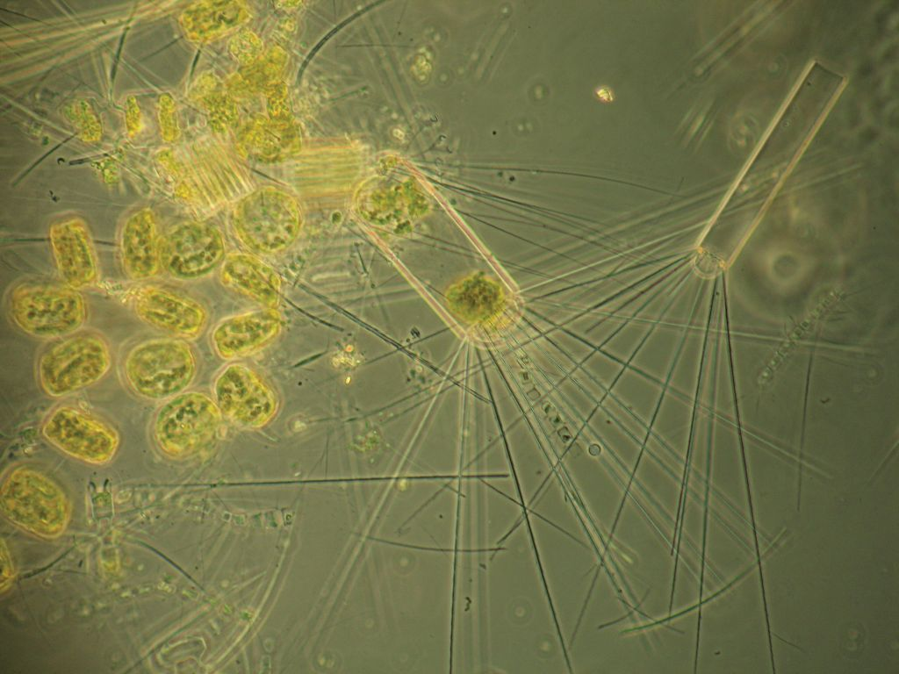

**6. VIVE LE HESITATION**

This most unique section of Pratibimb encourages its contributors to voice their opinions, whatever may be the topic, whatever may be their opinion. A voice is worth it, it’s always worth it. So, speak up and let your thoughts take flight!

