MUMBAI DABBAWALS

-By Samridhi Jain,2nd year, SRCC

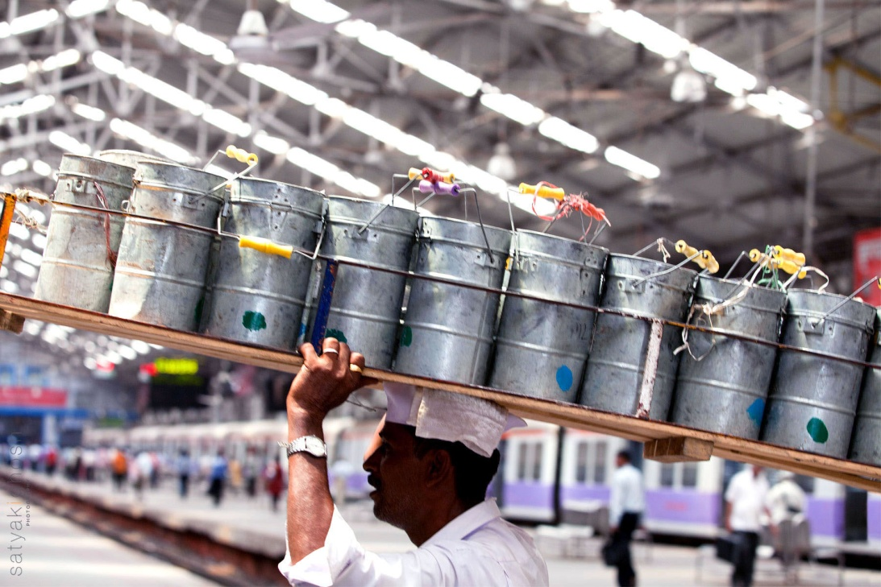

Clad in their traditional outfits and Gandhi caps, the 5000 or so dabbawalas in Mumbai transport around 2,00,000 lunchboxes through the city on every working day. That means conducting of 4,00,000 transactions in six hours each day, six days a week, 52 weeks a year.

The dabbawalas have been in business for around 100 years. These dabbawalas basically carry lunchboxes from their customers’ homes to their offices and return the boxes to their homes after the lunch hour. But why are their services required ? The reason is the crowded local trains of Mumbai which make it difficult to carry lunchboxes in the rush hour. So the dabbawalas carry their lunchboxes for them after the morning rush hour so that people can enjoy homemade food without worrying about carrying the lunchboxes to and fro their workplaces.

The management system of the Mumbai dabbawalas has been a topic for study for last few years. How these scarcely literate people have such an efficient delivery system that they have been awarded the Six Sigma certificate has been a topic on which various research papers, articles, books have been written. Their business practices are included in a subject in Graduate School of Journalism at University of California, Berkeley. They have been invited for lectures by IIM (Ahemedabad), IIM ( Lucknow), Chartered Accountants Chapter (Dubai) and Confederation of Indian Industries (CII) Conferences. They have a documentary made on their work by the Carnegie Mellon Professor Paul Goodman and a Harvard Business School Case Study.

**Structure**

To perform their work most efficiently, the dabbawalas have organized themselves into roughly 200 units of about 25 people each. These small groups have local autonomy. Such a flat organizational structure is perfectly suited to providing a low-cost delivery service.

**Process**

On any given day, a dabba changes hands several times. In the morning a worker picks it up from the customer’s home and takes it (along with other dabbas) to the nearest train station, where it is sorted according to its destination. It is then taken by train to the station closest to its destination. There it is sorted again and assigned to another worker, who delivers it to the right office before lunchtime. In the afternoon the process runs in reverse.The dabbas have basic codes indicating the neighborhood where the lunchbox needs to be delivered, the person who will make the delivery and the building and floor

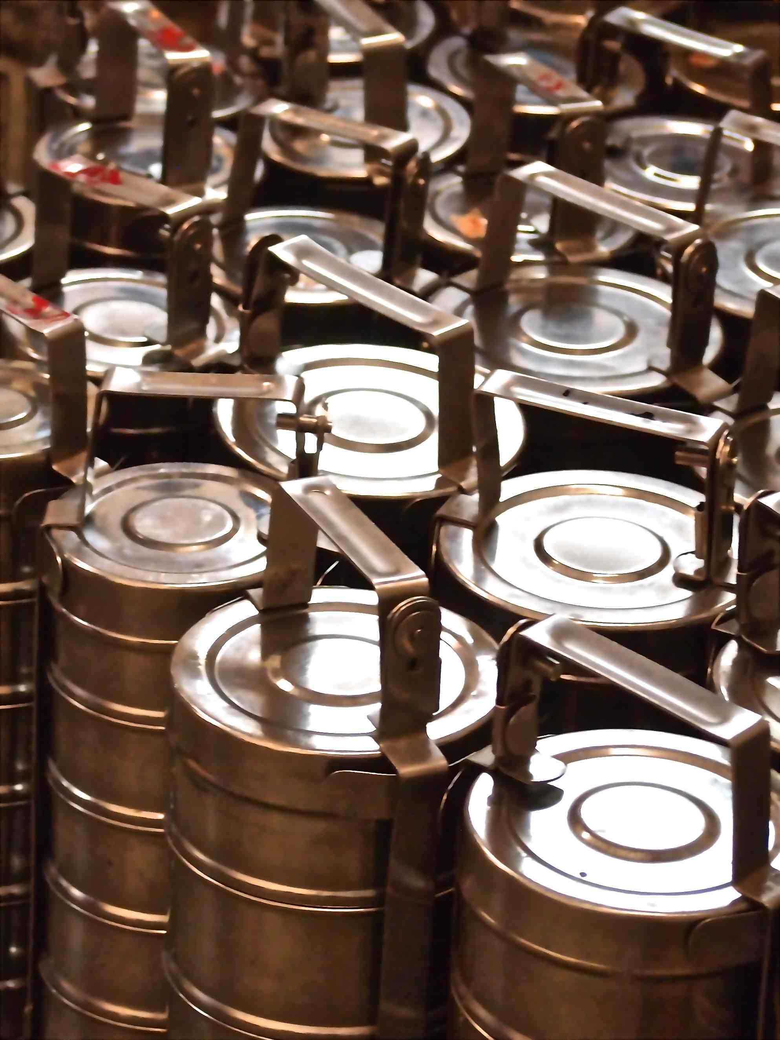

**Management**

The dabbawalas essentially manage themselves with respect to hiring, logistics, customer acquisition and retention, and conflict resolution.

When someone wants to join a local dabbawala group, the group will assess whether there’s enough demand to add another person. New hires are trained on the job by the group. They learn to assist in all activities. After a probation period of six months, they can buy into the business with a sum equal to 10 times their expected monthly income. So, for example, if a new hire expects to make 7,000 rupees a month at a particular unit, then he would need 70,000 rupees to become an equity partner who would share in the profits.

Workers with more than 10 years of experience serve as supervisors, or muqaddams. Every group has one or more muqaddams, who supervise the coding, sorting, and loading and unloading of dabbas and are responsible for resolving disputes, overseeing collections, and troubleshooting. They also pick up and deliver dabbas themselves. Members elect representatives from among the muqaddams to serve on two managing committees that meet monthly to tackle operational and organizational issues as well as problems that cannot be resolved at the local level.

The dabbawalas’ success is proof that with the right system in place, ordinary workers can achieve extraordinary results. Many lessons can be learned by the future managers from the overall management system of the dabbbawalas which works with one simple goal: **delivering food on time, every time.**