MY STORY

-By Hemangini Malhotra, BVCOE

So, after clearing all the hurdles of being a science student, clearing the entrances and finally getting into a reputed college, I thought it's finally over! Yes, the feeling of accomplishment was just coming. See? All that was worth it, I can sense the freedom in me. Now, I can do whatever I want, I am not supposed to attend the classes, I can have fun, and score well too. I had always thought that I would want to write articles, express myself, play badminton, sing and the endless list of hobbies made me happier because I thought now is the time. With all those hopes of getting out of the two year old nerdi-ness, as I entered the college, people came in telling me that now that you are in college, you have to focus on your career, as this is the stepping stone to the ladder of success. You need to join the societies, work there to enhance your skills, learn both on a technical as well as personal front, and score well, because that's how you are going to get a good company to hire you. But, it's going to be better they said, you will have fun in college, they said. Studies are much easier here, they said. Well, I believed in probably everything at the time. But, as it is well said, "You can't have your cake and eat it too". Slowly, I got enrolled in a few societies, thinking that hobbies are important but so is my placement. I started to miss my classes thinking that studies are not that of a big deal. I met new people and made new friends. Surely I learned a lot. This is fun!

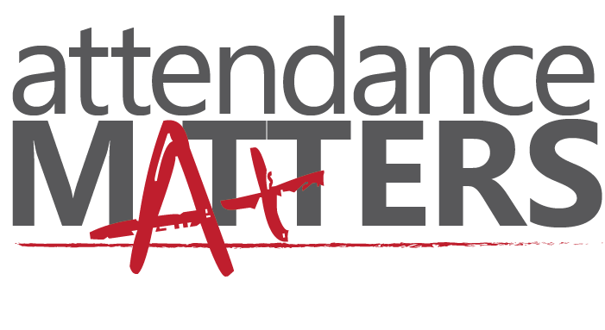

Then, one day I saw the notice board had a detention list (I swear, I had never heard of it. I didn’t even know that such things exist). To my surprise, I saw my name in it. Okay, so I realized after a while that aside from everything I missed, there was just another word that scared the hell out of people. ATTENDANCE! What was even worse, they were going to call my parents, and let them know about the same. Now that was so rude! I mean whatever happened to us being adults? Why didn’t I know about this before? Okay, I started to lose my mind. I wasn't sure what to do. So I went over to the teachers. With a little bit of sweet-talk; they gave me an alternate way of skipping the detention. I was supposed to attend all the classes, even the tutorials, the labs! Woah, that was just too much for me to take. Anyways, after attending all the lectures and pathetic tutorials to cover my attendance, I realized it’s time to balance things. I didn’t want to miss on the fun stuff you see!

So, usually the obvious step is to probably make a timetable. Since, I am in college, by now I was familiar with the fact that timetables are meant to be broken. Seriously, Come on. We don't even follow the college timetable. How can you expect anyone to follow the one made by themselves. So, firstly I made up my mind to do the work for a society only when I have a free lecture. I did attend all the important classes. I set my priorities on the basis of the deadlines I was given. In the start, all this made me crazy! But, I had to do it. After sometime, I saw that things have finally started to fall into place. It got a bit monotonous too. So, I wanted to fit-in my hobbies as they are the best ways to rejuvenate.



The sports week was approaching, and the notice board had it written all over. I saw the badminton trials notice, I just couldn't stop myself. I got selected in the round 1, that kind of made me happy, then the round 2, 3 , and so on!(there were 90+ registrations, so..).Thankfully, we were given an O.D. (On Duty), so that turned out well. Of course, I won (This is my article, what do you expect me to write?). The true sense of accomplishment came when I realized, that I was able to play badminton, complete the society work, attend my lectures, complete the cursed file work. So basically, it probably took me a semester to realize how to manage things. The only key is to take things slowly, and fit them in. And the proof is, after everything, I have had this time to write an article. So just take things as they come, and judge them whether what priority they deserve, all that will do the deed! Have fun, because, well, practically IT'S NEVER OVER! You will always have a lot on your plate. But, you will be a true winner only when you have fun, relax and learn! It's all about how you take it. It's all about the perspective, because stressing over everything is not going to help. You sure as hell don't want to waste your time to plan in how to get things done, rather than doing them now and save the rest of the time to go on a spree! Good luck.