The big time evil against time management: PROCRASTINATION

-By shreshtha jain, eee 2nd year,bvcoe



Procrastination. The word sounds heavy right? But this is a very common problem we are facing today. Google defines [**Procrastination**](http://www.procrastination-definition.com/) as the practice of carrying out less urgent tasks in preference to more urgent ones, or doing more pleasurable things in place of less pleasurable ones, and thus putting off impending tasks to a later time, sometimes to the "last minute" before the [deadline](http://en.wikipedia.org/wiki/Time_limit). In simpler words, “Delaying”. Even after knowing the importance of the work that we have to do and also that it cannot be ignored, if we leave it for tomorrow we procrastinate. Every procrastinator has his own reason to delay the work. Some say that they work better under pressure or simply that they are just too lazy. Procrastination is not just a time management problem it is also a psychological one. It also leads to many health problems related to immune system like frequent flu and cold. And it is quite obvious that a procrastinator can never work well in a team because their responsibility usually shifts to the other member burdening him and making them resentful of him. So if you are procrastinating, start working on ways to stop it. Take the very first step, accept the fact that you are procrastinating. For example, if you are taking up less important task instead of an important one or just waiting for the right mood to do the work. But remember delaying unimportant work is not procrastinating. After that, find out why are you procrastinating? Is it the task which is just too boring or are you unorganised?

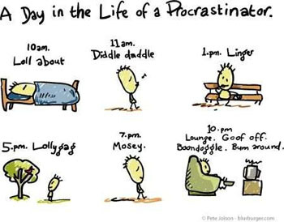

Whatever the reason may be, find a solution. If the work is boring then do it early, complete it fast and get over it. A basic problem with the people delaying their work is that they fool themselves by finding different reasons to do the same. Stop doing this. Instead motivate yourself to do the work in time. Like you can reward yourself if you complete a particular task without delaying it. Or ask your best friend to keep a check on you. It really works! Organise yourself, make a to-do list, set up your time bound goals and don’t hover over everything. Instead, stick to one work at a time. Stop estimating how unpleasant the work could be just go and give it a shot, and who knows? You may enjoy it. And then the most important point, while taking crucial decision don’t be afraid of making the wrong choices. Take up decisions, be confident and have faith in yourself.