** Events by BVPIEEE **

**ROBO SOCCER**

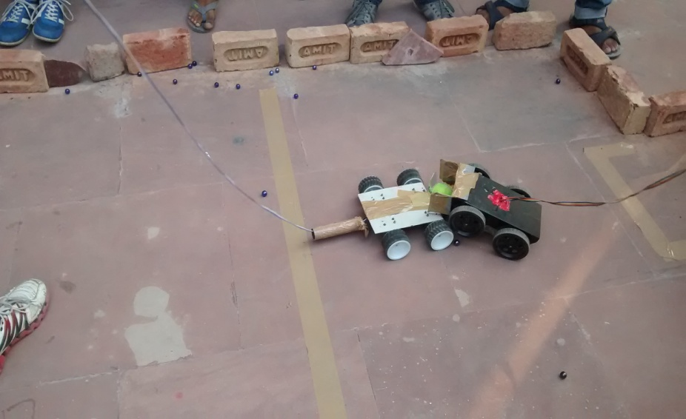

Robo Soccer was organized by BVPIEEE as a part of BVEST'14, technical fest  
of BVCOE on 28 October, 2014. There were 3 rounds in the event. Team with  
highest number of goals in given duration of time had been declared as  
qualified for next round and ultimately the winners. Total 12 teams were  
registered for the event.

Faculty Coordinator : Prof. Abhishek Gagneja  
Student Event Mangers : Mr. Aman Garg, Mr. Anshul Sharma  
Student Event Coordinators : Mr. Shubham Chugh, Mr. Amit Kushwaha  
1st Prize Winner : Mr. Kunwar Deepak, Mr. Nakul Garg (BVCOE)  
2nd Prize Winner :  Mr. Gaurav Sharma (Lingayas University ),  
                  Mr. Mandeep Deshwal (LU), Mr. Gaurav Negi (LU),

Mr. Ritesh Pal(LU), Mr. Intizar Khan( Echelon institutions)

**ROBO WARS**

ROBO WARS held during BVEST 2014 in basketball court was one interesting event. Although the participation were only three but as soon as the competition started the crowd gathered around the court to watch the robots tear each other apart. The crowd started hooting as the robots hustled and tried to throw each other out of the arena. Two of the participants ended up quitting the competition because of the heat of the competition and the fear of their robots being destroyed. It was surely one of the best robotics competition of BVEST 2014.

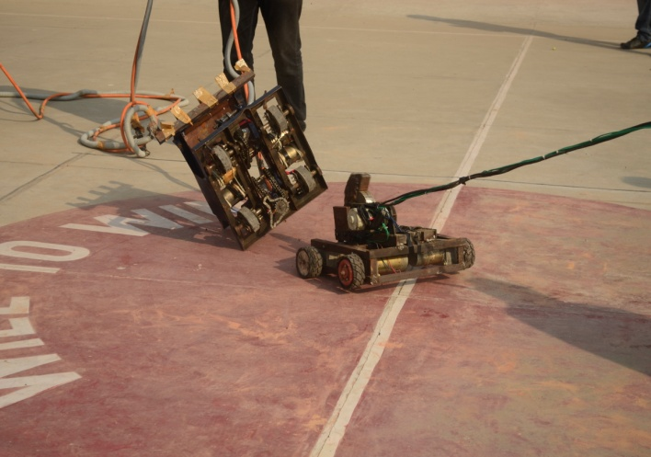

Faculty Coordinator : Prof. Abhishek Gagneja  
Student Event Mangers : Mr. Rishabh Goyal, Mr. Deepak Verma, Mr.Ruccmenya  
Student Event Coordinators : Mr. Sushant Lodhi, Mr. Aakash Kashyap  
1st Prize Winner : Mr. Gaurav Sharma (LU), Mr. Mandeep Deshwal (LU),

Mr.Gaurav Negi (LU),Mr.Ritesh Pal (LU),Mr.Intizar Khan(LU)

Mr.Mohit Pradnani, Mr.Amit Kumar Singh, Mr. Nishant Sharma, Mr.Shivaik Sehgal, Mr.Shivam Gupta

2nd Prize Winner :

**Think On Your Feet**

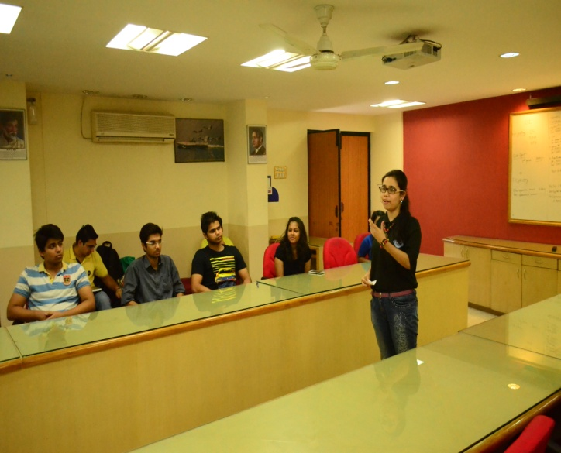

Think on your feet was organized by BVPIEEE as a part of BVEST'14, technical fest  
of BVCOE on 29 October, 2014. Think on your feet is an extempore event where a person is given a specific topic. Then he/ she had to speak for one minute on the given topic.

Faculty Coordinator : Prof. Abhishek Gagneja  
Student Event Mangers : Mr. Shrey Bagga, Mr. Divyanshu Sharma  
Student Event Coordinators : Mr. Subhav Duggal, Ms. Shefali Garg  
1st Prize Winner : Ms. Ayushi Grover  
2nd Prize Winner : Ms. Kanika Sharma, Ms. Medha Sharma

**Hack-a-thon**

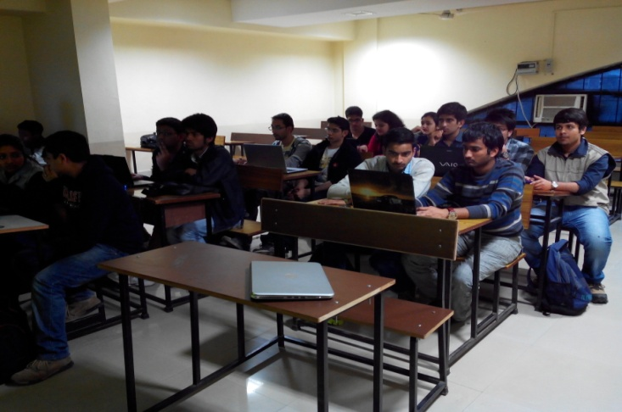

Use your skills to create an app or a website/web based application based on a theme which will be given on the spot. Test your creative minds in this coding marathon. Day 1 will involve 5 hrs of onsite coding. Day 2 will comprise of presenting your work. Coding can also be resumed offline.

Faculty Coordinator : Prof. Varun Srivastava  
Student Event Mangers : Mr. Aditya Dev Sharma, Mr. Kshitij Kaushik  
Student Event Coordinators : Mr. Kunal Sachdeva, Mr. Jayant Gulati, Ms. Vaani,

Mr. Nikhil

1st Prize Winner : Mr. Yogesh Madan

2nd Prize Winner : Tie b/w Mr. Purnank Jain & Ms. Yamini Jain

And Mr. Abhishek Sharma

**AD-MAD**

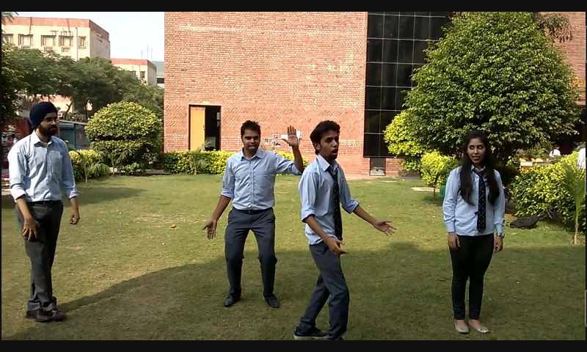

As a part of Bharati Vidyapeeth’s College of Engineering’s annual technical fest, BVEST’14, AD-MAD was one of the fun events that were conducted by BVPIEEE.

It was all about exploring the dimensions of creativity to enact funny, catchy and innovative advertisements to market a given item.

Faculty Coordinator : Prof. Varun Srivastava

Student Event Managers : Ms. Dharvi Verma, Ms. Payal Mangla, Mr. Sarthak Mittal

Student Event Coordinators : Ms. Manju Shah, Ms. Kanika Sharma

Mr.Karandeep Singh, Mr.Parvez Hassan, Mr. Chaitanya Swami, Ms.Vishakha Kaalra

1st Prize Winner :

2nd Prize Winner :

Mr. Shikhar Mittal, Mr. Priyansh Singh, Ms. Arushi Arora