**BVPIEEE at IEEE Delhi Student Congress 2015**

**10-11 January 2015**

**Delhi Technological University**

Execomm members from BVPIEEE represented the student branch at IEEE Delhi Student Congress. It is an initiative by IEEE Delhi Section on the lines of the IEEE All India Student Congress(AISC). The main motive of DSC is to improve networking across student branches within the Delhi section and the student branch of BVCOE took active part throughout the Congress making better interactions with student branches accross Delhi.

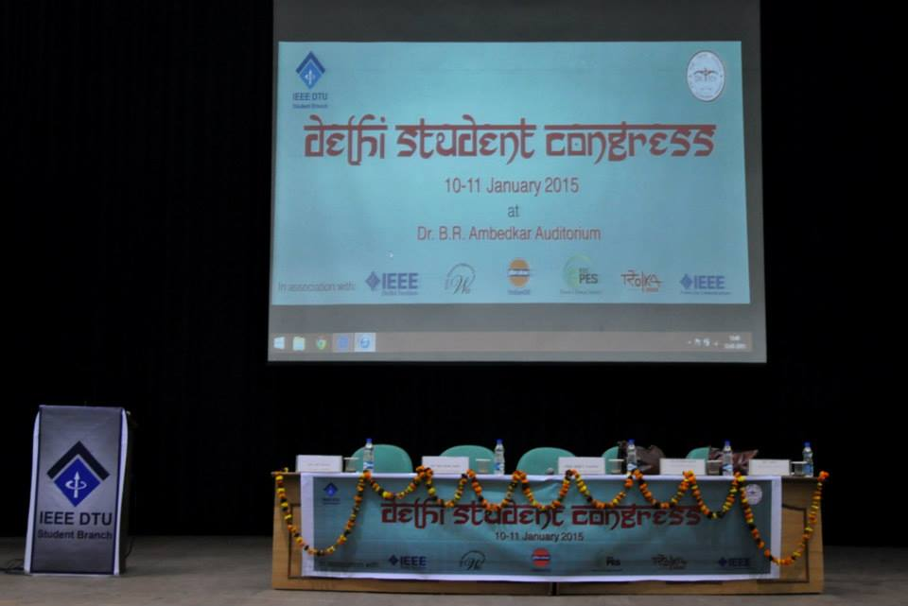

Having previously been hosted by IEEE NSIT Student Branch and IEEE JMI Student Branch at their respective institutions, IEEE DTU Student Branch was given the responsibility of hosting DSC 2015 and BVPIEEE took immense pleasure in congratulating the student branch of IEEEDTU for a good show.

It was an enriching experience for BVPIEEE as the student branch took home new friends; colleagues; lots of knowledge; and industrial exposure. Panel and general discussions among the attendees could make the Delhi Section as a whole aware of the issues with their co-branches in Delhi. It was a platform to discuss issues, share grievances and take steps for implementation of their feasible solutions for betterment of IEEE Delhi Section.

**Day 1, 10 January 2015**

Day-1 of the Congress started with the registrations of the attendees who were each given the congress kits. It was followed by a group activity aimed at improving the interaction of the attendees with people NOT belonging to their own student branches. The participants were distributed into teams and each team was allotted one volunteer. Each team, moderated by their volunteer, played a game called ‘What If?’ which was based on situational questions. Members from BVPIEEE took active part in the interactive activity and proved to be among the most aware student branches of Delhi section.

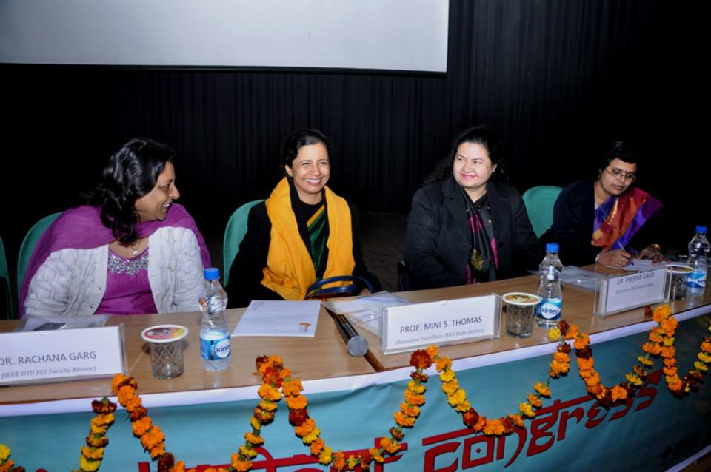

The inauguration ceremony began with lamp lighting, which was followed by welcome address by Dr. S.Indu, the Branch Counselor of the IEEE DTU Student Branch. She talked about the achievements and plans of DTU student branch of IEEE. Dr. Indu was followed by Prof. Mini Shaji Thomas (Executive Vice-Chair, IEEE Delhi Section), the Guest of Honor for the day whotalked about the benefits of being the members of IEEE as students and how to make the best use out of it. Mr. Ravi Batra, Chairperson of the IEEE DTU Student Branch, was the next to address the gathering. He informed the audience about the various events that IEEE DTU organizes round the calendar.This was followed by a short tea break where the attendees were seen interacting amongst themselves so as to improve networking and discuss about their branches and plans. After the tea break, Prof. Mini Thomas presented a keynote on the topic of ‘Smart Cities’- a new concept in modern technically sound societies of the world. The Indian Government has taken the following four important features into account for tagging a city as smart:-

1. Citizens

2. Employment

3. Quality of life

4. Infrastructure

She explained all the above points in detail and concluded her note with a summary of the basic concepts of a smart city. She asked students to contact her freely in case of any queries

The next in line to acknowledge the podium was Dr. Prerna Gaur who talked about the activities of Delhi section and the history and life of IEEE so far. She talked about prominent chapters of Asia Pacific region and mentioned that BVPIEEE is the only student Chapter in Asia Pacific region which has the Honour Society- HKN. (Lambda Eta Chapter). She talked about the SIGs conducted in student branches and also about the affinity group – ‘WIE: Women in Engineering’ and told about the activities held in the various IEEE branches and the student competitions organized by IEEE globally. Dr.Gaur then invited Dr. Rachana Garg  on the stage, who gave a presentation on WIE and PES. She went on about the plus points of being a WIE member and the WIE activities that are organized by different Student branches. Next to take the stage was Ms. Disha Chhabra (Author and DCE/IIM-C Alumni). She talked about making the right choices when it comes to one’s career.She was inspiring and made the attendees introspect into their career goals and decisions.

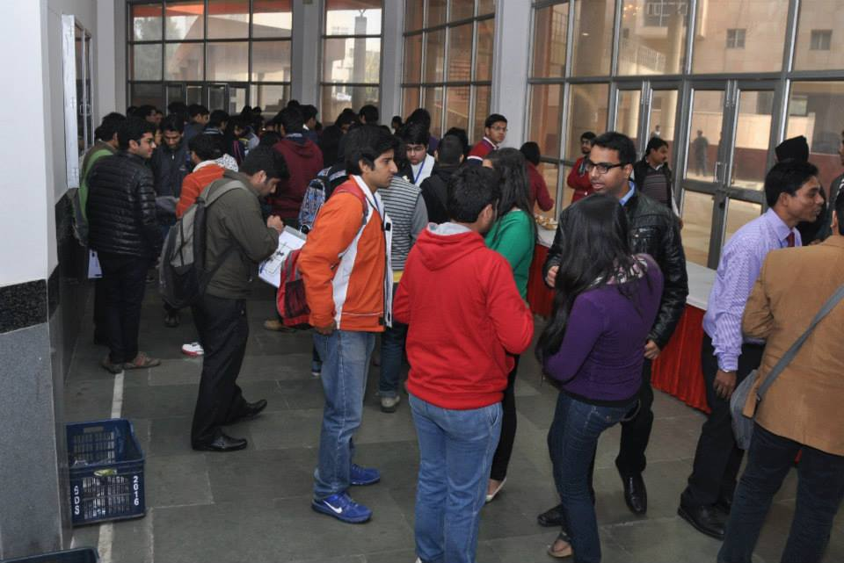

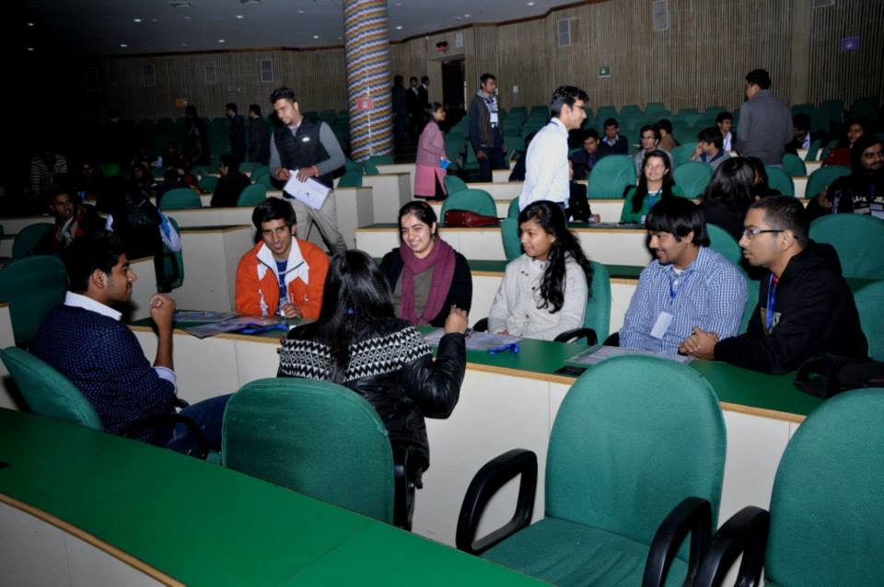

After the inspiring talk, the Congress broke for lunch. Lunch concluded and a group activity was initiated wherein the members were again divided into groups and a volunteer was assigned to each group. A poster making competition was held wherein they were assigned a topic/issue and were given 30 minutes to make the poster to present the same on the stage. All the members of BVPIEEE took active participation in their respective groups and interacted with immense enthusiasm. As the group activity concluded, the UAS – DTU (Unmanned Aerial Systems) team showcased their project along with a video of it onstage. A lot of people appreciated the innovation of the students and huge rounds of applause ensued.The last talk of the day was ‘IEEE Student Branch Administration - Running your Student Branch’; held by the Delhi SAC. The presentation was delivered by Mr. Gitansh Anand, Delhi Section Student Representative.

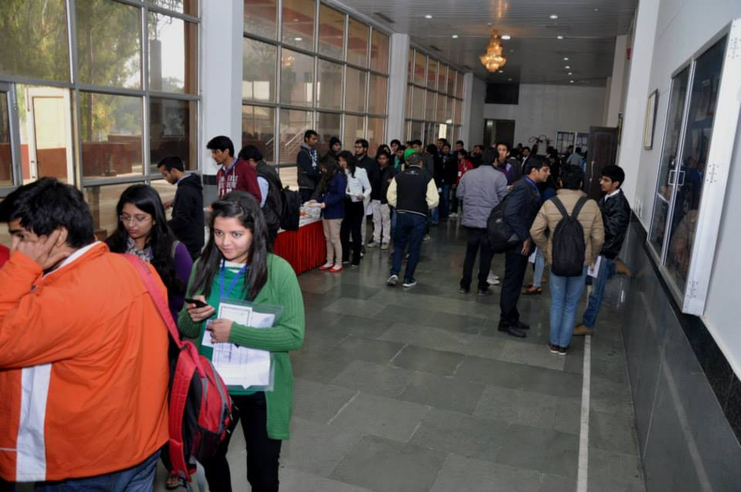

**Day 2, 11 January 2015**

The event commenced at 11:00 am the next day. Dr. Amit Roy, who is currently working with Freescale (India) as the Senior Principal Expert in Low Power Design Methodology and Power Integrity and Signal Integrity group took the participants through his presentation mainly along the lines of algorithmic development of low power design methodology and power/signal integrity of high speed communication interface.

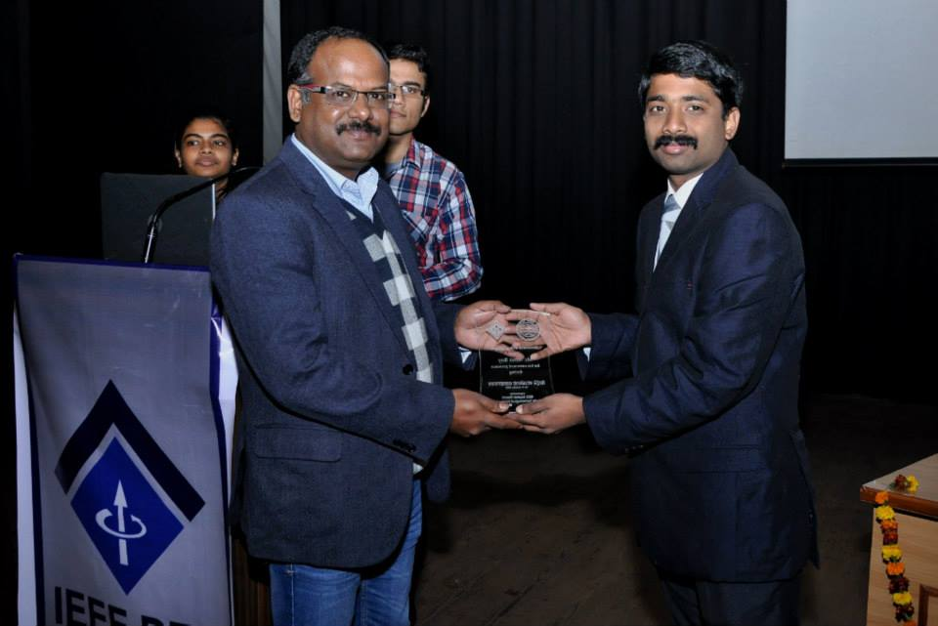

The talk was followed by a tea break where everyone gathered and interacted with each other enthusiastically. After the tea break Mr. Jitin Chawla, co-founder director, Centre for Career Development interacted warmly with all the attendees putting up questions and sharing inspirational stories. Mr. Chawla talked about the key factors including aptitude, personality, creativity and conventionality.Next in line was Mr. Suraj Raman, a city trainer, project head and mentor at Make a Difference (an NGO) talked about how having a privileged background is something that can be shared and how English as a language should be promoted. He encouraged participants to involve in programs for welfare and betterment of the society.

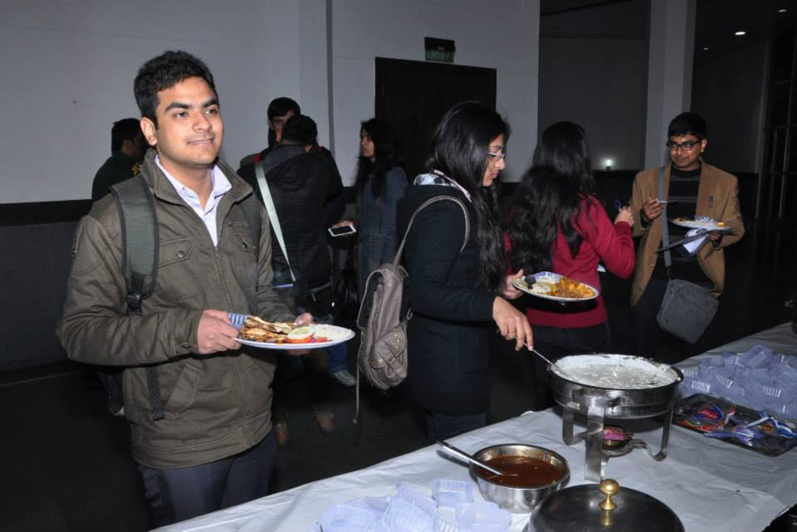

Post lunch, the student branches participated in the SB Presentation competition. Attendees from individual Student Branches were given the opportunity to give presentations at separate stalls to showcase their branch activities and share what they do. BVPIEEE had proudly put up their stall and Arunima Sharma and Priyansh represented the SB via the stall. IEEE-HKN, WIE and the 6 SIGs under BVPIEEE were all represented. The organisers were impressed by the stall as it was simple and sleak.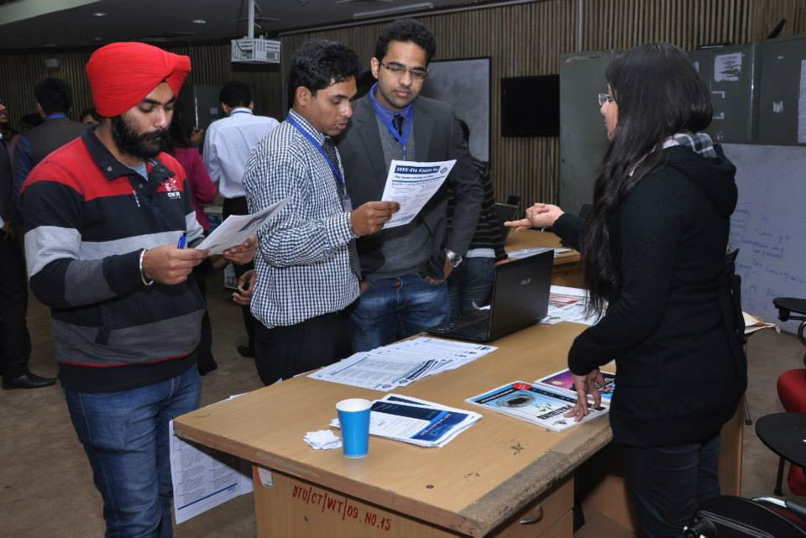

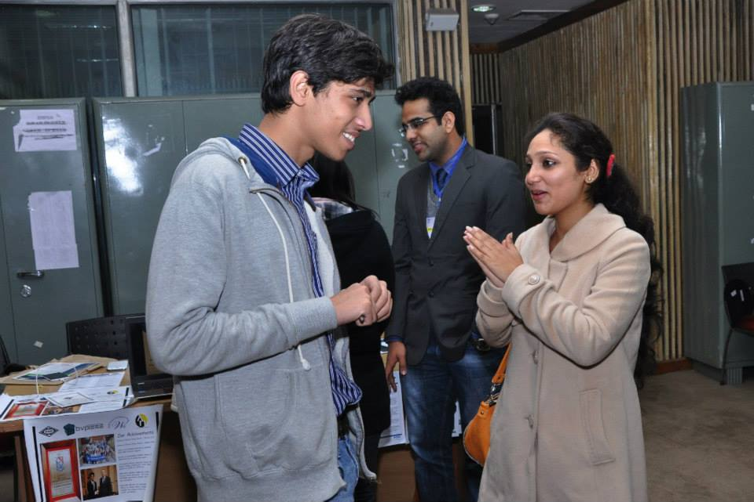

After the SB Presentation Competition, Mr. Kartik Misra, Vice Chairperson, IEEE Young Professionals, IEEE Delhi Section was welcomed. IEEE Young Professionals was started for the transition of students into young professionals and he was given the responsibility for the promotion of IEEE membership amongst fresh graduates and to provide career guidance for students and new graduates. He mainly talked about the development of any person on the whole as a techno manager and insisted on the importance of soft skills