ENTREPRENEURSHIP CELL, BVPIEEE  
MEET 1.0  
  
 - Shrey Bagga

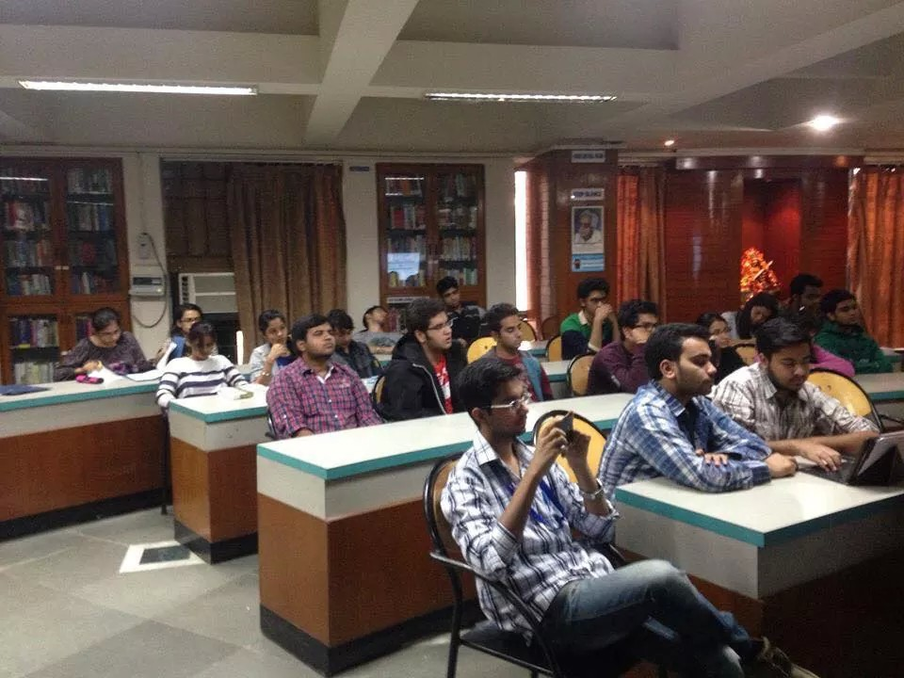

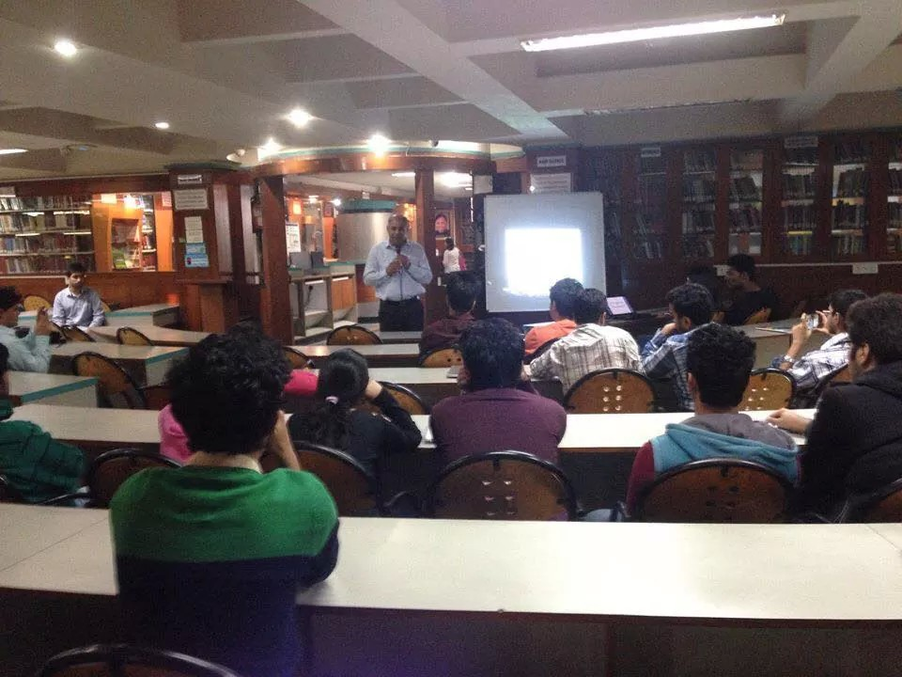

E-CELL, an SIG of BVPIEEE, conducted its first meet of the session on 19th November 2015. Conducted by Shrey Bagga and Ishtia Agghi, the details about the workshop are as follows:

The workshop covered three topics:

1. Basics of Entrepreneurship ( by Shrey Bagga) : where the three basic rules of entrepreneurship were covered.  First, what is your "why" i.e what is your reason for doing something.  Second, being in the present moment and lastly, BIOS ANALYSIS( Beliefs, Improvements , Oppurtunities, Strength )

2. Social Entrepreneurship (by Ravi, Representative of Saviour of the Earth Foundation); he discussed what is social entrepreneurship, how it can be achieved.  He also discussed what their NGO is doing for the same and how they overcame difficulties.

3. Idea Generation (by Gaurav Indra Sir) : He discussed in great detail of how can we bring out our creativity and ideas ; specially by looking in our surroundings.  He threw light on how can we get our ideas patent , also about software patents. We then had a discussion with him on the latest buzz BITCOIN.

Approximate turnout: 40 people  
  
Guest Speakers:

1. RAVI ( From Saviour of the Earth Foundation)  
2. Gaurav Indra

Interaction:

It was quite an interactive session. People asked question about how an NGO runs , the problems they face and how they overcome it.  
Also in a discussion with Gaurav Sir, people asked questions regarding what and how bitcoin functions. Also there were questions regarding idea generation.