FRESH ON CAMPUS 2014  
 - Naman Sharma

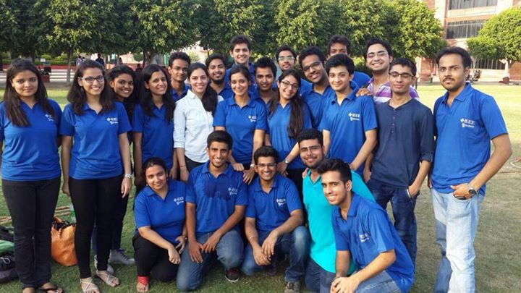

Fresh on Campus, an informal welcome for Freshers, organised on 27 August, 2014 by BVPIEEE, was a huge success in terms of participation and response. It was the second edition of Fresh On Campus, the inagural event being a huge success in 2013. It was singularly aimed at introducing IEEE and its Student Branch, serendipitously also bridging the gap between seniors and freshers by giving them a chance to meet and interact outside of the formal confines of the classroom. There were as many as three activities organised especially for this event. The first among them being, a Plantation Drive, which is an initiative taken up by BVPIEEE, in order to make the campus cleaner and greener. The Plantation Drive had active participation from teachers as well as students of the college. Mr Daman Sood, who is a renowned member of the IEEE Delhi Section Computer Scociety also graced the occcasion with his presence. The next activity organised was a social upliftment initiative by IEEE in the form of Toy Donation for underpriveleged kids. This too was a huge success, with BVPIEEE managing to collect a substantial number of toys and books for chidren. The final and easily the most popular activity was the ICE BREAKER event, where a list of tasks was handed over to previously decided, groups of students, each group having not more than 5 participants. It was ensured though, that no two participants were from same the branch so that the first year students got a chance to interact with freshers from other branches. Tasks included finding various things on campus, which a Fresher wouldn’t easily be able to spot in the first go, clicking particular pictures and many more fun filled activities. While the participants showed incredible enthusiasm for the only event of its kind; so did the volunteers. The whole BVPIEEE committee effectively managed the event, handling the turnout of more than a 150, which in itself is no mean feat. It highly encouraged freshers to learn more about IEEE and its events at Student Branch level, effect of which was observed in the events that followed.