**IEEE DAY 2014 AT BVCOE**



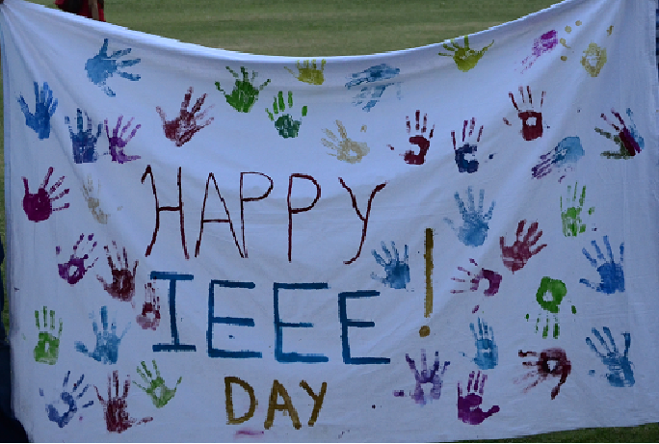

BVPIEEE and its HKN chapter, the Lambda Eta Chapter, celebrated IEEE Day in October, 2014 with enthusiasm and fervour. The event marked the inauguration of its flagship event **‘IEEE-HKN Research Mentorship Program**’. The program aims to bridge the gap between student and faculty members by providing students a platform to excel in the Research and Development (R&D) Department with the help of expert faculty members. The program was inaugurated by our esteemed guest Mr. Manoj Sharma of ECE Department who delivered a session on “Scope of writing a Research Paper”. Around 50 students participated in the inauguration program and were eager to be a part of the program in future. The session concluded with doubt session and feedback from students.

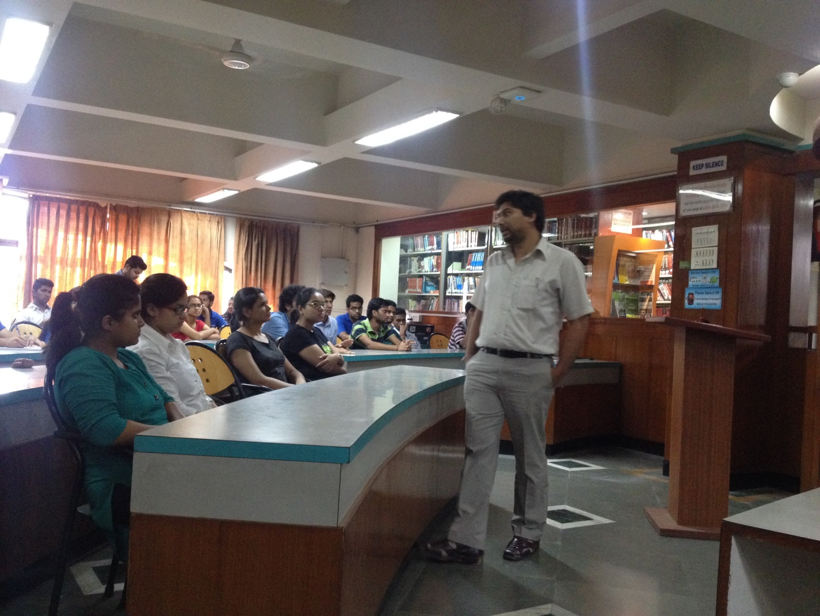

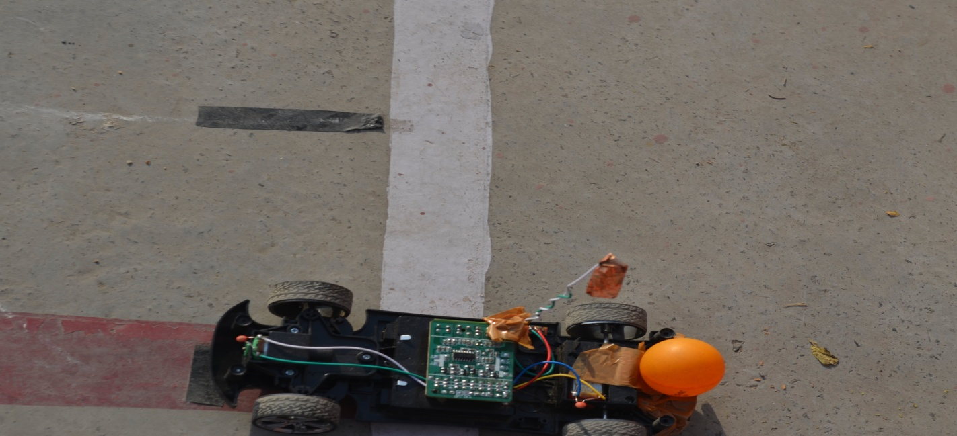   
 A robotics event named **'RoboBall**' was also organized. The aim of the event was to disseminate freshers to a competition of Robotics, where the challenge was to balance a ball on a wireless bot through a devious track. The one who took the least time and balanced the ball on the bot was the winner of the competition. The event saw a participation of 50 students, even the non-fanatics of robotics joining in to learn something new.

A **photowalk** was organised by the Digital Arts Society (DAS) of BVCOE. The aim of this event was to make the freshers aware of a photography technique called **Levitation** and make them acquainted with the basic rules of how it is implemented. Levitation is the rising of human body into the air by mystical means. More than 70 photography enthusiasts participated in the event and the organizers garnered a positive feedback from the participants.

A **toy-collection drive**, an initiative introduced by BVPIEEE in August 2014, was also taken up at IEEE Day. The proceeds of the drive will go to **Akshay Pratishthan**, an NGO, and it is a small way for the students to give back to the society.

Team BVPIEEE also organized a **Hand printing** activity. Students gathered in enthusiasm to participate in this convivial celebration, stamping their handprints with their favourite colours as the IEEE Day cheer spread across the college.

