THE DRAG FROM THAT FAG

* Anuj Narang, Software Developer, Egon Zehnder

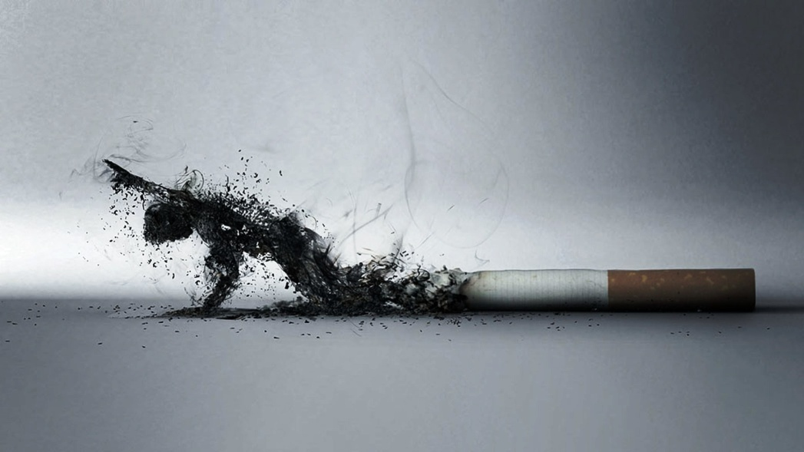

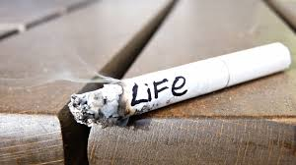

"Why do you do it? Practising how to poison yourself?"

"Calms my mind down. Trims the chaos inside. Say, shall I buy one for you?"

"I'm good. I'll just have a drag from your fag."

That's when it all started. I distinctly remember that dreary night. Sitting on the roadside in our pyjama bottoms we were making small talk about our future, when Shanky got all sappy and lit one. As for me, I only wanted to try it once. I wish I hadn't. Because now, I don't ever leave the house without a packet in the pocket. In no time it turned from a single drag to a lethal habit. A ritual rather. Brushing your teeth in the morning- check. Smoking one after lunch, tea and dinner- check, check and check. Getting chained to this kind of a lifestyle, for one day the ritual breaks, the mind shakes. 'No wonder I'm not able to focus. I didn't have my morning fag.' Without a shadow of doubt - addicted. 

Going by the book, a drug is a substance used in the treatment, cure, prevention, or diagnosis of disease or used to otherwise enhance physical or mental well-being. The latter part is something to ponder upon. One simply cannot overlook the ability of nicotine to regulate mood and improve cognitive functioning, which is presumably the motivation for its ubiquitous use. You do get a hit with each puff going inside, sometimes soothing the mind and at times getting the motor running. But there is a broader question at stake here - for how long? And at what cost?

New definition- a drug is anything that tends to provide short term felicity with no assurance of long-term enhancements. Painkillers, coffee, alcohol, Facebook, fornication and of course, the cigarettes, tend to come under this. One might have profound reasons to take those painkillers. But the same simply cannot be said about alcohol or cigarettes.  
Try picturing your cigarette as a royal cylindrical palace- ruled over in the inside by the king of addiction - Nicotine, engulfed inside the tobacco. With all the help harvested from his men- the army of toxins, the king shall perform his duty and slowly fulfil the promise made to his people. Grant them death! Make them martyrs.   
I sincerely believe that somewhere inside the heart of hearts of those sailing in the same boat as me, lurks fear - fear of the repercussions to be followed - the cancers, the ulcers and the ruined teeth to name a few. Yet we seldom have a problem in turning a blind eye to them, and shamelessly indulge in the act, daily. Many a time. Why? The truth is that most of us are oblivious of the extent of addiction. We keep assuming we can discontinue at will but somehow don’t want to at the moment. Moreover, we are always looking for reasons to continue doing it, or to rather not quit. Most common ones being- 'I want to smoke my sorrows away', 'helps me think more clearly', 'my life is too stressful' or the most recent one I heard- 'Lord Shiva used to smoke, why can’t I? (Courtesy: The Shiva Trilogy). Trust me, that'd be the Nicotine talking. Try quitting for a week and the reality might dawn on you eventually.

Ridding yourself from this addiction is not as straightforward as the non-smokers think it is. The king just does not let his people elude that easily. 90% of the smokers, in their life, have some day or the other thought of not smoking eventually having turned up with a cigarette in their mouth late in the very same day, turning into a lone wolf smoking in peace, fretting about the past or brooding over the future.

My father once said to me- "no man who has ever indulged in this practice can ever be the man he once was". But he can better his present, only if he wants to. How a smoker friend of mine in Lucknow and I have decided to tackle our current situation is to firstly reduce it by 50% a day. On not being able to hold one's horses and smoking the next one, one would have to telephone the other and apologize with all the shame and guilt in the world, the act being repeated as many times as the number of fags smoked upwards of the number after the reduction. The cycle is to be repeated each week till we get down to 1 a day and finally calling it quits.

And if that sounds too much of hard work, one can always switch to the relatively less harmful e-cigarettes. With persistence and professional health, this trap of an addiction can be overcome. A penny's worth of advice to all the non-smokers out there- there does exist a simple, decent and serene procedure of quitting or not indulging in smoking. Do not start it in the first place. Simply avoid that first drag from that fag.