AGONISED

* Vaani Sharma, BVCOE

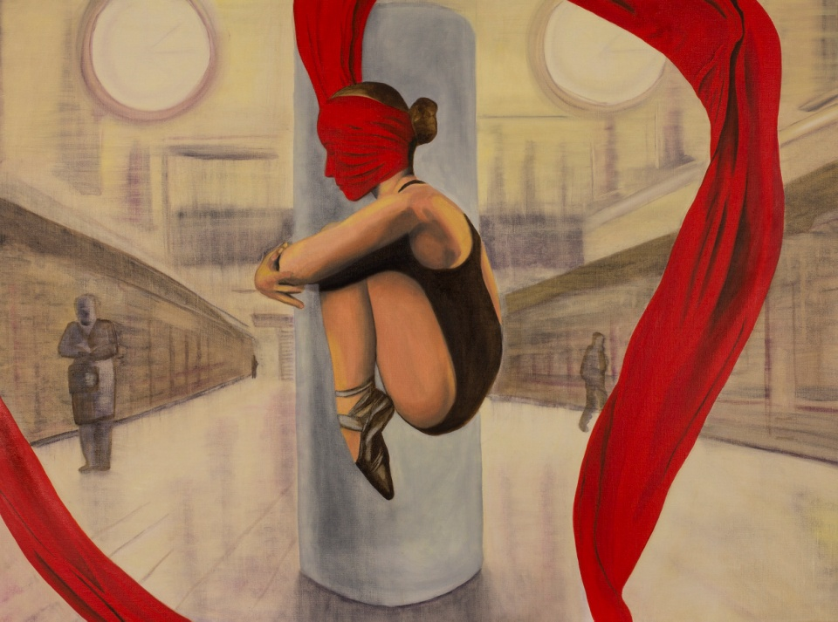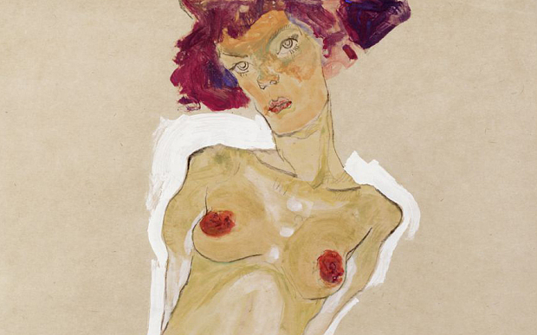

Brimming at the edge of my own insanity,  
Tapering with ire, stirring inventory  
Bestowed with peace yet a stranger to my own  
Suffering that i saddled with purgatory  
Desires overflow, drowning the one  
Who dare raise the voice over clattering din  
So much to hear and so much to follow  
My own thoughts get buried deep within  
A tale unheard yet untainted  
Of pain, tremble, anger, sin  
Those that the dark night lamented  
Wreath, it covers, my life bereft  
Of victory, nay, of destitution grave  
Lost I am in a whirlwind trip  
Vanquished courage yet honourably brave  
I am the candle, I burn and melt  
As the world bathes in my glory and light  
For the greater good I sacrifice myself  
Drudging myself day and night  
I am a mother whose heart knows no malice  
I am a daughter, so docile, so sweet  
I am chained and imprisoned so  
My plight sees no kind retreat  
Test me, I beg you, I come out shining  
But these thoughts remain unrequited, stoned  
I am a girl, a woman, a lady  
On whose birth they moaned  
Whose birth they mourned.