IS BEING GAY A CRIME?  
NO!

-Apporva Singhal, Vellore Institute of Technology

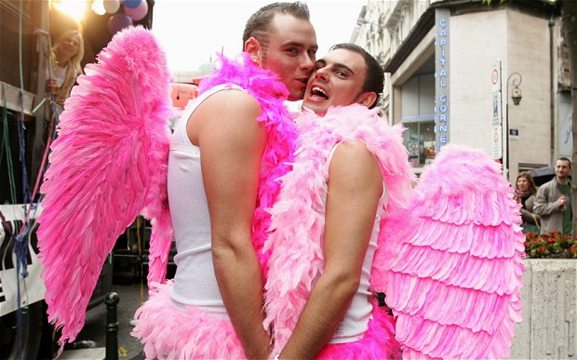

Ask anyone about how they feel about the concept of ‘love’, and I bet they won’t be able to stop themselves from uttering the words “Awww…it is beautiful!”

Yes they believe in love, they want it, they appreciate it, they like it, but only as long as it is between two opposite sexes. Why? We are still living in a world where people are repelled, disgusted and completely against homosexuals. All these phobias make sense to me except this one called homophobia. I feel it is completely irrational to have prejudices and discriminations against people who are gay, lesbian, bisexual or transgender.

The kind of reactions and insults they have to suffer are unimaginable. People literally run away when they spot a gay couple around. They would constantly stare at them and make them feel awkward as if they have come from another world. This feeling of alienation is found in almost every homosexual. And this attitude is being passed on from generations since kids are not any less afraid of homosexuality. There are cases of children screaming and being petrified of these people. This is not their fault since this mind set has been in existence for ages. There is an urgent need for this looking down upon homosexual behavior to change.

.Judge a person by what they do and not by who they love. If there is a right to education, a freedom to speech, I think it is high time we have a ‘freedom to love who ever we want’. We need to empathize with them since they are normal human beings like us. They deserve better than what they are getting right now. Imagine yourself getting up one morning and being looked down upon and hated by the world just based on your choice of being with the person you love. It seems unfair, doesn’t it! Well then let us change this set attitude and thinking for the better. Let us all give them a reason to believe that world after all is not that cruel a place.