NOTIONS OF BEAUTY AND POPULAR MEDIA

-Srishti Chaudhary, JMC

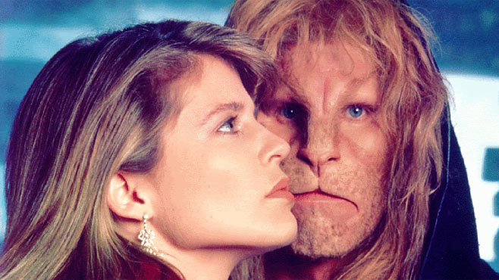

Beauty as a notion or phenomenon is so broadly implicit, that it can almost be understood as a Jungian archetype, a collectively inherited unconscious idea, universally present in individual thought. To define beautiful is difficult, as its implications are always assumed to be easily understood, that no further explanation is required, just as one would describe something as ‘nice’. 

Oxford defines beauty as something that pleases the senses aesthetically, with a special emphasis on sight. From this very point, the concept of something or someone as beautiful took on a very specific framework. While a difference between being beautiful and looking beautiful is well-recognized, the conventional tint through which beauty is viewed is efficiently in place. This tint, which is now an evocative machinery in the mind, has been largely sourced from what came to be known, as the third millennium rolled around, the popular culture and media. 

Edmund Burke, political theorist and philosopher, had noticed that the press, or the media, encouraged everyone, to develop opinions on everything. While this may seem an obvious thing to state, this extensive development and echoing of public opinion has led to every individual forming certain views, which are tallied with their past experiences and systems of morality, about anything that can be discussed. The media and the popular culture produced and reproduced their version of ‘the beautiful’, and once all this infinite information is as boundlessly disseminated as this, ideas about what is beautiful are created, reiterated and permanently sketched. 

Aristotle’s Golden Mean, which is considered as the perfect indication of what is beautiful, is present in face and body structures, and the more a structure complies to the golden mean, the more beautiful it is considered. So while there is still some consensus on what is beautiful, the popular media has acted like a very effective agent to promote very precise and definite ideas about what is beautiful. 

In fact, so effective is this agent that notions of beauty evolve exactly as how the popular media wants them to evolve. So while the later decades of the 20th century emphasized a curvaceous figure among women as beautiful, presently, prominent cheekbones, collarbones and smaller structures are considered to be pre-requisites for beauty. As different cultures are exposed to different art, the notions of beauty also vary. What is thought to be beautiful aesthetically in African countries may be very different from the same notion in France, or maybe south of India. But just as in everything else, the domination of the western ideals of beauty have pervaded other places on the globe. Attempting to create a uniform image of something which is as diverse as beauty is simply unhealthy. 

These notions, thanks to the vetting out by the popular media too, are insidious, causing people to behave in compliance with them. A conscious attempt to realize oneself of the complexities of beauty, and how no one idea can define what is beautiful, needs to be continuously made, and only then these can be overcome.