Birdeye: Company & Product Analysis

Company Overview
Birdeye is an AI-powered marketing and customer experience platform focused on local businesses and multi-location brands. It describes itself as “the #1 AI platform for Hyperlocal Marketing,” designed to help enterprise and franchise businesses manage online reputation, reviews, and customer feedback[1]. Birdeye was founded in 2012 and is headquartered in Palo Alto, California[2][3]. The company was started by brothers Naveen and Neeraj Gupta (former Google/Yahoo/Amazon engineers) and initially focused on helping healthcare providers get found online and improve their reputation[2][4]. Over time it has grown into a broad platform serving industries from healthcare and finance to retail and automotive. Birdeye’s core problem to solve is reputation and presence management: it gives businesses tools to collect and amplify customer reviews, maintain accurate directory listings, engage customers via messaging and social media, run surveys, and analyze feedback – all in one unified system[1][3]. In short, Birdeye tackles the fragmented, manual tasks of local marketing and online reputation, automating them with AI agents for businesses with many locations.

Main Motive in the Market
Birdeye’s mission is to help enterprise and multi-location brands “win locally” by delivering real business outcomes (like more leads, foot traffic, and revenue) via an AI-driven platform[4][1]. As the founders explain, they aim to “transform how enterprise brands win locally, delivering real business outcomes for thousands of locations and millions of consumers”[4]. The product was created to fill the gap left by traditional marketing tools, which typically require manual effort and aren’t built for multi-location complexity. By using autonomous AI agents and a single interface (“Service-as-a-Software”), Birdeye allows brands to automate tasks like requesting reviews, responding to customers, updating listings, and generating campaigns across all locations[4][5]. This is important for businesses because local reputation and discoverability directly impact customer acquisition. Birdeye’s platform aims to ensure consistent brand presence across search, social, and review sites, so that potential customers can find and trust each location of a business. In practice, Birdeye helps businesses boost their local search performance and reputation metrics – for example, customers report it can increase online visibility and drives measurable improvements in leads and reviews[1][6]. In summary, Birdeye was created to fill the market need for an integrated, AI-enhanced local marketing solution that raises brand trust and customer engagement at scale.

Products & Services
Birdeye offers a comprehensive suite of products and tools, most of which are powered by AI agents. Key offerings include:
- Review Management & Online Reputation: Birdeye Reviews (Reviews AI) lets businesses generate and manage reviews on 200+ sites from one dashboard[7]. It automates review requests (via SMS/email at the right time) and tracks all incoming feedback. Companies can reply to reviews using AI-generated or templated responses, and publish positive reviews to search and social to boost SEO[7][8]. Real-time dashboards show review counts, star ratings, sentiment over time, and competitor benchmarks (Birdeye Score, Sentiment Score, etc.)[9][10].
- Listings Management: Birdeye Listings ensures all business information (name, address, hours, etc.) is accurate across Google, Apple, Yelp, and hundreds of directories[11][12]. Its Listings Optimization Agent continuously scans for outdated or duplicate listings and automatically corrects them in real time[11]. For example, if a store’s hours change or a new location opens, Birdeye pushes updates across platforms from a single dashboard. This consistency improves local SEO and foot traffic. (Birdeye’s site notes a “Listings Scan” feature to audit your presence and an analytics dashboard to track listing performance[12].)
- Messaging & Chat (Customer Messaging): Birdeye Messaging consolidates SMS, email, webchat, and social messages into one inbox[13]. Staff can use it to send appointment reminders, promotional blasts, or service updates via text and chat. Key capabilities include shared inboxes by location, templates for quick replies, and assignment of conversations to team members[13]. The platform also supports webchat on websites: Birdeye’s 24/7 Chatbot AI engages visitors automatically (answering FAQs, booking appointments, capturing leads)[14][15], and can hand off to live agents when needed.
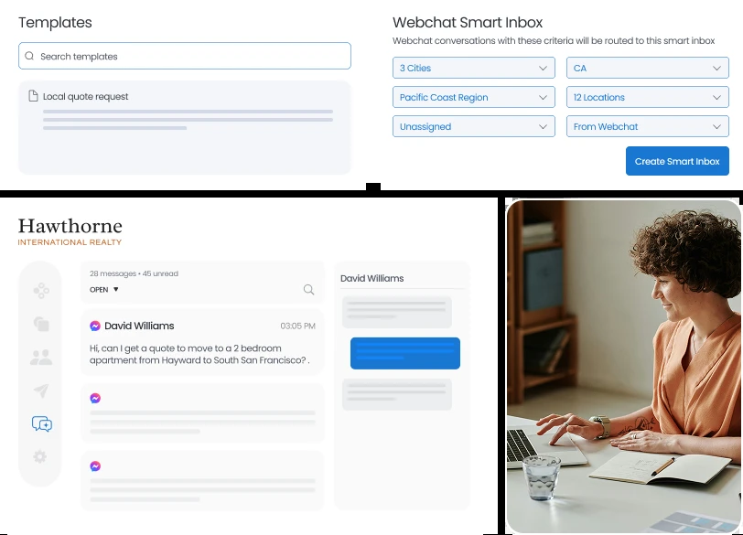
Birdeye’s Smart Inbox centralizes all customer conversations (SMS, webchat, social) and uses AI to suggest or draft responses. This example shows how messages from different channels are organized by location.[13]
From this single inbox, businesses track response times and conversation metrics. Automated workflows can trigger review requests or surveys right after chats. Birdeye’s multi-channel messaging replaces siloed systems, helping brands respond quickly and coordinate across locations[16][17].
- Chatbot AI (Website Conversational AI): The Chatbot AI engages website visitors 24/7, acting as a virtual assistant to qualify leads and answer questions[14]. It is “trained in minutes” by importing a site’s FAQ or content, so it can reply accurately. The chatbot can book appointments, gather contact info, or route the chat to a human agent when needed[15][18]. Businesses use it to capture visitors outside business hours. In practice, Birdeye’s Chatbot has a 24x7 Lead Assistant mode that deflects routine questions and a Smart Inbox for live chat management[15][17].
- Social Media Management (Social AI): Birdeye Social lets brands create, schedule, and publish posts across multiple social networks and locations using AI-generated content[19]. An AI “Publishing Agent” recommends post ideas (based on trends and brand voice) and schedules content at optimal times[19]. A “Social Engagement Agent” then monitors comments and direct messages, automatically drafting personalized replies (or routing to agents) to engage customers. Combined analytics show top-performing posts, engagement rates, and audience growth by location[19][20].
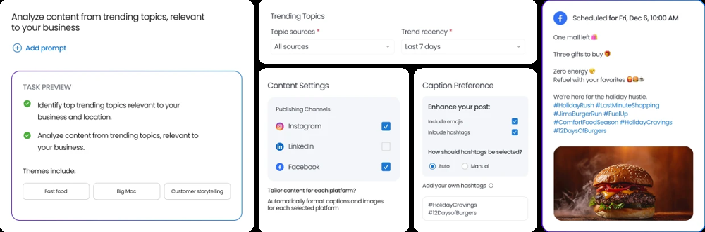
The Social AI interface helps create and schedule posts for different locations and channels. It also lets managers review and approve content. Birdeye automates publishing and engagement to keep social profiles active.[19]
- Surveys & Feedback: Birdeye Surveys lets businesses build and distribute customized surveys (NPS, customer satisfaction, etc.) via SMS, email, social messaging, or web chat[21][22]. Surveys can be triggered automatically after a transaction or visit. Pulse/text surveys increase response rates[23]. All responses feed into the Insights dashboard, where Birdeye’s AI analyzes open-text answers and tracks satisfaction trends[24]. Users can also append a review request at the end of a survey to drive ratings[21].
- Marketing Automation: Birdeye’s Marketing Automation module is designed for multi-location campaigns. Marketers specify goals (e.g. promote a new offer) and Birdeye’s AI agents create and run email/SMS workflows personalized by location[25][26]. The system automatically segments contacts (e.g. past customers in a ZIP code) using data from CRM, reviews, surveys, and online behavior[26]. It then sends messages at the best time/channel for each person and tracks opens, clicks, and conversions at each location[27][28]. The AI learns which content performs best and can even optimize subject lines or send times. This turns the insights (scores, feedback, visit data) directly into actions that drive sales.
- Analytics & Dashboards (Insights AI): Birdeye provides a unified insights dashboard with various scores and metrics. The Birdeye Score aggregates each brand’s reviews, surveys, and SEO signals into a single reputation index[9]. It also computes separate Sentiment Scores, Reputation Scores and Listings Scores by location, showing changes over time[9][10]. Users get AI-generated summaries that highlight trends (e.g. “Your average rating dropped by 0.2 stars this month”[29]) and actionable recommendations (e.g. “Respond to 15 new negative reviews to improve your score”[30]). The dashboard includes interactive visuals (maps, charts) for drilling into data.
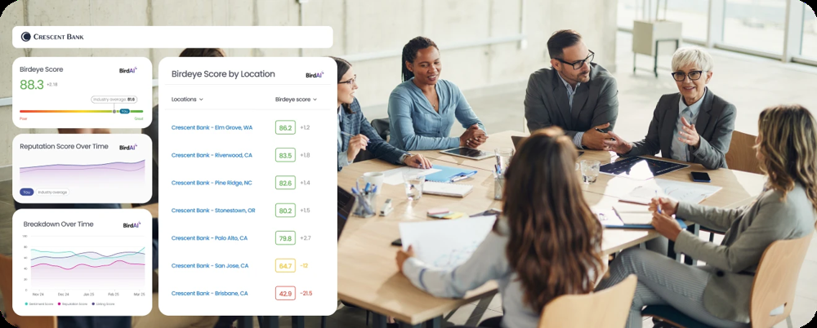
Birdeye’s Insights dashboard (as shown above) displays the Birdeye Score by location and visualizes reputation and listing performance. It integrates data from reviews, surveys, and SEO to give a holistic view of brand health.[9][31]
Marketers can customize reports, segment by geography or category, and even share branded analytics with executives. This analytics layer ties all Birdeye tools together and shows ROI on reputation and experience efforts.

Target Customers
Birdeye’s ideal customers are multi-location and franchise businesses that need to manage online presence at scale. Its platform is purpose-built for brands with many outlets – from dozens to thousands of locations[1][32]. Common industries include healthcare (clinics, hospitals), automotive (dealerships, service centers), home services (plumbing, roofing), financial services, dental and wellness chains, property management, retail and restaurants, and legal firms. (Birdeye’s case studies cover sectors from senior living to credit unions.) In each case, businesses want consistent reputation/reviews and customer engagement across all their branches. Birdeye also serves businesses of all sizes – from small franchises to Fortune 500 enterprises[32] – but its advanced AI features and enterprise-grade support particularly appeal to mid-market and large organizations. Agencies and multi-brand operators also use Birdeye to manage multiple client profiles.

Business Model
- Subscription SaaS: Birdeye is a cloud-based SaaS platform. Customers subscribe to its services on a per-location, per-month basis[33][34]. There are tiered plans (often named Starter, Growth, Dominate) that bundle different toolsets. For example, the Starter plan (review/listings/messaging) is the entry level, Growth adds social management, and Dominate adds AI Chatbot[33][34]. Pricing is largely custom and often quoted per location rather than a flat rate (the website prompts prospects to “schedule for quote” at each tier).
- Pricing Structure: Although Birdeye does not list standard prices, each plan includes core modules relevant to its name. All plans come with unlimited users and contacts, mobile apps, campaign tools, and support[35]. Add-ons like Surveys AI, Marketing Automation, or advanced integrations can be layered on. The average contract value is reportedly around ~$1.8K annually per location (GetLatka data). Birdeye also sells professional services (training, managed services) and has a partner/reseller network.
- Revenue & Growth: The company has shown rapid growth. For 2024 Birdeye reported roughly $146.8M in annual recurring revenue with about 80,000 customers[36]. This represents ~47% year-over-year growth from 2023. With Series C funding of $93M (in 2022) and high customer retention (and 1.1K+ employees) the business generates strong recurring revenue from its subscription model.

Competitive Analysis
Birdeye competes with other reputation and local marketing platforms. Key competitors include Podium, NiceJob (now part of G2/Paystone), Yext, and Reputation.com.
- Podium: Podium is known for its customer messaging and payments focus, targeting local businesses. Birdeye distinguishes itself by offering a broader, enterprise-ready platform. Unlike Podium, Birdeye has deep partnerships with Google (for seller ratings/ads) and Apple (Apple Business Connect) to optimize local SEO and omnichannel presence[37][38]. Birdeye also supports over 3,000 app integrations (Salesforce, HubSpot, etc.), whereas Podium offers far fewer (around 180)[39]. In user reviews, Birdeye customers often cite better support (24/7 help and dedicated managers) compared to Podium[40]. Podium’s strength is its ease of use for small businesses, but Birdeye’s strength is multi-location automation: for example, Podium lacks an automated listings corrector or AI-driven review response, both of which Birdeye provides.
- NiceJob: NiceJob focuses on SMBs looking to generate and display positive reviews. It is praised for simplicity and easy setup, especially for small teams[41]. However, it has a narrower feature set (mainly review collection and referrals). Birdeye, by contrast, is built for larger clients and multi-channel marketing. G2 reviews note that Birdeye “shines in centralizing reviews” and scaling to enterprise use[42], whereas NiceJob’s customers emphasize its straightforward review-invite process. In short, NiceJob may excel at simple SMB reputation tasks, but Birdeye’s comprehensive tools (reviews+listings+surveys+AI, etc.) give it more breadth for bigger organizations[42][41].
- Yext: Yext is a long-established platform known for managing online listings and knowledge panels across search engines. Compared to Yext, Birdeye offers a more unified reputation and engagement solution. Yext mainly helps keep listings consistent (and offers some review management), but Birdeye adds robust review generation, AI-driven responses, and marketing automation. Birdeye emphasizes AI agents and quick onboarding across thousands of sites[43][44], whereas Yext typically requires more manual configuration for campaigns. Reviews from former Yext customers (and Birdeye’s own messaging) highlight that Birdeye delivers additional value in customer engagement and ease of use, along with competitive pricing[45].
- Reputation.com: Reputation.com targets large enterprises with tools for reviews, surveys, social, and competitive benchmarking. Birdeye claims to outpace Reputation.com in integration and automation. For example, Birdeye integrates with 3000+ CRMs and systems[46], whereas Reputation.com supports only a handful of key partners. Birdeye also promotes “agentic” AI for automating reviews, responses, and follow-up surveys[47]; Reputation.com offers fewer AI capabilities (mostly sentiment analysis and automated review replies). On service, Birdeye provides 24/7 support to all clients[48], while Reputation.com typically allocates dedicated CSMs to larger accounts only. In summary, where Reputation.com is feature-rich but somewhat manual, Birdeye positions itself as more automated and easy to scale.

Technology & AI
Birdeye’s platform heavily leverages AI and machine learning. The core concept is BirdAI – autonomous AI agents trained for each marketing task. These are large-language-model workflows that can “reason, decide, and act” on marketing opportunities[5][49]. Birdeye uses both Industry AI (models tuned on billions of domain-specific data points) and Brand AI (custom models infused with a client’s own brand voice/rules) to ensure outputs are contextually relevant[50].
Key AI capabilities include: automated review response generation (replies to reviews tailored by sentiment/context, even translating non-English feedback)[51]; content creation (Social and Messaging AI draft posts and texts that match brand style); conversational AI (Chatbot uses LLM to carry on human-like chat); and automated workflows (Agents that send review requests or schedule social posts without human intervention). Birdeye emphasizes that its AI Agents can operate autonomously under user-defined guardrails (brand guidelines, compliance rules, optional human approvals)[52][53]. For example, a “Listing Agent” continuously fixes store hours and details on Google or Apple Maps based on periodic scans – a task beyond basic API automation.
Unlike generic tools (ChatGPT etc.), Birdeye’s AI is specialized for marketing outcomes. Birdeye measures and links AI activity to business results like traffic and revenue[54]. In short, the use of AI is a distinguishing strength: it not only assists users, but actively executes entire workflows (agentic marketing) to improve efficiency and consistency across hundreds of locations.

Market Position
Birdeye has established itself as a leader in the multi-location customer experience space. Its platform is used by tens of thousands of businesses (official sources cite over 150,000 businesses worldwide)[1]. Notable customers span major franchises and enterprises. The company is venture-backed (investors include Marc Benioff, Jerry Yang, Trinity Ventures, etc.) and has grown rapidly: 2024 revenue was ~$146.8M ARR with ~80K clients[36].
Customer reviews and industry rankings are generally positive. On G2, Birdeye holds a ~4.7/5 rating across thousands of reviews[55]. It has repeatedly topped G2 reports – for example, Birdeye was ranked the #1 enterprise solution in 12 categories and listed among the world’s top AI products (G2 Spring 2026)[45]. Customers often praise Birdeye for improving their online reviews, centralizing customer communication, and providing responsive support. Its reputation is strong among mid-market and enterprise users who appreciate the platform’s breadth and constant innovation (the company often leads with features like AI chat and Google integrations).
Birdeye distinguishes itself from other platforms through its “outcome-driven AI” approach. Instead of just offering tools, it emphasizes delivering direct ROI (e.g. showing how many new leads came from review campaigns). Its strategic partnerships (as a Google Premier Partner for local business) and focus on large-scale workflows set it apart from smaller players. In sum, Birdeye is widely regarded as a powerful, full-featured solution in the reputation/experience management industry, particularly for multi-location brands.

SWOT Analysis
- Strengths: Birdeye’s biggest strengths are its comprehensive feature set and AI focus. It combines reviews, listings, messaging, surveys, social, automation and analytics into one platform, which is rare in the market. Its BirdAI agents (3000+ integrations and Google/Apple partnerships) give it a technological edge. The founders’ background (Google, Amazon, etc.) and strong investor backing also inspire confidence. The platform has proven scale (150K+ users[1], ~47% annual growth[36]). Its high ratings and award rankings[45] reflect customer satisfaction with ease of use and support.
- Weaknesses: The platform’s breadth can be complex, especially for small businesses; there is a steep learning curve to leverage all features. Pricing is opaque (custom quotes), which can deter price-sensitive smaller clients. Some reviews mention occasional issues with customer support responsiveness or difficulties in navigating the extensive feature set. Birdeye also tends to focus on larger clients, so its solution may be overkill for very small businesses with few locations.
- Opportunities: The market trend strongly favors Birdeye. Online reputation management is a growing market (projected ~12.6% CAGR through 2031[56]) as businesses increasingly rely on online trust signals. AI-powered marketing tools are in high demand, and Birdeye’s leadership in AI-driven local search positions it well. It can expand internationally or into adjacent verticals (like hospitality or e-commerce) that need unified review/feedback management. New features (e.g. AI for emerging channels) and partnerships (e.g. with messaging platforms) present growth paths.
- Threats: Competition is intense. Other SaaS and AI startups may enter the space, and existing giants like Google or Microsoft could bundle similar capabilities into their platforms. Birdeye must continually innovate to stay ahead of Podium, Yext, and new niche players. Regulatory and trust issues are also threats: for example, increased FTC enforcement (e.g. fines for fake reviews[57]) means Birdeye must enforce compliance (though this also promotes its credibility). Economic downturns could lead clients to cut marketing spend, and high customer churn (cited ~12%) is a risk if competitors poach dissatisfied users. Lastly, rapid AI developments require Birdeye to keep up with technology changes to retain its edge.

Real-World Use Cases
Birdeye is used in practice by businesses across various industries:
- Healthcare: Clinics and medical groups use Birdeye to automate patient review collection and feedback. For example, Sutter Health adopted Birdeye across its hospitals to streamline patient outreach and centrally manage online reviews (using tiered response workflows)[58]. Arrow Senior Living (healthcare/senior care) leveraged Birdeye’s Search AI and messaging, achieving a 9.2% jump in AI search visibility and 52.8% more leads from 46 locations[59]. The platform’s HIPAA-compliant survey and messaging tools let healthcare providers track patient satisfaction in real time and follow up quickly on concerns.
- Restaurants: Chain restaurants rely on Birdeye to keep guest feedback in check across many locations. Black Bear Diner (150+ locations) credits Birdeye with scaling guest satisfaction; they use Birdeye to solicit reviews, respond to diners, and maintain a consistent brand voice online[60]. Multi-location food & beverage companies often set up Birdeye to automatically send review requests after each meal, manage negative feedback privately, and share positive reviews on their websites and social media.
- Retail & Automotive: Retail brands and auto service franchises deploy Birdeye for listings accuracy and review analysis. An auto parts/service retailer (Sun Auto Tire) used Birdeye Insights to process thousands of reviews quickly, enabling managers to identify and fix issues faster[61]. Contractors and roofing companies have used Birdeye’s social and messaging tools to turn local promotions into foot traffic. In retail, companies use automated messaging (SMS offers) and omni-channel messaging to bring customers back.
- Professional Services: Law firms and financial services also use Birdeye. Hupy & Abraham (a law firm) transformed a previously manual review workflow into an automated process without losing personal touch[62]. Credit unions like Chartway use Birdeye’s surveys and customer messaging to boost member engagement and trust[63]. Essentially, any business that interacts with customers and has multiple locations – from dentists to property managers – finds Birdeye’s combination of review generation, chat/messaging, and analytics beneficial.
- Franchises & Agencies: Marketing agencies and multi-brand groups use Birdeye to manage reputation across client portfolios. For example, agencies handling dental or veterinary clinics often roll out Birdeye to ensure each location maintains high online ratings and consistent business info. The multi-channel capabilities (mass texting for promotions, webchat for leads, etc.) are useful in service-based franchises like gyms, spas, or home repair networks.
These real-world examples show Birdeye’s versatility: healthcare providers use it to capture patient feedback, restaurants to elevate guest reviews, retailers and auto shops to streamline local SEO and service reminders, and professional services to automate testimonial gathering. In all cases, the platform helps businesses turn customer interactions into improved online reputations and measurable growth.

Future Potential
Birdeye is well-positioned for future growth given market trends. The online reputation management market alone is expected to grow rapidly (from ~$7.75B in 2026 to $14B by 2031[56]). Crucially, AI is becoming standard in this space – research notes that AI-driven sentiment analytics and automated response are accelerating sector growth[64]. Birdeye’s early investment in generative AI and now agentic AI (BirdAI) aligns with this trend. Moreover, as more consumers use AI assistants (ChatGPT, Google’s LLMs) for search, Birdeye’s Search AI (to improve visibility in AI-driven discovery) meets a new need.
The company’s partnerships (e.g. Google, Apple) and constant feature updates suggest its growth can continue. However, it must navigate challenges: evolving technology (e.g. new search algorithms), increased scrutiny of review authenticity, and competition. For example, Google could add more local marketing tools, or new startups could focus on niches like AI text generation for marketing. Birdeye will need to keep innovating (e.g. extending AI agents to new channels like WhatsApp or emerging social platforms) and ensure its platform remains secure and compliant (e.g. support for HIPAA/GDPR) as regulations evolve. Overall, the outlook is positive: demand for automated, cross-channel reputation management is strong, and Birdeye’s AI-driven approach gives it momentum to capture a growing share of that market.

Final Summary
Birdeye has built a strong, feature-rich platform in the customer experience and reputation management industry. It addresses clear business needs (local search visibility, unified feedback management, customer engagement) and backs them with AI-driven automation. Companies choose Birdeye because it consolidates disparate tools into one solution – simplifying marketing and customer engagement across dozens or thousands of locations. With a record of solid revenue growth and many large customers[36], it is seen as a credible leader. Its unique use of “agentic AI” (autonomous marketing agents) and strategic partnerships (Google, Apple) differentiate it from peers. In conclusion, Birdeye is a powerful business/product in its space: it delivers tangible outcomes (more leads, higher ratings, loyal customers) for its clients.

