Mini Project Report – Pawred Flutter App
Oct 27, 2026 · @R
Pawred Mobile: A Flutter App for Health-First Dog Matchmaking
Mini Project · Submitted by Adish Shah (A110), Manya Sanghvi (A133), Kavya Shah (A114), Juee Shimpi (A118) · Guided by [Guide Name] · [Department], [College Name] · Academic Year 2026–27

Table of Content
Sr. No. |  | Content
1. |  | Declaration
2. |  | Acknowledgement
3. |  | Abstract
4. |  | Table of Content
5. |  | List of Figures
6. |  | List of Tables
7. |  | List of Abbreviation
8. |  | Chapter 1 — Introduction
 | 1.1 | Objectives of the System
 | 1.2 | Scope of the Project
9. |  | Chapter 2 — Literature Review
 | 2.1 | Existing Recommendation Techniques
 | 2.2 | Applications of Recommendation Systems in E-commerce
10. |  | Chapter 3 — Implementation
 | 3.1 | Weekly Implementation of Tasks
 | 3.2 | System Development & Deployment
11. |  | Chapter 4 — Result Analysis
 | 4.1 | Performance Evaluation
12. |  | Chapter 5 — Conclusion
 | 5.1 | Future Enhancements
13. |  | References

1. Declaration
We declare that this written submission represents our ideas in our own words. Where others' ideas or words have been included, we have adequately cited and referenced the original sources. We also declare that we have adhered to all principles of academic honesty and integrity and have not misrepresented, fabricated or falsified any idea, data, fact or source in our submission.
Adish Shah (A110), Manya Sanghvi (A133), Kavya Shah (A114), Juee Shimpi (A118) · Signature: ____________ · Date: ____________

2. Acknowledgement
We express our sincere gratitude to our project guide, [Guide Name], for their constant guidance and feedback throughout this mini project. We thank [Head of Department] and the faculty of [Department], [College Name], for providing the facilities and support needed to complete this work. We also thank our classmates and families for their encouragement.

3. Abstract
Pawred Mobile is a cross-platform mobile application, built with Flutter, that helps dog owners in India find a healthy, compatible breeding partner for their dog. It brings the Pawred matchmaking system to Android and iOS phones, where most owners already spend their evenings.
The app recommends only compatible dogs: opposite sex, the same breed unless both owners accept other breeds, at least 18 months old, and with a complete profile. Dogs that have already liked the user are shown first, and each suggestion carries plain-language fit notes such as same breed, same city, health-verified and close in age. Every profile shows vaccination status and health documents, and a Verified badge appears once an administrator has checked them.
Owners like a specific photo or prompt answer, a mutual like creates a match, and matched owners chat inside the app. The screen designs follow the mobile layout of the Pawred web application so that both versions look and behave the same.
Keywords: Flutter, Dart, mobile application, recommendation system, matchmaking, pet health verification.

5. List of Figures
Fig. No. | Title | Chapter
3.1 | Architecture of the Flutter app | 3
4.1 | Reference UI design: welcome, sign-in and sign-up | 4
4.2 | Reference UI design: onboarding and Discover | 4
4.3 | Reference UI design: dog profile, Likes you and Matches | 4
4.4 | Reference UI design: chat, edit profile and settings | 4

6. List of Tables
Table No. | Title | Chapter
2.1 | Comparison of recommendation techniques | 2
2.2 | Recommendation systems in e-commerce and mobile platforms | 2
3.1 | Weekly implementation plan | 3
3.2 | Technology stack of the Flutter app | 3
3.3 | App screens and their purpose | 3
4.1 | Functional test results | 4
4.2 | Performance targets | 4

7. List of Abbreviation
Abbreviation | Full Form
API | Application Programming Interface
APK | Android Package Kit
CBF | Content-Based Filtering
CF | Collaborative Filtering
IDE | Integrated Development Environment
JSON | JavaScript Object Notation
REST | Representational State Transfer
SDK | Software Development Kit
UI | User Interface
UX | User Experience

Chapter 1 — Introduction
Responsible dog breeding depends on finding a partner of the right breed, the right age and in good health. In India most owners search through classified ads, social media posts and WhatsApp groups, which offer no health records and no compatibility filtering.
Pawred solves this with a recommendation system modelled on dating apps such as Hinge. The team first built Pawred as a web application. This project brings the same system to phones as a native mobile app built with Flutter, so one Dart codebase runs on both Android and iOS.

1.1 Objectives of the System
- Build a cross-platform mobile app for Android and iOS from a single Flutter codebase.
- Recommend only compatible dogs: opposite sex, same breed by default, and at least 18 months old.
- Show dogs that have already liked the user first, then the newest profiles.
- Explain each recommendation with plain-language fit notes.
- Let owners add photos, prompt answers and health documents to their dog's profile.
- Replace blind swiping with likes on a specific photo or prompt, with an optional comment.
- Turn a mutual like into a match and open a chat between the two owners.
- Keep the look and flow consistent with the Pawred web app.

1.2 Scope of the Project
In scope
- Mobile app for Android and iOS phones.
- Sign-up, sign-in and four-step onboarding (basics, photos, prompts, health).
- Discover screen in feed and grid layouts, with verified-only and same-city filters.
- Dog profile, edit profile and settings screens.
- Likes you, matches and chat screens with unread badges.
Out of scope
- The admin panel for verifying documents and handling reports, which stays on the web.
- Payments, stud fees or contracts between owners.
- Veterinary diagnosis; the app records documents and does not judge medical fitness.

Chapter 2 — Literature Review
A recommendation system predicts which items a user is likely to want and shows them in ranked order. Pawred uses a hard-constraint, content-based approach because breeding rules are fixed and a new platform has too little interaction data for collaborative filtering.

2.1 Existing Recommendation Techniques
Table 2.1 — Comparison of recommendation techniques
Technique | How it works | Strengths | Limitations
Content-based filtering | Recommends items whose attributes match the user's profile or past choices | Works for new items; explainable | Narrow suggestions; needs good item attributes
Collaborative filtering | Uses ratings or actions of similar users | Finds unexpected items | Cold-start and sparsity problems
Matrix factorisation | Learns hidden user and item vectors from interactions | Accurate at scale | Needs large data; hard to explain
Knowledge/constraint-based | Applies explicit rules and requirements | No history needed; always valid results | Rules maintained by hand
Hybrid | Combines two or more of the above | Offsets each one's weaknesses | More complex to build
Reciprocal recommendation | Recommends people to people; both sides must accept | Fits dating and job platforms | Must model two preferences at once
Pawred combines a constraint-based filter (sex, breed, age, completeness) with a reciprocal signal: a dog that has already liked the user is ranked first, because a like back creates a match at once.

2.2 Applications of Recommendation Systems in E-commerce
E-commerce is the largest commercial use of recommendation systems, and most of it now happens in mobile apps. Recommendations raise conversion, basket size and retention by surfacing relevant products on a small screen where browsing is slow.
Table 2.2 — Recommendation systems in e-commerce and mobile platforms
Platform | Application | Technique
Amazon | “Customers who bought this also bought” | Item-to-item collaborative filtering
Flipkart / Myntra apps | Similar products and personalised home feed | Hybrid content + collaborative
Netflix | Personalised rows of films and shows | Matrix factorisation, hybrid
Spotify | Discover Weekly playlists | Collaborative filtering + audio features
Hinge / Tinder | Daily suggested profiles in a mobile-first app | Reciprocal recommendation
Instagram | Explore feed and grid | Engagement-based ranking
Pawred Mobile borrows the feed and grid layouts of these apps, the “why this fits” explanations of e-commerce, and the mutual-consent matching of dating apps.

Chapter 3 — Implementation
Pawred Mobile is written in Dart with the Flutter framework, so the same code builds an Android app and an iOS app. Its screens follow the mobile layout of the Pawred web app, and it applies the same matching rules.

3.1 Weekly Implementation of Tasks
Table 3.1 lists the work completed in each week. [Adjust the weeks and tasks to match your actual schedule.]
Table 3.1 — Weekly implementation plan
Week | Tasks completed | Output
1 | Studied the problem and the Pawred web app; listed the screens and matching rules the mobile app must support | Requirements and screen list
2 | Set up Flutter and the IDE; created the project, folder structure, theme (colours, fonts) and bottom navigation | Running app shell
3 | Built sign-up and sign-in screens and connected authentication | Working login
4 | Built the four-step onboarding: basics, photos, prompt answers, health documents | Dog profile creation
5 | Built the Discover screen in feed and grid layouts with filters and fit notes | Discover screen
6 | Built the dog profile, likes on a photo or prompt, Likes you and Matches screens | Liking and matching
7 | Built the chat screen with read receipts; built settings and edit profile | Chat and settings
8 | Tested on emulator and phone, fixed bugs, built the release APK and wrote this report | Release build and report

3.2 System Development & Deployment
Technology stack. The app uses the packages in Table 3.2. It talks to the same backend as the Pawred web app, so both apps share one database, one set of accounts and one set of matching rules.
Table 3.2 — Technology stack of the Flutter app
Layer | Technology | Purpose
Framework | Flutter 3 (stable channel) | One codebase for Android and iOS
Language | Dart 3 with null safety | App logic and user interface
User interface | Material 3 widgets, custom ThemeData, google_fonts | Pawred colours, serif headings, rounded cards
Layouts | flutter_staggered_grid_view | Two-column masonry grid on Discover
Navigation | go_router with a ShellRoute bottom navigation bar | Discover, Likes you, Matches and Settings tabs
State management | flutter_riverpod | Providers for the session, active dog, Discover list, likes, matches and chat
Networking | dio | JSON requests to the Pawred backend API
Data models | freezed + json_serializable | Immutable Dog, Photo, Prompt, Like, Match and Message classes
Backend | Pawred backend API (Next.js on Vercel), PostgreSQL via Prisma | Same database and matching rules as the web app
Authentication | Better Auth email/password sessions; token stored with flutter_secure_storage | Sign-up, sign-in and staying signed in
Photos | image_picker, flutter_image_compress, cached_network_image | Pick, shrink and upload photos; cache dog photos
Documents | file_picker | Upload vaccination cards and certificates (PDF or image)
Chat updates | Timer.periodic polling every 4 seconds | New messages and read receipts, as on the web
Tools | VS Code / Android Studio, Android emulator, Flutter DevTools | Development, debugging and profiling
Table 3.3 — App screens and their purpose
Screen | Purpose
Welcome | Explains Pawred and its breeding rules; links to sign-up
Sign in / Sign up | Creates an account or signs the owner in
Onboarding (4 steps) | Basics, photos, prompt answers and health documents for the dog
Discover | Compatible dogs in a feed or grid, with verified-only and same-city filters
Dog profile | Photos, health chips and the “why this dog fits” notes
Likes you | Likes received, the photo or prompt liked, and like back or decline
Matches | Matched dogs with the last message and unread count
Chat | Messages between matched owners with read receipts
Edit profile / Settings | Edit the dog's details, add another dog, sign out
Recommendation logic. The app shows only dogs that pass the same filter as the web app: not the user's own dog, opposite sex, at least 18 months old, same breed unless both owners are open to other breeds, complete profile, and not already liked, passed or matched. Dogs that already liked the user come first, then the newest profiles. Fit notes list same breed, same city, health-verified and close in age (within 3 years).
Project structure. The code is organised by feature, so each screen keeps its widgets, providers and logic together:
lib/
main.dart app entry: ProviderScope, theme, router
router.dart go_router routes and the bottom navigation shell
core/ dio API client, secure storage, theme, constants
models/ Dog, DogPhoto, PromptAnswer, HealthDoc, Like, Match, Message
data/ repositories: auth, dogs, discover, likes, matches, chat
providers/ Riverpod providers for each repository and screen
features/
auth/ welcome, sign in, sign up
onboarding/ 4-step stepper: basics, photos, prompts, health
discover/ feed, grid, filters, fit notes
profile/ dog profile, edit profile, settings
likes/ likes you, like back / not for us
matches/ matches list, chat
widgets/ PhotoCarousel, HealthChip, LikeButton, MessageBubble
Development. The app has four layers (Fig. 3.1). Each screen is a ConsumerWidget that watches a Riverpod provider. Providers call repositories, and repositories call the backend through one dio client that adds the session token to every request. JSON responses are parsed into freezed model classes, so screens never handle raw maps.
- Onboarding is a four-step Stepper with form validation that mirrors the web rules: name and breed required, date of birth at least 18 months ago, three prompt answers, and photos compressed on the phone before upload.
- Discover asks the backend for compatible dogs, which are already filtered and ranked admirers-first. The feed is a ListView of profile cards with a swipeable PhotoCarousel; the grid is a two-column masonry view. Filter chips (Verified only, same city) refresh the provider.
- Liking a photo (double-tap) or a prompt (heart button) opens a bottom sheet for an optional comment. If the other dog has already liked back, the API returns a match and the app shows the match screen.
- Chat loads the latest messages, then polls every 4 seconds for new ones and marks them read. Unread counts feed the badges on the bottom navigation bar.
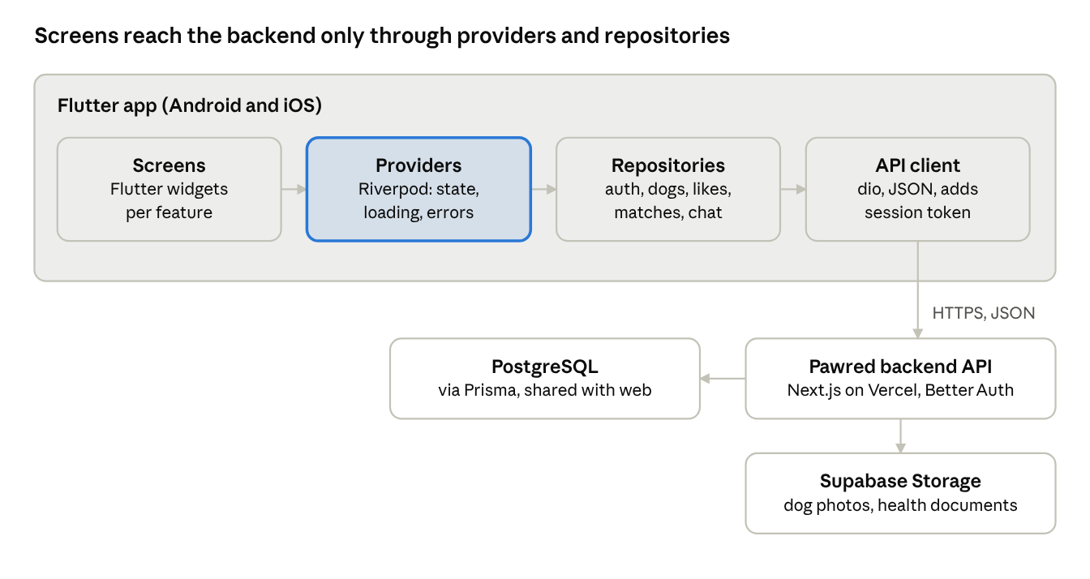
Fig. 3.1 — Architecture of the Flutter app
The web app and the Flutter app share the backend, database and file storage; only the screens differ.
Deployment. Debug builds run on the Android emulator and on an Android phone connected over USB, with hot reload during development. The backend address is passed at build time with --dart-define=API_URL=…, so the same code can point at a local server or the deployed one. The release app is built with flutter build apk --release, or flutter build appbundle for the Google Play Store. An iOS build needs a Mac with Xcode (flutter build ios).

Chapter 4 — Result Analysis
The app covers the full owner journey on a phone: sign up, create a dog profile, discover compatible dogs, like, match and chat. Figures 4.1 to 4.4 show the screen designs the Flutter app follows.
Note on the figures: these are reference UI designs taken from the mobile view of the Pawred web application and placed in a phone frame. They show the layout and flow the Flutter screens implement. They are not screenshots of the Flutter build. All names, dogs and messages are made-up sample data.
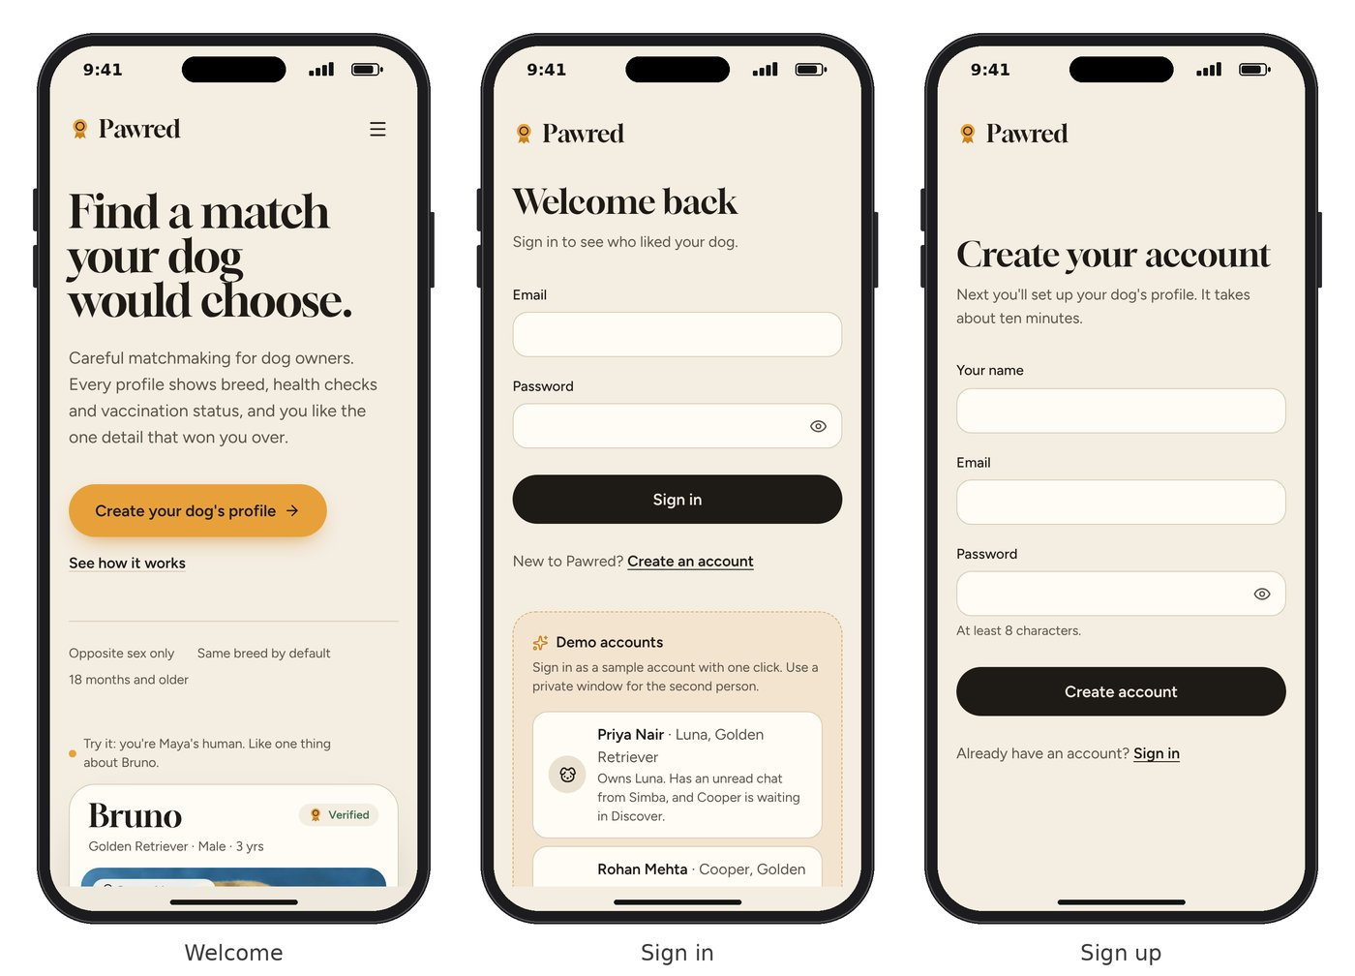
Fig. 4.1 — Reference UI design: welcome, sign-in and sign-up screens
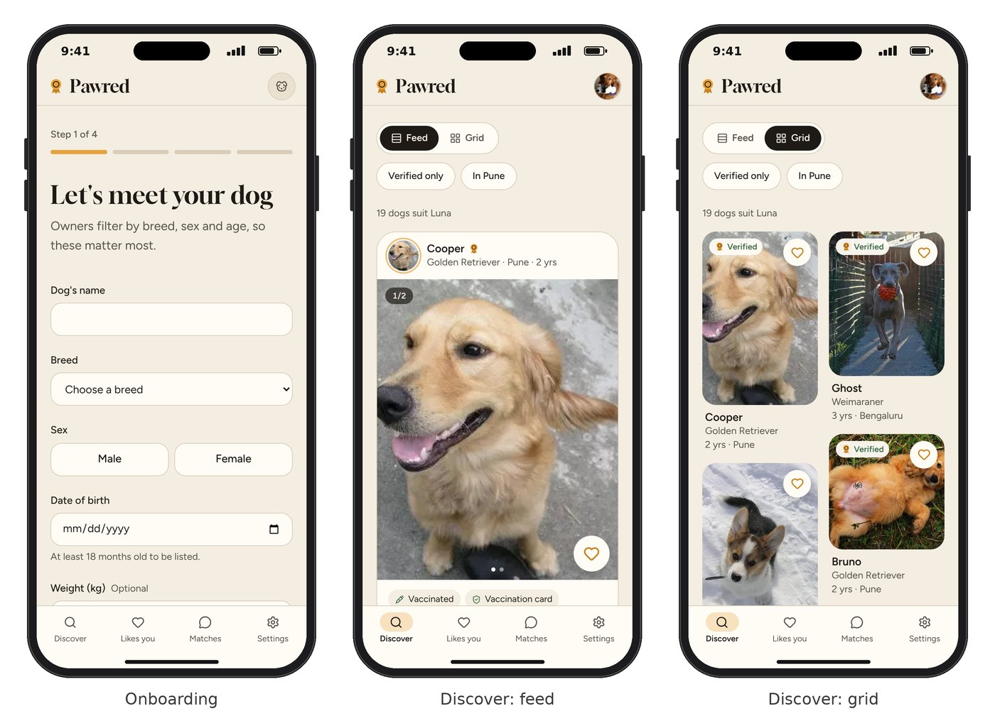
Fig. 4.2 — Reference UI design: onboarding step 1, Discover feed and Discover grid
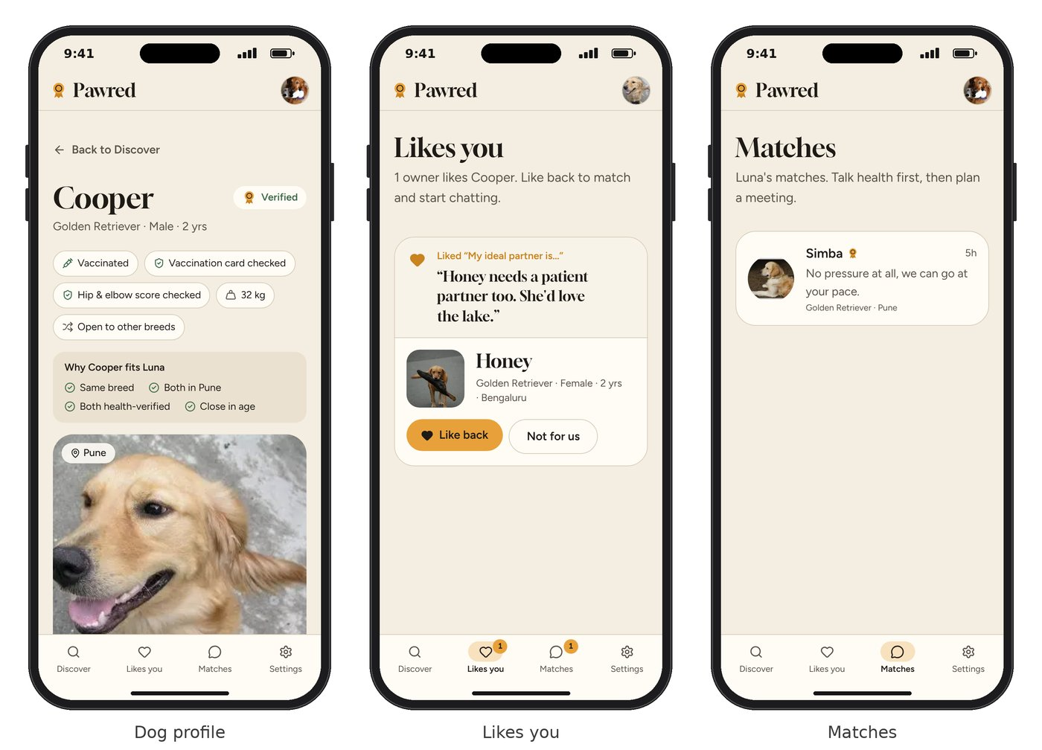
Fig. 4.3 — Reference UI design: dog profile with fit notes, Likes you, and Matches
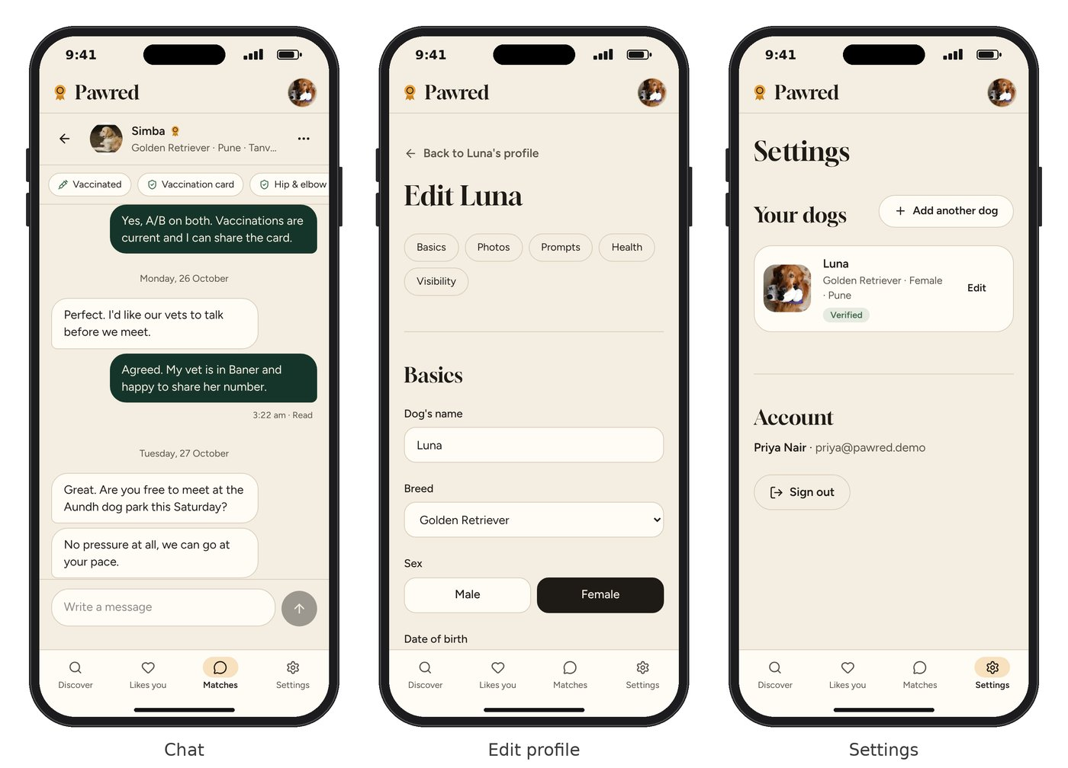
Fig. 4.4 — Reference UI design: chat with read receipts, edit profile, and settings

4.1 Performance Evaluation
Table 4.1 — Functional test results (fill the Result column after testing the Flutter app on a phone)
Test ID | Test case | Expected result | Result
T1 | Sign up with name, email and password | Account created; onboarding opens | [Pass/Fail]
T2 | Complete the 4 onboarding steps | Dog profile saved with photos, prompts and documents | [Pass/Fail]
T3 | Open Discover as a female Golden Retriever | Only male dogs, same breed, aged 18 months or more | [Pass/Fail]
T4 | Switch between feed and grid; apply filters | Layout and list update correctly | [Pass/Fail]
T5 | Like a specific photo with a comment | Receiver sees the photo and comment under Likes you | [Pass/Fail]
T6 | Receiver likes back | Match created; both owners can chat | [Pass/Fail]
T7 | Send a chat message | Message appears on the other phone, then “Read” | [Pass/Fail]
T8 | Edit the dog's details | Changes saved and shown on the profile | [Pass/Fail]
T9 | Rotate the phone, use a small screen | Layout stays readable; nothing cut off | [Pass/Fail]
T10 | Sign out and reopen the app | Sign-in screen shown; data protected | [Pass/Fail]
Recommendation quality. Because the filter is rule-based, every suggestion is valid by construction: no dog shown breaks the sex, breed, age or completeness rules. Showing admirers first shortens the path to a match to one tap, and fit notes make each suggestion explainable.
App performance. Table 4.2 sets the performance targets for the release build. Measure each one with Flutter DevTools on a mid-range Android phone and record the result.
Table 4.2 — Performance targets
Measure | How it is measured | Target | Result
Release APK size | Size of the file from flutter build apk --release --split-per-abi | Under 25 MB | [measure]
Cold start time | App launch to first Discover frame (DevTools timeline) | Under 2 seconds | [measure]
Scrolling smoothness | Frame rate while scrolling the Discover feed (DevTools performance view) | 60 fps, no janky frames | [measure]
Photo upload | Time to compress and upload one photo on 4G | Under 3 seconds | [measure]
New chat message | Time for a sent message to appear on the other phone | Within 4 seconds (one poll) | [measure]
The main techniques that keep the app fast are cached network images, photos compressed before upload, lazily built lists (ListView.builder), and const widgets where the content does not change.

Chapter 5 — Conclusion
Pawred Mobile brings a health-first, explainable dog matchmaking system to Android and iOS from one Flutter codebase. It recommends only compatible dogs, shows likely matches first, explains why each dog fits, and keeps health information on every profile. Specific likes, mutual matching and in-app chat replace the guesswork of classifieds and WhatsApp groups, and the design stays consistent with the Pawred web app.

5.1 Future Enhancements
- Push notifications for new likes, matches and messages (for example with Firebase Cloud Messaging).
- Real-time chat using WebSockets instead of refreshing for new messages.
- Location-based search using the phone's GPS to sort dogs by distance.
- Document scanning with the camera and OCR to read vaccination dates.
- Offline mode that caches profiles and chats for weak network areas.
- Learned ranking using collaborative filtering once enough likes and matches exist.
- Regional language support for owners across India.
- Publishing on the Google Play Store and Apple App Store.

References
- F. Ricci, L. Rokach and B. Shapira, Recommender Systems Handbook, 3rd ed., Springer, 2022.
- G. Linden, B. Smith and J. York, “Amazon.com recommendations: Item-to-item collaborative filtering,” IEEE Internet Computing, vol. 7, no. 1, pp. 76–80, 2003.
- Y. Koren, R. Bell and C. Volinsky, “Matrix factorization techniques for recommender systems,” Computer, vol. 42, no. 8, pp. 30–37, 2009.
- L. Pizzato, T. Rej, T. Chung, I. Koprinska and J. Kay, “RECON: A reciprocal recommender for online dating,” Proc. ACM RecSys, pp. 207–214, 2010.
- R. Burke, “Hybrid recommender systems: Survey and experiments,” User Modeling and User-Adapted Interaction, vol. 12, pp. 331–370, 2002.
- Flutter Documentation. https://docs.flutter.dev
- Dart Language Documentation. https://dart.dev/guides
- Riverpod Documentation. https://riverpod.dev
- go_router package. https://pub.dev/packages/go_router
- dio package. https://pub.dev/packages/dio
- Better Auth Documentation. https://www.better-auth.com/docs
- Material Design 3 Guidelines. https://m3.material.io
- Web Content Accessibility Guidelines (WCAG) 2.2, W3C. https://www.w3.org/TR/WCAG22/

