Mini Project Report
Oct 24, 2026 · @R
Pawred: A Health-First Dog Matchmaking and Recommendation System
Mini Project (DJS23AMD302L) · Submitted by Adish Shah (A110), Manya Sanghvi (A133), Kavya Shah (A114), Juee Shimpi (A118) · Guided by [Guide Name] · [Department], [College Name] · Academic Year 2026–27

Table of Content
Sr. No. |  | Content
1. |  | Declaration
2. |  | Acknowledgement
3. |  | Abstract
4. |  | Table of Content
5. |  | List of Figures
6. |  | List of Tables
7. |  | List of Abbreviation
8. |  | Chapter 1 — Introduction
 | 1.1 | Objectives of the System
 | 1.2 | Scope of the Project
9. |  | Chapter 2 — Literature Review
 | 2.1 | Existing Recommendation Techniques
 | 2.2 | Applications of Recommendation Systems in E-commerce
10. |  | Chapter 3 — Implementation
 | 3.1 | Weekly Implementation of Tasks
 | 3.2 | System Development & Deployment
11. |  | Chapter 4 — Result Analysis
 | 4.1 | Performance Evaluation
12. |  | Chapter 5 — Conclusion
 | 5.1 | Future Enhancements
13. |  | References

1. Declaration
I/We declare that this written submission represents my/our ideas in my/our own words. Where others' ideas or words have been included, I/we have adequately cited and referenced the original sources. I/We also declare that I/we have adhered to all principles of academic honesty and integrity and have not misrepresented, fabricated or falsified any idea, data, fact or source in my/our submission.
Adish Shah (A110), Manya Sanghvi (A133), Kavya Shah (A114), Juee Shimpi (A118) · Signature: ____________ · Date: ____________

2. Acknowledgement
We express our sincere gratitude to our project guide, [Guide Name], for their constant guidance and feedback throughout this mini project. We thank [Head of Department] and the faculty of [Department], [College Name], for providing the facilities and support needed to complete this work. We also thank our classmates and families for their encouragement.

3. Abstract
Pawred is a web-based matchmaking and recommendation system that helps dog owners in India find a healthy, compatible breeding partner for their dog. Unlike classified ads and WhatsApp groups, Pawred puts health first: every profile carries vaccination status, health checks and optional pedigree papers, and an administrator verifies documents before a Verified badge appears.
The system uses a rule-based, content-filtered recommendation engine. Candidates are filtered on opposite sex, same breed (unless both owners accept other breeds), a minimum age of 18 months, a complete active profile, and no prior interaction. Dogs that have already liked the user are ranked first, followed by the newest profiles. Each suggestion is explained with plain-language “fit notes” such as same breed, same city, health-verified and close in age.
Likes target a specific photo or prompt answer, a mutual like creates a match, and matched owners chat in real time. The application is built with Next.js 16 (App Router), React 19, TypeScript, Tailwind CSS, Prisma ORM, PostgreSQL on Supabase and Better Auth, and is deployed on Vercel.
Keywords: recommendation system, content-based filtering, matchmaking, Next.js, PostgreSQL, pet health verification.

5. List of Figures
Fig. No. | Title | Chapter
3.1 | System architecture of Pawred | 3
4.1 | Landing page | 4
4.2 | How it works page | 4
4.3 | Safety page and breed guide | 4
4.4 | Sign-in and sign-up pages | 4
4.5 | Onboarding | 4
4.6 | Discover, Feed view | 4
4.7 | Discover, Grid view | 4
4.8 | Discover on a phone | 4
4.9 | Dog profile | 4
4.10 | Edit dog profile | 4
4.11 | Settings | 4
4.12 | Likes you and matches | 4
4.13 | Chat | 4
4.14 | Admin overview | 4
4.15 | Admin verifications | 4
4.16 | Admin reports and users | 4

6. List of Tables
Table No. | Title | Chapter
2.1 | Comparison of recommendation techniques | 2
2.2 | Recommendation systems in e-commerce platforms | 2
3.1 | Weekly implementation plan | 3
3.2 | Technology stack | 3
3.3 | Database entities | 3
4.1 | Functional test results | 4

7. List of Abbreviation
Abbreviation | Full Form
API | Application Programming Interface
CBF | Content-Based Filtering
CF | Collaborative Filtering
CRUD | Create, Read, Update, Delete
ORM | Object-Relational Mapping
RLS | Row-Level Security
RSC | React Server Components
SQL | Structured Query Language
UI | User Interface
WCAG | Web Content Accessibility Guidelines

Chapter 1 — Introduction
Responsible dog breeding depends on finding a partner that is the right breed, the right age and in good health. In India, most owners search through classified ads, social media posts and WhatsApp groups. These channels give no way to check health records and no filtering for compatibility, so owners spend time on unsuitable matches and risk passing on hereditary disease.
Pawred addresses this with a recommendation system modelled on modern dating apps such as Hinge. It suggests only compatible dogs, explains why each suggestion fits, and gives verified health information a central place on every profile.

1.1 Objectives of the System
- Recommend only biologically and practically compatible dogs: opposite sex, same breed by default, and at least 18 months old.
- Rank recommendations so that likely matches appear first: dogs that have already liked the user, then the newest profiles.
- Explain each recommendation in plain language (same breed, same city, health-verified, close in age).
- Store vaccination cards, hip and elbow scores, genetic tests and pedigree certificates, and let an administrator verify them.
- Replace blind swiping with specific likes on a photo or prompt answer, with an optional comment.
- Turn a mutual like into a match and open a real-time chat between the two owners.
- Give administrators tools to verify documents, handle reports, pause dogs and ban users, with every action logged.

1.2 Scope of the Project
In scope
- Web application usable on mobile and desktop browsers.
- Owner sign-up, sign-in and onboarding of one or more dog profiles with photos, prompts and health documents.
- Discover page in Feed and Grid views, with filters for verified dogs and city.
- Likes, passes, matches, chat with read receipts, and unread badges.
- Admin panel for verifications, reports, users and an activity feed.
- Public pages: landing page, how it works, safety and breed guides.
Out of scope
- Payments, stud fees or contracts between owners.
- Native Android/iOS apps.
- Veterinary diagnosis; the system records documents and does not judge medical fitness.
- Professional kennels; the target user is the regular pet owner.

Chapter 2 — Literature Review
A recommendation system predicts which items a user is likely to want and presents them in ranked order. Pawred uses a hard-constraint, content-based approach because breeding rules are fixed, and because a new platform has too little interaction data for collaborative filtering.

2.1 Existing Recommendation Techniques
Table 2.1 — Comparison of recommendation techniques
Technique | How it works | Strengths | Limitations
Content-based filtering | Recommends items whose attributes match the user's profile or past choices | Works for new items; explainable | Narrow suggestions; needs good item attributes
Collaborative filtering (user/item based) | Uses ratings or actions of similar users | Finds unexpected items; no domain features needed | Cold-start and sparsity problems
Matrix factorisation | Learns latent user and item vectors from the interaction matrix | Accurate at scale (Netflix Prize) | Needs large data; hard to explain
Knowledge/constraint-based | Applies explicit rules and requirements | No history needed; guarantees valid results | Rules must be maintained by hand
Hybrid | Combines two or more of the above | Offsets weaknesses of each | More complex to build
Reciprocal recommendation | Recommends people to people; both sides must accept | Fits dating and job platforms | Must model two preferences at once
Pawred combines a constraint-based filter (sex, breed, age, completeness) with a simple reciprocal signal: a dog that has already liked the user is ranked first, because a like back creates a match immediately.

2.2 Applications of Recommendation Systems in E-commerce
E-commerce is the largest commercial use of recommendation systems. They raise conversion, basket size and retention by surfacing relevant products.
Table 2.2 — Recommendation systems in e-commerce and similar platforms
Platform | Application | Technique
Amazon | “Customers who bought this also bought” | Item-to-item collaborative filtering
Netflix | Personalised rows of films and shows | Matrix factorisation, hybrid models
Flipkart / Myntra | Similar products and personalised home feed | Hybrid content + collaborative
Spotify | Discover Weekly playlists | Collaborative filtering + audio content features
Hinge / Tinder | Daily suggested profiles | Reciprocal recommendation
LinkedIn | People you may know, job suggestions | Graph-based and reciprocal
Pawred borrows from both groups: the product-style filtering and “why this fits” explanations of e-commerce, and the mutual-consent matching of dating platforms.

Chapter 3 — Implementation
Pawred is a full-stack TypeScript web application: one Next.js codebase renders the pages, runs the matching logic on the server, and talks to a PostgreSQL database hosted on Supabase.

3.1 Weekly Implementation of Tasks
The project was carried out over eight weeks by a team of four. Table 3.1 lists the work completed in each week. [Adjust the weeks and tasks to match your actual schedule.]
Table 3.1 — Weekly implementation plan
Week | Tasks completed | Output
1 | Chose the problem, studied how owners find breeding partners today, and listed the matching rules (opposite sex, same breed, 18 months or older) | Problem statement and requirements
2 | Reviewed recommendation techniques; designed the database schema and the look of the app | Literature review, ER design, UI direction
3 | Set up Next.js, Tailwind, Prisma and Supabase; wrote the first migrations; built sign-up, sign-in and roles with Better Auth | Working authentication
4 | Built dog onboarding: basics, photos, prompt answers and health documents, with file upload to storage | Dog profiles with health documents
5 | Built the matching engine (compatibility filter, ranking, fit notes) and the Discover feed and grid | Discover page
6 | Built likes, passes, matches and chat with read receipts and unread badges | Likes you, Matches and Chat pages
7 | Built the admin panel (verifications, reports, users, activity feed); enabled row-level security | Admin panel
8 | Built the landing and information pages; seeded demo data; tested, fixed and deployed on Vercel; wrote this report | Deployed app and report

3.2 System Development & Deployment
System architecture. Fig. 3.1 shows how the parts of Pawred fit together.
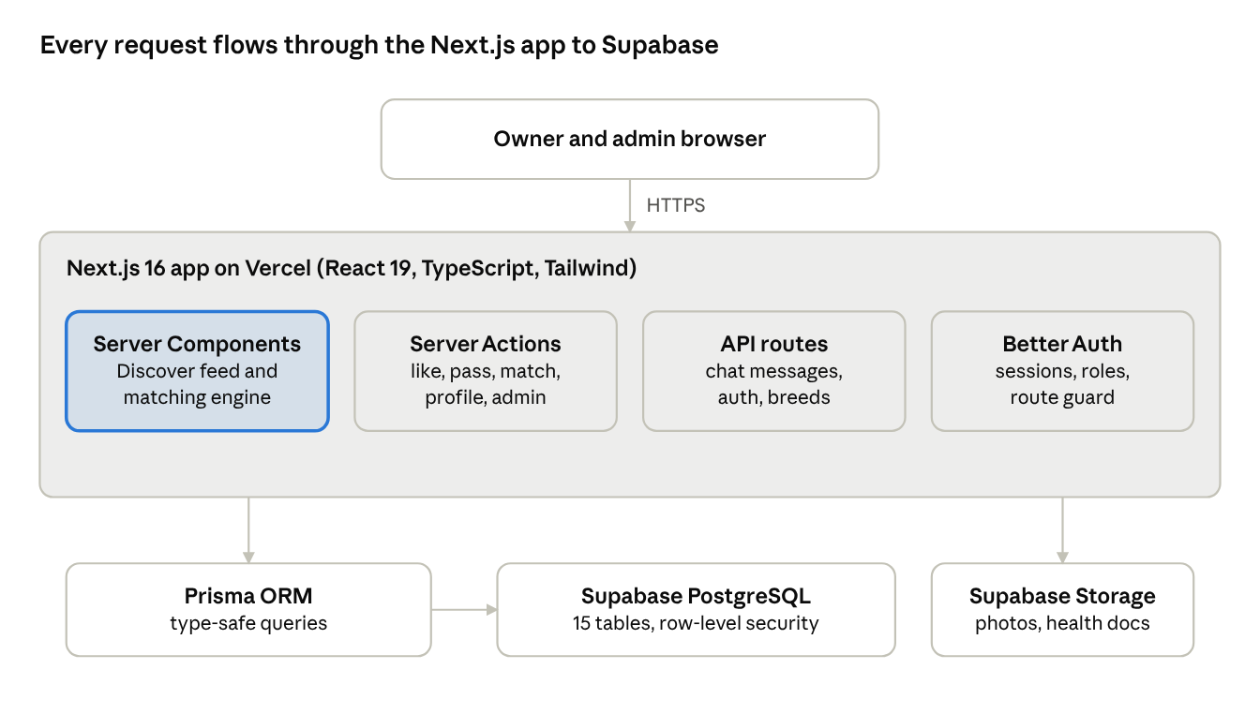
Fig. 3.1 — System architecture of Pawred
The browser never queries the database directly. Pages are React Server Components that call the matching engine on the server; user actions such as liking, passing and editing a profile are Server Actions; chat messages use an API route that the open chat polls every few seconds. Photos and health documents are stored in Supabase Storage.
Table 3.2 — Technology stack
Layer | Technology | Purpose
Frontend | Next.js 16 (App Router), React 19, Tailwind CSS 4, Motion | Pages, layout, animation
Language | TypeScript 5 | Type safety across client and server
Validation | Zod 4 | Validates every form and action input
Authentication | Better Auth | Email/password sign-in, sessions, owner and admin roles
Database | PostgreSQL on Supabase, Prisma 7 ORM | Data storage, migrations, row-level security
File storage | Supabase Storage | Dog photos and health documents
Hosting | Vercel | Build, deploy and serve the app
Table 3.3 — Database entities
Entity | Stores
User, Session, Account, Verification | Owners, admins and their login sessions
Dog | Name, breed, sex, date of birth, city, active flag, verification status
DogPhoto, PromptAnswer | Up to several photos and three prompt answers per dog
HealthDoc | Vaccination, hip and elbow, genetic and pedigree documents with review status
Like, Pass | A like on a specific photo or prompt with an optional comment; a pass
Match, Message | A mutual like and the chat messages with read time
Report, ActivityLog, Notification | User reports, admin actions, in-app notifications
Recommendation algorithm. For the active dog (the seeker), the engine builds one database filter and returns candidates in ranked order:
- Exclude the seeker, the owner's other dogs, banned owners and inactive profiles.
- Keep only the opposite sex and dogs born at least 18 months ago.
- Keep the same breed; if the seeker is open to other breeds, also keep dogs whose owners are open to other breeds.
- Keep only complete profiles (at least one photo and prompt answers).
- Remove dogs already liked, passed or matched.
- Apply optional filters: verified only, city.
- Rank dogs that already liked the seeker first, then the newest profiles.
- Attach fit notes: same breed, same city, health-verified, close in age (within 3 years).
Match flow. Owner A likes a photo or prompt on dog B → B's owner sees it under Likes You → a like back creates a Match → both owners can chat, with read receipts and unread counts.
Development. The app was built in modules: authentication and onboarding, dog profiles and health documents, Discover and matching, likes and matches, chat, and the admin panel. Pages are grouped into route groups for marketing, auth, app and admin, so each gets its own layout and access rules. Pending likes and match lists are cached and refreshed by tag whenever an action changes them.
Database. The schema is defined in Prisma and versioned through four migrations: initial schema, row-level security, auth roles and admin activity actions. A seed script creates 41 sample dogs, 7 matches, chats and 3 demo accounts for testing.
Security. Passwords and sessions are handled by Better Auth. A route proxy blocks signed-out users from app pages and non-admins from admin pages. Row-level security is enabled on the database tables, and all inputs are validated with Zod.
Deployment. The code is hosted on GitHub and deployed on Vercel. On each deploy, Vercel runs prisma migrate deploy and then next build. Environment variables hold the database URL, Supabase keys and auth secret. A demo mode flag shows one-click demo sign-ins and is switched off for a real launch.

Chapter 4 — Result Analysis
The system meets all seven objectives in section 1.1: every Discover suggestion obeys the breeding rules, admirers appear first, and a mutual like opens a working chat. Results were checked against the seeded sample data (41 dogs, 7 matches, 3 demo accounts) using the demo walkthrough.
The screens below were captured from the running application. All owners, dogs, chats and health documents shown are made-up sample data. Three demo accounts were used: Priya Nair (owner of Luna), Rohan Mehta (owner of Cooper) and the Pawred Admin. Where two screens share one figure, the first is on top.
Public pages
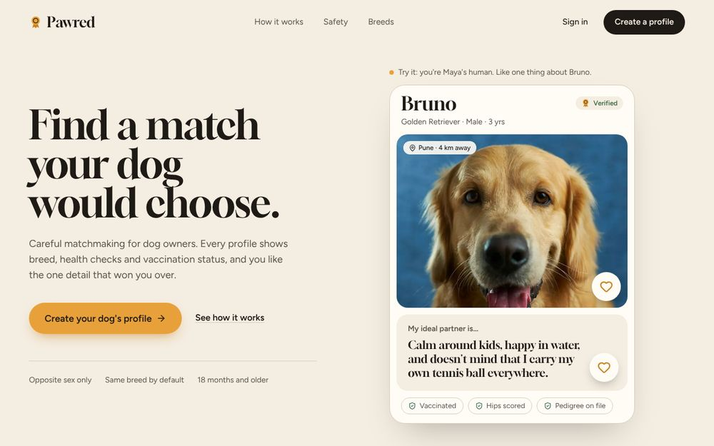
Fig. 4.1 — Landing page with a sample profile visitors can like
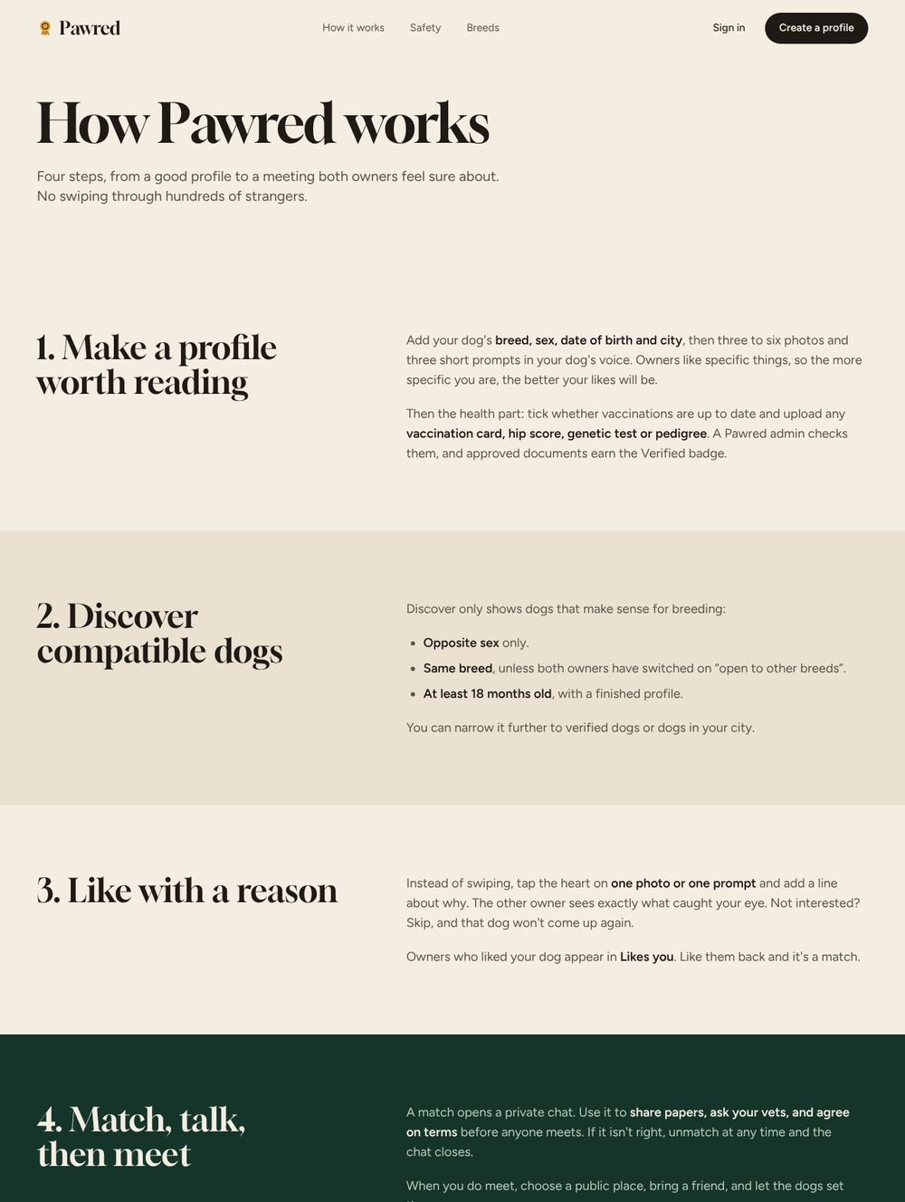
Fig. 4.2 — How it works page
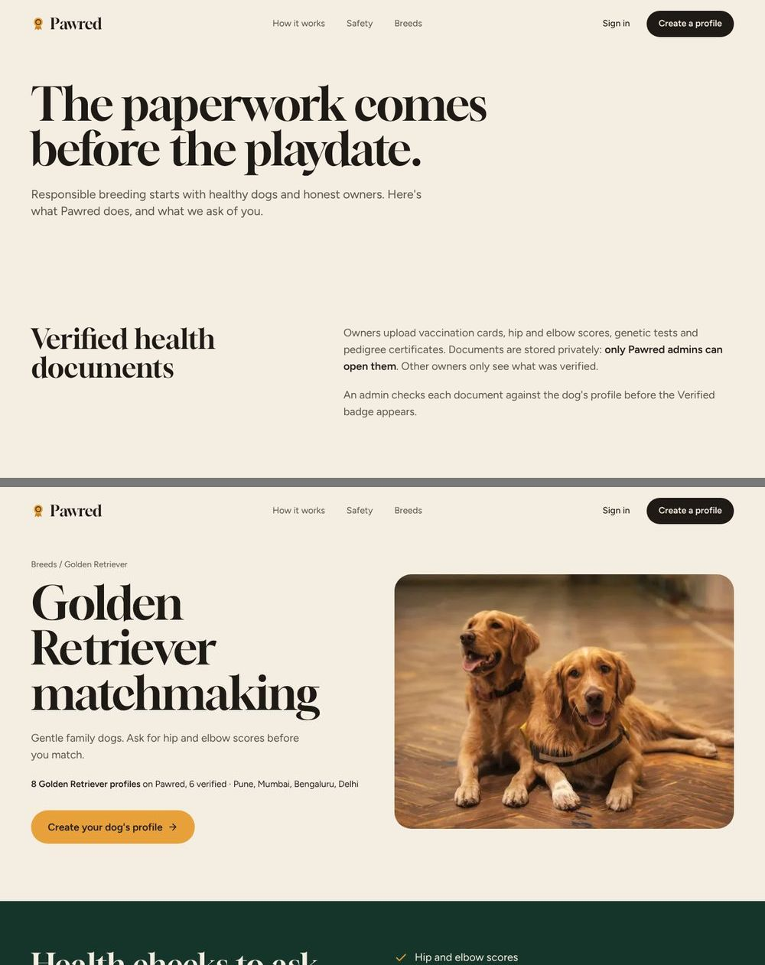
Fig. 4.3 — Safety page (top) and breed guide for Golden Retrievers (bottom)
Sign-up, sign-in and onboarding
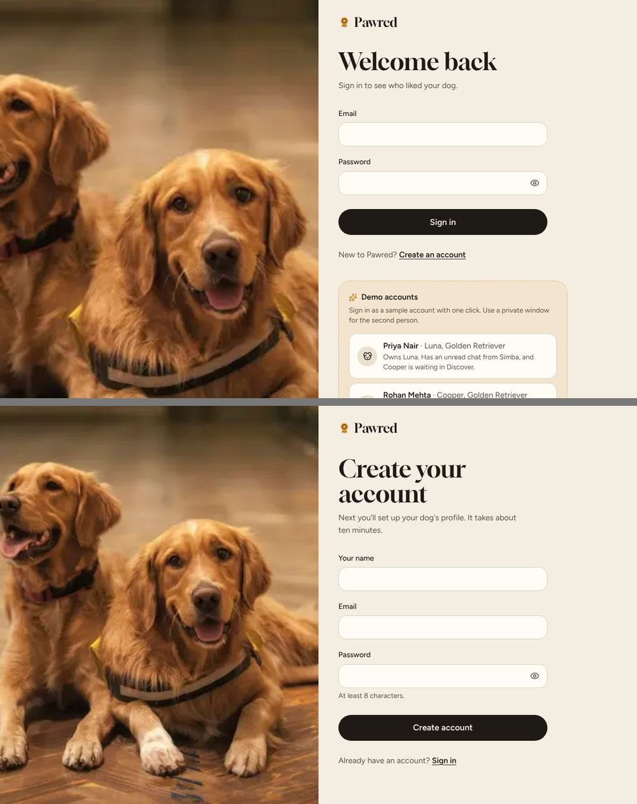
Fig. 4.4 — Sign-in page with one-click demo accounts (top) and sign-up page (bottom)
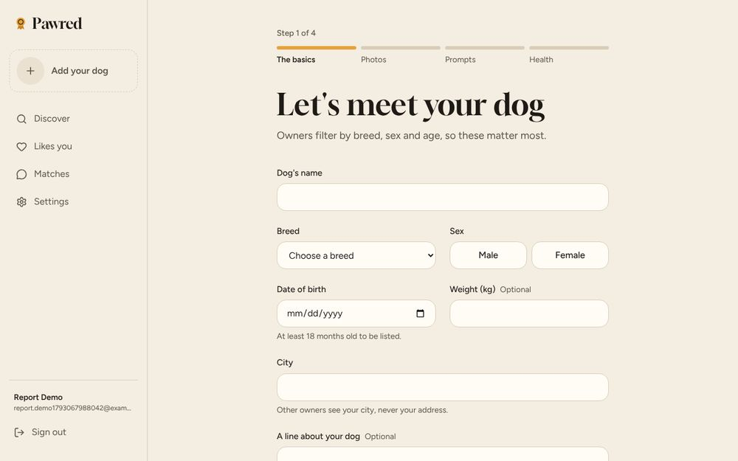
Fig. 4.5 — Onboarding step 1 of 4: the basics (name, breed, sex, date of birth, city)
Discover
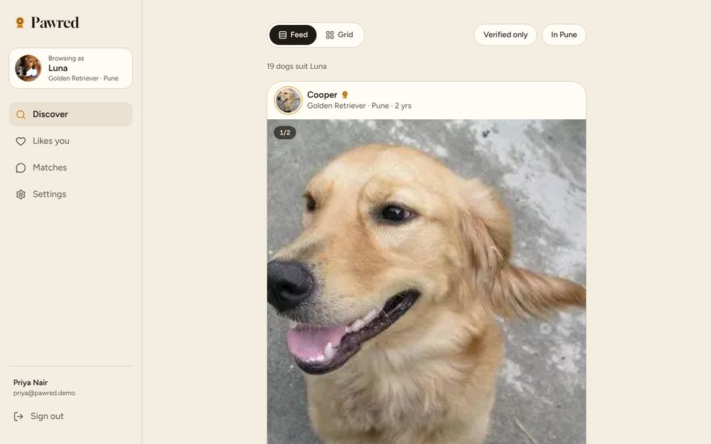
Fig. 4.6 — Discover, Feed view: dogs that suit Luna, with Verified-only and city filters
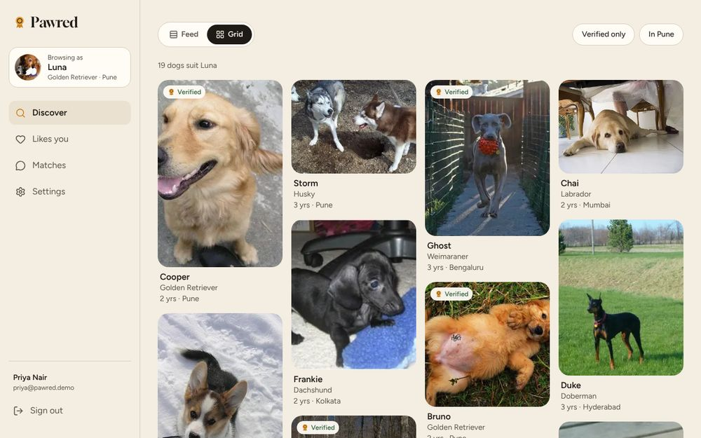
Fig. 4.7 — Discover, Grid view
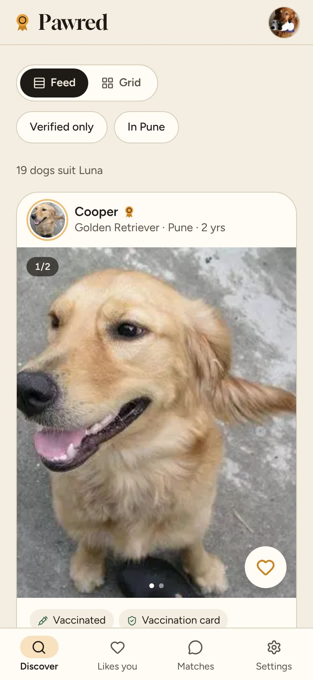
Fig. 4.8 — Discover on a phone
Dog profile and settings
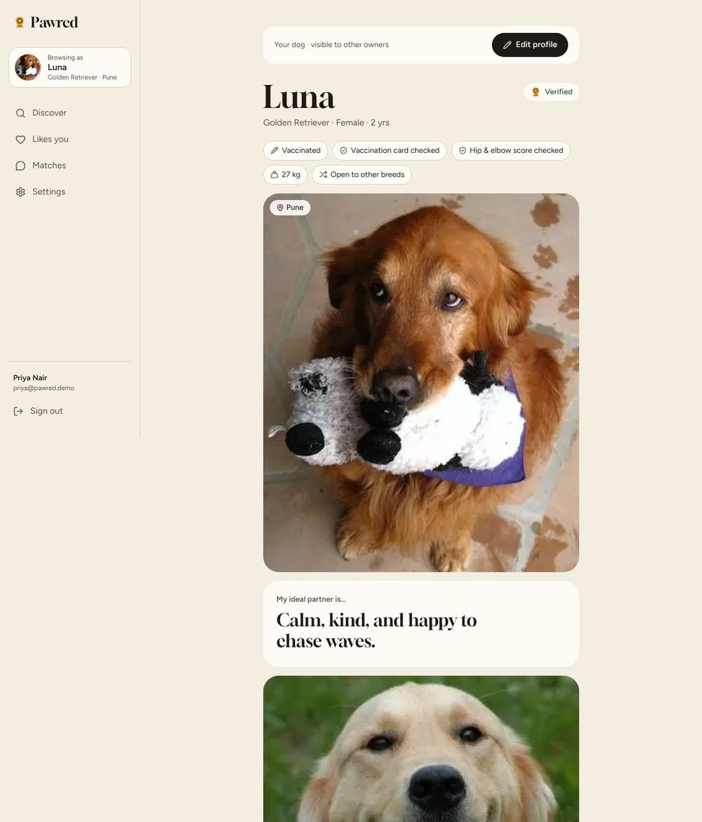
Fig. 4.9 — Dog profile page (Luna)
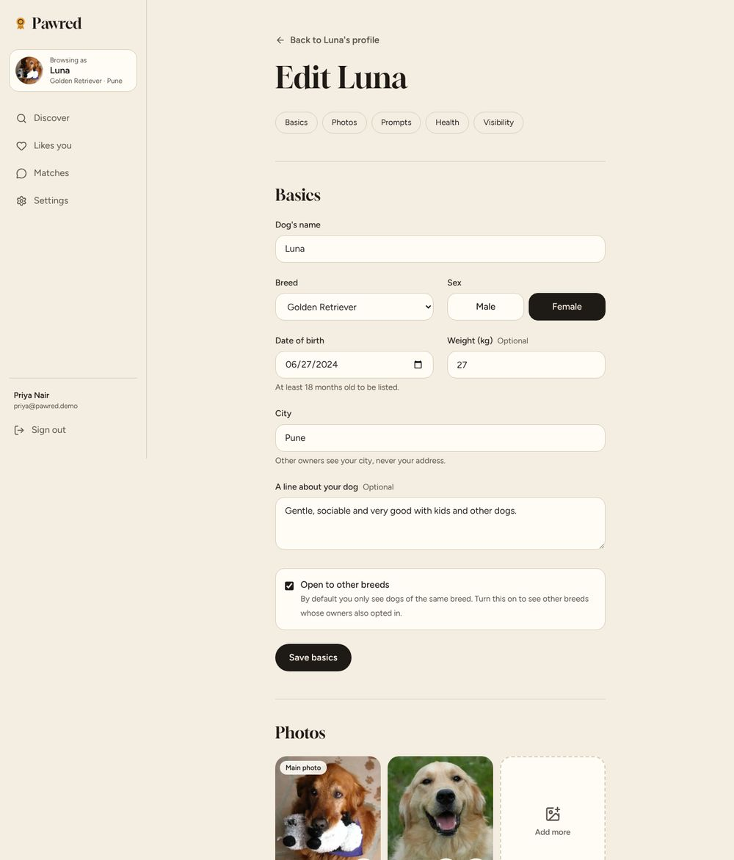
Fig. 4.10 — Edit profile: basics, photos, prompts, health and visibility
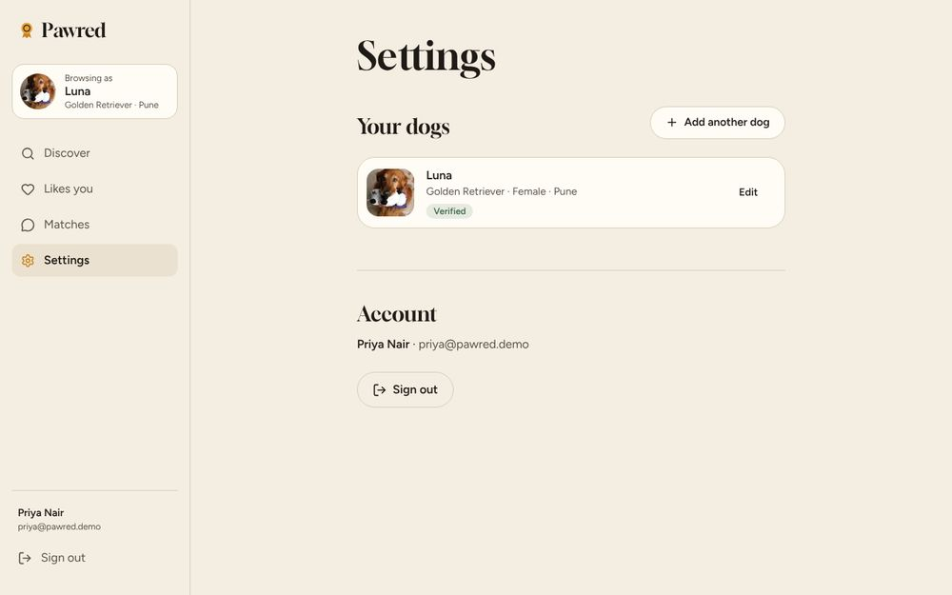
Fig. 4.11 — Settings: the owner's dogs and account
Likes, matches and chat
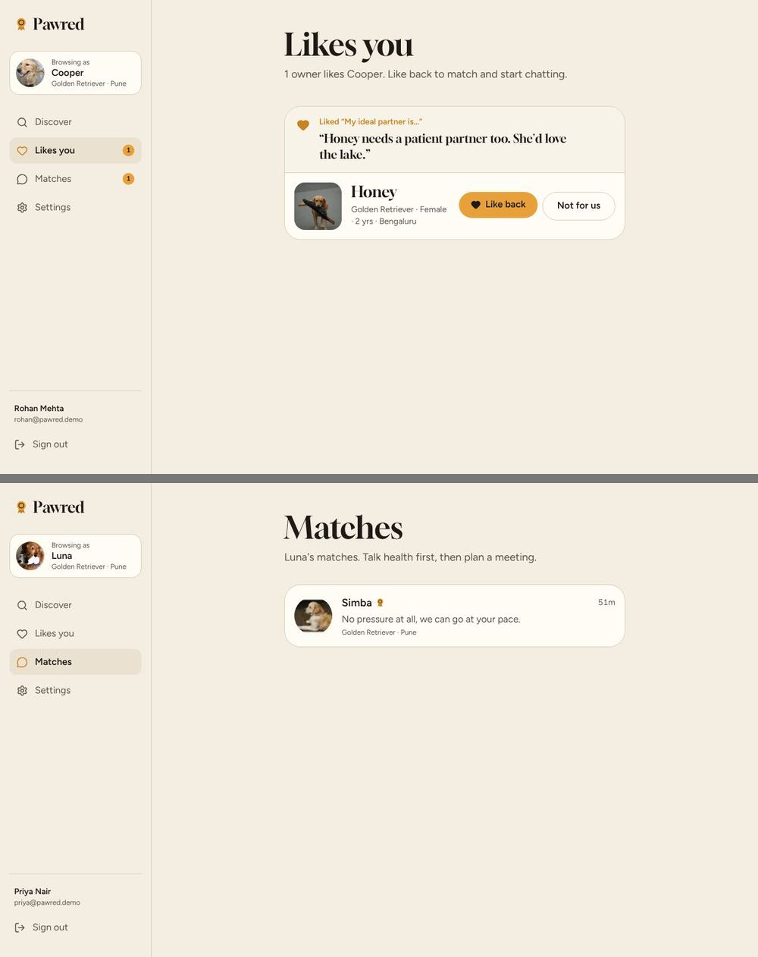
Fig. 4.12 — Likes you (top): Honey liked a prompt on Cooper's profile, and the owner can like back or decline; Matches list with unread badges (bottom)
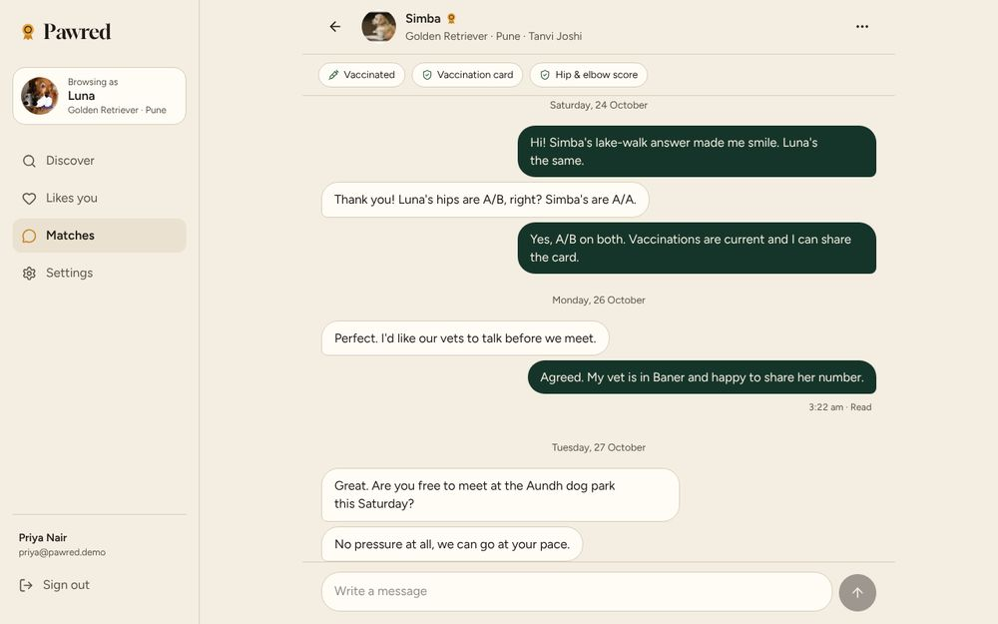
Fig. 4.13 — Chat between matched owners, with read receipts
Admin panel
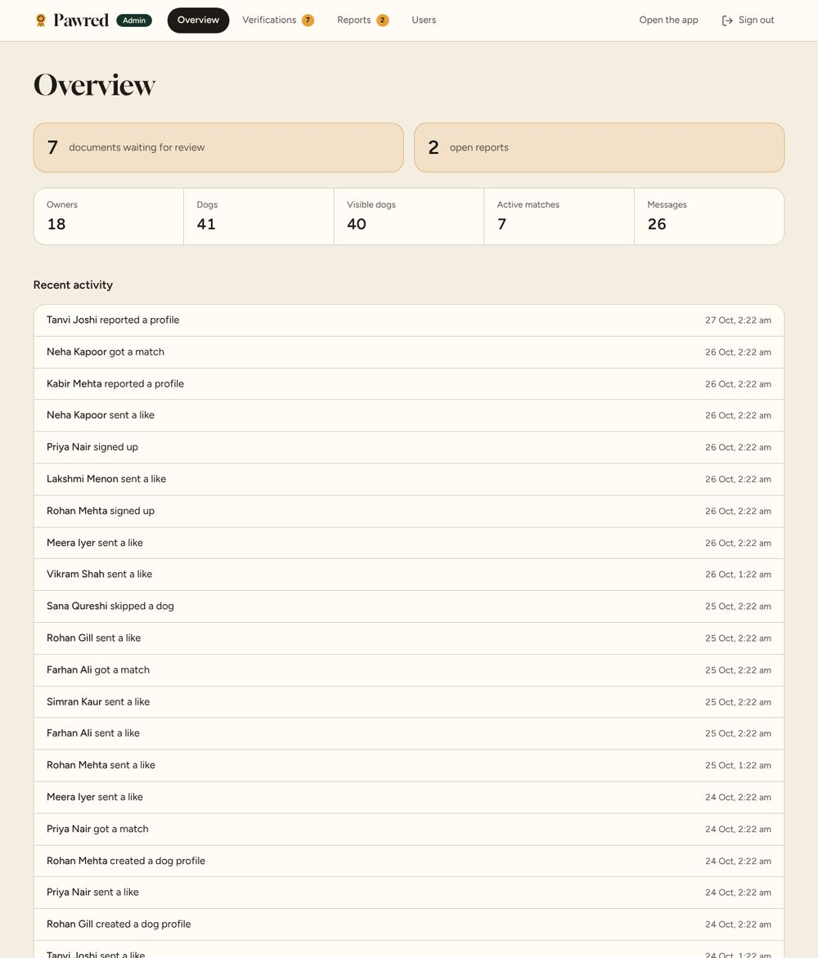
Fig. 4.14 — Admin overview: totals and recent activity
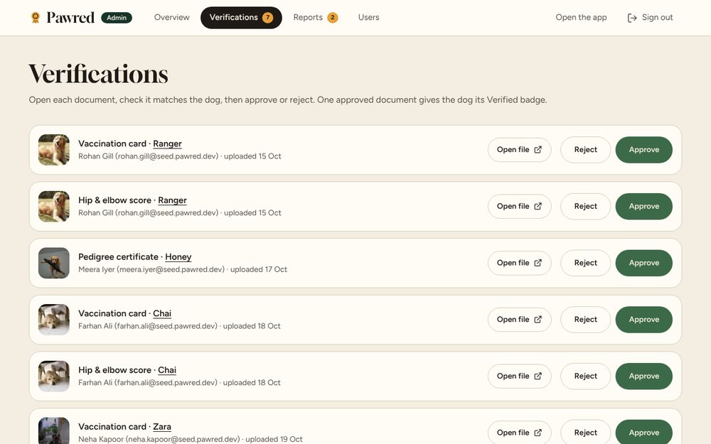
Fig. 4.15 — Admin verifications: approve or reject health documents
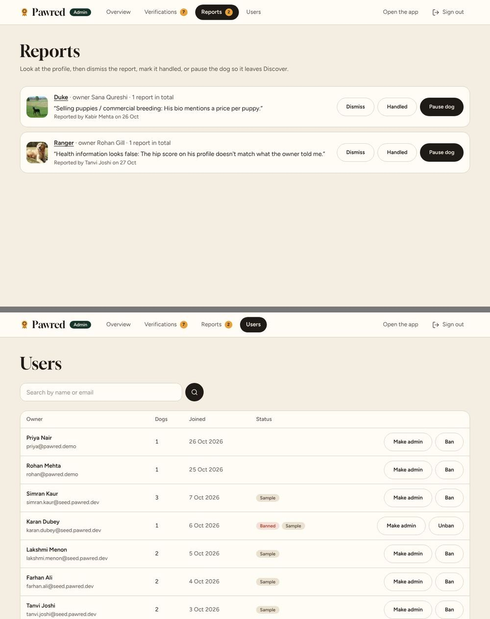
Fig. 4.16 — Admin reports (top) and users (bottom)

4.1 Performance Evaluation
Table 4.1 — Functional test results (fill the Result column after running each test)
Test ID | Test case | Expected result | Result
T1 | Sign up and create a dog profile with photos and 3 prompts | Profile saved and shown in Discover to compatible dogs | [Pass/Fail]
T2 | Open Discover as a female Golden Retriever | Only male dogs, same breed, aged 18 months or more | [Pass/Fail]
T3 | A dog has already liked the user | That dog appears first in Discover | [Pass/Fail]
T4 | Like a specific photo with a comment | Receiver sees the photo and comment under Likes You | [Pass/Fail]
T5 | Receiver likes back | Match created; both owners can chat | [Pass/Fail]
T6 | Send a chat message | Message appears in the other window within a few seconds, then “Read” | [Pass/Fail]
T7 | Pass on a dog | Dog no longer shown in Discover | [Pass/Fail]
T8 | Admin approves a health document | Dog shows the Verified badge | [Pass/Fail]
T9 | Admin pauses a dog or bans an owner | Dog hidden from Discover; action listed in the activity feed | [Pass/Fail]
T10 | Signed-out user opens /discover; owner opens /admin | Redirected to sign-in; admin pages refused | [Pass/Fail]
Recommendation quality. Because the filter is rule-based, every suggestion is valid by construction: no recommended dog breaks the sex, breed, age or completeness rules. The ranking puts reciprocal interest first, which shortens the path to a match to one tap. Fit notes make every suggestion explainable, which classic collaborative filtering cannot offer.
Efficiency. The Discover page fetches admirers, newest profiles and the remaining count in one round of three parallel database queries. Pending likes and match lists are cached per dog and refreshed only when an action changes them. The open chat polls for new messages at a fixed interval rather than reloading the page.
Speed and accessibility. [Insert Lighthouse scores for Performance, Accessibility, Best Practices and SEO for the landing and Discover pages.] The design targets WCAG AA contrast, visible keyboard focus and reduced motion.

Chapter 5 — Conclusion
Pawred shows that a rule-based, explainable recommendation system fits a domain where the rules are fixed and trust matters more than surprise. It recommends only compatible dogs, ranks likely matches first, tells owners why each dog fits, and puts verified health records on every profile. Specific likes, mutual matching and in-app chat replace the guesswork of classifieds and WhatsApp groups. The project covers a full-stack web application from database design and authentication to deployment on Vercel.

5.1 Future Enhancements
- Learned ranking: once enough likes and matches exist, add collaborative filtering or a hybrid model to rank compatible dogs by predicted mutual interest.
- Distance-based search: use location coordinates to sort and filter by kilometres, not just city.
- Real-time chat: replace polling with WebSockets or Supabase Realtime.
- Automated document checks: OCR to read vaccination dates and flag expired records before admin review.
- Genetic compatibility hints: warn when both dogs carry the same hereditary-disease marker from their test reports.
- Mobile app and push notifications for new likes, matches and messages.
- Regional language support for owners across India.

References
- F. Ricci, L. Rokach and B. Shapira, Recommender Systems Handbook, 3rd ed., Springer, 2022.
- G. Linden, B. Smith and J. York, “Amazon.com recommendations: Item-to-item collaborative filtering,” IEEE Internet Computing, vol. 7, no. 1, pp. 76–80, 2003.
- Y. Koren, R. Bell and C. Volinsky, “Matrix factorization techniques for recommender systems,” Computer, vol. 42, no. 8, pp. 30–37, 2009.
- L. Pizzato, T. Rej, T. Chung, I. Koprinska and J. Kay, “RECON: A reciprocal recommender for online dating,” Proc. ACM RecSys, pp. 207–214, 2010.
- R. Burke, “Hybrid recommender systems: Survey and experiments,” User Modeling and User-Adapted Interaction, vol. 12, pp. 331–370, 2002.
- Next.js Documentation, Vercel. https://nextjs.org/docs
- Prisma ORM Documentation. https://www.prisma.io/docs
- Supabase Documentation. https://supabase.com/docs
- Better Auth Documentation. https://www.better-auth.com/docs
- Web Content Accessibility Guidelines (WCAG) 2.2, W3C. https://www.w3.org/TR/WCAG22/

