# ONLINE

# COMPETITIVE

# PROGRAMMING

# PORTAL

1. **INTRODUCTION**
   1. *Purpose and Objective…………………………………………….….…3*
   2. *Project Category……………………….………………………………3*
   3. *Scope………………………………………………………………...3*
   4. *Document Conventions………………………………………………….4*
   5. *Definitions, Acronyms and Abbreviations…..………………………………4*
   6. *Technologies to be used…………………………………………………5*
   7. *Overview……………………………………………………………..5*
   8. *References…………………………………………………………….5*
2. **OVERALL DESCRIPTION**
   1. *Product Perspective……………………………………………………............6*
   2. *Software Interface……………………………………………………...7*
   3. *Hardware Interface…………………………………………………..7-8*
   4. *Product Schedule…………………………………………………….8-9*
   5. *Product Functions…………………………………………………10-12*
   6. *User Characteristics………………………………………………..…12*
   7. *Constraints………………………………………………………….13*
   8. *Assumptions and Dependencies…………………………………………13*
   9. *Entity Relationship diagram……………………….………….…….13-14*
   10. *Data Flow Diagram………………………………………….……15-18*
   11. *Database Design………………………………………………….19-20*
3. **SPECIFIC REQUIREMENTS**
   1. *Performance Requirements…………………………………………...…21*
   2. *Design Constraints……………………………………………………21*
   3. *Software System Attributes Requirements*
      1. *Reliability……………………………………………………………….21*
      2. *Availability……………………………………………………………...22*
      3. *Security………………………………………………………………....22*
      4. *Maintainability…………………………………………………...…..22-23*
   4. *Future Scope………………………………………………………....23*
   5. *Tentative Layout……………………..………………………..……..24*

# Introduction: Purpose and Objective:-

The *Online Competitive Programming Portal* is developed with the objective to allow students of Computer Science to practice and hone their programming skills. It provides an opportunity to students and individuals to practice programming at any time of the day. This web-app also allows it’s user to compare himself/herself to other users as the results and ranks of other users are published under a common area.

# Project Category:-

The project is a web-based application working on a Relational Database Management System – architecture.

# Scope:-

This project is comparatively much broad and productive than the usual way of practicing programming. The scope of this project could be summarised in the following points:

* It can be used by Universities and Private Educational Institutes to conduct programming contests and mock tests.
* Being a web-based application the user can access the portal from any part of the world.
* Does not require an examiner to be physically present with the user thereby greatly increasing portability.
* Helps users to achieve greater productivity in lesser time.

# Document Conventions:-

This document is prepared using the IEEE’s recommended practice for Software Requirement Specification.

# Definitions, Acronyms and Abbreviations:-

The various acronyms and abbreviations found throughout the project:

* H.T.M.L. => Hyper Text Mark-up Language.
* C.S.S. => Cascading Style Sheet.
* J.S.P. => Java Server Pages.
* O.C.P.P => Online Competitive Programming Portal.
* J.2E.E. => Java To Enterprise Edition.
* S.Q.L. => Structured Query Language.

# Technologies To Be Used:-

Various technologies which will be used during the implementation phase of this project are:

* **H.T.M.L.:** Application Design.
* **C.S.S.:** Application Style and Formatting.
* **JavaScript:** Scripts for validations and small tweaks.
* **J.2E.E. (J.S.P., Servlet , JavaBeans):** Application Architecture.
* **MySQL:** Database Architecture.

# Overview:-

This S.R.S. document will include primarily two sections, they are:  
 **Overall Description:** Major components of the system, interconnections, and external interfaces will be described under this section.

**Specific Requirements:** The constraints and limitations of the system, the role of the user of the web-app will be defined in this section.

# References:-

The project is prepared with references from various sources like *STACKOVERFLOW*, *STACKEXCHANGE* and *IEEE’s* website.

# Overall Description: Product Perspective:-

O.C.P.P. as in Online Competitive Programming Portal is developed with the perspective to be *open-source*, under the *GNU General Public License*. This web-based application depicts a perfectly capable Client-Server model allowing it’s users to practice programming problems. This project helps it’s users to sharpen-up their coding skills in a virtual environment in absence of a guide or a teacher.

**Database Server**

## FIGURE: PRODUCT PERSPECTIVE

# Software Interface:-

The software requirements for the project to work efficiently are listed as follows:

* **FRONT-END (CLIENT-SIDE):**
  + Any Windows or Linux based operating system.
  + A working internet connection.
  + An internet browser, preferably supporting H.T.M.L.5 and C.S.S.3.
* **WEB-SERVER:**
  + A Linux or Unix environment with Apache Tomcat.
  + Although any latest web-server could host the project but Apache Tomcat is recommended for optimum performance.
* **DATABASE SERVER:**
  + The project uses MYSQL as it’s Database.

# Hardware Interfaces:-

The minimum hardware requirements for the project to be hosted and used are:

* **CLIENT SIDE:**
  + **MINIMUM REQUIREMENTS:**
    - Intel Atom or Celeron Processor with
    - 128 Mega-Bytes of R.A.M.
    - A working internet connection.
* **SERVER SIDE:**
  + **MINIMUM REQUIREMENTS:**
    - Intel Pentium Processor with
    - 512 Mega-Bytes of R.A.M.
    - 1.5 G.B. Hard Disk for project source and web-server.
    - Storage space for Database according to database size.
  + **RECOMMENDED REQUIREMENTS:**
    - Intel Multi-Core Processor with
    - 1 Giga-Byte of R.A.M.
    - 1.5 G.B Hard Disk for project source and web-server.
    - Storage space for Database according to database size.

# Product Schedule:-

The product is scheduled to be completed within 2.8 months or around 90 days. A complete chart of the process or activities to be done is given below which is divided into two parts,

* *Project Evaluation & Review Technique* chart.
* *GANTT* chart (Named after Henry L. Gantt).

# pert_chart.png

**FIGURE: PERT CHART**

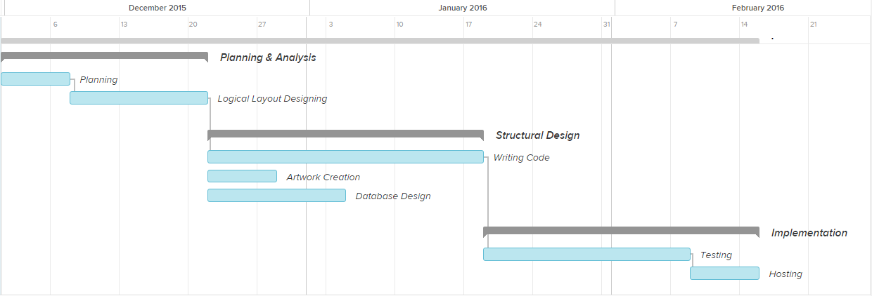

**FIGURE: GANTT CHART**

# Product Functions:-

# This application allows it’s registered users to enter the ‘Competition Module’ and start practicing on programming problems. Various *Modules* of the project are described as follows:

**REGISTRATION MODULE:** This module will allow a first-time visiting user to register his/her credentials into the portal’s database. Upon successful registration they will be redirected to the login module where they can provide their credentials to enter the competition module.

**LOGIN / LOG-OUT MODULE:** This module will also be divided under two parts, i.e. User and Admin. On the basis of some pre-defined logic the user will be directed to either user’s area or admin area based on their login credentials.

**COMPETITION MODULE:** This module will give access to the competition area to it’s users. The difficulty level of the competition will be divided into three modes – Easy, Intermediate or Expert. The user will be given a program which will be fetched from the database on the fly. The user will then have to type the program in their preferred language in the provided area and submit the same.

**RESULTS MODULE:** This module will provide the result of the user currently logged-in. The result will be presented under three categories of the programs the user has attempted i.e. Easy, Intermediate & Expert.

**RANKING MODULE:** Under this module the Name and Rank of top ten scorers will be displayed. The module will only be accessible by logged-in users.

**MANAGEMENT MODULE (ADMIN):** This module is specifically for administrators only. A normally registered user will not be able to access this area. Upon logging-in the admin could then manage user-profiles, results and rankings of the users.

**MANAGEMENT MODULE (USER):** Under this module a registered user could manage his/her profile, delete his account etc.

# User Characteristics:-

The users interacting with the system is divided into two sub-classes:

**ADMINISTRATORS:** The admin will interact with the system to manage the database and user profiles.  
**USERS (COMPETITORS):** These are the users who will be taking part into the programming competition and checking their results & rankings.

# Constraints:-

This application is constrained with a properly running internet connection. Since it fetches data from the database server over the internet, it is crucial that a proper internet connection is maintained at all times for the application to function.  
Also the web-portal will also be constrained by the capacity of the database. Since it’s a multi-user platform the database may queue-up incoming requests if it exceeds a certain limit.

# Assumptions and Dependencies:-

Proper working of this web-app is dependent on the internet connectivity of the user’s computer.

* It is assumed that the user has a basic knowledge of operating a computer system.
* It is assumed that the user does not cheat during the competition time.

# Entity Relationship Diagram:-

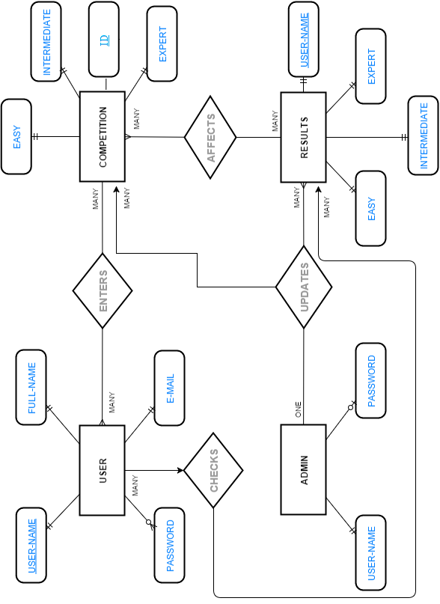

Data Flow Diagram:-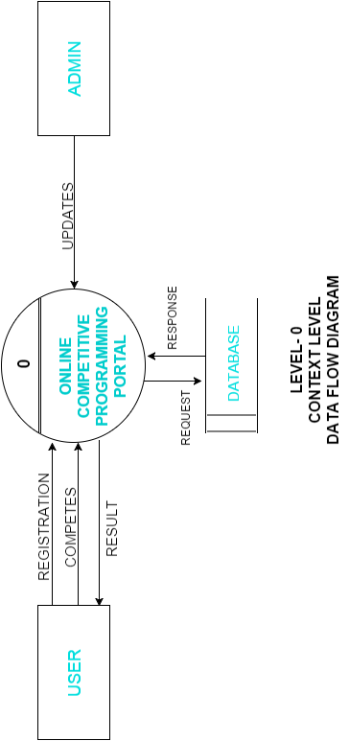

# dfd-1.png

# dfd2.png

# dfd3.png

# Database Design:-

Following figure illustrates the database design of the project (Tables and Relationship between them).

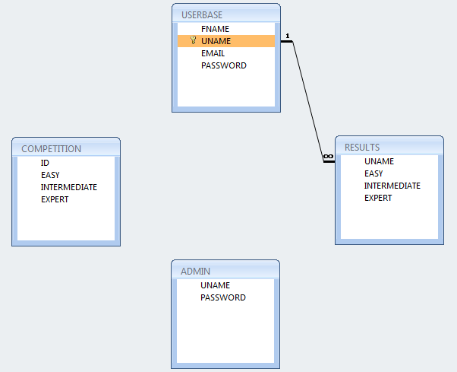

# data_dictionary.pngData Dictionary :-

# Specific Requirements:

# Performance Requirements:-

* Loading speed of all web-pages should be under 2 to 3 seconds.
* Any operation based on Database should not take more than 5 seconds.

# Design Constraints:-

The O.C.P.P. project must adhere to the following standards or protocols:

* Web pages are to be designed using HTML-5 and formatted using CSS-3 transitional standards.
* W3C Web Accessibility standards, Web Content Accessibility Guidelines, should be followed including keyboard navigation, alternate titles for images, etc.

# Software System Attributes Requirements:-

# Reliability:-

The database operations should be completed within 5 seconds and must be reliable more than 99.5% of time.

# Availability:-

The portal should be designed to be available no less than 99.99% of time. All upgrades to system including software updates, patches and fixes must be done without taking the portal offline.

# Security:-

Security standards to be followed are:

* User Id’s and Passwords of users must be hashed using one-way hashing algorithms before storing them into databases.
* Appropriate methods like *CAPTCHA’s* should be implemented to prevent machine brute-force attacks.
* Any input by user must be validated and sanitized for SQL injection scenarios.
* A well-defined password policy is to be adopted including password-change frequency, invalid attempts, etc.

# Maintainability:-

* Every code module should have a well documented manual including logic.
* All code components should be thoroughly tested and the test coverage should be more than 80%.

# Future Scope:-

Currently the project is a standalone application developed from scratch but in future with a wider range of audience the project can be ported to a professional industry-standard framework.  
Performance of the project can also be improved by implementing the project on a multi-server platform.  
Also, currently the software only supports manual checking of the user-submitted solution codes. This in future could be automated for a number of programming languages, as required.

# Project Ownership:-

This project is ***NOT*** done for any client/ industry, it’s complete ownership lies with the *Project Creator*.

# C:\Users\user\Desktop\edit\project_temp\synopsis\layout.pngTentative Layout:-