ASSIGNMENT 4

Kesav Adithya Venkidusamy

2021-10-05

# Markdown Basics

## Favorite Foods

1. Chicken
2. Pork
3. Egg

## Images

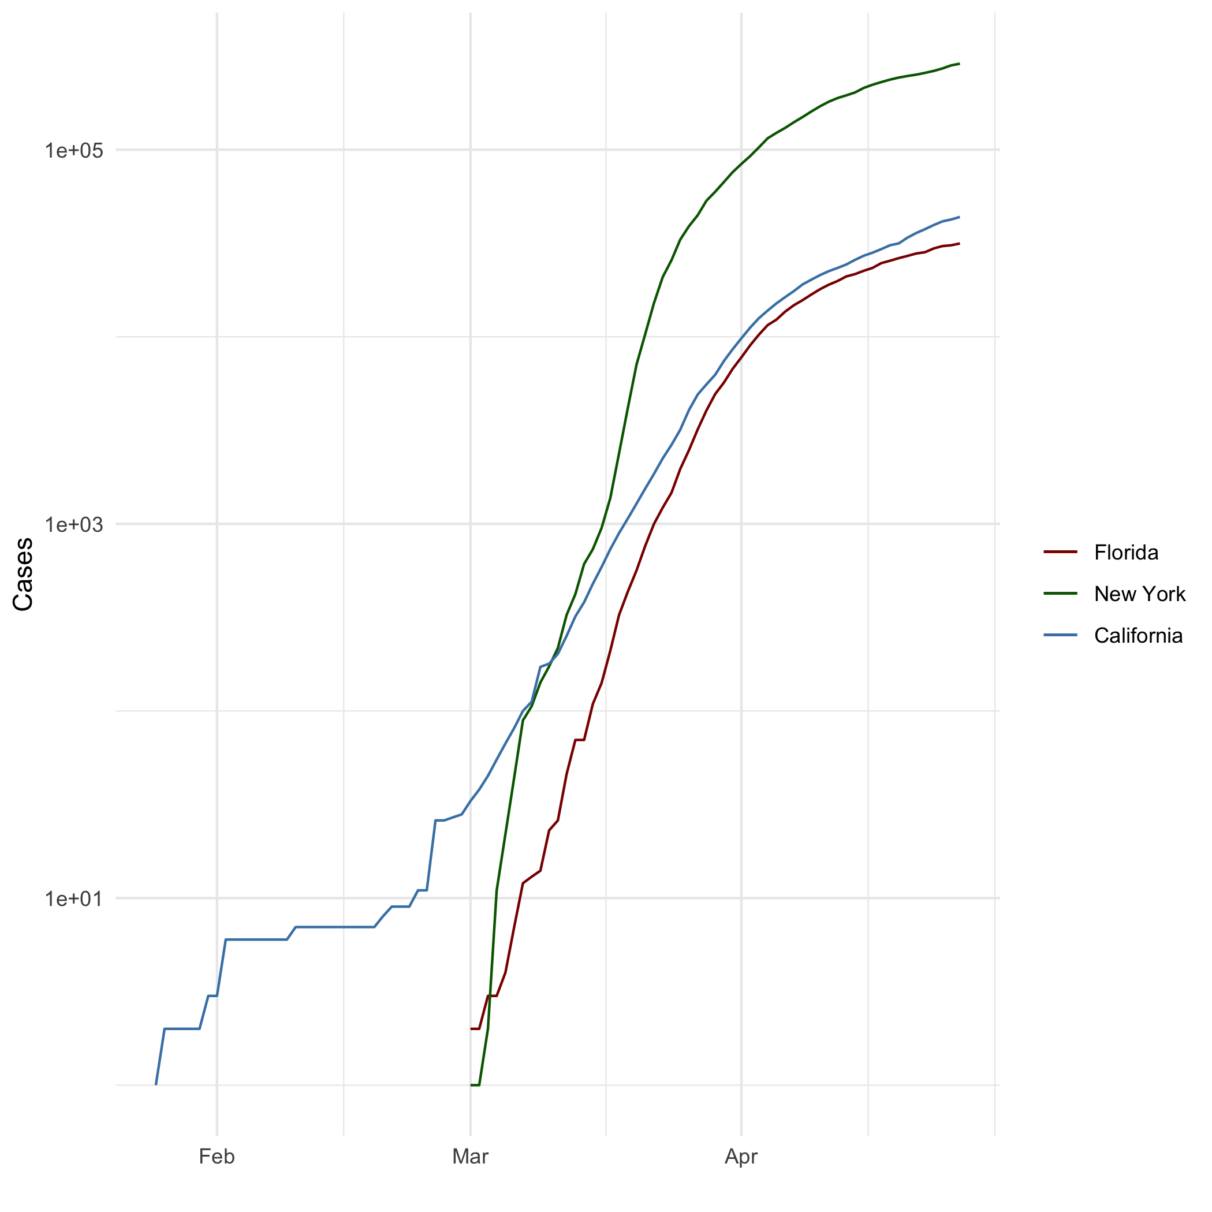

All cases

## Add a Quote

“Anyone who has never made a mistake has never tried anything new” - Albert Einstein

## Add an Equation

###Standard Score

$P(A∣B)=\frac{P(B∣A) P(A)}{P(B)}$

## Add a Footnote

Footnote for R Markdown exercise.[1]

## Add Citations

* R for Everyone (Lander 2014).
* Discovering Statistics Using R (Field, Miles, and Field 2012).

# Inline Code

## NY Times COVID-19 Data

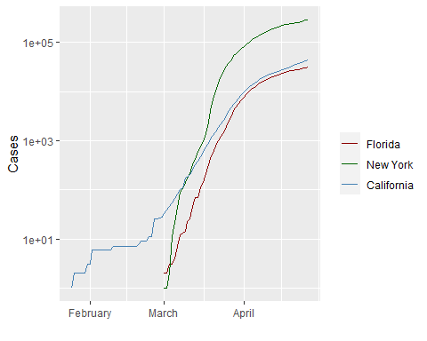

## R4DS Height vs Earnings

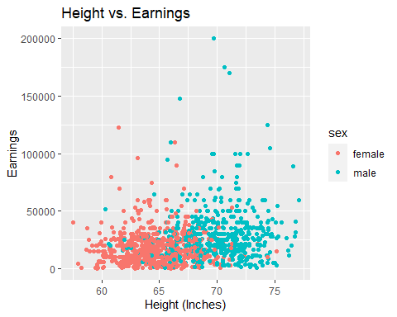

# Tables

name <- c("Aragon", "Bilbo", "Frodo", "Galadriel", "Sam", "Gandalf", "Legolas", "Sauron", "Gollum")  
race <- c("Men", "Hobbit", "Hobbit", "Elf", "Hobbit", "Maia", "Elf", "Maia", "Hobbit")  
in_fellowship <- c(TRUE, FALSE, TRUE, FALSE, TRUE, TRUE, TRUE, FALSE, FALSE)  
ring_bearer <- c(FALSE, TRUE, TRUE, FALSE, TRUE, TRUE, FALSE, TRUE, TRUE)  
age <- c(88, 129, 51, 7000, 36, 2019, 2931, 7052, 589)  
  
  
characters_df <- data.frame(name, race, in_fellowship, ring_bearer, age)

## Knitr Table with Kable

library(knitr)  
  
knitr::kable(characters_df, caption='One Ring to Rule Them All')

One Ring to Rule Them All

|  |  |  |  |  |
| --- | --- | --- | --- | --- |
| name | race | in_fellowship | ring_bearer | age |
| Aragon | Men | TRUE | FALSE | 88 |
| Bilbo | Hobbit | FALSE | TRUE | 129 |
| Frodo | Hobbit | TRUE | TRUE | 51 |
| Galadriel | Elf | FALSE | FALSE | 7000 |
| Sam | Hobbit | TRUE | TRUE | 36 |
| Gandalf | Maia | TRUE | TRUE | 2019 |
| Legolas | Elf | TRUE | FALSE | 2931 |
| Sauron | Maia | FALSE | TRUE | 7052 |
| Gollum | Hobbit | FALSE | TRUE | 589 |

## Pandoc Table

library(pander)  
  
Name <- c("Aragon", "Bilbo", "Frodo", "Sam", "Sauron")  
Race <- c("Men", "Hobbit", "Hobbit", "Hobbit", "Maia")  
`In Fellowship` <- c("Yes", "No", "Yes", "Yes", "No")  
`Is Ring Bearer` <- c("No", "Yes", "Yes", "Yes", "Yes")  
Age <- c(88, 129, 51, 36, 7052)  
  
pantable_df <- data.frame(Name, Race, `In Fellowship`, `Is Ring Bearer`, Age)  
  
pandoc.table(pantable_df, style='grid')

##   
##   
## +--------+--------+---------------+----------------+------+  
## | Name | Race | In.Fellowship | Is.Ring.Bearer | Age |  
## +========+========+===============+================+======+  
## | Aragon | Men | Yes | No | 88 |  
## +--------+--------+---------------+----------------+------+  
## | Bilbo | Hobbit | No | Yes | 129 |  
## +--------+--------+---------------+----------------+------+  
## | Frodo | Hobbit | Yes | Yes | 51 |  
## +--------+--------+---------------+----------------+------+  
## | Sam | Hobbit | Yes | Yes | 36 |  
## +--------+--------+---------------+----------------+------+  
## | Sauron | Maia | No | Yes | 7052 |  
## +--------+--------+---------------+----------------+------+

# References

Field, A., J. Miles, and Z. Field. 2012. *Discovering Statistics Using r*. SAGE Publications. <https://books.google.com/books?id=wd2K2zC3swIC>.

Lander, J. P. 2014. *R for Everyone: Advanced Analytics and Graphics*. Addison-Wesley Data and Analytics Series. Addison-Wesley. <https://books.google.com/books?id=3eBVAgAAQBAJ>.

1. The footnote will appear at the bottom of the page.