Project: Census Income Prediction

Kesav Adithya Venkidusamy

**Census Income Prediction**

**Introduction**

Income prediction is important for a variety of areas in the private and nonprofit sectors. One critical area this affects is marketing, where income segmentation of the population is an extremely important tool. Businesses may make different variations of their items designated for certain subgroups of the population, and these subgroups often include the income of individuals. Income prediction also helps to identify those individuals who are of a lower income that may need the most assistance, who some nonprofits strive to identify and assist. The ability to predict the income of individuals from this information has far-reaching impacts for every industry.

The data for our project was extracted from the [1994 Census bureau database](http://www.census.gov/en.html) by Ronny Kohavi and Barry Becker. The problem statement of this project is to identify the dataset feature or features which are mostly related to or affecting the income of a household. With the dataset having 48,842 records, we will be able to predict an answer to our problem statement. The dataset consists of 15 features of which 6 are numerical and rest are categorical with “income” being the target. The target variable income contains 2 values. It will indicate if the individual's income is less than 50 thousand dollars per year or greater than 50 thousand dollars income per year.

A set of clean records was extracted using the following conditions: ((AAGE>16) && (AGI>100) && (AFNLWGT>1) && (HRSWK>0))

**Abstract:** Predict whether income exceeds $50K/year based on census data

|  |  |
| --- | --- |
| **Data Set Characteristics** | Multivariate |
| **Attribute Characteristics** | Categorical, Integer |
| **Associated Tasks** | Classification |
| **Number of Instances** | 48842 |
| **Number of Attributes** | 14 |
| **Missing Values** | Yes |
| **Area** | Social |
| **Date Donated** | 5/1/1996 |

**Attribute Information:**

|  |  |  |
| --- | --- | --- |
| **Feature Name** | **Feature Description** | **Feature Type** |
| age | Age of the person | Continuous |
| workclass | Work class of the person | Discrete |
| fnlwgt | Final Weight | Continuous |
| education | Education of the person | Discrete |
| education-num | Number of years the person | Continuous |
| marital-status | Marital status of the person | Discrete |
| occupation | Occupation of the person | Discrete |
| relationship | Relationship of the person to the family | Discrete |
| race | Race of the person | Discrete |
| sex | Sex of the person | Discrete |
| capital-gain | Capital Gain | Continuous |
| capital-loss | Capital Loss | Continuous |
| hours-per-week | Hour the person worked for a week | Continuous |
| native-country | Native country | Discrete |
| Income | Income of the person | Target |

**Exploratory Data Analysis**

The problem statement of this project is to identify the dataset feature(s) which are mostly related to or affecting the income of household. With dataset having total number of records as 48842, we would be able to predict or answer our problem statement. The dataset consists of 15 features of which 6 are numerical and rest all are categorical with “income” being the target. The target variable income contains 2 values <=50K and >50 which would be subsequently converted to 0 and 1 respectively. The details are shown in figure 1.

Among 14 features, we see missing/null values present only for below features. I have given the percentage of missing values for each of the feature in table 1. We noticed that the values where ‘workclass’ is missing, also has ‘occupation’ missing. While trying to identify the extra rows where ‘occupation’ is missing, we observed the workclass is ‘Never-Worked’. Since the percentage of null values present in these features is low, the rows will be removed from the dataset.

|  |  |  |
| --- | --- | --- |
| **Feature Name** | **# Of missing Values** | **Percentage** |
| workclass | 2799 | 5.7% |
| occupation | 2809 | 5.8% |
| native-country | 857 | 1.8% |

**Table 1: Features with null values and percentage**

**Figure 1: Features and dtypes**

The income column is our target variable with 2 values - ‘<=50K’ and ‘>50K’. The count of these values is 37155 and 11687 respectively, suggesting that people with income higher than 50K are significantly less, and our data set is kind of imbalanced considering the target variable. However, we will evaluate the outcome and apply filter to the dataset, if required.

**Visualizations**

As mentioned before, the dataset contains 6 numerical features and 8 categorical features as follows, and ‘income’ feature being the target variable.

Numerical: age, fnlwgt, educational-num, hours-per-week, capital-gain, capital-loss

Categorical: workclass, education, marital-status, occupation, native-county, relationship, race, gender

The following are the visualizations used based on nature of the feature.

***Histogram****:* Histogram is used to identify the distribution of numerical features present in the dataset.

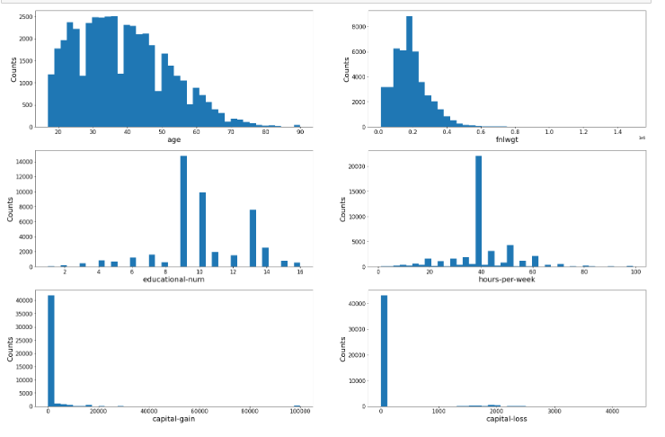

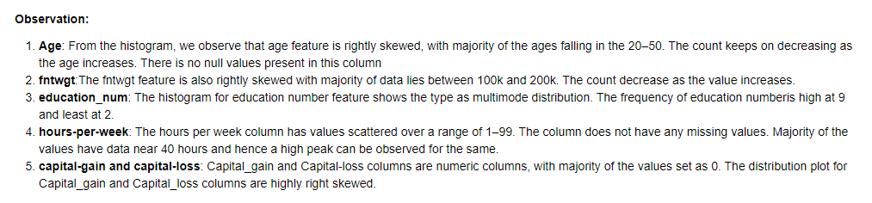

***Heat Map****:* Heat map has been created to understand Pearson’s correlation between the target variable ‘income’ and other numerical variables. We observed that all numerical features have positive correlation with the target except fnlwgt feature. Among the features having positive correlation, age and education-num features are having high value. The details are shown in the below heat map chart.

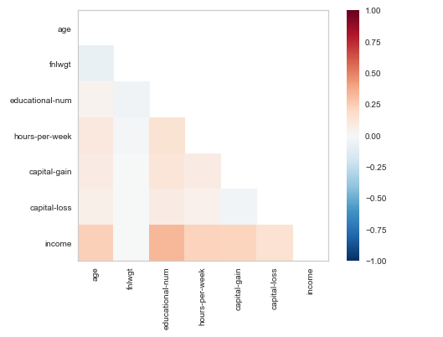

***Bar and Stacked Bar Graph:*** Bar graph has been plotted for all categorical features to understand the distribution of data among unique values. Stacked bar chart has been plotted to compared those earning less than or equal to 50K (represented as 0) and greater than 50K (represented as 1) for all the categorical features.

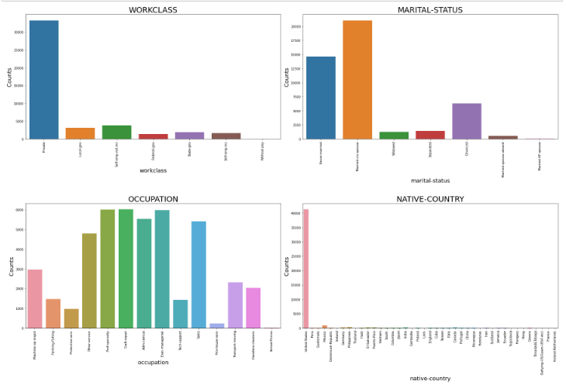

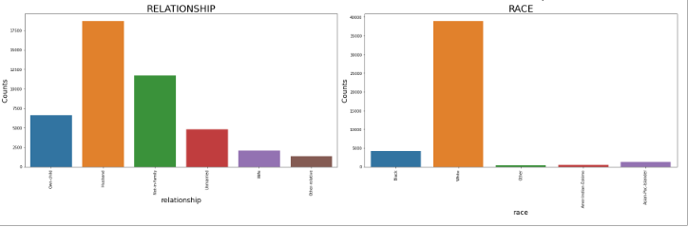

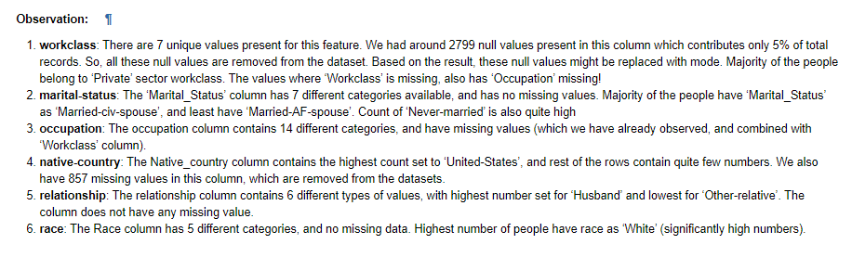

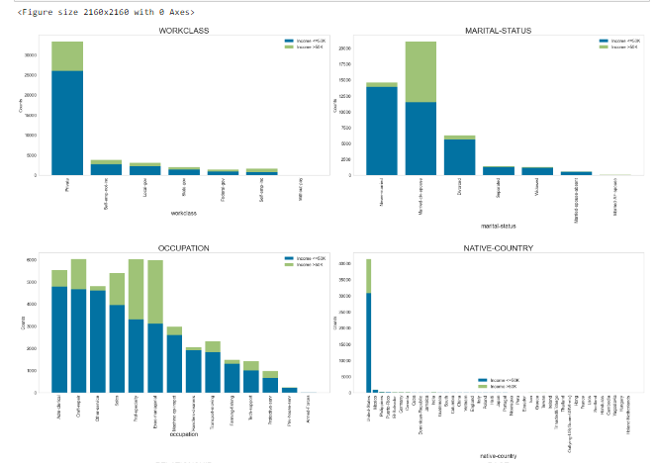

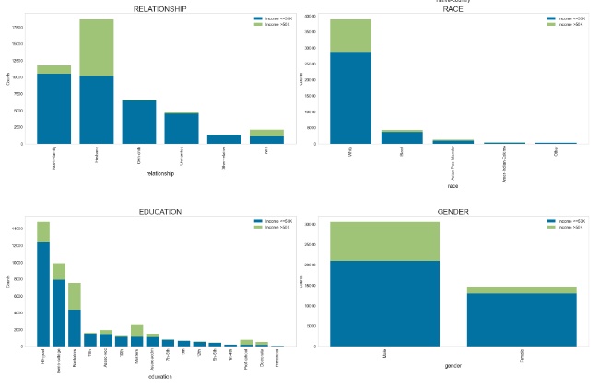

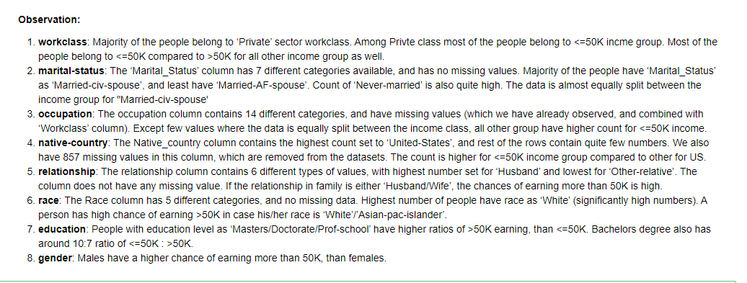

While evaluating the data for null values, the workclass column has 2799 null values, occupation column has 2809 null values, and native-country column has 857 null values. The mode was calculated for each column and was used to replace the null values respectfully. A comparison was done to find duplicates within the data. A duplicate was decided using all columns for comparison. This evaluation determined 52 duplicates which were removed from the base dataset accordingly. After much discussion, we decided to use all the columns presented in the original data load.

We started by using a label encoder method for the categorical variables, see figure 4.1. After the data was split into train and test, this method was then applied to our model choices and the accuracy measurements were evaluated. We then applied a standard scaler to our train and test data and applied the same model choices. Those results helped us decide the best encoding method.

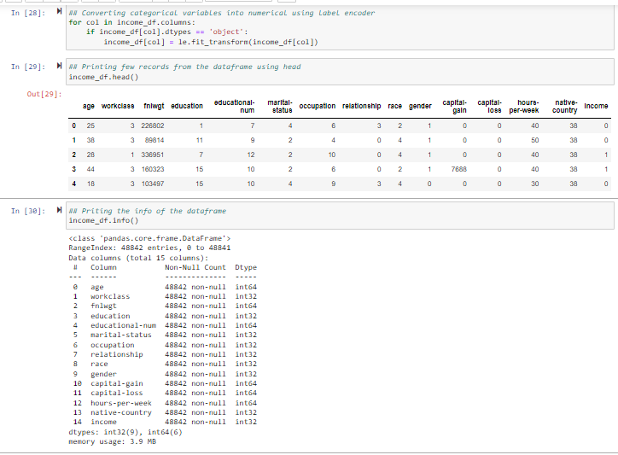

*Figure: 4.1: Dataset after applying label encoder*

**Model Building**

**Logistic Regression**

For this project, the first model we chose to build is Logistic Regression with all the features. The accuracy for this model was 83%. To further evaluate the accuracy, a confusion matrix was created. See figure 4.2. Although there was a high level of predicting incomes below 50K, the prediction on incomes above 50K was not enough as the false negatives seem to be higher. See figure 4.2.

*Figure: 4.2 Confusion matrix for Logistic Regression*

Initially, logistic regression has been applied of the dataset with all 14 features and got AUC score is 0.74. Although the AUC score is in acceptable range of 0.7 to 0.8, we tried to apply StandardScalar on the dataset to resize the distribution of variables so that mean of the observed value is 0 and the standard deviation is 1. We received slight improvement in the score to 0.83 (83%). Then, we tried to remove irrelevant features like capital-gain, capital-loss and fnlwgt from the dataset and ran Logistic regression with and without StandardScalar. We received the score as .8074 (80.74%) and .8108 (81.08%) respectively.

We also noticed the F1 score for the minority class (earning income > 50K) gradually increases when we ran logistic regression after applying StandardScalar and removing irrelevant features from the dataset.

**Decision tree**

Next, we moved to the Decision tree model to see if this model improved the accuracy score of prediction. All the features were evaluated. The accuracy score for this model was came to 82% which is a slight reduction that the Logistic Regression model. From the confusion matrix for this model, see figure 4.3, we observe that the model did seem to improve the predictions for income >50K but degraded in predicting incomes < 50K.

*Figure: 4.3 Confusion matrix for Decision Tree*

We followed similar approach for decision tree classifier as we did for logistic regression and received the accuracy as .8214 (82.14%) when we consider all the features from the dataset. This is slightly high compared to what we received for logistic regression. However, when we tried to run decision tree classifier on the dataset standardized using StandardScalar, the score didn’t improve much. We also noticed that score got decreased when we apply decision tree classifier algorithm on the dataset after removing irrelevant features.

We noticed the F1 score for the minority class (earning income > 50K) gradually decreases when we ran decision tree classifier model after applying StandardScalar and removing irrelevant features from the dataset. Initially, the F1 score for minority class is 0.62 and decreased to 0.53 during the subsequent modeling.

**Random Forest classifier**

The third model is Random Forest classifier with all features. The accuracy score for this model is observed to be at about 87% which is the highest so far. The confusion matrix for the random forest classifier is represented in figure 4.4.

*Figure: 4.4 Confusion matrix for Random Forest Classifier*

We can observe from the confusion matrix that the predicted values for the target feature have greatly improved with 10470 predictions for income under 50K and 2212 correct predictions for income over 50K.

The same accuracy has been obtained after applying StandardScalar. Upon applying modeling on the dataset after removing irrelevant features, the score for random forest model has been reduced to 82.32%. The F1 score for the minority class (earning income > 50K) gradually decreases when we ran decision tree classifier model after applying StandardScalar and removing irrelevant features from the dataset. Initially, the F1 score for minority class is 0.69 and decreased to 0.53 during the subsequent modeling.

**Features removed from the dataset during 2nd iteration:**

* Capital-gain - Most of the rows are having value as 0
* Capital-loss - Most of the rows are having value as 0
* Fnlwgt - Not giving any meaningful information

**Model Evaluation**

The scores that we received for each model are represented in the table below.

|  |  |  |  |  |  |
| --- | --- | --- | --- | --- | --- |
| **Model** | **# Of Features** | **Accuracy** | **F1 Score (Income <=50K)** | **F1 Score (Income >50K)** | **AUC Score** |
| Logistic Regression | All (14) | 79.80% | 0.88 | 0.40 | 0.74 |
| Decision Tree | All (14) | 82.14% | 0.88 | 0.62 | 0.76 |
| Random Forest | All (14) | 86.55% | 0.91 | 0.69 | 0.91 |
| Logistic Regression with StandardScalar | All (14) | 83.01% | 0.89 | 0.56 |  |
| Decision Tree with StandardScalar | All (14) | 82.17% | 0.88 | 0.63 |  |
| Random Forest with StandardScalar | All (14) | 86.54% | 0.91 | 0.69 |  |
| Logistic Regression | After removing unwanted fields (11) | 80.74% | 0.88 | 0.49 | 0.81 |
| Decision Tree | After removing unwanted fields (11) | 78.44% | 0.86 | 0.53 | 0.72 |
| Random Forest | After removing unwanted fields (11) | 82.32% | 0.89 | 0.60 | 0.87 |
| Logistic Regression with StandardScalar | After removing unwanted fields (11) | 81.07% | 0.88 | 0.50 |  |
| Decision Tree with StandardScalar | After removing unwanted fields (11) | 78.44% | 0.86 | 0.53 |  |
| Random Forest with StandardScalar | After removing unwanted fields (11) | 82.18% | 0.89 | 0.60 |  |
| Logistic Regression – Target variable with 5 best features using X2 | With Top 5 Feature | 79.99% | 0.88 | 0.48 | 0.81 |
| Decision Tree – Target variable with 5 best features using X2 | With Top 5 Feature | 79.56% | 0.87 | 0.54 | 0.77 |
| Random Forest – Target variable with 5 best features using X2 | With Top 5 Feature | 80.86% | 0.88 | 0.57 | 0.85 |

**Accuracy:** Accuracyrepresents the number of correctly classified data instance over the total number of data instances.

**F1 Score:** F1-Score is a metric which considers both precision and recall.

* **Precision:** Positive predictive value
* **Recall:** true positive rate

**AUC Score:** What area under the ROC curve describes good discrimination? We will use the following rule of thumb

* 0.5: This suggests no discrimination, so we might as well flip coin
* 0.5-0.7: We consider this as poor discrimination, not much better than a coin toss
* 0.7-0.8: Acceptable discrimination
* 0.8-0.9: Excellent discrimination
* >0.9: Outstanding discrimination

Among all 3 models and multiple iterations, we noticed the AUC score is high for the Random Forest which is 0.91 when we run on the dataset with all 14 features without Standard Scalar. However, the score got reduced to 0.87 when we run on the dataset after removing unwanted features.

**Feature Selection**

Using SelectKBest, we tried to find the 5 best features after removing unwanted features from the dataset and following are the best features in the dataset which shows higher impact to the target variable “income” compared to other features present in the dataset.

* Age
* Education-num
* Marital-Status
* Relationship
* Hours-per-week

Upon running logistic regression, decision tree classifier and random forest classifier model on the dataset with top 5 best features, the score turned out as 79.99%, 79.5% and 80.86% respectively. The corresponding AUC scores are 0.81, 0.77 and 0.85 respectively.

Figure 4.5 represents a “Scores Plot”, that shows the accuracy results of the different scenarios compiled in our analysis.

*Figure: 4.5 Accuracy for different models applied on income dataset*

|  |  |
| --- | --- |
| **Test** | **Features** |
| Pearson's correlation matrix (figure 4.6) - Feature correlation to target variable "income" | **Numerical Variables:**  Age Education-num Hours-per-week  **Categorical Variables:** Gender Education |
| Chi-Squared (X2) Test - 5 Best features correlated to "Income" | Relationship education-num age marital-status hours-per-week |
| Using Feature Importance of Random Forest Classifier (figure 4.7) | Relationship education-num age marital-status hours-per-week |

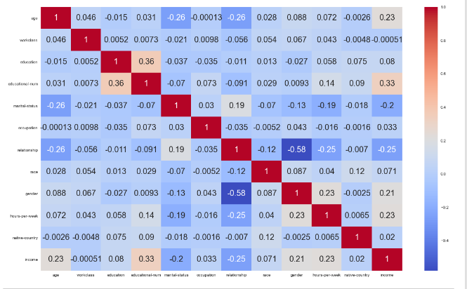

*Figure 4.6: Pearson’s correlation matrix*

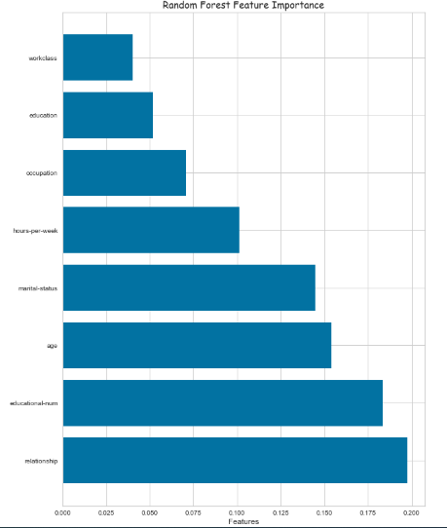

*Figure 4.7: Feature importance method of Random Forest*

**Conclusion:**

Out of three model, Random Forest Classifier is the best model to predict the income of the household as the score is higher compared to Logistic Regression and Decision Tree Classifier when we try to run the model for different scenarios.

Among various methods used to find 5 best features in the dataset, all the methods (Pearson’s correlation, chi-squared and feature importance of RF) provided age, education-num and hours-per-week as best features which have high impact on the target variable “income” compared to other features in the dataset. Pearson’s correlation gave Gender and Education as next best features, while chi-squared and feature importance of RF gave relationship and marital-status as best features having high impact.

From figure 4.7, the following features having high impact of the target variable “income”

1. Relationship: Relationship of the person to the family
2. Education-num: Number of years the person had education
3. Age: Age of the person
4. Marital-status: Marital status of the person
5. Hours-per-week: Hour the person worked for a week

The following are some of the recommendations to earn a higher income >50K.

1. You should work more hours per week to earn more income (Example: one who works 80 hours earn more compared to the one who works only 40 hours)
2. You should study for a greater number of years (number of education years) to earn high income.
3. The model also predicted that married persons earn more compared to unmarried persons. This may be due to the fact that a person with more experience (in term of years) is earning more compared to freshers. Mostly, the persons with more experience are married.
4. Model predicts that older people earn more compared to younger people. This implies that older people would have more experience who in turn earn more. So, you should get old to earn more income.

### **Reference:**

Abbott, D. (2014). *Applied Predictive Analytics: Principles and Techniques for the Professional Data Analyst*. John Wiley & Sons, Inc.

<https://www.census.gov/en.html>

<https://www.kaggle.com/datasets/uciml/adult-census-income>

<https://www.techtarget.com/searchbusinessanalytics/definition/logistic-regression>

<https://support.minitab.com/en-us/minitab-express/1/help-and-how-to/modeling-statistics/regression/how-to/binary-logistic-regression/before-you-start/data-considerations/>