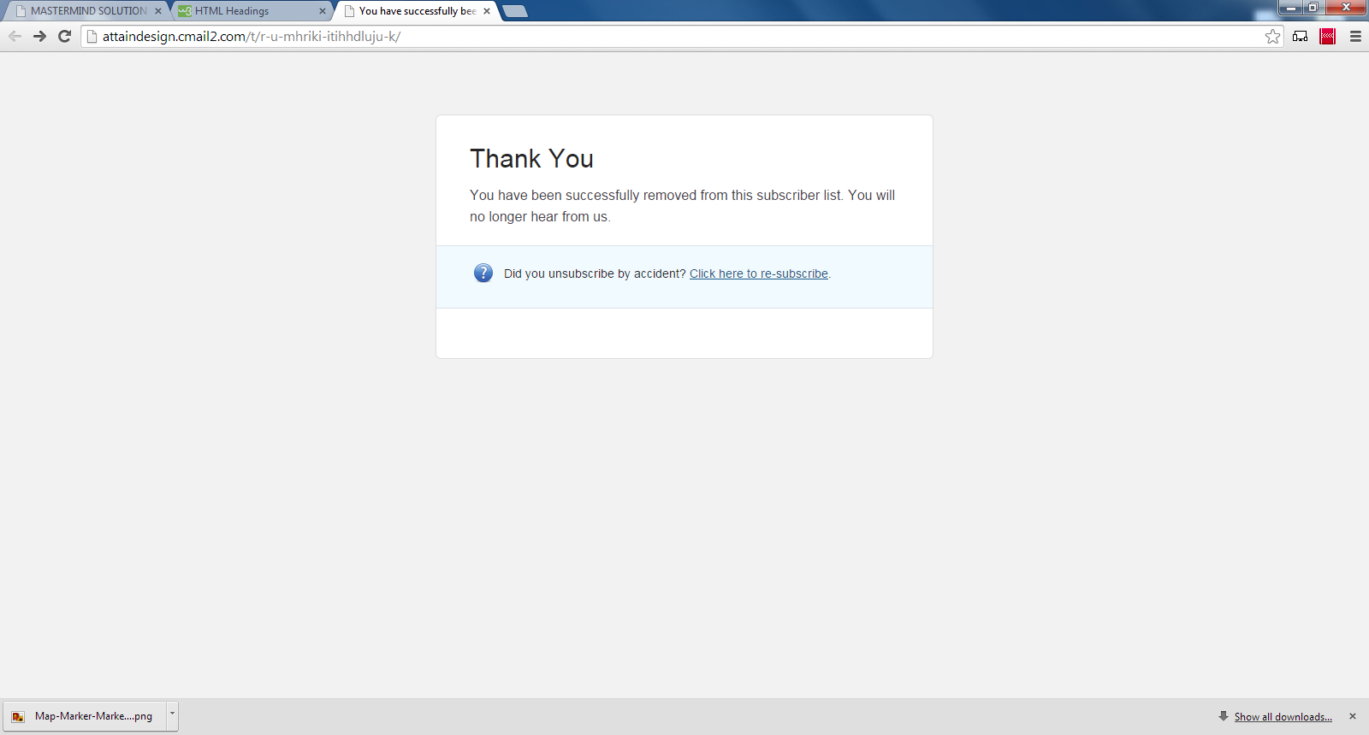

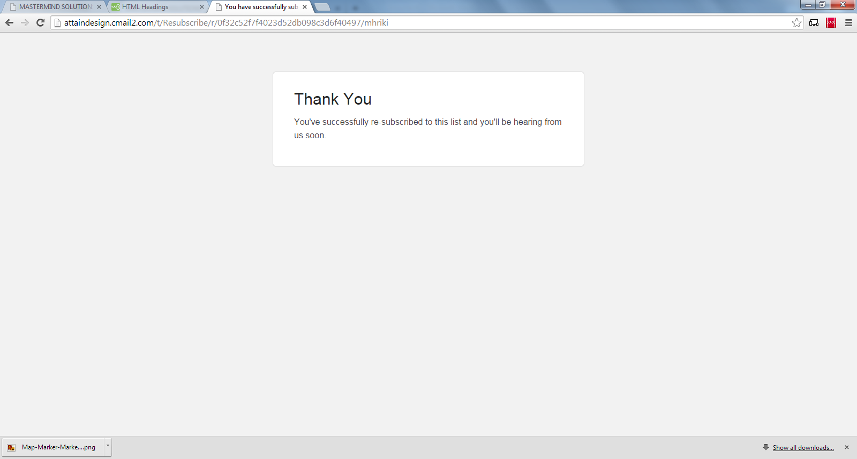

http://attaindesign.cmail2.com/t/r-u-mhriki-itihhdluju-k/

http://attaindesign.cmail2.com/t/Resubscribe/r/0f32c52f7f4023d52db098c3d6f40497/mhriki