# A number of numbers on a white background Description automatically generatedGiven

The orbits have the same period (periodic motion).

# Find and Answers

1. Calculate two potential values for initial radial position (x0) which satisfy the energy matching condition.
   1. -90.131941697608339418673865550641 km
   2. -14446.935127623028441248959329124 km
2. Plot this trajectory by generating the following 4 plots: Relative position in the x-, y- and z-directions vs time and a 3-D plot of the position trajectory over this time period.
   1. Figure 1
   2. 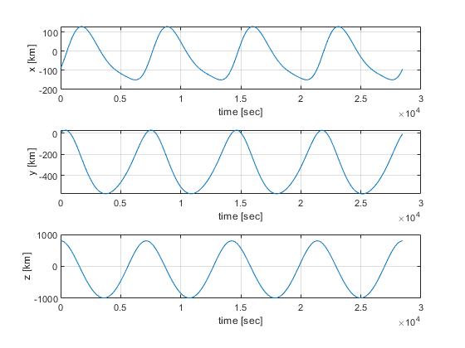
   3. 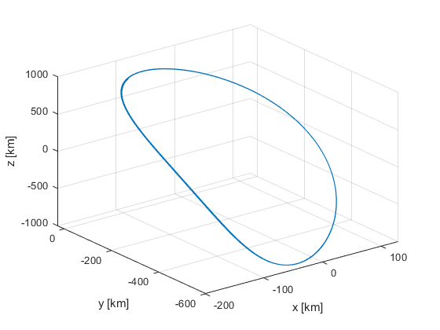Figure 2

# Assumptions

* R2BEOM

# Units

All units are in Km or Km/s and radians or radians/s.

# Analysis

The final image is periodic and a validation of my math. I also was able to compare my answer with Cadet Keegstra and we had the same answer.