# Given

The orbits have the same period (periodic motion).

# Find and Answers

* You should see that while the value of the energy matching condition remains constant and ~0, the value of the HCW condition diverges from 0 as 𝑥𝑥 increases. Explain this result.
  + This is because the HCW conditions require the assumption that, “Target and Chase satellites are near each other with similar velocities” as the distance between the target and the chase increase this assumption is broken and the equations to predict where the chase will be begin break down.

Figure 1

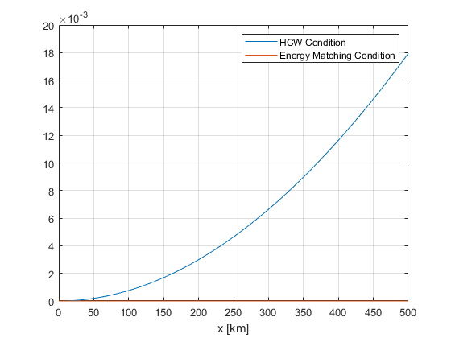

Figure 2 – Relative Trajectory at 5 km

Figure 3 – Relative Trajectory at 500 km

# Assumptions

* R2BEOM, no perturbations
* HCW
  + R2BEOM, no perturbations
  + Target and Chase satellites are near each other with similar velocities.
  + Target is in a circular orbit.

# Units

All units are in Km or Km/s and radians or radians/s.

# Analysis

The periods in the beginning are the same so the orbit should be periodic. The figures show that the motion is periodic. Comparing the energy matching equation between the General Non-linear EOM solution is only possible because the orbital periods are equal. If this were not the case we could not measure the error accrued by the HCW equations as shown in figure 2.