HW08

# Find and Answers

## Exercise 1

### Mission Phase: Rendezvous Ops

When you can measure angular distance relative to the detector –

Minimum Range = 85,944 m

### Mission Phase: Close-Proximity

When you can measure the angular diameter on the detector - Available after the target makes up greater than 1 pixel.

Maximum Range = 85,944 m

Minimum Range = 5,729.747 m

### Mission Phase: Final Approach

When you can measure the angular diameter on the detector of features on the satellite-

Maximum range = 5,729.747 m

## Exercise 2

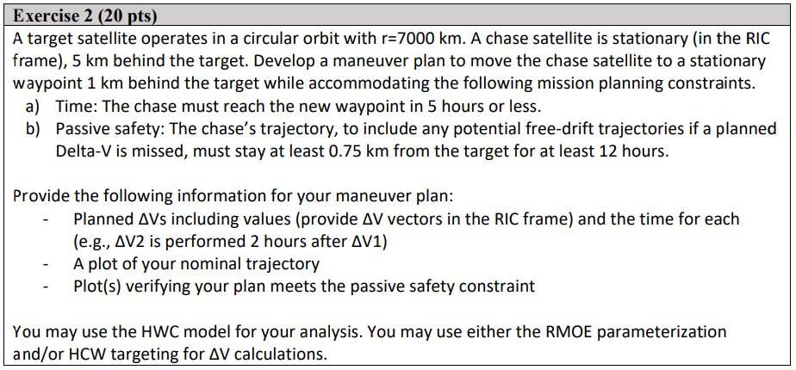

**Order of events**

**Delta V_1 in the RIC frame at [s]:**

0 sec

[km/s]:

-9.689293e-04 x-hat

1.222604e-04 y-hat

0 z-hat

**Position in the RIC frame after [s]:**

3600 sec

[km]:

1 x-hat

5.017440e-01 y-hat

6.450338e-03 z-hat

**Velocity in the RIC frame after [s]:**

3600 sec

[km/s]:

-4.838096e-01 x-hat

-9.669854e-01 y-hat

-1.441056e+00 z-hat

**Delta V_2 in the RIC frame at [s]:**

3600 sec

-8.868671e-03 x-hat

5.299824e-04 y-hat

0 z-hat

**Position in the RIC frame after [s]:**

18000 sec

[km]:

2.220446e-16 x-hat

-1.000000e+00 y-hat

0 z-hat

**Velocity in the RIC frame after [s]:**

18000 sec

[km/s]:

8.217575e-03 x-hat

6.522428e-04 y-hat

0 z-hat

**Time before final burn [s]:**

14400 sec

**Delta V_3 in the RIC frame at at [s]:**

18000 sec

[km/s]:

-8.217575e-03 x-hat

-6.522428e-04 y-hat

0 z-hat

# Plots

**Combined Plot**

# Assumptions

HCW Assumptions

* Tgt and chase are close
* Tgt orbit is circular (it is)

R2BEOM (no pert)

# Units

All units are explained with the answers.

# Analysis

It was much easier to find an orbit that did not cross within 0.75 km when I caused a velocity in the x direction.