**Engineering Exploration – Introduction to AR/VR (23EE003)**



**PROJECT REPORT**

**on**

***Components of Jet Turbine***

**BATCH-2022**

**Project Mentor**

Dr. Karthick

**Student Name & ID**

**Name of Student 1 Id : ADITYA PRAKASH (2211981025)**

**Name of Student 2 Id : ADITYA MISHRA (2211981024)**

**Name of Student 3 Id : ADITYA CHAUDHARY (2211981020)**

**Name of Student 4 Id : KHUSHDEEP (2211981199)**

**Sustainable Development Goals**



**Problem Statement:** **We cannot afford a Jet Turbine for teaching mechanical engineering students the components of it. So we created an AR app that will show the components of a Jet Turbine and its description.**

**Need Statement:**

* AR apps can be used in educational settings to teach students or professionals about the various components of a jet turbine. Users can explore and interact with 3D models of turbine parts, learning about their functions, assembly, and maintenance.
* Engineers can use AR apps to visualize and test new designs or modifications to jet turbine parts.
* Companies in the aerospace industry might use AR apps as sales tools.

**Detailed working of Components of AR/VR**

**PROTOTYPE PHOTOGRAPHS**

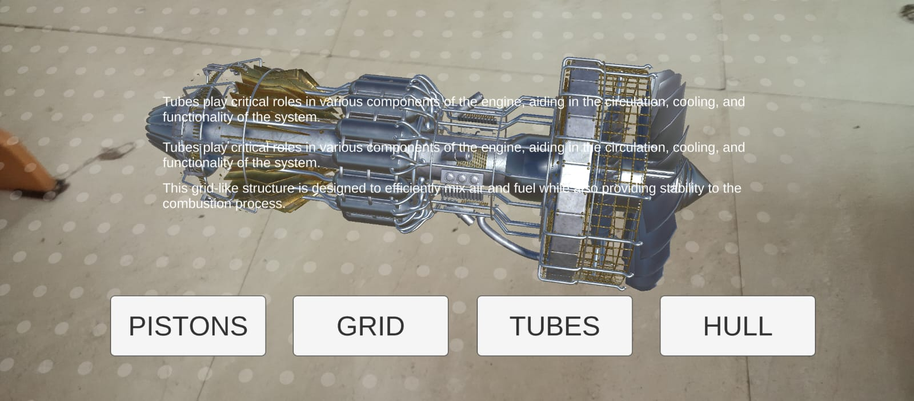

**Code for execution of project:-**

using System.Collections;

using System.Collections.Generic;

using UnityEngine;

using UnityEngine.XR.ARFoundation;

using UnityEngine.XR.ARSubsystems;

public class ARPlacement : MonoBehaviour

{

public GameObject arObjectToSpawn;

public GameObject placementIndicator;

private GameObject spawnedObject;

private Pose PlacementPose;

private ARRaycastManager aRRaycastManager;

private bool placementPoseIsValid = false;

void Start()

{

aRRaycastManager = FindObjectOfType<ARRaycastManager>();

}

// need to update placement indicator, placement pose and spawn

void Update()

{

if (spawnedObject == null && placementPoseIsValid && Input.touchCount > 0 && Input.GetTouch(0).phase == TouchPhase.Began)

{

ARPlaceObject();

}

UpdatePlacementPose();

UpdatePlacementIndicator();

}

void UpdatePlacementIndicator()

{

if (spawnedObject == null && placementPoseIsValid)

{

placementIndicator.SetActive(true);

placementIndicator.transform.SetPositionAndRotation(PlacementPose.position, PlacementPose.rotation);

}

else

{

placementIndicator.SetActive(false);

}

}

void UpdatePlacementPose()

{

var screenCenter = Camera.current.ViewportToScreenPoint(new Vector3(0.5f, 0.5f));

var hits = new List<ARRaycastHit>();

aRRaycastManager.Raycast(screenCenter, hits, TrackableType.Planes);

placementPoseIsValid = hits.Count > 0;

if (placementPoseIsValid)

{

PlacementPose = hits[0].pose;

}

}

void ARPlaceObject()

{

spawnedObject = Instantiate(arObjectToSpawn, PlacementPose.position, PlacementPose.rotation);

}}

**DIVISION OF WORK IN TEAM:-**

| **Name of student** | **ID** | **Role** |
| --- | --- | --- |
| **A ADITYA PRAKASH** | **2211981025** | **IDEA, WORK ON UNITY, CODING, SCRIPTS** |
| **B ADITYA MISHRA** | **2211981024** | **BUTTONS** |
| **C ADITYA CHAUDHARY** | **2211981020** | **DESCRIPTION** |
| **D KHUSHDEEP** | **2211981199** | **ASSET** |

**Conclusion:-** The Unity Project Components of Jet Turbine successfully demonstrates the potential of AR for interactive and engaging experiences. It showcases the capability of AR in the education field.