**Adisri Sarode**

1. Using features of Java 11, read the data from a text file (File name: StudentList.txt).

Calculate the count of students and print the names as well as the total count of

students on the screen. (If any line in file doesn’t contain a name, for such a record

blank space should not be printed in the output)

Hint: Use java 11 features of files and String methods to reduce the lines of code to

be written.

import java.io.*;

import java.util.Scanner;

public class Assignment3Q1 {

public static void main(String[] args) throws IOException {

// File path is passed as parameter

File file = new File("C:\\Users\\adisr\\Desktop\\JavaAssignments\\Java11Assignments_StudentList.txt");

Scanner sc = new Scanner(file);

int count = 0;

while (sc.hasNextLine()){

String string = sc.nextLine();

if(string.length()!=0){

System.out.println(string.trim());

count++;

            }

        }

System.out.println("Total number of students present in the txt file are: "+count);

sc.close();

    }

}

Output:

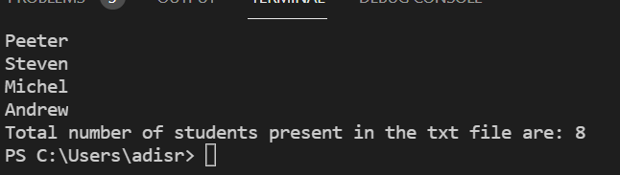

2. Write a program with menu to accept the price of certain items and display their total.

When user selects Option 1: should accept the prices of different products and insert

these prices into first file (each amount to be inserted in a newline in the file). Next,

total of these values should be saved in a new file. Option 2: should allow the user to

view the total of these prices from the second file.

**Sample Output:**

Select your option (1: Insert New Price, 2: View Purchase Total, 3: Exit)

> 1

> Insert 1st price:

> 100

> Price has been saved to the file

> Do you want to enter price for more items? (Yes/No)

> Yes

> Insert 2nd price:

> 200

> Price has been saved to the file

> Do you want to enter price for more items? (Yes/No)

> No

> Select your option (1: Insert New Price, 2: View Purchase Total, 3: Exit)

> 2

> Total Price of all items is: 300

> Select your option (1: Insert New Price, 2: View Purchase Total, 3: Exit)

> 3

exit program….

Hint: Use java 11 features of files and String methods to reduce the line of code.

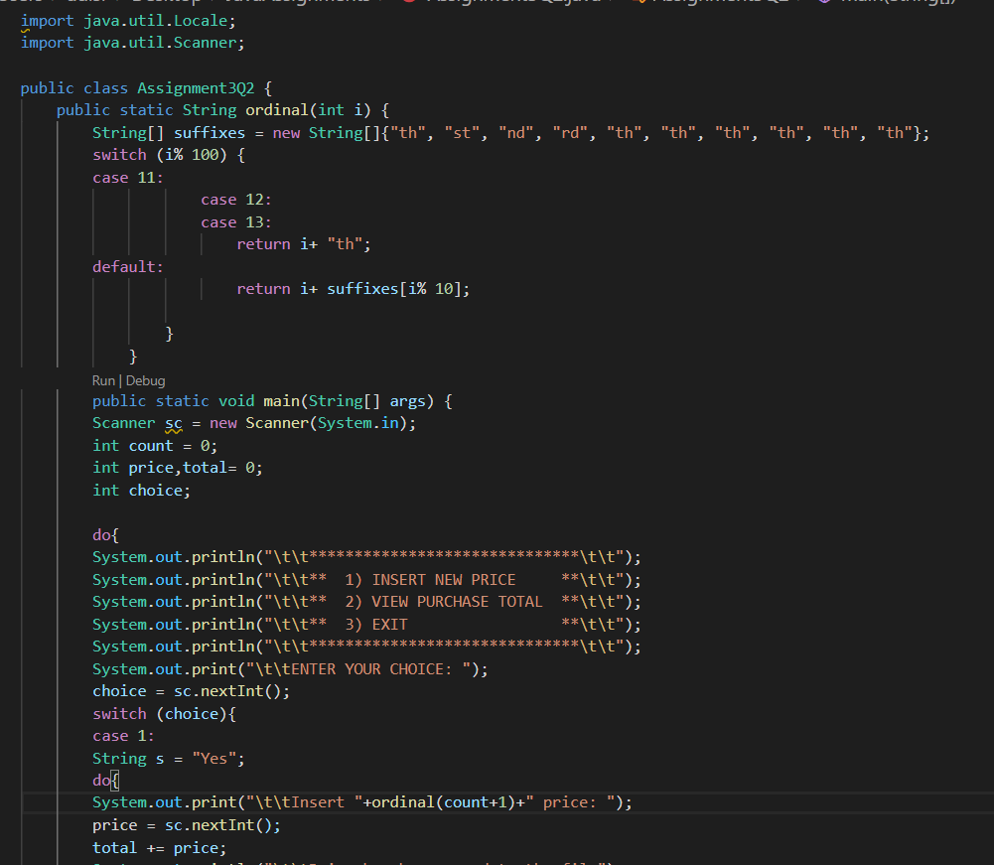

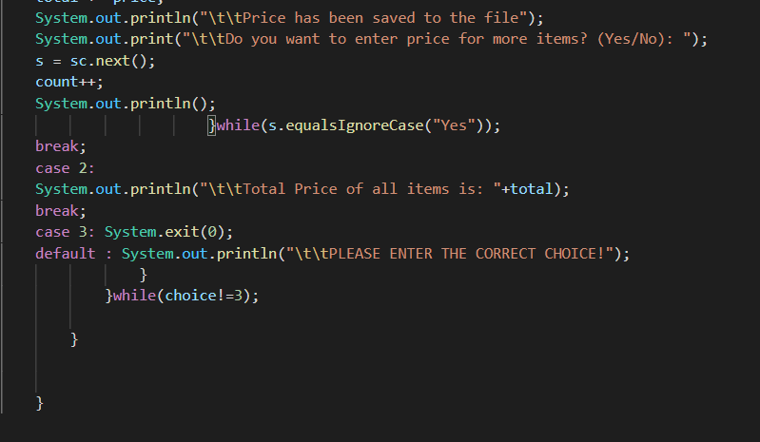

OUTPUT:

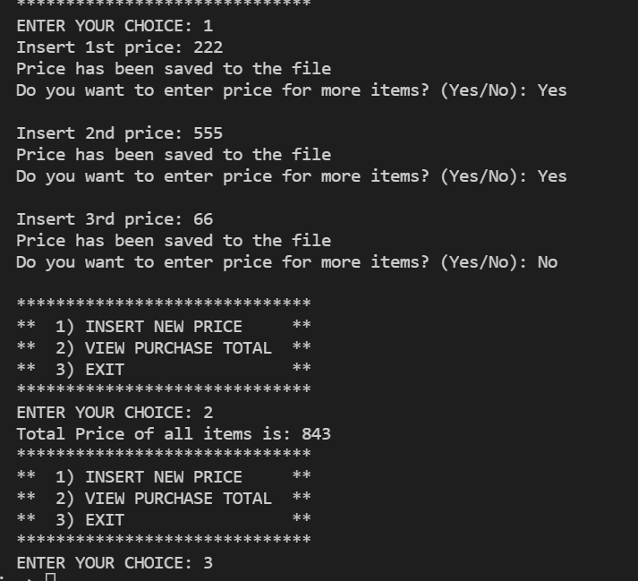

3. Write a code using HttpClient API which sends a GET request

to https://httpbin.org/get, and print out the response header, status code, and

body for the given URL.

Sample output could be (Note: date and other attribute values may differ in your

results):

access-control-allow-credentials:[true]

access-control-allow-origin:[*]

connection:[keep-alive]

content-length:[273]

content-type:[application/json]

date:[Fri, 06 Aug 2021 13:07:41 GMT]

server:[gunicorn/19.9.0]

200

{

"args": {},

"headers": {

"Content-Length": "0",

"Host": "httpbin.org",

"User-Agent": "Java 11 HttpClient Bot",

"X-Amzn-Trace-Id": "Root=1-610d341d-092dc33f698b192a219426d1"

},

"origin": "43.255.221.184",

"url": "https://httpbin.org/get"

}

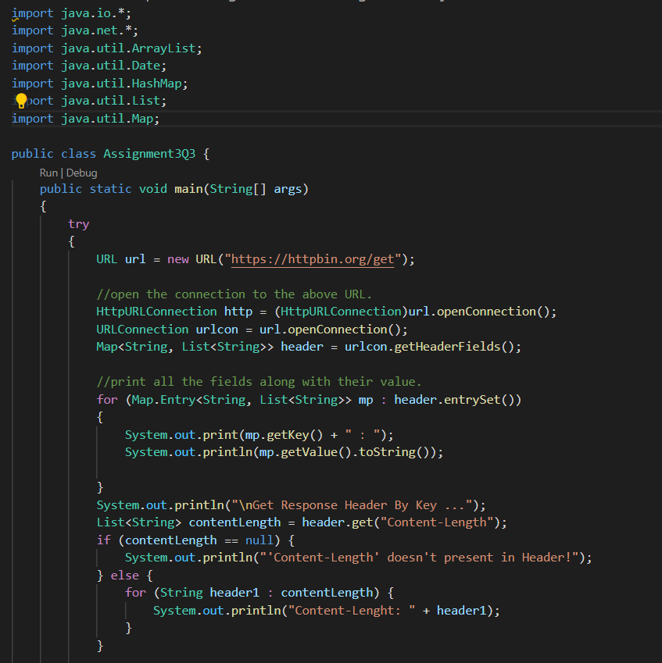

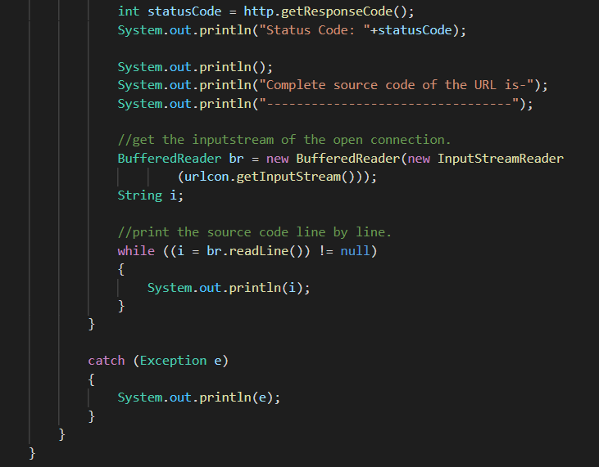

OUTPUT:

