**GIT & GITHUB  
ADISRI SARODE  
  
GIT BRANCHING   
SECTION 1- HTML ASSIGNMENTS**

22. Create an empty directory ‘Assignments’ & cd to ‘Assignments’.

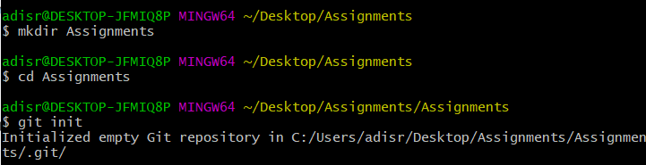

23. Create a file README.txt inside ‘Assignments’ & write few lines about the contents of ‘Assignments’ folder.

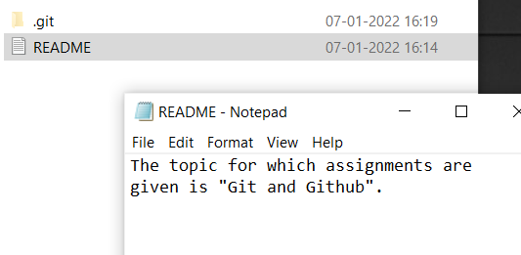

24. Commit README.txt file.

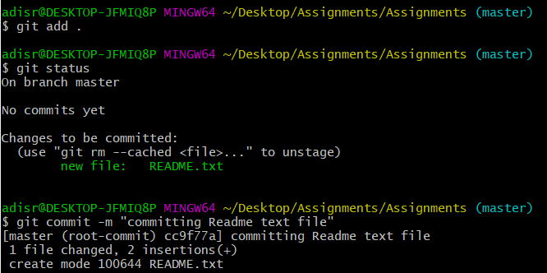

25. Now create a new branch ‘html-assignments’.

26. Switch to ‘html-assignments’ branch.

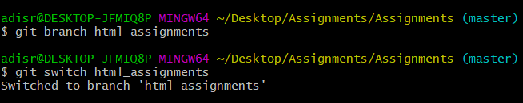

27. Copy all HTML assignments inside ‘Assignments’ folder.

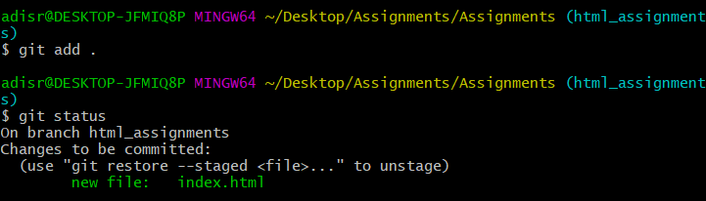

28. Commit HTML assignments into ‘html-assignments’ branch

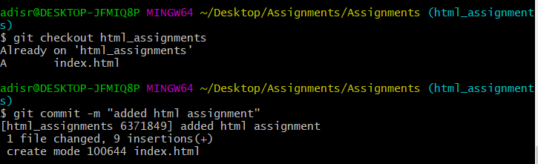

29. Make minor changes into few files belonging to ‘html-assignments’ branch.

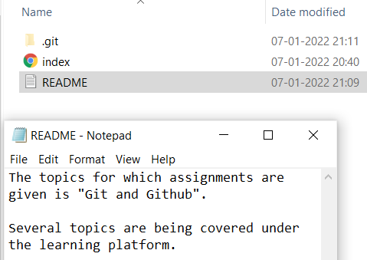

30. Commit those changed files.

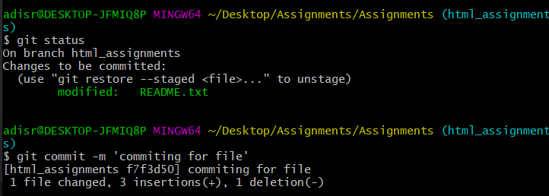

31. Switch to master branch.

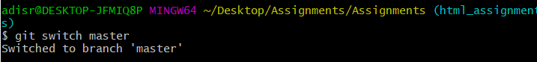

32. Make minor changes into README.txt file & commit those changes into master.

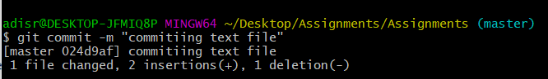

33. Again switch to ‘html-assignments’ branch.

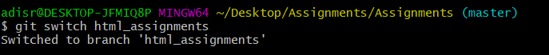

34. Make minor changes into few files belonging to ‘html-assignments’ branch.

35. Commit those changes.

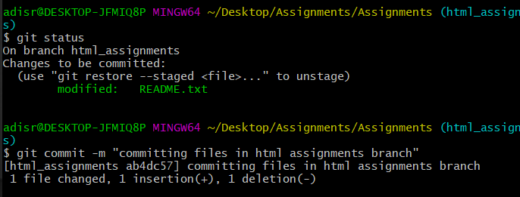

36. Switch to master.

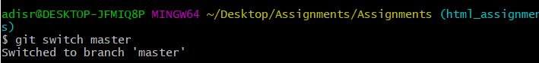

37. Merge ‘html-assignments’ branch into master. Confirm all html assignments are shown in master.

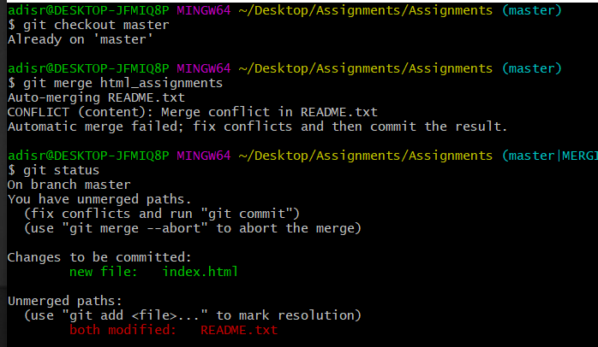

38. Finally delete the ‘html-assignments’ branch.

