**GIT & GITHUB**

**ADISRI SARODE**

**Git Branching**

**SECTION 2- CSS ASSIGNMENT**

1. Create a new branch ‘css-assignments’.



2. Switch to ‘css-assignments’ branch.

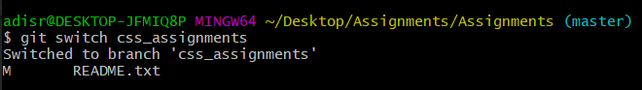  
  
3. Copy all CSS assignments inside ‘Assignments’ folder.

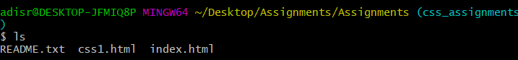  
  
4. Commit CSS assignments into ‘css-assignments’ branch.   
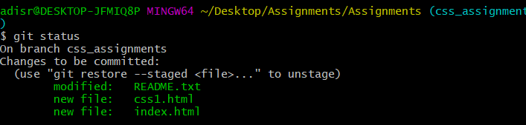

5. Make minor changes into README.txt file on line 1 belonging to ‘css-assignments’ branch.   
-> Minor changes made in README text file.

6. Commit those changed files.   
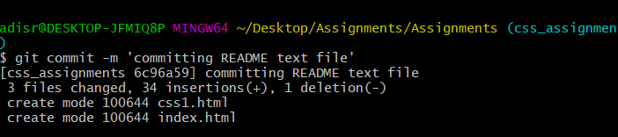

7. Switch to master branch.

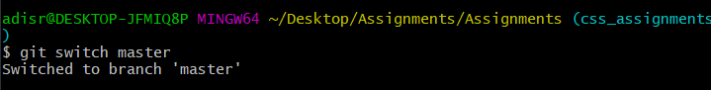

8. Make minor changes into README.txt file on line 3 & commit those changes into master.

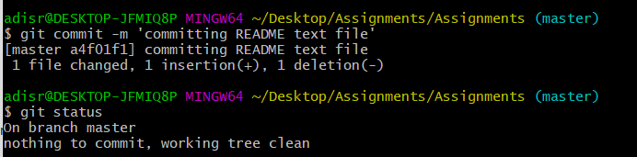

9. Again switch to ‘css-assignments’ branch.

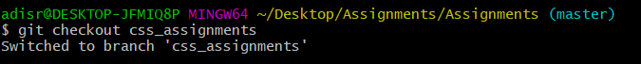

10. Make minor changes into few files belonging to ‘css-assignments’ branch.

-> Minor changes are made.

11. Commit those changes.

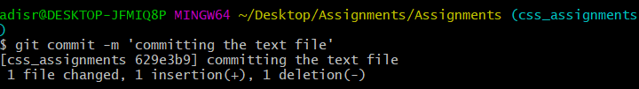

12. Switch to master.

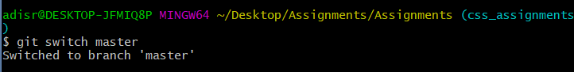

13. Merge ‘css-assignments’ branch into master. Confirm all css assignments are shown in master.

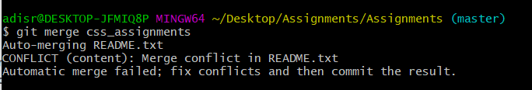  
  
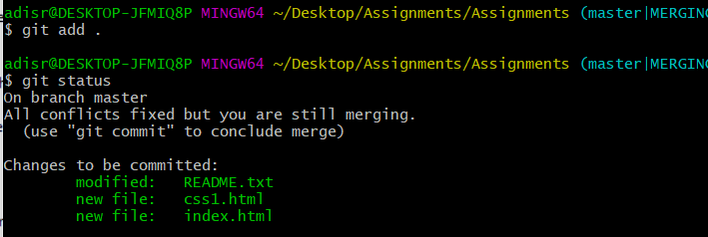

14. Finally delete the ‘css-assignments’ branch.

