**GIT & GITHUB**

**ADISRI SARODE**

**GIT BRANCHING**

**SECTION 3- JavaScript Assignments**

1. Create a new branch ‘js-assignments’.



2. Switch to ‘js-assignments’ branch.



3. Copy all JavaScript assignments inside ‘Assignments’ folder.



4. Commit JavaScript assignments into ‘js-assignments’ branch.

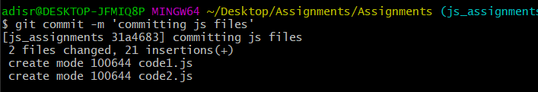

5. Make minor changes into README.txt file on line 1 belonging to ‘js-assignments’ branch.   
-> Minor changes made into the file.

6. Commit those changed files.

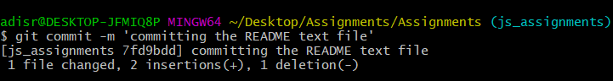

7. Switch to master branch.



8. Make minor changes into README.txt file on line 1 & commit those changes into master.

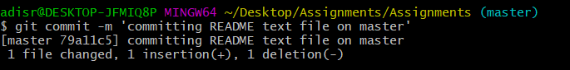

9. Again switch to ‘js-assignments’ branch.

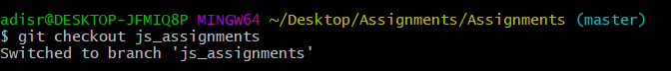

10. Make minor changes into few files belonging to ‘js-assignments’ branch.

->Minor changes made in the code1.js file

11. Commit those changes.

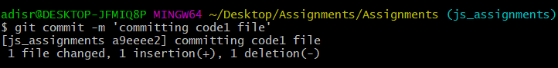

12. Switch to master.



13. Merge ‘js-assignments’ branch into master. Confirm all JavaScript assignments are shown in master.

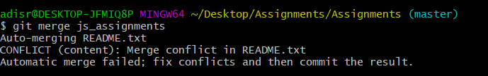  
  
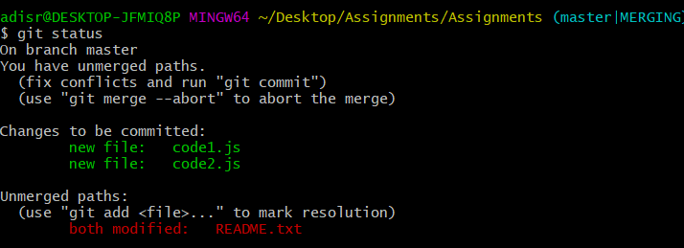

14. Finally delete the ‘js-assignments’ branch.   
  
