**GIT & GITHUB  
ADISRI SARODE  
  
GIT REMOTING**

Objective: Pushing source code into GITHUB & collaborate team members.

SECTION-1 (Pushing assignments to remote repository)

39. Create a github account if you do not have already.

40. Login on into github account.

41. Create new public repository ‘freshersbatch-oct16’.

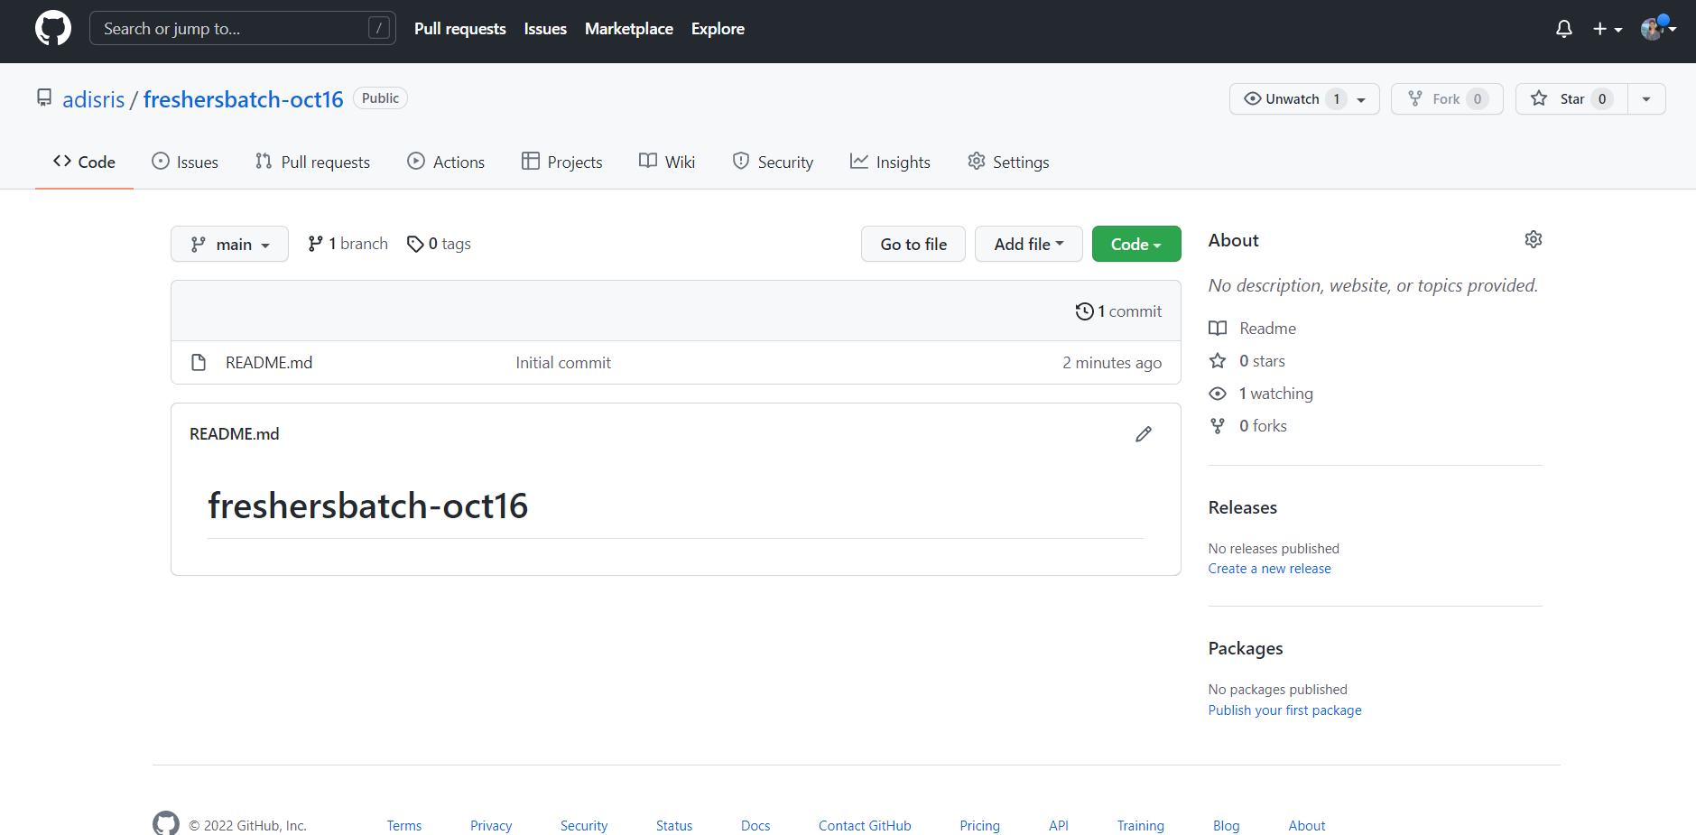

42. Commit & push any sample file to this repository under ‘Assignments’ directory.

**