**Flow diagram**

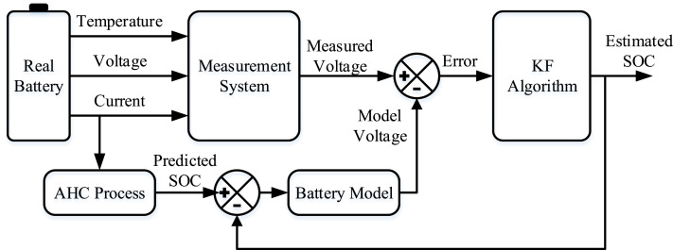

**Ampere-Hour Counting (AHC)?**

AHC estimates the SOC of a battery by integrating the current over time, based on the formula:

**How AHC is Used in Diagram?**

1. The **Real Battery** provides current, voltage, and temperature data.
2. The **AHC Process** integrates the current to predict the SOC.
3. The **Battery Model** uses this predicted SOC to estimate the battery voltage.
4. The difference (error) between **measured voltage** and **model voltage** is corrected using the **Kalman Filter (KF) Algorithm** to improve SOC estimation.

**Limitations of AHC**

* **Drift Over Time:** Small errors accumulate, reducing accuracy.
* **Initial SOC Dependency:** Requires a known initial SOC.
* **Battery Aging:** Capacity degradation affects accuracy.

**Why is Kalman Filtering Used in SOC Estimation?**

Methods like **Ampere-Hour Counting (AHC)** accumulate errors over time due to sensor inaccuracies, battery aging, and temperature effects. The **KF algorithm** continuously corrects SOC estimates by comparing measured values with a battery model, reducing drift and improving accuracy.

**How the KF Algorithm Works in SOC Estimation**

1. **Measurement System** collects real-time battery data (Voltage, Current, Temperature).
2. **Battery Model** predicts the expected voltage using a mathematical model based on the estimated SOC.
3. **Error Calculation:** The difference between **Measured Voltage** and **Model Voltage** is computed.
4. **Kalman Filter Algorithm:**
   * It **updates the SOC estimate** by adjusting it based on the measurement error.
   * It considers system **noise**, uncertainties, and battery characteristics to refine the prediction.
5. The **corrected SOC estimate** is used for more accurate battery monitoring.

**Advantages of KF Algorithm for SOC Estimation**

✅ **Reduces Measurement Noise:** Filters out fluctuations in voltage and current measurements.  
✅ **Compensates for Sensor Drift:** Corrects errors in Ampere-Hour Counting.  
✅ **Adaptive to Battery Changes:** Adjusts SOC estimates as the battery ages.  
✅ **Accurate Real-Time SOC Tracking:** Useful for electric vehicles (EVs), energy storage systems, and IoT battery monitoring.

**Reference:** research paper: <https://www.sciencedirect.com/science/article/abs/pii/S1364032119304332>