Week 3: Python-Based Machine Learning
Model Development and Evaluation Plan
Hypothetical Project: Customer Churn Prediction

1. Introduction
This report presents a structured plan for developing and evaluating a Python-based machine learning system for customer churn prediction. The goal is to predict whether a customer is likely to discontinue a service using historical customer information such as tenure, contract type, monthly charges, service usage, payment method, and customer support interactions. The plan covers the complete machine learning lifecycle from problem definition and preprocessing to model selection, training, evaluation, interpretation, and optional deployment.
Because Week 3 is a planning exercise and no dataset or code execution is required, the proposed workflow is designed to be realistic, reproducible, and adaptable to a future real-world dataset.

2. Problem Definition

2.1 Business Problem
Customer churn can reduce revenue and increase the cost of acquiring replacement customers. A predictive model can help identify customers with a high probability of leaving so that a company can prioritize retention actions such as targeted communication, service improvements, or suitable offers.

2.2 Machine Learning Problem
The task is formulated as supervised binary classification. The target variable is Churn, with two possible classes: 1 (customer churns) and 0 (customer remains). The model will learn patterns from historical labelled customer records and produce a churn probability for new customers.

2.3 Success Criteria
- Build a reliable classification model with strong generalization to unseen customers.
- Prioritize recall when missing a potential churner is more costly than contacting an additional customer.
- Maintain a useful balance between precision and recall using F1-score.
- Use ROC-AUC and cross-validation to assess discrimination and stability.
- Produce interpretable results that can support practical retention decisions.

3. Proposed Machine Learning Workflow
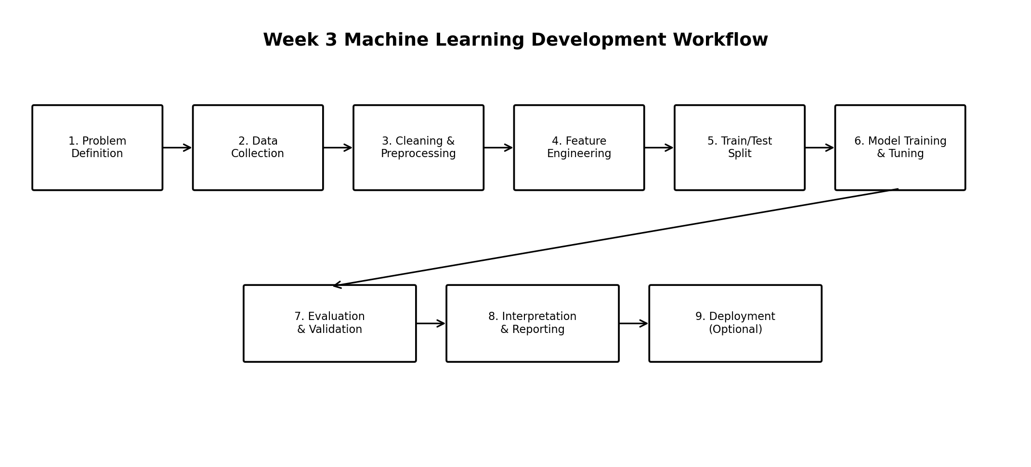
Figure 1. End-to-end machine learning workflow proposed for the customer churn project.

4. Data Preprocessing Plan

4.1 Data Understanding and Quality Checks
- Inspect rows, columns, data types, target distribution, and unique values.
- Check duplicate records and inconsistent category labels.
- Identify missing values and determine whether missingness is random or systematic.
- Review numerical ranges and categorical levels for obvious data-entry errors.

4.2 Handling Missing Values
- For numerical variables, consider median imputation when distributions are skewed or contain outliers.
- For categorical variables, use the most frequent category or an explicit 'Unknown' category when appropriate.
- Avoid leaking information from the test set into preprocessing; fit imputation rules only on training data.

4.3 Encoding and Scaling
- Use one-hot encoding for nominal categorical variables such as contract type or payment method.
- Use ordinal encoding only when categories have a genuine order.
- Scale numerical variables for algorithms that are sensitive to feature magnitude, such as logistic regression.
- Tree-based models generally do not require feature scaling, but a consistent preprocessing pipeline should still be maintained.

4.4 Outlier Treatment
Outliers will be detected using box plots, interquartile-range rules, and domain checks. Extreme observations will not automatically be removed because they may represent legitimate high-value customers. Depending on the business context, options include retaining them, capping extreme values, transforming skewed variables, or investigating the source records.

4.5 Feature Engineering
- Create tenure groups such as new, established, and long-term customers.
- Derive average monthly usage or support-contact frequency where source variables allow it.
- Create meaningful ratios or aggregated service-usage features when justified.
- Avoid features that use information occurring after the churn event because they can cause target leakage.

5. Feature Selection
Candidate predictors will be screened using domain knowledge, data quality, correlation analysis, feature importance, and model-based selection. Highly redundant variables may be removed or combined. Features with very high missingness, no meaningful variation, or potential target leakage will be excluded. Feature selection must be performed within the training workflow so that the test set remains an unbiased estimate of future performance.

6. Model Selection and Training

6.1 Candidate Models
- Logistic Regression: a strong and interpretable baseline for binary classification.
- Decision Tree: easy to visualize and capable of modelling non-linear relationships.
- Random Forest: an ensemble of decision trees that can capture non-linear interactions and is generally robust to mixed feature patterns.
- Gradient Boosting: a powerful ensemble approach that can provide strong predictive performance after careful tuning.

6.2 Selected Model: Random Forest
Random Forest is proposed as the primary model because customer churn is likely to depend on non-linear combinations of customer behaviour, contract characteristics, charges, and service usage. Random Forest can model these interactions without requiring strict assumptions about the underlying relationships. It also provides feature-importance information that can help explain which variables contribute to predictions.

6.3 Training Procedure
- Separate the target variable from predictor features.
- Split the dataset into training and held-out test sets using a stratified split.
- Construct preprocessing steps and model training as a single reproducible pipeline.
- Train candidate baseline models on the training data.
- Tune the selected model using cross-validation.
- Compare tuned candidates using the predefined evaluation metrics.
- Evaluate the final model once on the untouched test set.
- Document the model version, preprocessing choices, parameters, metrics, and assumptions.

6.4 Hyperparameter Tuning
- For Random Forest, tune parameters such as number of trees, maximum tree depth, minimum samples per split/leaf, and feature sampling strategy.
- Use RandomizedSearchCV for an efficient initial search and GridSearchCV for a focused final search if computational resources permit.
- Use stratified cross-validation so each fold maintains a similar class distribution.
- Select parameters based on the chosen validation metric rather than test-set performance.

7. Evaluation Metrics
Because churn is a classification problem, several complementary metrics will be used rather than relying on accuracy alone.
- Accuracy: proportion of all predictions that are correct. Useful when class distribution is reasonably balanced.
- Precision: proportion of predicted churners who actually churn. Important when retention actions are costly.
- Recall: proportion of actual churners correctly identified. Important when failing to identify a churner has a high business cost.
- F1-score: harmonic balance between precision and recall, useful when both matter.
- ROC-AUC: measures the model's ability to distinguish churners from non-churners across classification thresholds.
- Confusion Matrix: summarizes true positives, true negatives, false positives, and false negatives.
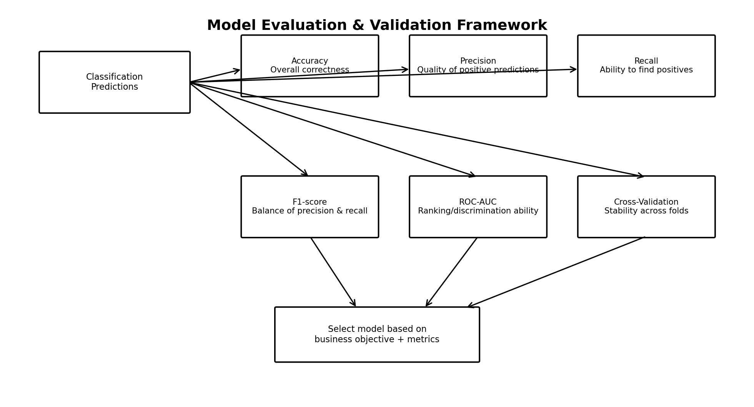
Figure 2. Proposed evaluation and validation framework for the classification model.

8. Validation Strategy
The training data will be evaluated using stratified k-fold cross-validation. The training set is divided into k folds; the model trains on k-1 folds and validates on the remaining fold, repeating the process until every fold has served as validation data. Mean and variation across folds will be reported to assess stability. The final test set will remain untouched until model selection and tuning are complete.
- Use stratification to preserve the churn/non-churn ratio across folds.
- Avoid preprocessing leakage by fitting transformations separately within each training fold through a pipeline.
- Compare cross-validation scores with the final test-set scores.
- Investigate large differences between validation and test performance as a possible sign of overfitting or data shift.

9. Potential Challenges and Solutions
- Class imbalance: use stratified splitting, suitable metrics, class weights, or resampling techniques where justified.
- Overfitting: control tree complexity, use cross-validation, and compare training with validation performance.
- Data leakage: define a clear prediction point and ensure all features are available before that point.
- Missing or inconsistent data: apply systematic quality checks and document every preprocessing decision.
- Interpretability: use feature importance and, where appropriate, SHAP-style explanations in a future implementation.
- Changing customer behaviour: monitor model performance after deployment and retrain when data drift becomes significant.

10. Optional Model Deployment Plan
After validation, the final model could be packaged in a reproducible Python pipeline and exposed through a simple API or business application. A deployment system would receive customer attributes, apply the same preprocessing steps, and return a churn probability and risk category. Model and data versions should be recorded so predictions remain traceable.
- Save the trained pipeline and model using an appropriate model-serialization approach.
- Expose predictions through an API such as a lightweight Python web service.
- Monitor prediction quality, input-data drift, latency, and failure rates.
- Schedule periodic retraining using newly labelled customer outcomes.
- Use version control and a rollback process for model updates.

11. Tools and Python Libraries
- Pandas: data loading, cleaning, transformation, aggregation, and tabular analysis.
- NumPy: numerical operations and array-based computation.
- Scikit-learn: preprocessing, train/test splitting, model training, pipelines, hyperparameter tuning, cross-validation, and evaluation metrics.
- Matplotlib and Seaborn: static diagnostic plots and model evaluation visualizations.
- Plotly: optional interactive visualizations for exploratory analysis and reporting.
- Jupyter Notebook: optional environment for documenting a future implementation and experiments.
- Git/GitHub: version control for notebooks, documentation, diagrams, and future source code.

12. Reproducibility and Documentation Plan
- Record the dataset source, data dictionary, and prediction target definition.
- Document all cleaning, encoding, scaling, and feature-engineering decisions.
- Keep preprocessing and model steps in a reproducible pipeline.
- Record random seeds where appropriate.
- Maintain a model experiment log containing model type, parameters, validation scores, and observations.
- Report the final confusion matrix and selected metrics on the held-out test set.
- Document limitations, assumptions, ethical considerations, and possible sources of bias.

13. Expected Outcomes
The expected outcome is a clearly defined and reproducible machine learning development plan that can later be implemented when a suitable customer dataset is available. The plan should produce a validated churn classification model, identify important predictive factors, provide reliable evaluation evidence, and create a foundation for future deployment and monitoring.

14. Conclusion
This Week 3 plan covers the complete conceptual lifecycle of a Python-based machine learning project. Customer churn prediction is treated as a binary classification problem, with Random Forest proposed as the primary model and Logistic Regression, Decision Tree, and Gradient Boosting as comparison candidates. The use of careful preprocessing, feature engineering, stratified cross-validation, hyperparameter tuning, and multiple evaluation metrics will help reduce leakage and overfitting while providing a realistic estimate of model performance. The workflow can be directly extended into an executable Python implementation when a real dataset becomes available.

