WEEK 2 TASK
Exploratory Data Analysis (EDA) and Visualization Framework Design
Python-based, dataset-agnostic framework | Planned effort: 34 hours

1. Introduction to EDA
Exploratory Data Analysis (EDA) is the systematic process of inspecting, summarizing, visualizing, and validating data before formal statistical modeling or machine learning. EDA helps analysts understand dataset structure and quality, discover distributions and relationships, detect anomalies, formulate hypotheses, and identify risks that could affect later conclusions.
This framework is intentionally dataset-agnostic. It can be adapted to customer, financial, operational, scientific, or other datasets. The process moves from broad inspection to focused investigation: understand the data, assess quality, study individual variables, examine relationships, explore interactions, and communicate evidence-based findings.

2. Objectives
- Understand dimensions, schema, variable meanings, units, and measurement levels.
- Assess missing values, duplicates, invalid values, inconsistent categories, and outliers.
- Characterize numerical and categorical distributions with appropriate statistics and plots.
- Identify associations, trends, group differences, and useful interactions.
- Generate hypotheses and candidate features for later modeling.
- Document assumptions, transformations, findings, and limitations for reproducibility.

3. Potential Data Types
Type | Examples | Key checks | Useful visuals
Continuous numerical | Revenue, temperature | Range, skewness, missingness, outliers | Histogram, KDE, box plot, scatter
Discrete numerical | Visits, transactions | Integer validity, zero/negative values | Bar chart, histogram
Nominal categorical | Region, product | Unique labels, spelling/case consistency | Count/bar plot
Ordinal categorical | Low/Medium/High | Correct ordering and levels | Ordered bar, box/violin
Datetime | Date, timestamp | Timezone, gaps, frequency | Line chart, rolling trend
Boolean/binary | Yes/No, 0/1 | Allowed values, balance | Proportion/count plot
Text / ID | Comments, identifiers | Uniqueness, length, PII | Length distribution; text analysis

4. EDA Workflow
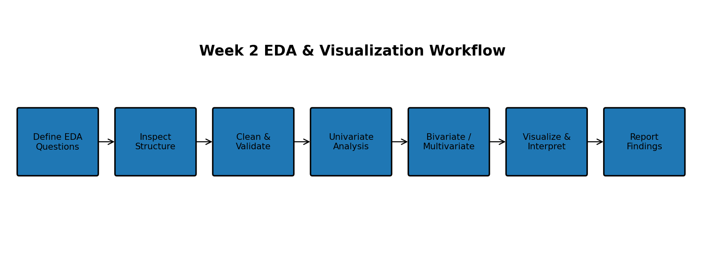
The workflow is iterative. Findings can send the analyst back to validation or cleaning. This reduces the risk of premature conclusions.

5. Data Inspection and Quality Validation
Initial structure: Load data with pandas; inspect shape, columns, dtypes, head/tail, index, and memory usage.
Schema validation: Compare observed fields with the expected data dictionary, units, and definitions.
Missingness: Calculate counts and percentages overall and by relevant groups; inspect missingness patterns.
Duplicates: Check exact duplicates and duplicate business keys where domain rules permit.
Validity: Detect impossible ranges, invalid dates, unexpected categories, and inconsistent formats.
Category normalization: Standardize whitespace, capitalization, spelling variants, and explicit unknown labels.
Outlier screening: Use IQR, robust statistics, percentiles, domain limits, and visual inspection.

6. Univariate Analysis
Univariate analysis studies one variable at a time. Numerical variables will be summarized with count, mean, median, standard deviation, quartiles, minimum/maximum, skewness, and distribution shape. Categorical variables will be summarized with frequency, percentage share, unique levels, and rare-category review.
- Numerical: histogram/KDE, box plot, percentile summary, and optionally ECDF.
- Categorical: sorted count/bar plots with counts and percentages.
- Datetime: frequency by day/week/month and identification of gaps or unusual periods.
- Quality review: identify high missingness, near-zero variance, and suspicious cardinality.

7. Bivariate Analysis
Bivariate analysis examines two variables to identify group differences, associations, monotonic patterns, and potential predictors.
Pair | Techniques
Numeric × Numeric | Scatter plot, correlation, regression trend, hexbin for dense data.
Numeric × Categorical | Box/violin, strip/swarm, grouped summary statistics.
Categorical × Categorical | Contingency table, grouped/stacked bars, normalized proportions.
Datetime × Numeric | Line chart, rolling average, seasonal grouping.

8. Multivariate Analysis
- Correlation matrix and heatmap for numeric variables, while noting that correlation is not causation.
- Pair plots for a selected subset of variables.
- Faceted plots to test whether relationships change across important groups.
- Use color/size/shape encodings only when they remain readable and have a clear analytical purpose.
- For high-dimensional data, PCA or another dimensionality-reduction method may be used as an exploratory aid, clearly separated from final modeling.

9. Missing Data Strategy
Missing values will not be treated automatically as errors. First quantify missingness, inspect its pattern, understand its domain meaning, then select and document a treatment. The post-treatment distribution will be compared with the original.
- Deletion only when justified and sample loss is negligible.
- Numerical: median or other justified imputation; avoid automatic mean imputation.
- Categorical: explicit 'Unknown' or justified mode treatment.
- Time series: forward/backward fill or interpolation only when consistent with the measurement process.
- Document every treatment and its possible impact.

10. Outlier Strategy
Outliers will be investigated rather than removed mechanically. IQR, z-scores where appropriate, robust statistics, percentile thresholds, and domain-specific limits are screening tools. Extreme values may be valid rare events, errors, or evidence of a population change.
- Flag suspicious observations before modifying them.
- Validate extreme values against domain rules or source records where possible.
- Compare results with and without influential observations when appropriate.
- Use transformations, winsorization, or robust models only when analytically justified.

11. Visualization Strategy
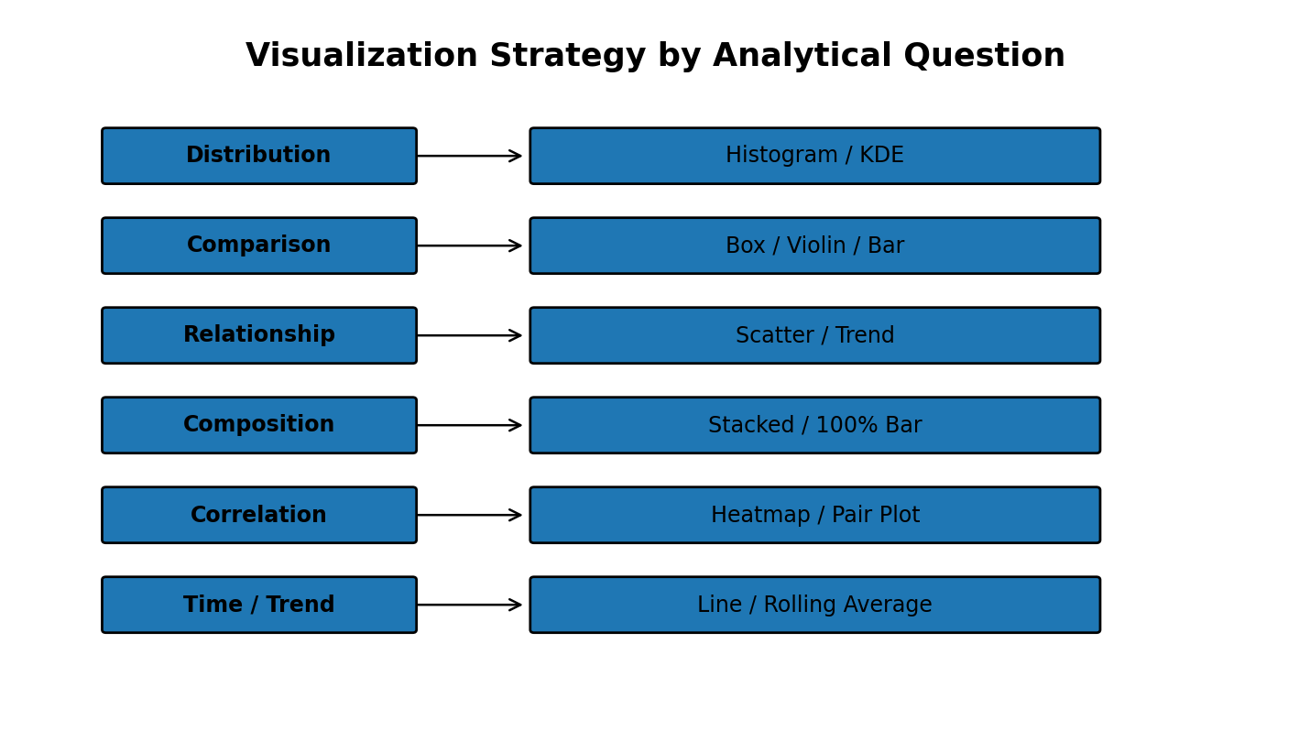
Plot | Purpose | Key consideration
Histogram / KDE | Distribution and skewness | Choose meaningful bins; avoid over-smoothing.
Box / Violin | Spread, median, group differences, outliers | Consider sample size and group counts.
Bar / Count | Category frequencies or summaries | Sort categories; show percentages when useful.
Scatter | Relationship between numerical variables | Use transparency or aggregation for dense data.
Heatmap | Correlation or matrix summaries | Interpret carefully; correlation is not causation.
Pair plot | Selected multivariate relationships | Limit variables for readability.
Line chart | Temporal trend and seasonality | Sort timestamps and choose suitable aggregation.

12. Visualization Design Principles
- Use clear titles, axis labels, units, legends, and captions.
- Prefer simple encodings; avoid decorative 3D effects.
- Keep scales and category ordering consistent across related charts.
- Avoid misleading axis truncation unless clearly justified.
- Handle overplotting with transparency, aggregation, jitter, or hexbin.
- Design for readability and accessibility.
- Every chart should answer a defined analytical question and have a concise takeaway.

13. Python Libraries and Tools
Tool | Contribution
pandas | Loading, inspection, filtering, grouping, aggregation, reshaping, missing-value handling.
NumPy | Numerical arrays, transformations, and calculations.
Matplotlib | Core plotting, annotations, custom layouts, and figure control.
Seaborn | Statistical distributions, categorical plots, scatter plots, and heatmaps.
Plotly | Interactive exploratory charts and dashboards.
SciPy | Optional statistical tests and scientific calculations.
Jupyter Notebook | Interactive analysis and narrative documentation.
Git / GitHub | Version control, collaboration, and artifact storage.

14. Reporting and Documentation Plan
The final EDA notebook/report will follow a consistent structure:
- Executive Summary
- Dataset Overview
- Data Quality
- Univariate Findings
- Bivariate Findings
- Multivariate Findings
- Visual Evidence
- Limitations
- Recommendations / Next Steps
- Appendix and Reproducibility Notes
For reproducibility, record library versions where practical, notebook execution order, data-processing decisions, random seeds for stochastic procedures, and dataset source/version. Sensitive information should be excluded or appropriately anonymized before publication.

15. Quality Review Checklist
- All variables have documented meanings, types, units, and valid ranges where known.
- Missing values and duplicates have been assessed and decisions documented.
- Outliers are investigated using statistical and domain reasoning.
- Charts have readable labels, appropriate scales, and clear analytical purposes.
- Important findings are supported by statistics and visual evidence where possible.
- No causal claim is made from association alone.
- Potential leakage, selection bias, and sampling limitations are noted.
- The analysis can be rerun and important visuals reproduced.

16. Planned 34-Hour Timeline
Activity | Hours
Task definition and EDA questions | 2
Dataset structure and data-type framework | 3
Data quality and missingness strategy | 4
Outlier/anomaly strategy | 3
Univariate framework | 4
Bivariate and multivariate framework | 5
Visualization selection and design | 4
Python libraries and reusable plotting approach | 2
Reporting/documentation plan | 3
Review, formatting, and final QA | 4
TOTAL | 34

17. Expected Outcomes and Challenges
Expected outcomes include a reusable EDA checklist, a dataset-adaptable visualization framework, a clear documentation structure, and a disciplined approach to identifying data-quality and analytical risks before modeling.
Challenge | Mitigation
High-cardinality categories | Use top-N views or justified grouping.
Class imbalance | Report proportions and avoid accuracy-only summaries.
Large datasets | Use appropriate sampling, aggregation, and efficient plotting.
Confounding variables | Use stratification/faceting and avoid causal interpretation.
Messy dates/categories | Normalize formats and validate business rules.
Visualization overload | Prioritize question-driven charts with clear takeaways.

18. Conclusion
This Week 2 framework establishes a complete and logical approach to EDA and visualization without relying on a specific dataset. It combines data-quality assessment, univariate, bivariate, and multivariate exploration with question-driven visualization and reproducible reporting, preparing the project for later technical implementation.

