Week 4: Comprehensive Data Science Report
and Insights Presentation Plan
Hypothetical Customer Churn Prediction Project
Purpose: A professional, executive-ready plan for communicating data science findings, actionable insights, and recommendations to technical and non-technical stakeholders.

1. Executive Summary
The project aims to understand and predict customer churn so that a business can identify customers at risk of leaving and take targeted retention actions. The proposed analysis combines data preparation, exploratory analysis, feature engineering, classification modeling, and evaluation to convert customer-level information into practical business insights.
The hypothetical findings indicate that churn risk is likely to be influenced by factors such as customer tenure, service usage, contract characteristics, customer support interactions, and monthly charges. Customers with shorter relationships and unfavorable service or contract conditions may represent higher-risk groups. A predictive model can rank customers by estimated churn risk, while visual analysis can explain the patterns behind those predictions.
The final communication should focus less on technical model details and more on what changed, why it matters, which customers are most at risk, and what management can do next. The expected business outcome is a focused retention strategy that prioritizes high-risk customers and measures whether interventions reduce future churn.

2. Methodology Overview
- Problem definition: define customer churn as the target business outcome and establish measurable objectives.
- Data understanding: review customer demographics, tenure, services, billing, contract information, support history, and churn status.
- Data preparation: handle missing values, duplicates, inconsistent categories, and unsuitable records; encode categorical variables and scale numerical variables when required.
- Exploratory analysis: perform univariate, bivariate, and multivariate analysis to identify distributions, relationships, trends, anomalies, and possible churn drivers.
- Feature engineering and selection: create meaningful variables such as tenure groups, service counts, payment behavior, and engagement indicators; retain features with business and statistical relevance.
- Model development: compare suitable classification algorithms such as Logistic Regression, Decision Tree, Random Forest, and other ensemble methods.
- Validation and evaluation: use train/test separation and cross-validation; assess accuracy, precision, recall, F1-score, confusion matrix, and ROC-AUC, with particular attention to recall and F1-score for identifying churners.
- Business interpretation: translate model and EDA results into customer segments, retention priorities, and measurable recommendations.

3. Hypothetical Insights and Analysis
Insight 1 — Tenure: Customers with shorter tenure are expected to show higher churn risk. This suggests that the early customer lifecycle is an important retention window.
Insight 2 — Contract and service experience: Customers on less committed contracts or with weaker service experiences may be more likely to leave. Improving onboarding and service quality can therefore be strategically important.
Insight 3 — Monthly charges: Higher recurring charges may be associated with increased churn for some customer groups, especially where perceived value is low. Pricing and plan-fit analysis should accompany any retention action.
Insight 4 — Customer support behavior: Repeated support interactions can indicate unresolved friction. These customers should be reviewed for service issues rather than treated only as a numerical risk score.
Insight 5 — Risk prioritization: A churn probability score enables the organization to prioritize limited retention resources instead of offering the same intervention to every customer.

4. Mock-up Visualizations
The following charts are illustrative mock-ups for demonstrating how findings would be communicated. They do not represent results from a real dataset.
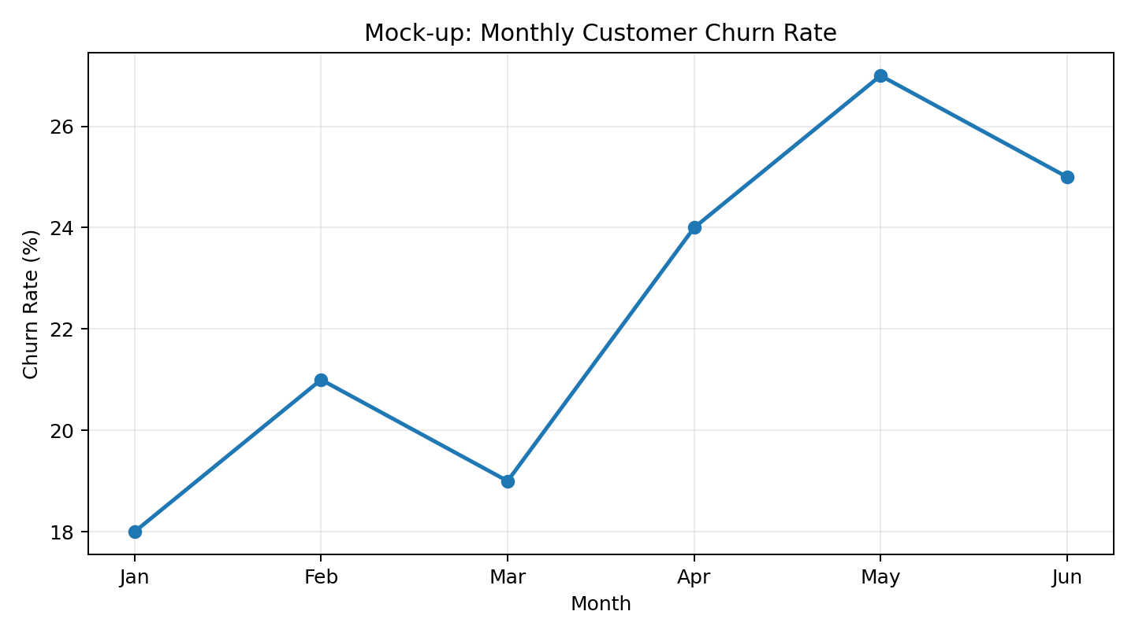
Figure 1. Monthly churn trend — useful for showing whether churn is stable, increasing, or concentrated in particular periods.
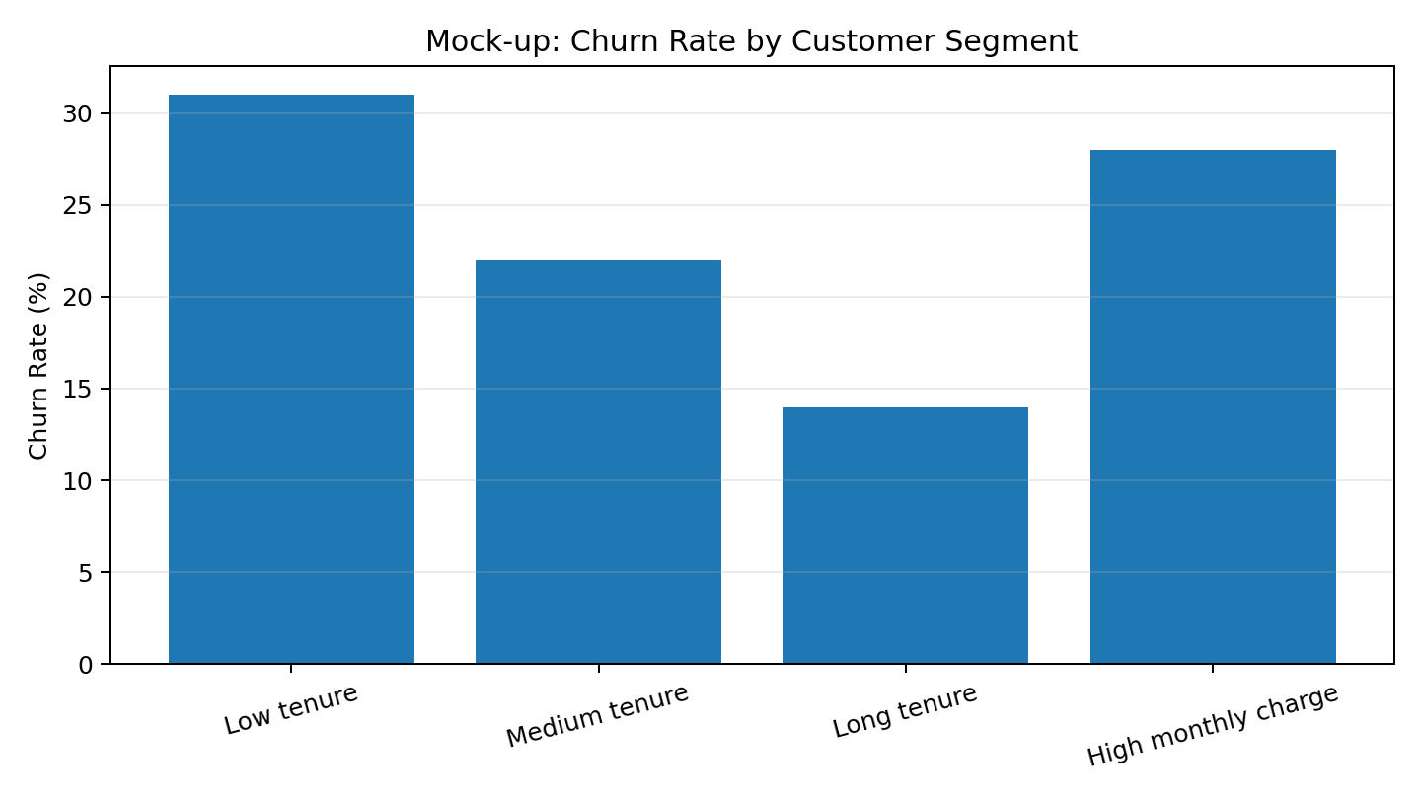
Figure 2. Segment comparison — useful for identifying groups that may need different retention strategies.

5. Planned Visual Story
- Executive KPI cards: total customers, churn rate, high-risk customer count, and estimated retention opportunity.
- Trend chart: show churn over time and highlight meaningful increases or decreases.
- Segment comparison: compare churn rates across tenure, contract, service, payment, and customer-value groups.
- Distribution plots: use histograms and box plots to explain important numerical variables and detect outliers.
- Relationship plots: use scatter plots or grouped plots to examine relationships between charges, tenure, usage, and churn.
- Correlation heatmap: summarize relationships among numerical variables while avoiding claims of causation.
- Confusion matrix and ROC curve: present model quality in a simplified way when discussing predictive performance.
- Feature-importance chart: show which variables contribute most strongly to model predictions, with a clear statement that importance is not the same as causation.

6. Communicating Results to a Non-Technical Audience
The presentation should follow a simple story: What is happening? Why does it matter? Who is most affected? What should we do? How will we measure success? Technical terminology should be minimized or translated into plain language. For example, instead of beginning with ROC-AUC or hyperparameters, the presentation can first explain how accurately the system identifies customers who may leave and how that information supports retention decisions.
Each slide should communicate one primary message. Visuals should use clear titles, direct annotations, and limited text. Any uncertainty or limitation should be stated openly so stakeholders understand that predictions support decisions rather than guarantee outcomes.

7. Actionable Recommendations
- Create an early-tenure retention program with onboarding support and proactive customer check-ins.
- Prioritize high-risk customers using model scores, while combining predictions with customer-service context.
- Investigate repeated support interactions and resolve recurring service problems before they become churn triggers.
- Review high-charge customer groups for plan suitability, perceived value, and targeted offers.
- Use controlled retention experiments to compare interventions and measure incremental impact.
- Track churn, retention rate, intervention acceptance, and customer value after deployment.
- Periodically retrain and validate the model as customer behavior, products, and pricing change.

8. Future Work
- Validate all hypotheses on a real and sufficiently representative dataset.
- Compare additional models and calibration methods where appropriate.
- Introduce explainability techniques so individual predictions can be reviewed responsibly.
- Build a dashboard for monitoring churn trends, risk segments, and retention outcomes.
- Establish model monitoring for data drift, performance degradation, and changes in customer behavior.
- Evaluate fairness and unintended impacts across relevant customer groups before operational use.

9. Proposed Executive Presentation Structure
Slide | Topic | Key Message
1 | Business Problem | Customer churn creates a measurable retention and revenue challenge.
2 | What the Data Shows | A small number of customer characteristics explain important churn patterns.
3 | Who Is at Risk? | Risk can be prioritized by customer segment and predictive score.
4 | Why It Matters | Early intervention can focus resources on customers with the greatest potential value.
5 | Recommended Actions | Use targeted onboarding, service recovery, and plan-fit interventions.
6 | Measurement | Track churn reduction, retention, customer value, and intervention effectiveness.
7 | Next Steps | Validate, deploy carefully, monitor, and continuously improve.

10. Limitations and Responsible Interpretation
Because this is a hypothetical project, the insights and chart values are illustrative rather than empirical findings. A real project would require data-quality checks, representative sampling, leakage prevention, appropriate validation, and careful interpretation of model outputs. Correlation or feature importance should not automatically be interpreted as causation. Business decisions should combine predictive evidence with domain knowledge, customer context, and measured outcomes.

11. Conclusion
A strong data science report does more than present model scores: it connects analysis to decisions. This plan turns a customer churn problem into an executive narrative supported by visual evidence, prioritized customer groups, practical retention actions, and measurable next steps. The final implementation should validate the proposed insights on real data and establish a feedback loop in which business outcomes continuously improve the analytical solution.

