WEBDEVELOPMENT LAB-4

NAME : ADITYA KUMAR

ROLL: 22IT3002

BRANCH: INFORMATION TECHNOLOGY

T1.

<!DOCTYPE html>

<html lang="en">

<head>

<meta charset="UTF-8">

<meta name="viewport" content="width=device-width, initial-scale=1.0">

<title>Color Changer</title>

<style>

body {

font-family: Arial, sans-serif;

text-align: center;

margin: 50px;

}

h1 {

color: #333;

}

button {

padding: 10px 20px;

font-size: 16px;

cursor: pointer;

}

</style>

</head>

<body>

<h1 id="heading">Click the button to change the color!</h1>

<button onclick="changeColor()">Change Color</button>

<script>

function changeColor() {

var heading = document.getElementById('heading');

var currentColor = heading.style.color;

var currentBackgroundColor = document.body.style.backgroundColor;

heading.style.color = getRandomColor(currentColor);

document.body.style.backgroundColor = getRandomColor(currentBackgroundColor);

}

function getRandomColor(currentColor) {

var letters = '0123456789ABCDEF';

var color = '#';

for (var i = 0; i < 6; i++) {

color += letters[Math.floor(Math.random() \* 16)];

}

if (color === currentColor) {

return getRandomColor(currentColor);

}

return color;

}

</script>

</body>

</html>

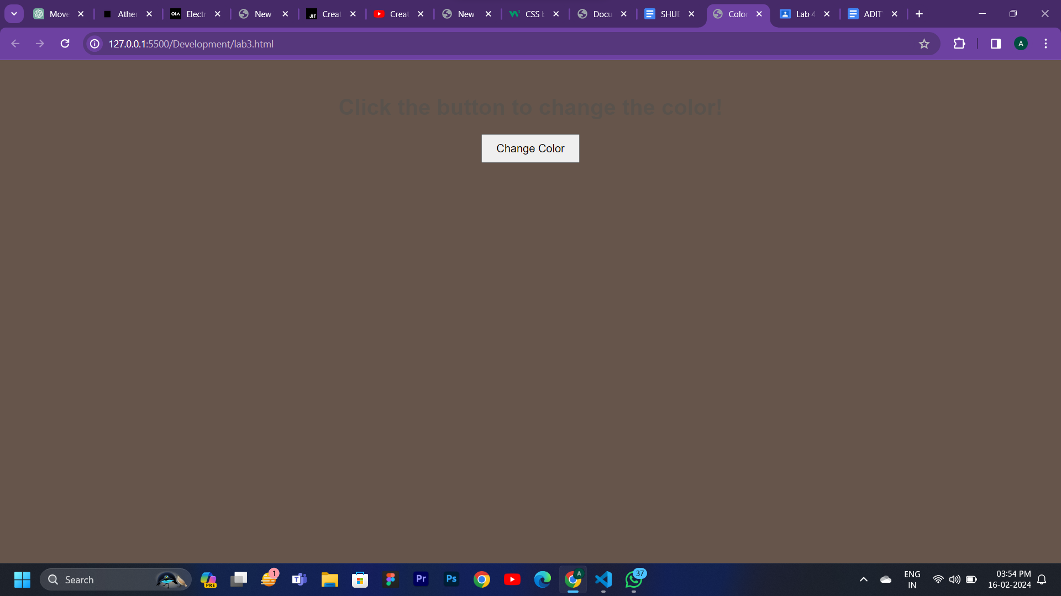

T2.

<!DOCTYPE html>

<html lang="en">

<head>

<meta charset="UTF-8">

<meta name="viewport" content="width=device-width, initial-scale=1.0">

<title>Document</title>

</head>

<body>

<h1 id="jg">helloooo</h1>

<script>

document.body.style.backgroundColor = 'green';

document.getElementById("jg").style.color = "red";

document.getElementById("jg").style.fontSize = "48px";

document.getElementById("jg").innerHTML = "hello";

var button = document.createElement("button");

button.innerHTML = "Click me";

document.body.appendChild(button);

</script>

</body>

</html>

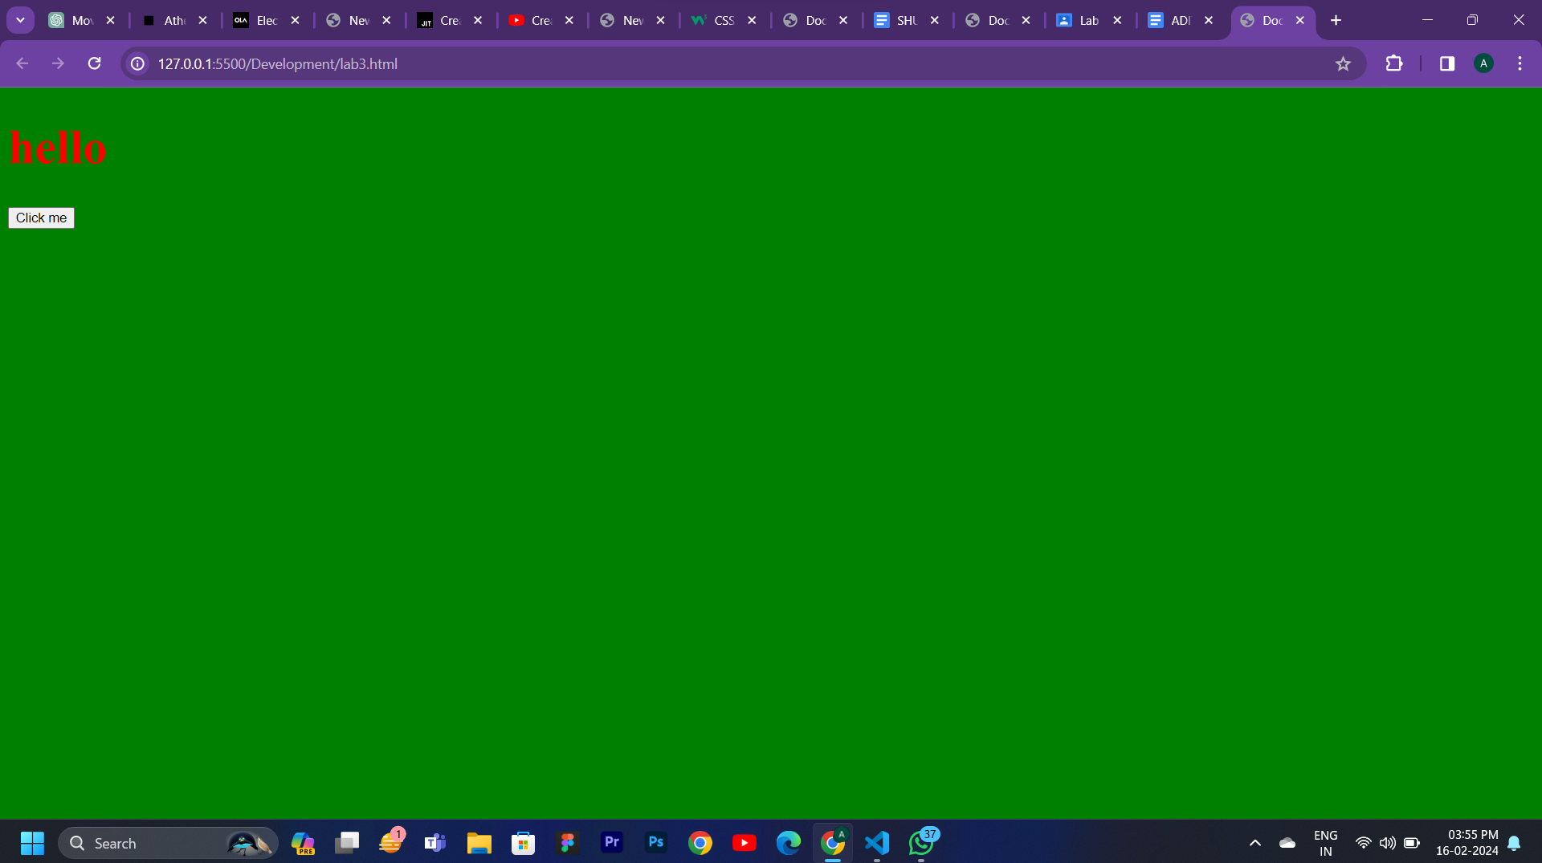

T3.<!DOCTYPE html>

<html lang="en">

<head>

<meta charset="UTF-8">

<meta name="viewport" content="width=device-width, initial-scale=1.0">

<title>Change Background and Text</title>

<style>

.green-background {

background-color: green;

}

</style>

</head>

<body>

<h1 id="heading">This is the heading</h1>

<button id="changeButton">Change Background and Text</button>

<script>

alert("Before assigning the class attribute.");

document.getElementById("changeButton").addEventListener("click", function() {

document.body.classList.add("green-background");

document.getElementById("heading").textContent = "Background and Text Changed";

alert("After assigning the class attribute.");

});

</script>

</body>

</html>

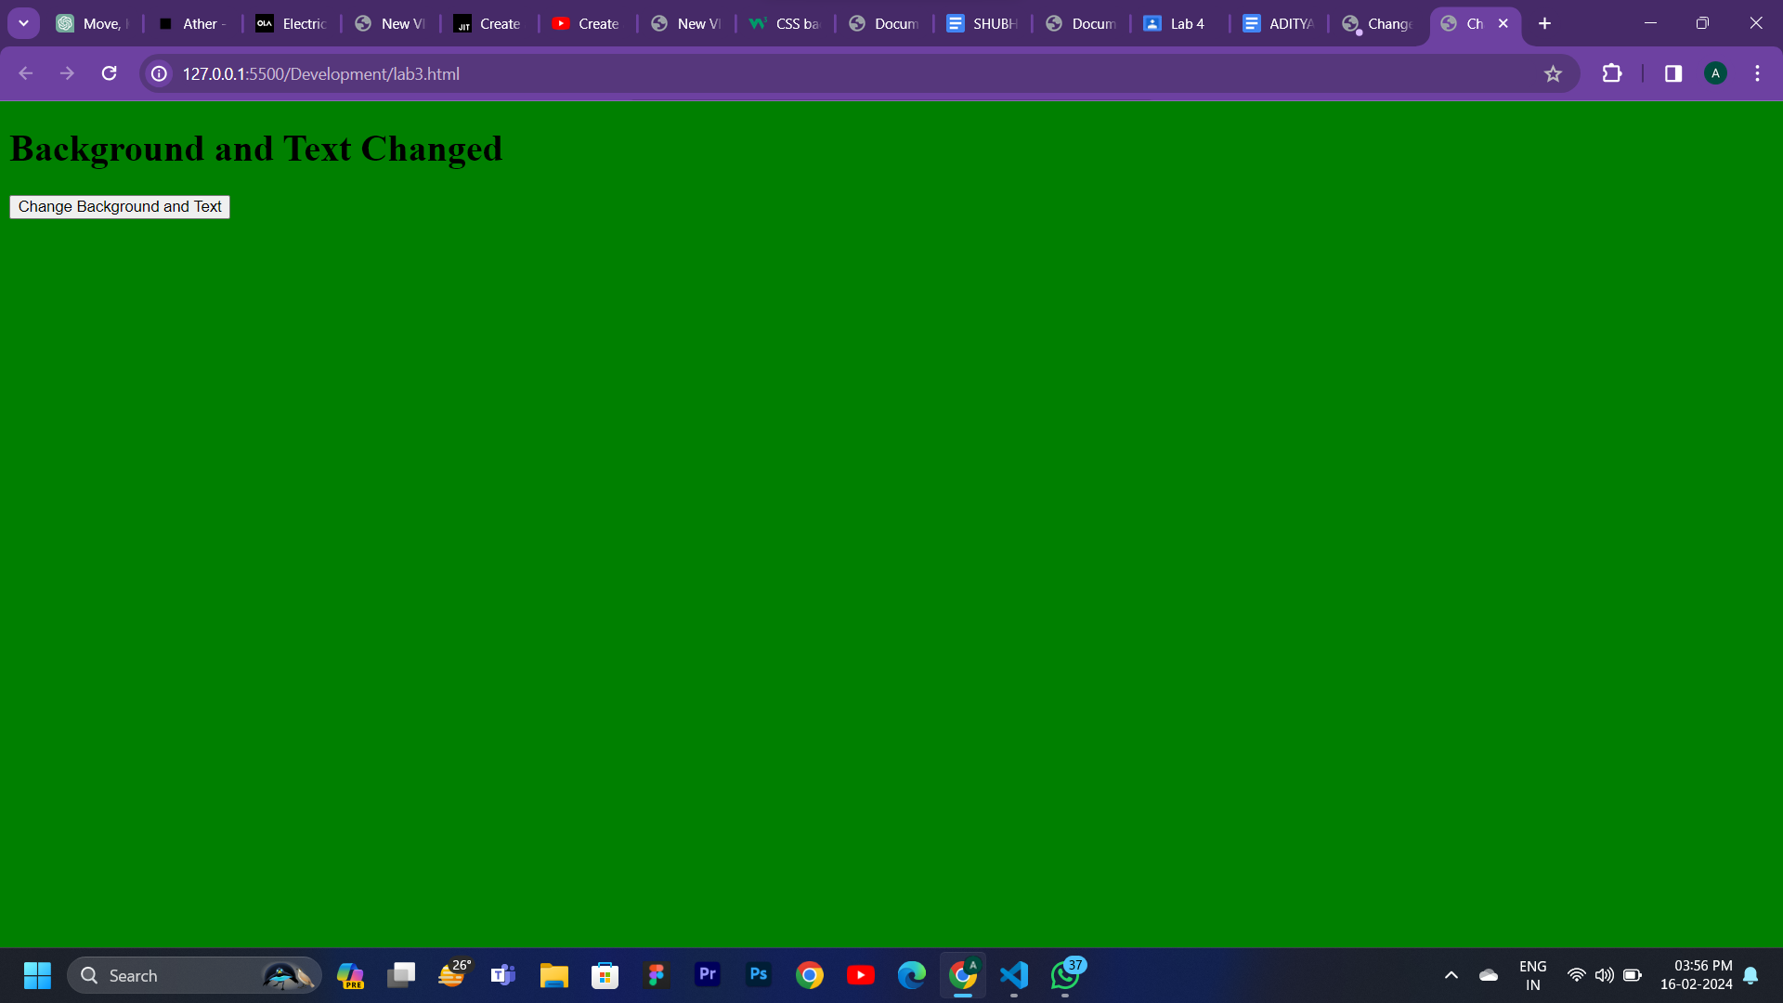

T4.<!DOCTYPE html>

<html lang="en">

<head>

<meta charset="UTF-8">

<meta name="viewport" content="width=device-width, initial-scale=1.0">

<title>Content Replacer</title>

<style>

body {

font-family: Arial, sans-serif;

text-align: center;

margin: 20px;

}

section {

border: 2px solid #333;

padding: 20px;

margin: 20px;

}

.original-content {

color: #333;

font-size: 18px;

}

.new-content {

color: rgb(84, 234, 219);

font-size: 24px;

font-weight: bold;

}

button {

padding: 10px 20px;

font-size: 16px;

cursor: pointer;

}

</style>

</head>

<body>

<h1>Welcome to the Content Replacer Page</h1>

<section id="mainSection" class="original-content">

<p>This is the original content inside the main section. Click the button to replace it!</p>

</section>

<button onclick="replaceContent()">Replace Content</button>

<script>

function replaceContent() {

var mainSection = document.getElementById('mainSection');

mainSection.innerHTML = '<p>This is the new content inside the main section with a different style!</p>';

mainSection.className = 'new-content';

}

</script>

</body>

</html>

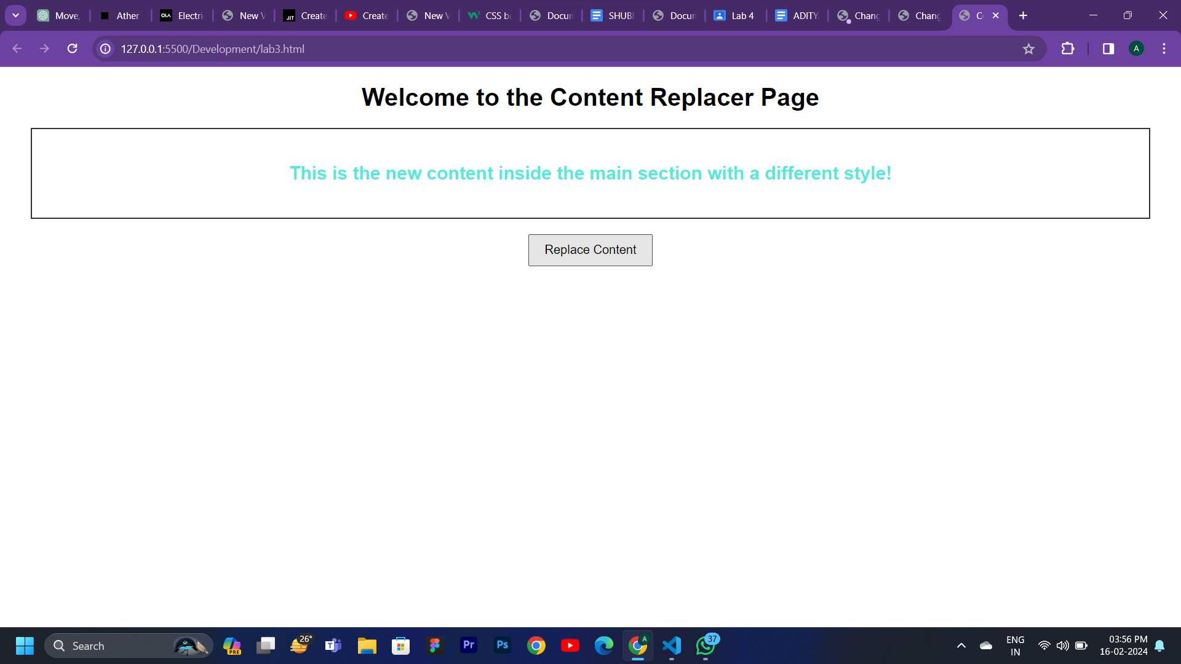

T5.

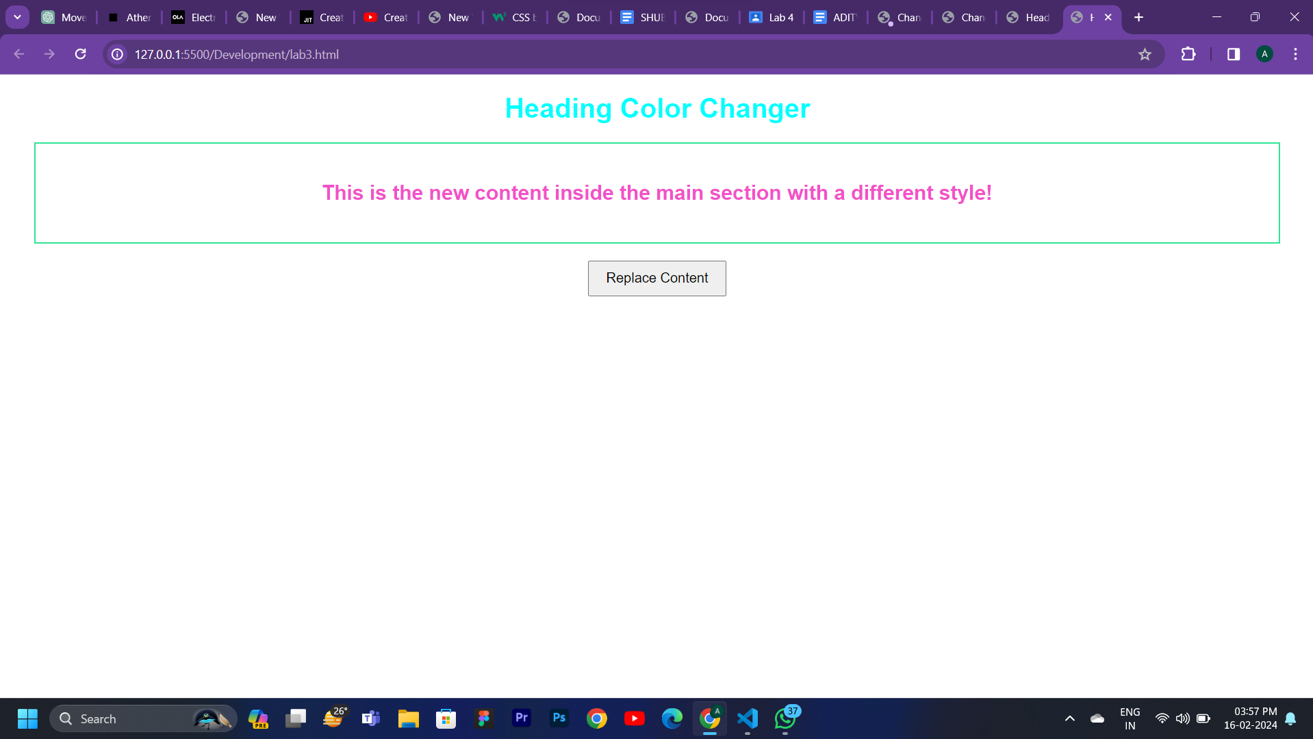

T6.<!DOCTYPE html>

<html>

<head>

<style>

body {

font-family: Arial, sans-serif;

}

.grid-container {

display: grid;

grid-template-columns: repeat(4, 1fr);

grid-gap: 10px;

padding: 10px;

}

.grid-item {

padding: 20px;

text-align: center;

border: 1px solid #ddd;

border-radius: 5px;

}

.grid-item img {

width: 50px;

height: 50px;

}

</style>

</head>

<body>

<h1>Web Browser Icons and Latest Versions</h1>

<div class="grid-container">

<div class="grid-item">

<img src="D:\Gargi mam. webdev\chrome.png" alt="Chrome">

</div>

<div class="grid-item">

<img src="D:\Gargi mam. webdev\edge.jpg" alt="edge">

</div>

<div class="grid-item">

<img src="D:\Gargi mam. webdev\firefox.jpg" alt="Firefox">

</div>

<div class="grid-item">

<img src="D:\Gargi mam. webdev\safari.jpg" alt="safari">

</div>

<div class="grid-item">

<img src="D:\Gargi mam. webdev\opera.jpg" alt="opera">

</div>

<div class="grid-item">

<p>57.0</p>

</div>

<div class="grid-item">

<p>16.0</p>

</div>

<div class="grid-item">

<p>52.0</p>

</div>

<div class="grid-item">

<p>10</p>

</div>

<div class="grid-item">

<p>44</p>

</div>

</div>

</body>

</html>

