|  |  |
| --- | --- |
|  | **eMediCare**  **Technical Design Document** |
| |  |  |  |  | | --- | --- | --- | --- | |  | **Prepared By / Last Updated By** | **Reviewed By** | **Approved By** | | **Name** | 1. Shekhar Deshpande(POD Lead)  2.Kashish Manglani  3. Swastika Maji  4.Aditaya Maharana  5.Narendran Ravichandran | Abhik Raha : Mentor Kavitha : Trainer |  | | **Role** |  |  |  | | **Signature** |  |  |  | | **Date** |  |  |  | |
|  |

Table of Contents

1.0 Introduction 3

1.1 Purpose of this document 3

1.2 Project overview 3

2.0 Solution Summary 3

2.1 Scope 3

2.2 Assumptions 3

2.3 Dependencies 3

2.4 Risks 3

3.0 Schematic Diagram 3

4.0 System Design 4

4.1 Proposed design 4

4.2 Component inventory 4

5.0 Database Design 4

5.1 Data Model 4

5.2 Tables Structure 4

6.0 Appendices 4

6.1 Glossary 4

6.2 Other 5

7.0 Terms & Conditions 5

8.0 Change Log 5

# Introduction

## Purpose of this document

The purpose of this document is to document the technical design, component details and Database design. This will also capture the scope, assumptions, risk, dependencies of this project.

## Project overview

The purpose of the project entitled “eMediCare” provides online medical services to everyone hardly matters whether they live in metro or a remotely located village. Users can connect through their home internet and can book appointments.

The main function of the system is that it can be used by the patients to take online appointments of doctors, view their previous health records, reports etc. The doctors can give online appointments and e-prescriptions. The users can register and store their details and retrieve these details as and when required, and also to manipulate these details meaningfully. In case of any medical error ,patient can register a complaint and admin will try to resolve the issue.

# Solution Summary

## Scope

Online Medical Management System enables healthcare providers to improve operational effectiveness, reduce medical errors, reduce time consumption and enhance delivery of quality of care. It is an end-to-end internet based software application used to ensure the streamlining of the managerial and administrative work at the hospital.

As stated in the earlier modules of this document, this product will have a database for storing, adding and modifying patient data, and prescriptions. It will also allow the system to create and view patient's log files that contains the previous transactions with the clinic, such as check-ups. This enables transparency, as well as it shows to the patient what happened in the previous visit to the clinic.

The **eMediCare** has good potential to grow since it provides specialty health care to the remote hospitals. The growth could be the connectivity between:-

a) District hospitals/ health centers and super-specialty hospitals in the cities.

b) Community Health Centers at block level and district hospital and

c) Primary Health Centre at village level and community health centers for health care and delivery of medical advice.

## Assumptions

1) It will show doctors list according to their specialization domain.

2) Sign up page consist of user option either patient or doctor and their details which stored in Database Mysql.

3) Database will work properly and store the records of the User.

4) Admin will add doctors and deactivate doctor in the system.

5) Patients can take his prescription, send lab reports to doctor, see all the previous, current, and future appointments.

6. Only Doctor can see the details of patient not Admin or any other person.

## Dependencies

1. Admin can add doctors only when he/she is available to serve.
2. Patient can take an appointment only when the status of doctor is available.
3. Patient can only cancel the future appointments if any.

## Risks

Sensitive data, such as electronic health records(EHRs), can be compromised and manipulated by digital criminals, and inadequate cleansing or sterilization can open up patients to new infections and ailments.

EHRs is the risk of patient privacy violations, which is an increasing concern for patients due to the increasing amount of health information exchanged electronically. To relieve some of these concerns, policymakers have taken measures to ensure safety and privacy of patient data.

# Schematic Diagram

A schematic, or schematic diagram, is a representation of the elements of a [system](https://en.wikipedia.org/wiki/System) using abstract, graphic [symbols](https://en.wikipedia.org/wiki/Symbol) rather than realistic pictures. It gives an overview of overall system.

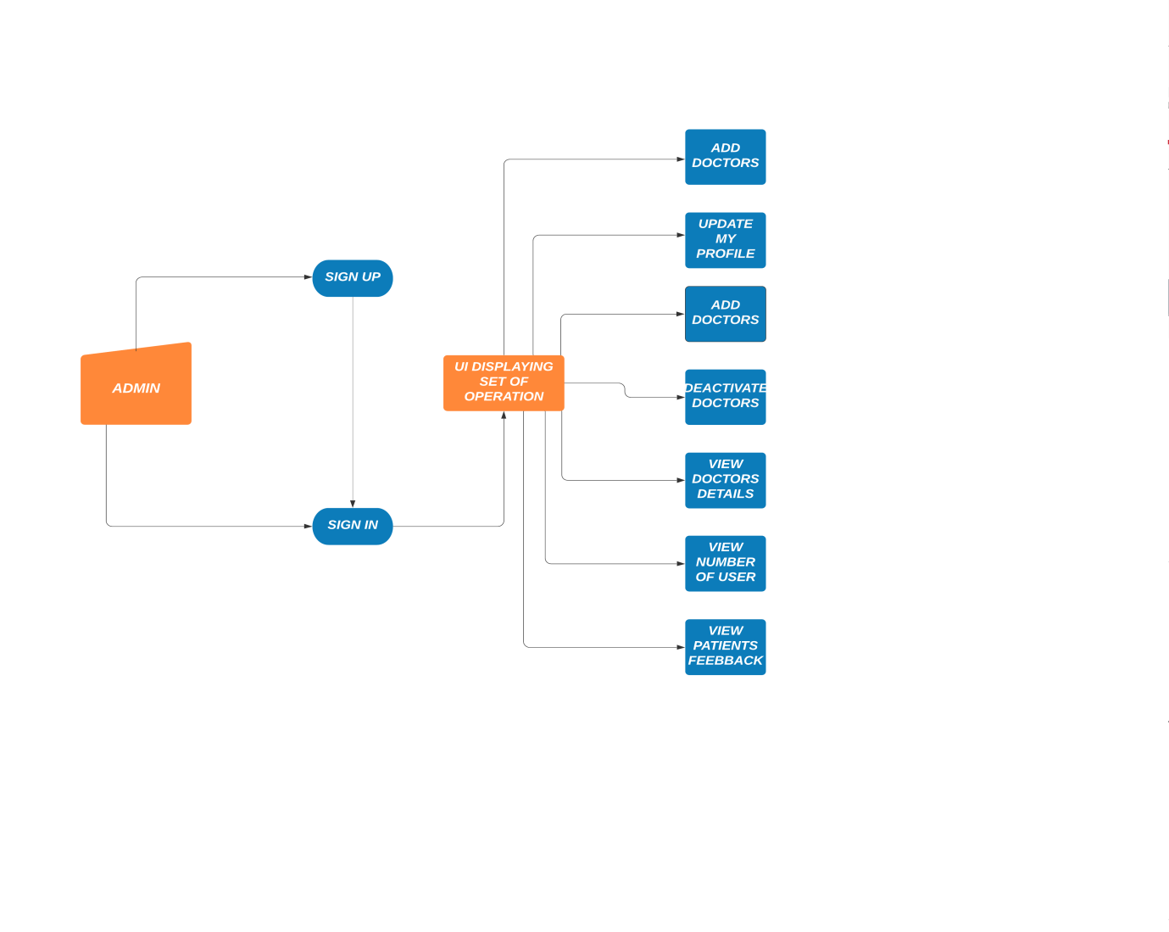

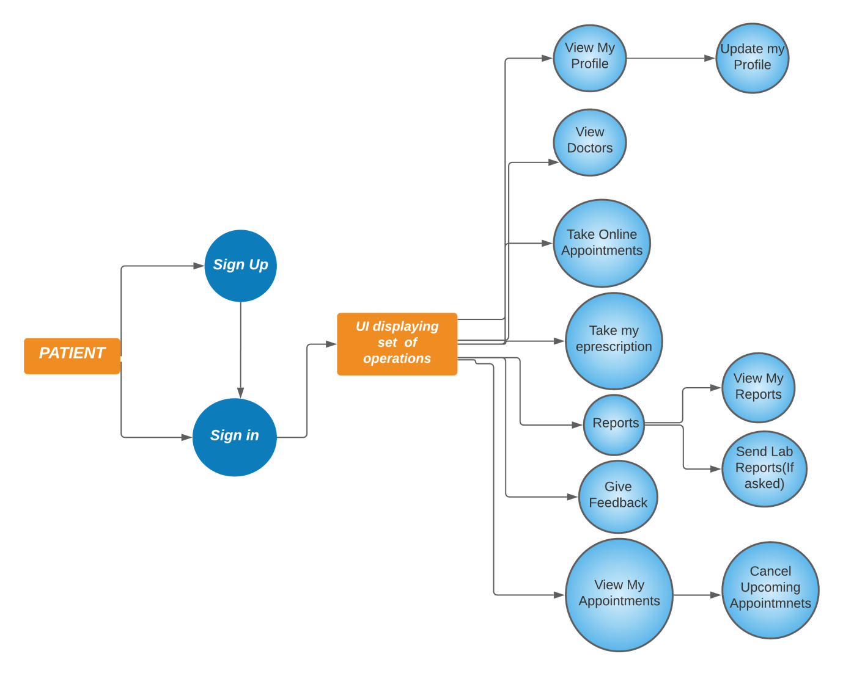

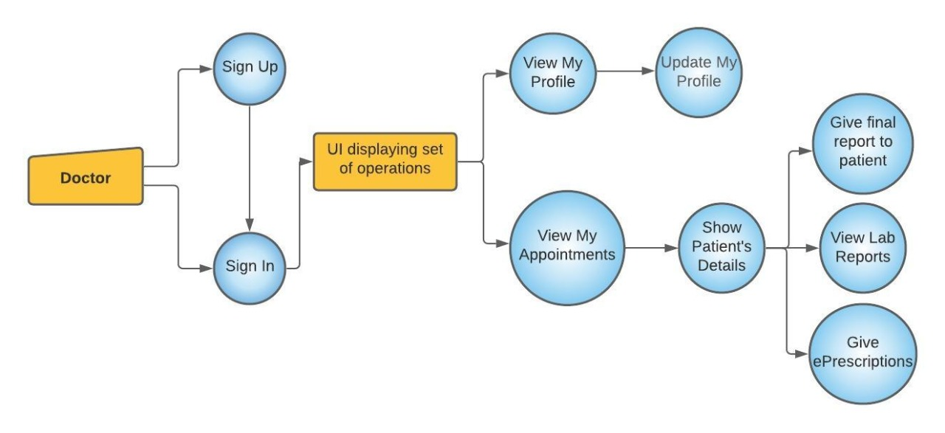

# System Design

## Proposed design

### Sequence Design

1. Login

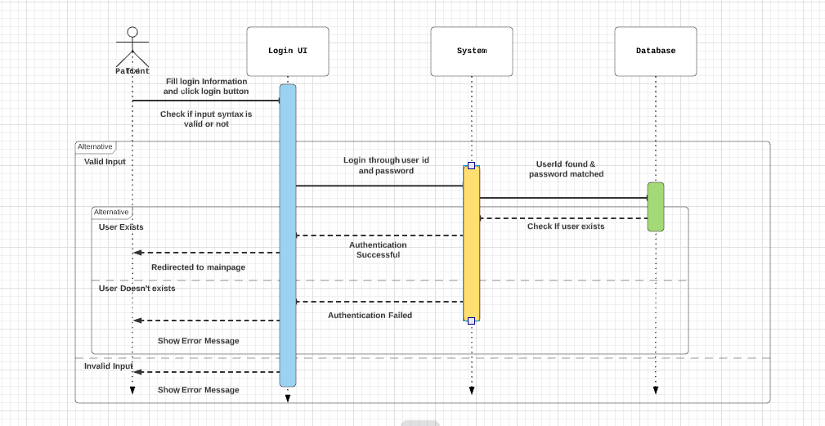

1. Add and view doctor

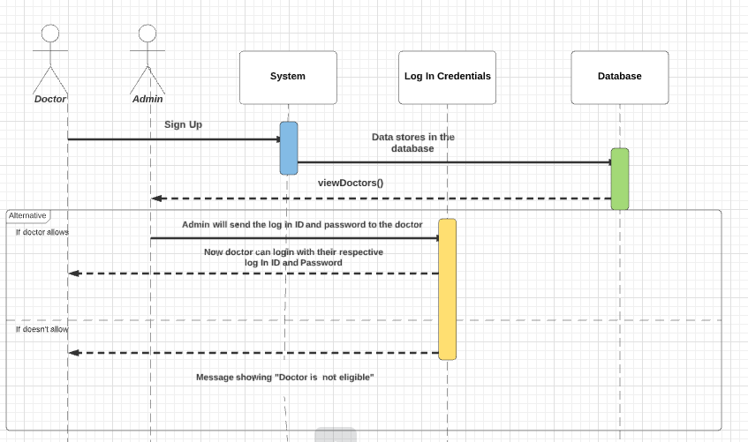

1. Booking Appointments

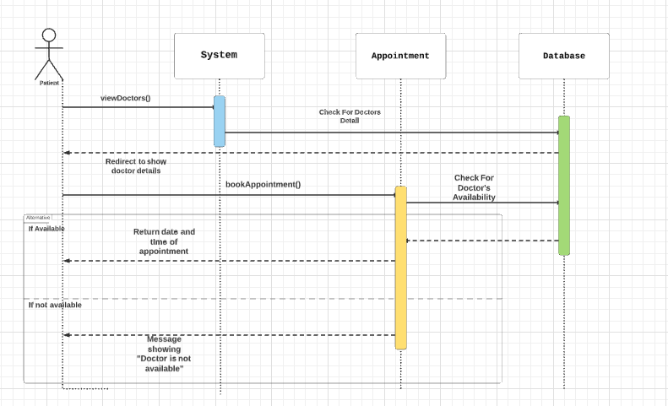

1. View Appointments and View Patients

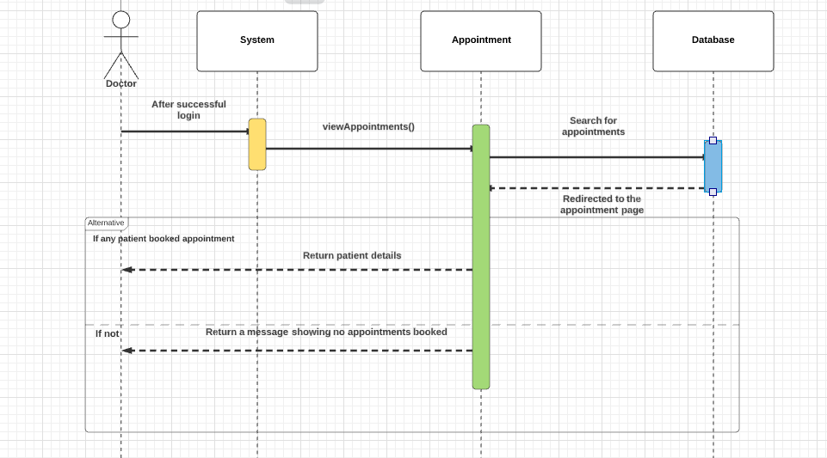

1. Reports

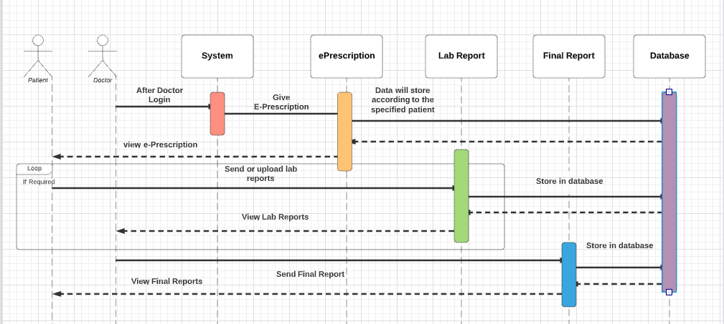

1. Give/View Feedback

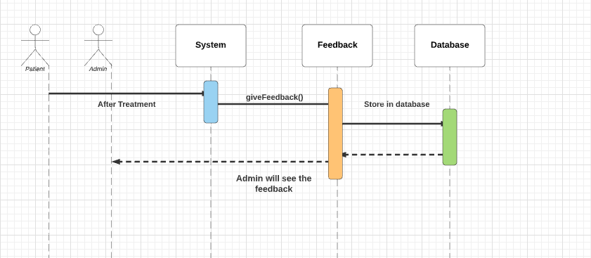

## Component inventory

1. Admin :
   1. Add doctors
   2. Update profile
   3. Deactivate doctor
   4. View doctor details
   5. View Number of Users
   6. View patient feedback
2. Patient
   1. View profile
      1. Update profile
   2. View doctors
   3. Take online appointments
   4. Take prescription
   5. Reports
      1. View report
      2. Send lab report
   6. Give Feedback
   7. View my appointments
      1. Cancel Upcoming Appointments
3. Doctor
   1. View profile
      1. Update profile
   2. View appointment
      1. Show patient details
         1. Give e-Prescription
         2. View lab reports
         3. Give final report

## UseCase Diagram

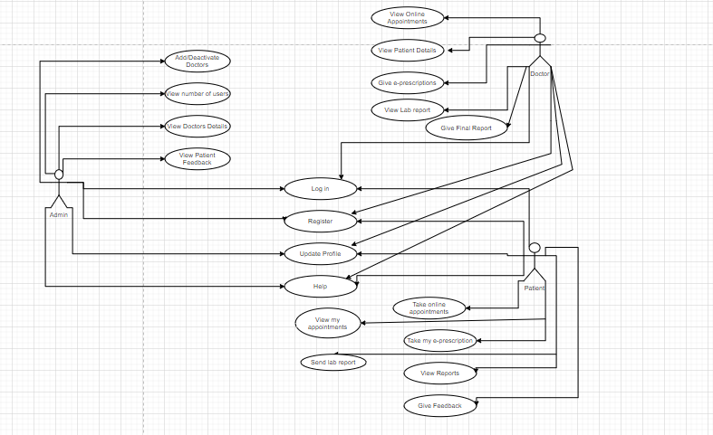

# Database Design

## Data Model

### ER-Diagram

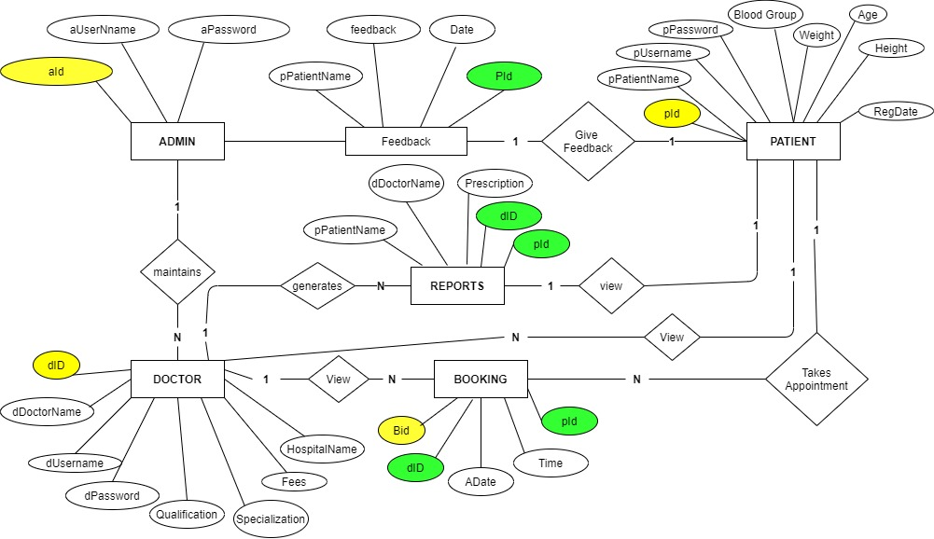

## Tables Structure

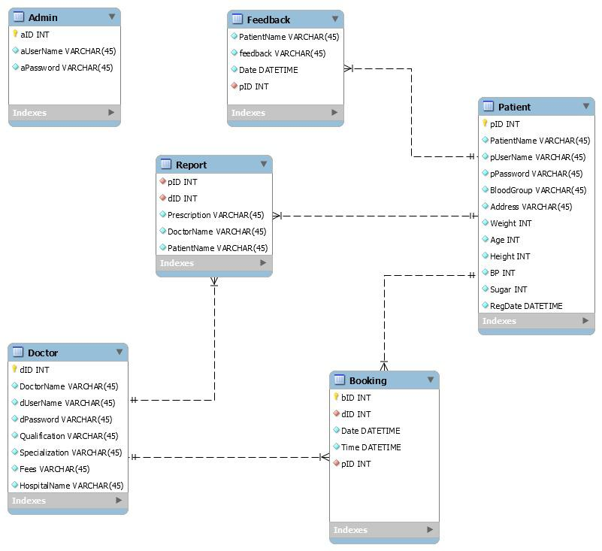

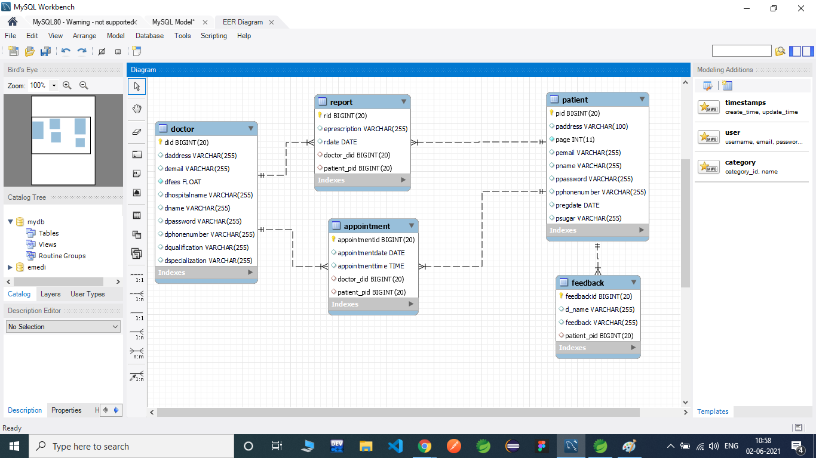

* 1. Admin

|  |  |  |  |
| --- | --- | --- | --- |
| **Column Name** | **Data Type** | **Length** | **Nulls** |
| aID (PK) | INT |  | Not Null |
| aUserName | VARCHAR | 45 | Not Null |
| aPassword | VARCHAR | 45 | Not Null |

* 1. Patient

|  |  |  |  |
| --- | --- | --- | --- |
| **Column Name** | **Data Type** | **Length** | **Nulls** |
| pID (PK) | INT |  | Not Null |
| PatientName | VARCHAR | 45 | Not Null |
| pUserName | VARCHAR | 45 | Not Null |
| pPassword | VARCHAR | 45 | Not Null |
| BloodGroup | VARCHAR | 45 | Not Null |
| Address | VARCHAR | 150 | Not Null |
| Weight | INT |  | Not Null |
| Age | INT |  | Not Null |
| Height | INT |  | Not Null |
| BP | INT |  | Not Null |
| Sugar | INT |  | Not Null |
| RegDate | DATETIME |  | Not Null |

* 1. Doctor

|  |  |  |  |
| --- | --- | --- | --- |
| **Column Name** | **Data Type** | **Length** | **Nulls** |
| dID (PK) | INT |  | Not Null |
| DoctorName | VARCHAR | 45 | Not Null |
| aUserName | VARCHAR | 45 | Not Null |
| aPassword | VARCHAR | 45 | Not Null |
| Qualification | VARCHAR | 45 | Not Null |
| Specialization | VARCHAR | 45 | Not Null |
| Fees | VARCHAR | 45 | Not Null |
| HospitalName | Vs1ARCHAR | 45 | Not Null |

* 1. Booking

|  |  |  |  |
| --- | --- | --- | --- |
| **Column Name** | **Data Type** | **Length** | **Nulls** |
| bID (PK) | INT |  | Not Null |
| dID (FK) | INT |  | Not Null |
| Date | DATETIME |  | Not Null |
| Time | DATETIME |  | Not Null |
| pID (FK) | INT |  | Not Null |

* 1. Report

|  |  |  |  |
| --- | --- | --- | --- |
| **Column Name** | **Data Type** | **Length** | **Nulls** |
| pID (FK) | INT |  | Not Null |
| dID (FK) | INT |  | Not Null |
| Prescription | VARCHAR | 45 | Not Null |
| DoctorName | VARCHAR | 45 | Not Null |
| PatientName | VARCHAR | 45 | Not Null |

* 1. Feedback

|  |  |  |  |
| --- | --- | --- | --- |
| **Column Name** | **Data Type** | **Length** | **Nulls** |
| PatientName | VARCHAR |  | Not Null |
| feedback | VARCHAR | 45 | Not Null |
| Date | DATETIME |  | Not Null |
| pID (FK) | INT |  | Not Null |

# Appendices

## Glossary

|  |  |
| --- | --- |
| **Acronyms** | **Definitions** |
|  |  |

## Other

# Terms & Conditions

***Disclaimer: Please do not circulate or distribute this document outside of Cognizant Network, We have a Zero Tolerance Policy. Kindly adhere to 100% Compliance at all times.***

# Change Log

*Please note that this table needs to be maintained even if a Configuration Management tool is used.*

|  |  |  |  |  |
| --- | --- | --- | --- | --- |
| Version Number | Changes made | | | |
| V<n.n> | *<If the change details are not explicitly documented in the table below, reference should be provided here>* | | | |
| Page no | Changed by | Effective date | Changes effected |
|  |  |  |  |
|  |  |  |  |
|  |  |  |  |
|  |  |  |  |