

Abstract
The Smart Warehouse Grid Locator is a Java-based software system designed to simulate efficient item storage and retrieval within a warehouse environment. Modern warehouses demand fast, accurate tracking of thousands of items across large storage areas, and manual methods are prone to errors and delays. This project provides an automated approach by modelling the warehouse as a two-dimensional grid, where each cell can hold an item object containing an identifier, name, and quantity.
Developed using Object-Oriented Programming (OOP) principles, the system leverages a
structured class design with a GridItem class encapsulating item attributes and a Warehouse class managing the 2D grid. The search engine uses nested loops to traverse the grid and return precise row-column coordinates for any queried item. This design demonstrates encapsulation, modular class architecture, and spatial data management in a practical real-world context.
The project serves as a foundational model for inventory management and can be extended with dynamic input, graphical interfaces, and database connectivity for enterprise-scale deployment.

Introduction
The Smart Warehouse Grid Locator is designed to simulate how modern logistics systems automate the storage and retrieval of inventory. Warehouses with hundreds or thousands of products require a systematic mechanism to locate items instantly, reducing search time and improving operational efficiency.
This project is built using Java and Object-Oriented Programming (OOP) concepts, making the code modular, reusable, and easy to maintain. The warehouse is modelled as a 2D grid array, where each position can store a GridItem object.

The project mainly consists of the following key components:
- GridItem Class (Data Model) → Stores individual item data: ID, Name, and Quantity.
- Warehouse Class (Grid Manager) → Manages a 2D array of GridItem objects and provides search functionality.
- Main Class (Driver) → Instantiates the system, populates the grid, and performs search operations.

The system provides features such as grid-based spatial storage, coordinate-based item retrieval using nested loops, and null-safe slot handling. It demonstrates practical use of 2D arrays, OOP encapsulation, and algorithmic searching within a structured Java application.

Objectives
- Model a warehouse as a 2D grid capable of storing item objects at specific coordinates.
- Design a GridItem class to encapsulate item identity (ID, Name, Quantity).
- Implement a search function using nested loops to locate items by their unique ID.
- Return precise grid coordinates (row, column) when an item is found.
- Apply OOP concepts: Encapsulation, Class Design, Constructor usage, and Modular Programming.

Scope
The Smart Warehouse Grid Locator is applicable to small-to-medium inventory management scenarios and serves as a foundational model for real-world warehouse systems. It is particularly suitable for academic demonstrations of 2D arrays and OOP class design in Java.
In its current form, the system operates on a fixed-size grid defined at compile time, with items manually assigned to positions. Future iterations of the project may include:
- Dynamic grid resizing with user-defined dimensions.
- Database connectivity (e.g., MySQL or SQLite) to persist inventory data between sessions.
- Graphical User Interface (GUI) using JavaFX or Swing for interactive grid visualization.
- Real-time item addition, deletion, and update functionality.
- Barcode or QR-code integration for physical warehouse mapping.

System Requirements
Component | Details
Hardware | Computer with at least 2 GB RAM; any modern processor
Operating System | Windows 10 / macOS / Linux (any OS with JDK support)
Java Version | Java JDK 8 or higher (JDK 11+ recommended)
IDE / Editor | VS Code, Eclipse, IntelliJ IDEA, or any Java-supported IDE
Build Tool | Javac (command line) or IDE built-in compiler

Methodology
The system follows a structured, step-by-step approach to build and operate the warehouse locator:
- Design the GridItem Class: Define the item blueprint with attributes (itemId, itemName, quantity) and a parameterized constructor for initialization.
- Design the Warehouse Class: Declare a 2D array of type GridItem[][] and set the grid dimensions. Initialize all grid slots to null to represent empty positions.
- Populate the Grid: Create GridItem objects using constructors and assign them to specific [row][column] coordinates in the grid.
- Implement the Search Method: Use nested for loops to iterate through every cell. Compare each non-null item's ID with the search query. Return coordinates on a match.
- Handle Edge Cases: If no item matches, print a 'not found' message. If a slot is null (empty), skip it to avoid NullPointerException.
- Run and Test: Invoke the search method from the main class with various item IDs to verify correct coordinate output and edge case handling.

Flowchart
The flowchart below illustrates the complete execution flow of the Smart Warehouse Grid Locator, from system initialization to item search and result output.
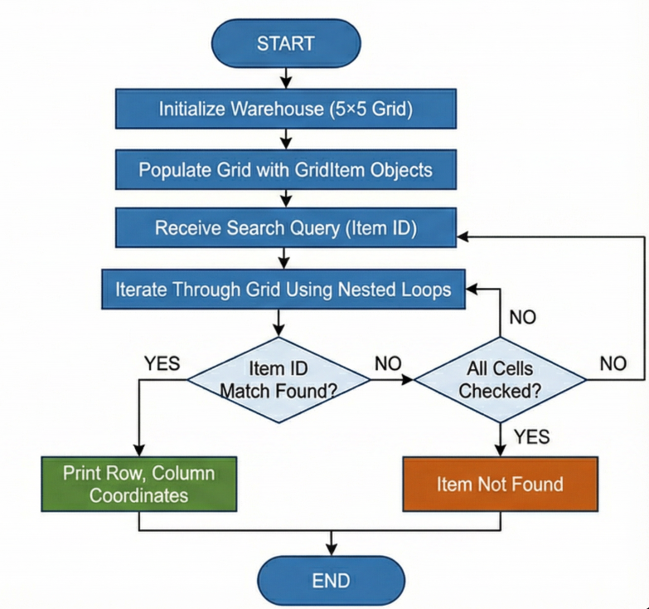

Class Diagram
The class diagram below represents the structural design of the system, showing the two core classes and their relationship.
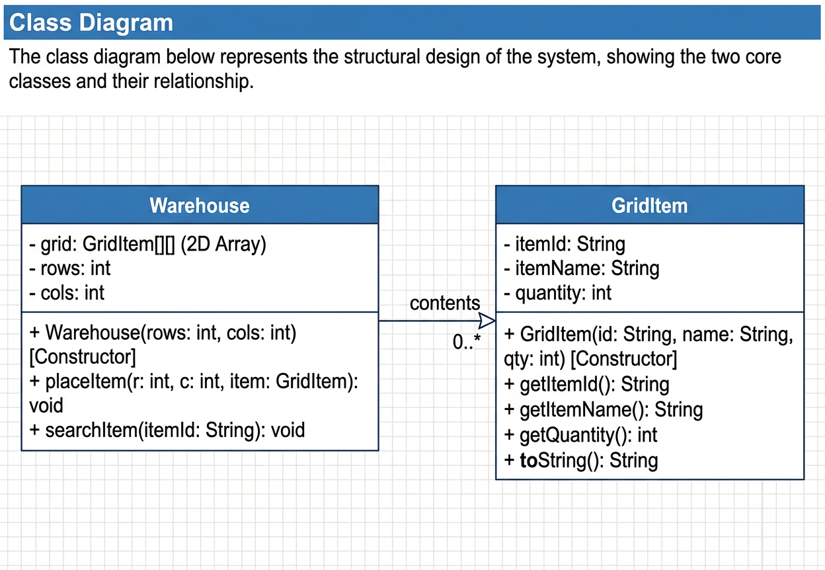

Class Descriptions

GridItem Class
- Variables:
- String itemId — Unique identifier for the item (e.g., "I101")
- String itemName — Descriptive name of the item (e.g., "Laptop")
- int quantity — Number of units stored at this grid location
- Methods:
- Parameterized Constructor — Accepts itemId, itemName, quantity as arguments
- getItemId() — Returns the item's unique identifier
- getItemName() — Returns the item's name
- getQuantity() — Returns the stock quantity

Warehouse Class
- Variables:
- GridItem[][] grid — A 2D array storing all item references in the warehouse layout
- int rows, int cols — Dimensions defining the size of the warehouse grid
- Methods:
- Constructor — Initializes the grid array with specified dimensions; all cells start as null
- placeItem(int r, int c, GridItem item) — Assigns a GridItem to a specific grid coordinate
- searchItem(String itemId) — Uses nested loops to find an item by ID and print its location
- displayGrid() — Iterates the grid and prints all stored items with their positions

Main Class
- Variables:
- No instance variables — operates entirely through the static main() method
- Methods:
- main(String[] args) — Entry point: creates a Warehouse instance, populates the grid with GridItem objects, and performs test searches

Implementation
The system is implemented using a class hierarchy that follows core OOP principles:
- GridItem Class (Data Model): This is the foundational data class that acts as a blueprint for each inventory item. It stores itemId, itemName, and quantity as private attributes, enforcing encapsulation. The parameterized constructor ensures that every GridItem object is initialized with valid data upon creation.

- Warehouse Class (Grid Logic): This class owns the 2D array and all grid operations. On construction, it allocates a GridItem[rows][cols] array with all cells set to null (empty slots). The placeItem() method allows controlled insertion at specific coordinates. The searchItem() method contains the core algorithm: two nested for loops traverse every row and column; for each non-null cell, it compares the item's ID with the search query and prints the coordinates upon a match.

- Main Class (Driver): The main() method orchestrates the entire workflow. It creates a Warehouse object, populates sample grid positions using placeItem(), and calls searchItem() with various IDs to demonstrate both successful lookups and not-found scenarios.

Sample Input / Output
The following output is generated when the program is executed with sample data:

$ javac Main.java && java Main

Searching for item ID: I101
Item found at Row: 0, Column: 0

Searching for item ID: I102
Item found at Row: 1, Column: 2

Searching for item ID: I999
Item not found in warehouse.

Future Enhancements
- Database Integration: Connect the system to a database (e.g., MySQL) to persistently save warehouse inventory, enabling data retention across program sessions.
- Graphical User Interface (GUI): Replace the terminal-based output with a window-based application using JavaFX or Swing, providing a visual grid map of the warehouse.
- Dynamic Grid Resizing: Allow users to specify grid dimensions at runtime instead of hardcoding the size, supporting warehouses of varying scales.
- Item Update and Deletion: Implement methods to modify item details or remove items from specific grid positions, reflecting real inventory changes.
- Multi-Item Search and Sorting: Add support for searching by item name or quantity range, and sorting grid contents for efficient browsing.

Gantt Chart

1. Planning & Structure
A Gantt chart provides a visual timeline for breaking the project into specific tasks — class design, coding, and testing — with clear daily targets. Even for a focused OOP project, planning the class hierarchy and interactions is essential before writing any code.

2. Time Management
The project is structured across 7 days to ensure thorough implementation and testing:

Task | Day 1 | Day 2 | Day 3 | Day 4 | Day 5 | Day 6 | Day 7
Class Design & Planning | ✔ | ✔
Coding GridItem & Warehouse |  |  | ✔ | ✔
Search Logic Implementation |  |  |  | ✔ | ✔
Testing & Bug Fixing |  |  |  |  |  | ✔
Documentation & Report |  |  |  |  |  |  | ✔

This structured approach ensures each OOP concept is implemented correctly and the system is fully functional within the deadline.

Conclusion
The Smart Warehouse Grid Locator successfully demonstrates the application of Object-Oriented Programming concepts — encapsulation, class design, and constructors — alongside core data structures, specifically 2D arrays, in a practical Java application. The project simulates a real warehouse scenario where items are stored at precise grid coordinates and can be retrieved efficiently using a nested-loop search algorithm.
By completing this project, the core OOP principle of modular, reusable class design is reinforced through a tangible, real-world use case. The system is scalable and provides a strong foundation for future enhancements such as GUI integration, database connectivity, and dynamic inventory management. Overall, the project bridges theoretical programming concepts with practical software design skills.

References
Book Format
[1] H. Schildt, Java: The Complete Reference, 12th ed. New York: McGraw-Hill, 2021.
Website Format
[2] Oracle, "Java Arrays," Oracle. [Online]. Available: https://docs.oracle.com/javase/tutorial/java/nutsandbolts/arrays.html
Journal Article Format
[3] A. Kumar and S. Patel, "Grid-Based Inventory Management using Object-Oriented Design Patterns," International Journal of Computer Applications, vol. 12, no. 3, pp. 45-52, 2023.
Conference Paper Format
[4] M. Sharma, "Efficient Warehouse Simulation using 2D Arrays in Java," in Proc. National Conference on Software Engineering (NCSE), 2024, pp. 88-94.

