**Functionability:**

Convenience and practicality should be fully considered in the design of the main interface. Every Desktop interface is a visual interface, which has its unique layout configuration files. We can configure various layout and resources files according to the requirements, such as images, text and color reference, which can form different visual interface and glaring effect.

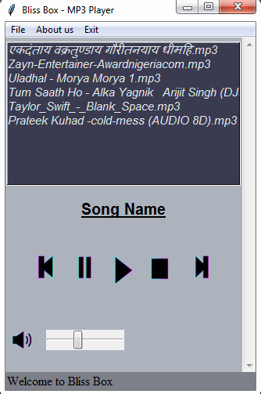

**The main play interface design**

Interface design of adding songs

There are no corresponding songs for the first time user enters the program; users need to add songs of their respective choices in the Bliss Box. Therefore, you need to enter the adding songs’ interface. The empty playlist needs to add songs which can be chosen from the Local Hard disk or a Pen drive to add.

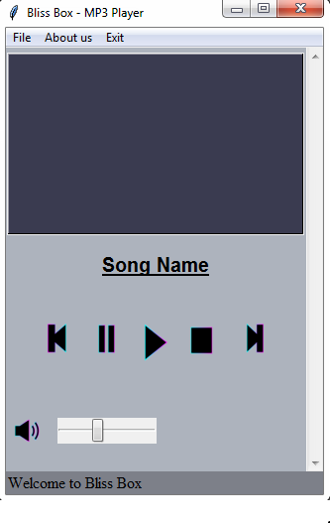

**Interface design before adding songs**

To add new songs go to File 🡪 New and select a track or multiple audios to play as per the user’s choice.

When need to use the player to play appropriate music, click the play button to realize the function.

When need to use the player to switch to the previous song, click on “Move Previous music” button to realize the function.

When need to use the player to play the next song, click on “the next music” button to realize the function.

**1) Playlist design:**

The Playlist view shows one song’s name in every row. It highlights the name of the song being played.

If the user wishes to delete a certain track from the playlist, the user can do so by selecting the track 🡪 File 🡪 Delete and the selected track will be omitted from the playlist.

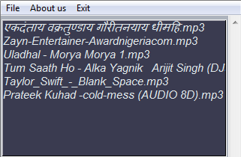

**The Playlist View**

 The design and realization of play menus

Play menus includes five functions. The details are as below:

|  |  |
| --- | --- |
| **File** | **Includes the New & Delete options** |
| **New** | **Creates new playlist/Adds new songs to playlist** |
| **Delete** | **Delete songs from existing playlist** |
| **About us** | **Provides information about the application** |
| **Exit** | **Quit and exit the application** |

**2) Play mode**

Play mode of the player includes single cycle, play in order etc. When a song is being played, the name of the track being played is displayed above the music player controls. Similarly it is also highlighted in the playlist.

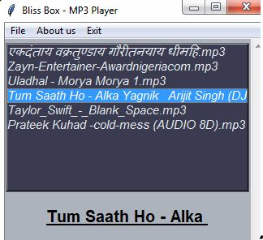

The Music Player controls and the function of each one of them is listed as:



Play : Start playing the selected song

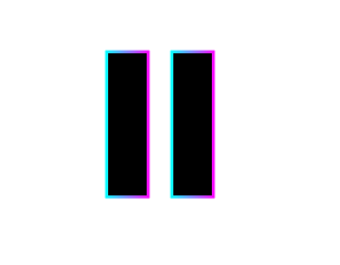

Pause : Stops/Pauses the track being played



Previous: Plays the previous track/song

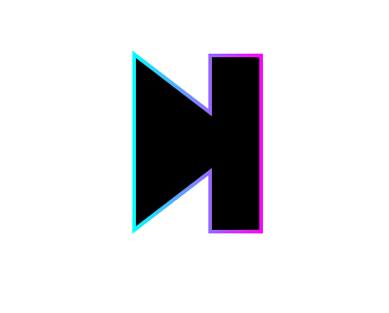

Next: Plays the next track/song



Stop: Plays the previous track/song



Volume: Controls Volume / Allows to increase or decrease volume of current track

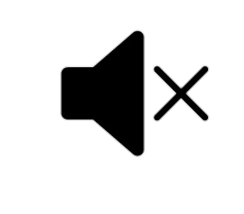

Mute: Mutes the volume of song being played

**3) Data Storage**