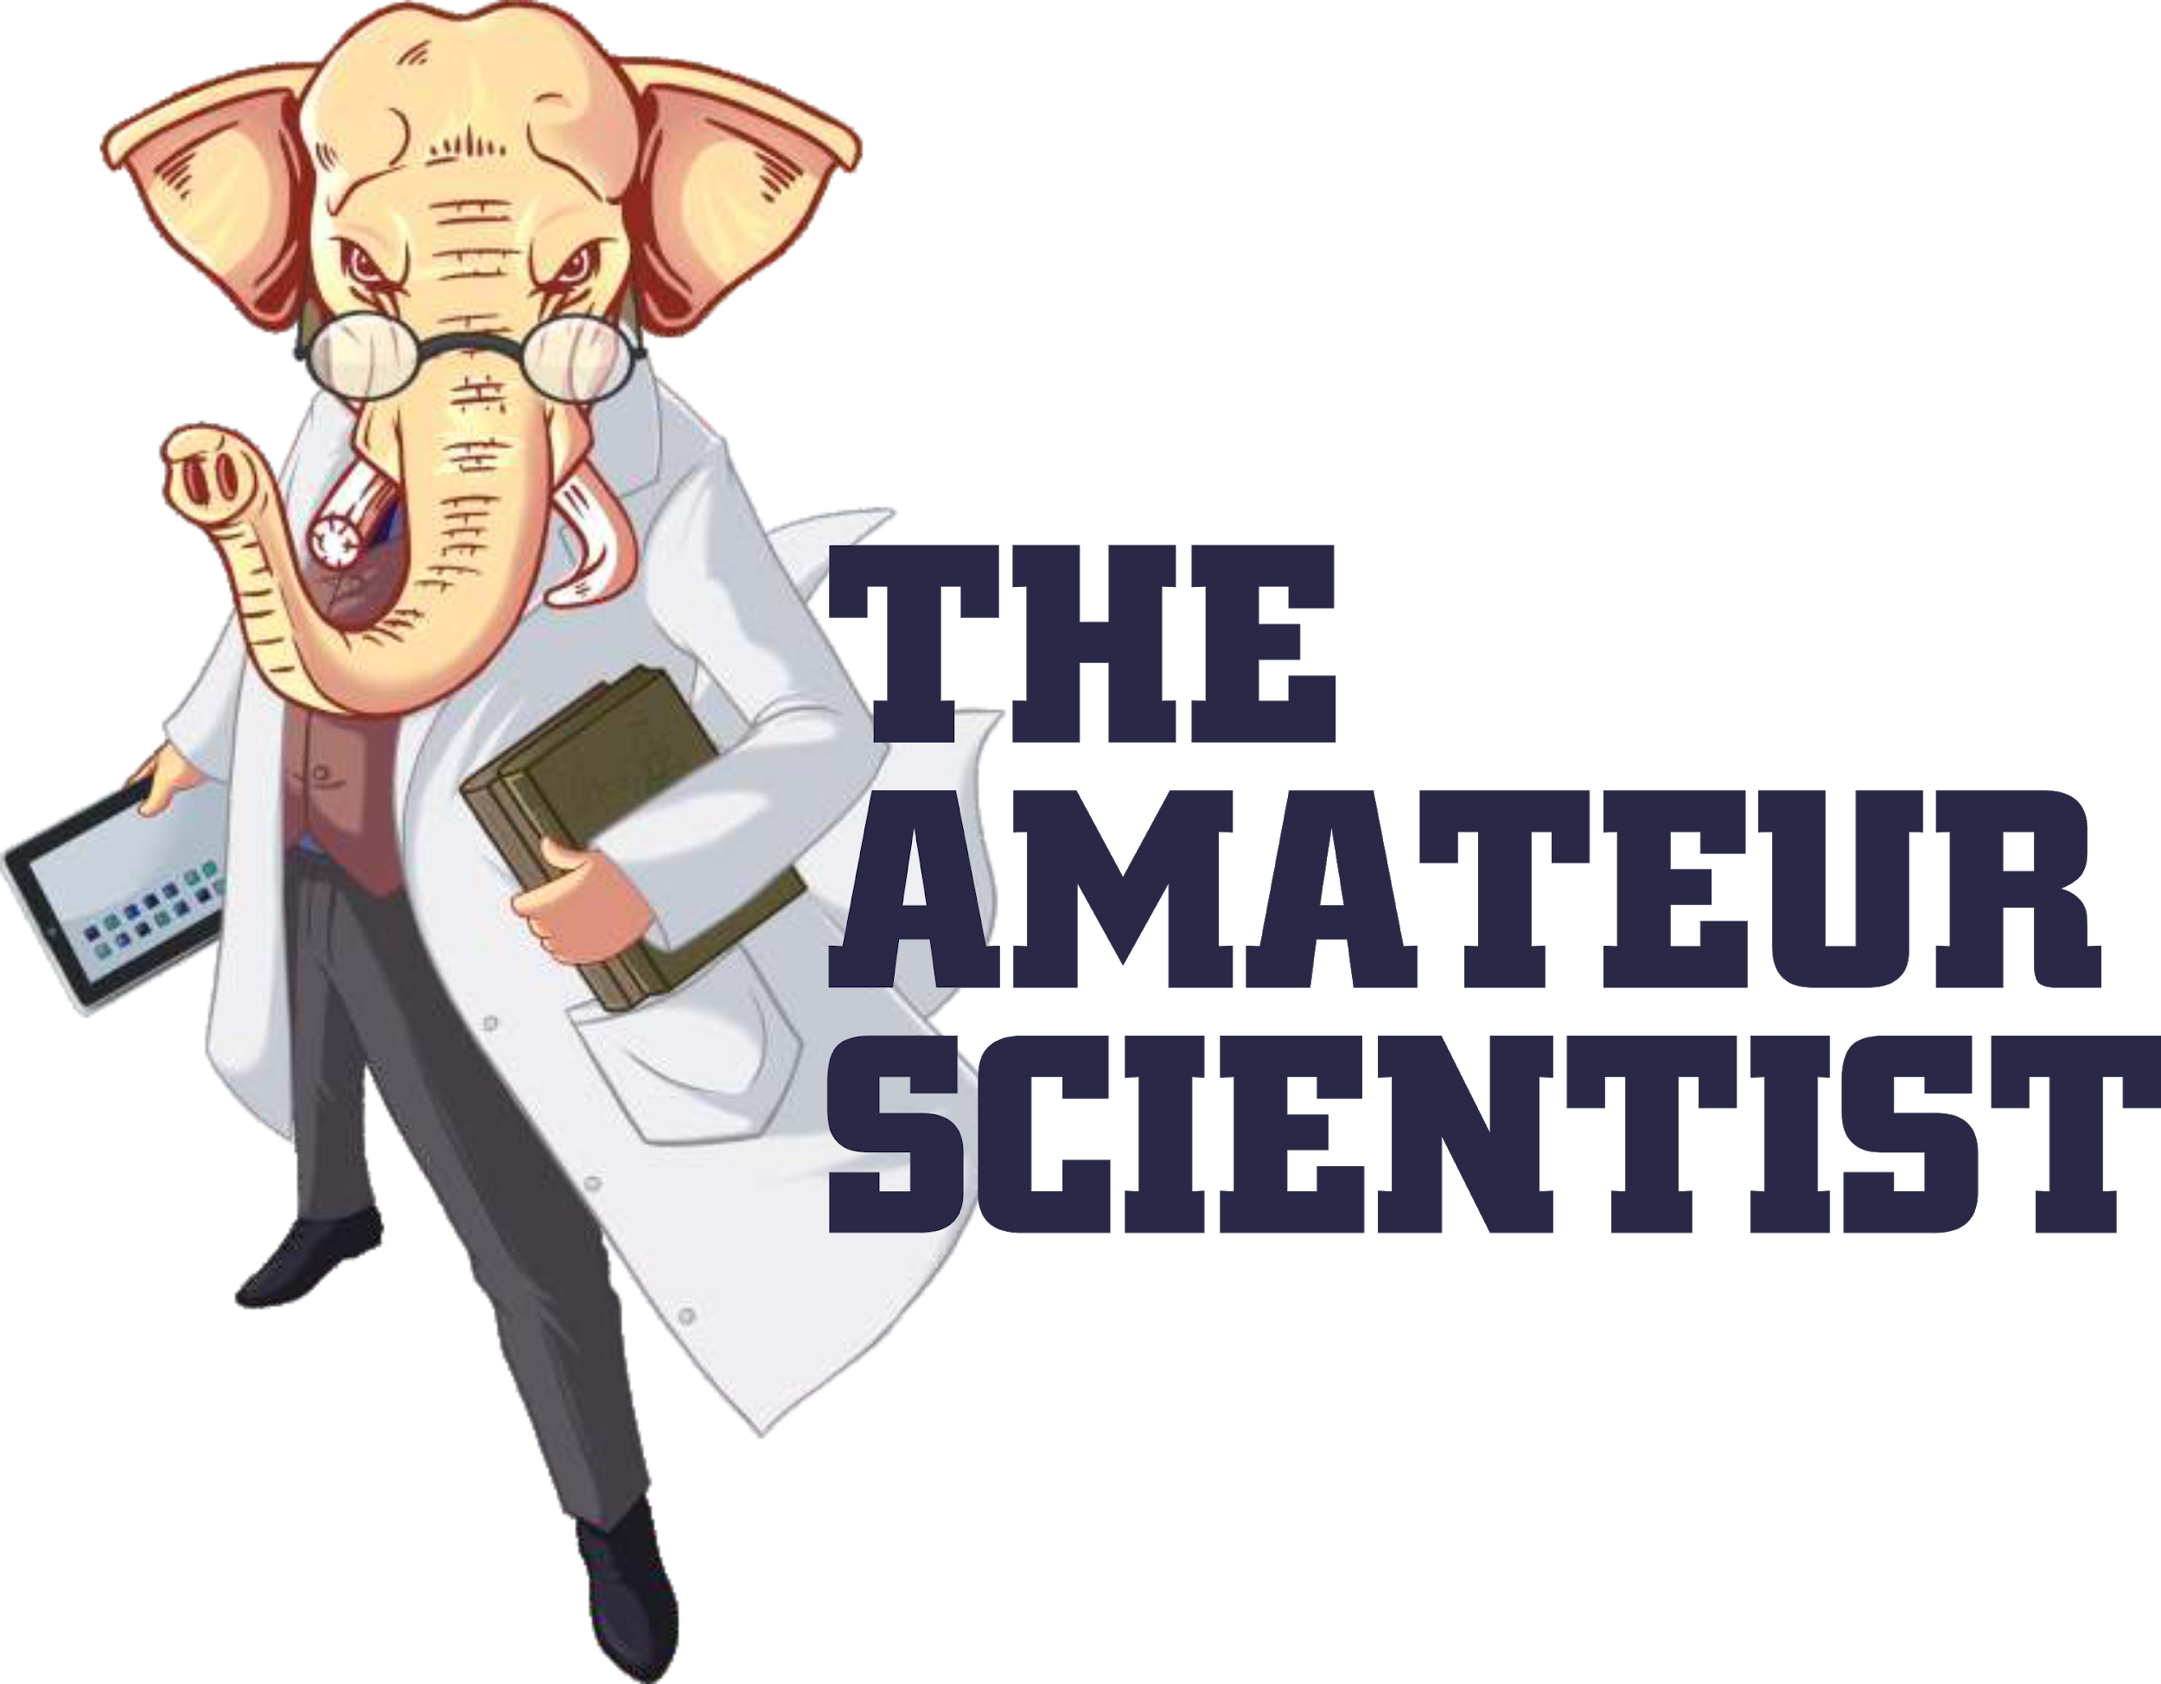



Respected ma’am/sir,

Greetings! PES University, Bangalore presents the seventh edition of ‘The Amateur Scientist 2019’, a unique science fest for students presently in classes 8to 12 from well reputed and distinguished schools all across the country, enabling them to amass substantial amounts of scientific knowledge that’s sure to propel them in their aspirations to learn and excel. With various events ranging from science exhibition to workshops in the biggest names in the scientific community, TAS 19 has it all. It is an unmissable opportunity to learn with attendees nearing the 10,000 mark every year.

We’d be honoured if you could fit us in your busy schedule and let us tell you more above this fantastic learning initiative taken up and fully sponsored by PES University as a gesture of goodwill to the academic society.

Trust to hear from your office soon.

Thanking You,

Yours sincerely,

TAS Core Team

PES University

Bangalore