EC302: VLSI DESIGN LAB

Report submitted in partial fullfilment of course
on VLSI Design Lab (EC302)

Under the guidance of
Dr. Ramesh Kini



Submitted by:
Adithi Sadananda Upadhya
191EC101

Department of Electronics & Communication Engineering
National Institute of Technology Karnataka, Surathkal
Srinivasnagar 575025 Karnataka, India

Contents

Lab 1: Study of VI characteristics of NMOS Transistor 3

Input-Output Characteristics 3
Varying Width 4
Varying Length 7
Varying VTO 9
Varying LAMBDA Id vs Vdd 10
Varying VSB 12
Varying Temperature 13

Lab 2: Study of MOS Inverter with passive resistive load 14

Lab 3: Study of MOS inverter with active load – NMOS and PMOS (pseudo NMOS load) 11

Lab 4: Study of CMOS Inverter 12

Lab 5: Study of CMOS gates 13

PART 1: CIRCUIT SIMULATION WITH NGSPICE

Lab 1: Study of VI characteristics of NMOS Transistor

Objective: To study the input and output characteristics of NMOS Transistor, effects of L, W, VTO, LAMBDA, VSB, and temperature on the behavior of the transistor

(a) Input-Output Characteristics

.include ./t14y_tsmc_025_level3.txt
*netlist
m1 vdd in 0 0 cmosn l=1u w=0.55u
*power sources
v_dd vdd 0 3.3
v_in in 0 3.3

.control
dc v_in 0 3.3 0.1 v_dd 0 3.3 1
run
setplot dc1
plot -v_dd#branch

dc v_dd 0 3.3 0.1 v_in 0 3.3 1
run
setplot dc2
plot -v_dd#branch
.endc
.end

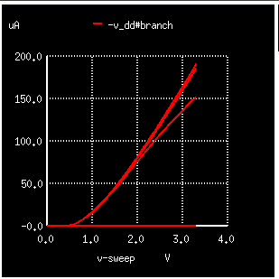

Figure 1: IDS vs VGS for varying VDS

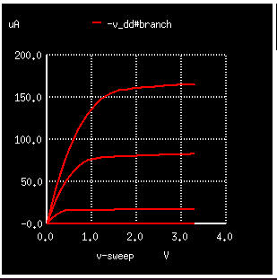

Figure 2: IDS vs VDS for varying VGS

(b) Varying Width

.include ./t14y_tsmc_025_level3.txt

*netlist
m1 vdd in 0 0 cmosn l=1u w=0.5u

*power sources

v_dd vdd 0 3.3
v_in in 0 3.3

.dc v_dd 0 3.3 0.1 v_in 0 3.3 1

*computing the response for various widths
.control
foreach wid 125e-9 500e-9 2500e-9
alter m1 w=$wid
run
end
.endc

*plotting the output for various widths
.control
foreach iter 1 2 3
setplot dc$iter
plot -vdd#branch
end
.endc

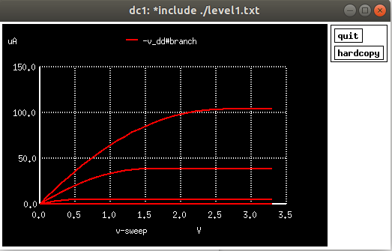
Figure 3: For width = 125n

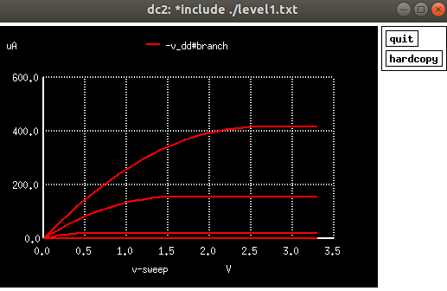
Figure 4: For width = 500n

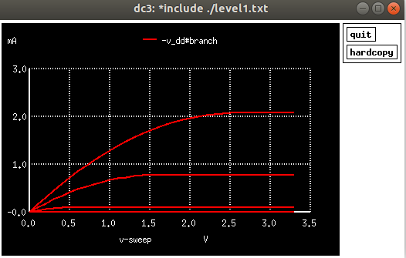
Figure 5: For width = 2500n

Conclusion: As seen in the VI characteristics above, with the increase in the value of width (W), the drain current (Id) increases.

(c) Varying Length

.include ./t14y_tsmc_025_level3.txt

*netlist
m1 vdd in 0 0 cmosn l=3u w=0.5u

*power sources
v_dd vdd 0 3.3
v_in in 0 3.3

.dc v_dd 0 3.3 0.1 v_in 0 3.3 1

*computing the response for various lengths
.control
foreach len 125e-9 500e-9 2500e-9
alter m1 l=$len
run
end
.endc

*plotting the output for various lengths
.control
foreach iter 1 2 3
setplot dc$iter
plot -v_dd#branch
end
.endc
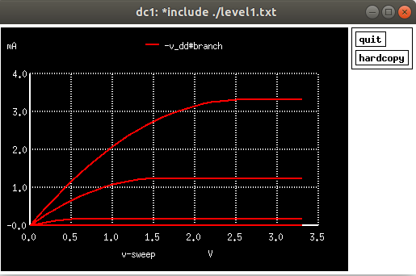

Figure 6: For length=125n

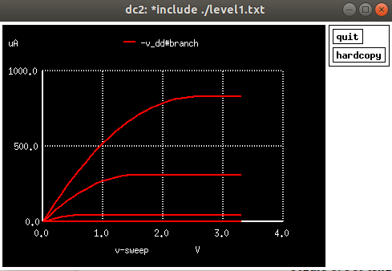

Figure 7: For length = 500n

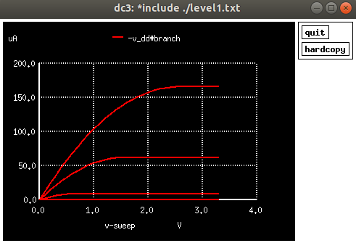

Figure 8: For length = 2500n

Conclusion: From the VI characteristics as seen above, with the increase in the value of length (L), the drain current (Id) decreases.

(d) Varying VTO

.include /home/adithi/vlsi_lab/Part1/level1.txt
.model cmosn nmos LEVEL=1 VTO=.03
m0 out in Vss 0 cmosn

*sources
Vgnd Vss 0 dc 0
vdd out 0 dc 5

*input_source
Vin in 0 dc 5
.dc Vin 0 5 .1

.control
foreach val 0.5 1 2
altermod m0 VTO = $val
run
end
.endc

.control
foreach iter 1 2 3
setplot dc$iter
end
plot dc1.vdd#branch*-1 dc2.vdd#branch*-1 dc3.vdd#branch*-1
.endc
.end
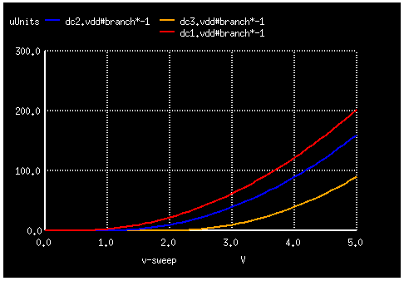

Figure 9: For Varying VTO
Conclusion: In the above figure for VI characteristics, as the value of VTO increases, the drain current decreases.

(e) Varying LAMBDA

.include /home/adithi/vlsi_lab/Part1/level1.txt
.model cmosn nmos LEVEL=1 VTO=.03
m1 vdd in 0 0 cmosn

*sources
v_dd vdd 0 3.3
v_in in 0 3.3

.dc v_dd 0 3.3 0.1 v_in 0 3.3 1

.control
foreach ld .01 .05 .09
altermod m1 LAMBDA = $ld
run
end
.endc

.control
foreach iter 1 2 3
setplot dc$iter
plot -v_dd#branch
end
.endc
.end

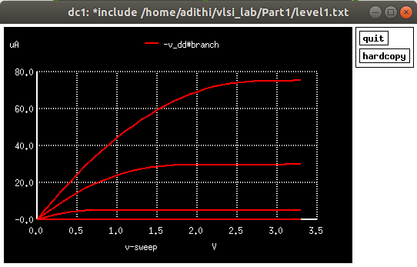
Figure 10: Id Vs Vdd for LAMBDA = 0.01

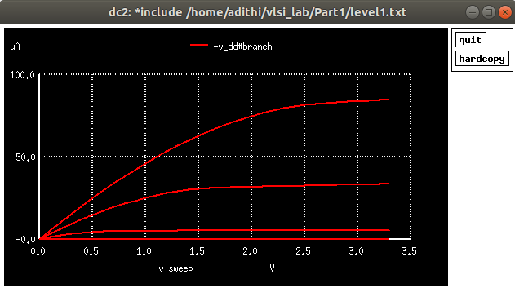
Figure 11: Id Vs Vdd for LAMBDA = 0.05

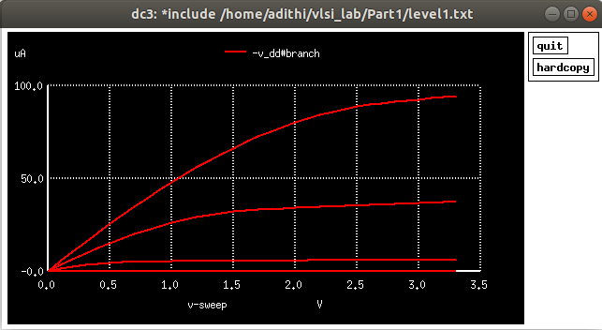
Figure 12: Id Vs Vdd for LAMBDA = 0.09

Conclusion: The Id vd Vdd curve is linear at first, then slowly varies in the saturation region due to channel length modulation which should otherwise be constant. As lambda is increased, the saturation region drain current also increases slightly as the drain-to-source voltage increases.

(f) Varying VSB

.include ./t14y_tsmc_025_level3.txt

*netlist
m1 vdd in s 0 cmosn l=1u w=0.55u

*power sources
v_dd vdd 0 5
v_in in 0 5
v_ss s 0 0

.dc v_in 0 5 0.1 v_ss 0 3 1
.control
run
setplot dc1
plot -v_dd#branch
.endc
.end

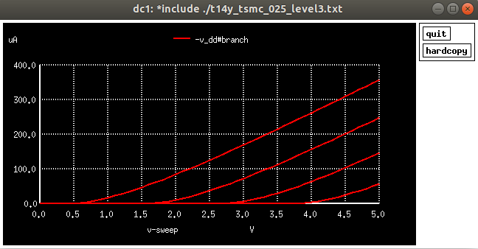
Figure 13: For varying VSB

Conclusion: As VSB is increased, the threshold voltage also increases due to body-effect.

(g) Varying temperature

.include ./t14y_tsmc_025_level3.txt
m0 out in Vss 0 cmosn TEMP=27

*sources
Vgnd Vss 0 dc 0
vdd out 0 dc 5

*input_source
Vin in 0 dc 5
.dc Vin 0 5 .1

.control
foreach t1 27 50 100
alter m0 TEMP=$t1
run
end
.endc

.control
foreach iter 1 2 3
setplot dc$iter
end
plot dc1.vdd#branch*-1 dc2.vdd#branch*-1 dc3.vdd#branch*-1
.endc
.end
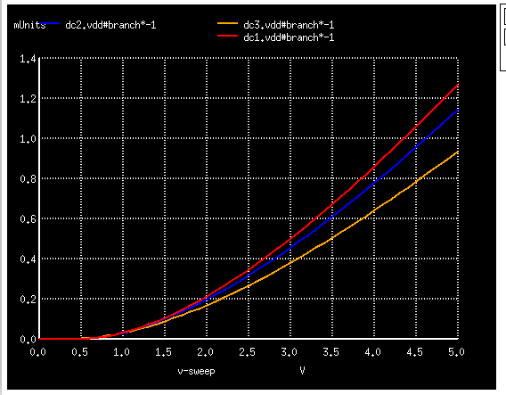
Figure 14: For varying temperature

Conclusion: From the VI characteristics as seen above, as temperature increases, it is observed that current (Id) decreases.

Lab 2: Study of MOS Inverter with passive resistive load

Objective: To study the transfer function, noise margin, effect on risetime, falltime, propagation delay, power and energy consumed of a MOS Inverter for various L, W of the transistor, load capacitance and rise/fall time of input.

(a) Varying load resistance and width

.include ./t14y_tsmc_025_level3.txt

*netlist
m0 out in 0 0 cmosn l=1.8u w=6.4u
r0 vdd out 100

*power sources
Vdd vdd 0 5
Vin in 0 dc 2.5 pulse(0 5 0.01n 0.05n 0.05n 10n 20n)

* computing the response for various load resistance values
.control
foreach res 100 1k 100k
alter r0=$res
tran 0.1ns 2n
dc Vin 0 5 0.1
end
.endc

.control
foreach iter 1 2 3
setplot dc$iter
setplot tran$iter
end

plot tran1.in tran1.out tran2.out tran3.out
plot dc1.out dc2.out dc3.out vs in
plot tran1.Vdd#branch*vdd*-1 tran2.Vdd#branch*vdd*-1 tran3.Vdd#branch*vdd*-1
.endc
.end

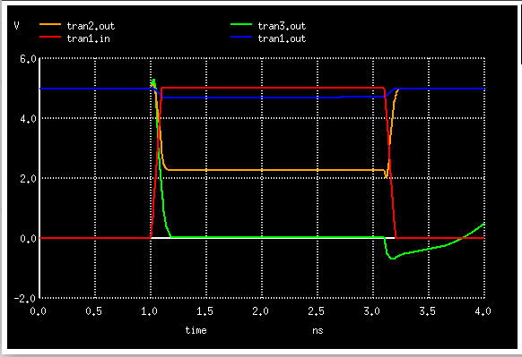
Figure 15: Transient analysis - due to varying Resistance

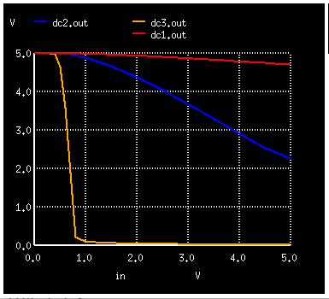

Figure 16: DC Analysis – VTC due to varying resistance ( Vout vs Vin)

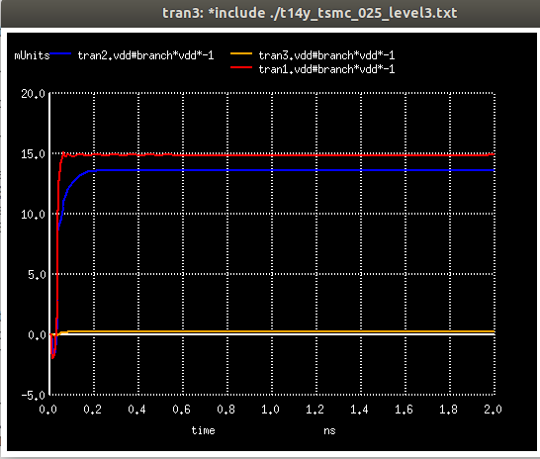

Figure : Effect on power due to varying resistance

Conclusion: For a given W/L ratio of driver NMOS, as load resistance (R_{L}) increases -
- Inverter gain increases ; VTC slope increases
- VTC curve shifts left
- Power consumption decreases

Varying width:

.include ./t14y_tsmc_025_level3.txt
m0 out in 0 0 cmosn w=6.4u l=1.8u ad=6.84p pd=10.8u as=6.84p ps=10.8u
r0 vdd out 1k

Vdd Vdd 0 dc 5
Vin in 0 dc 2.5 pulse(0 5 0.01n 0.05n 0.05n 10n 20n)
.dc Vin 0 5 0.1

* computing the response for various widths
.control
foreach wid 125e-9 500e-9 2500e-9
alter m0 w=$wid
tran 0.1ns 2n
run
end
.endc

* plotting the output for various widths
.control
foreach iter 1 2 3
setplot dc$iter
setplot tran$iter
end
plot dc1.out dc2.out dc3.out vs in
plot tran1.Vdd#branch*vdd*-1 tran2.Vdd#branch*vdd*-1 tran3.Vdd#branch*vdd*-1
plot tran1.in tran1.out tran2.out tran3.out
.endc
.end

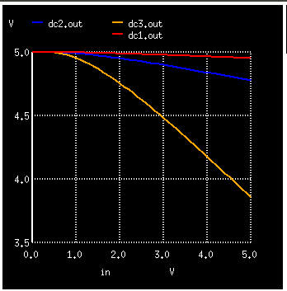

Figure : DC Analysis – VTC due to varying aspect ratio ( Vout vs Vin)

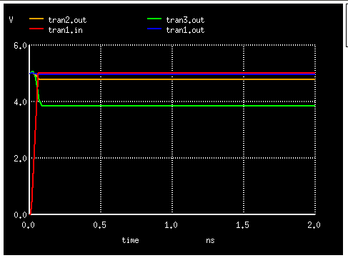

Figure : Tranient Analysis – varying aspect ratio
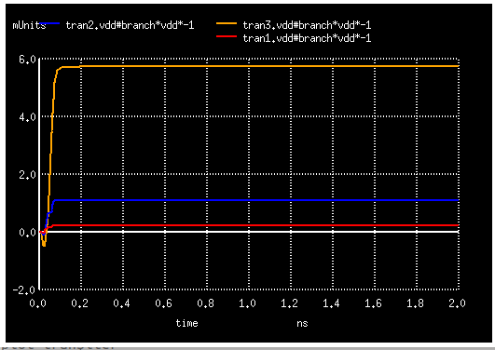
Figure : Effect on power due to varying aspect ratio

Conclusion: For a given load resistance (RL) , as aspect ratio (W/L) increases -
• Tplh increases and Tphl decreases
• VTC curve shifts left
• Power consumption increases

Lab 3: Study of MOS Inverter with active load - NMOS and PMOS (pseudo NMOS load)

Objective: For a MOS Inverter with active load – NMOS and PMOS (pseudo NMOS load), study the transfer function, noise margin, effect on risetime, falltime, propagation delay, power and energy consumed with variation in L and W of the pullup and pulldown transistors. Also power and energy consumed with non ideal step input.

