EC302: VLSI DESIGN LAB

Report submitted in partial fullfilment of course

on VLSI Design Lab (EC302)

**Under the guidance of**

**Dr. Ramesh Kini**



**Submitted by:**

**Adithi Sadananda Upadhya**

**191EC101**

Department of Electronics & Communication Engineering

National Institute of Technology Karnataka, Surathkal

Srinivasnagar 575025 Karnataka, India

**Contents**

**Lab 1: Study of VI characteristics of NMOS Transistor 3**

Input-Output Characteristics 3

Varying Width 4

Varying Length 7

Varying VTO 9

Varying LAMBDA Id vs Vdd 10

Varying VSB 12

Varying Temperature 13

**Lab 2: Study of MOS Inverter with passive resistive load 14**

**Lab 3: Study of MOS inverter with active load – NMOS and PMOS (pseudo NMOS load) 11**

**Lab 4: Study of CMOS Inverter 12**

**Lab 5: Study of CMOS gates 13**

PART 1: CIRCUIT SIMULATION WITH NGSPICE

**Lab 1: Study of VI characteristics of NMOS Transistor**

**Objective:** To study the input and output characteristics of NMOS Transistor, effects of L, W, VTO, LAMBDA, VSB, and temperature on the behavior of the transistor

**(a) Input-Output Characteristics**

.include ./t14y_tsmc_025_level3.txt

*netlist

m1 vdd in 0 0 cmosn l=1u w=0.55u

*power sources

v_dd vdd 0 3.3

v_in in 0 3.3

.control

dc v_in 0 3.3 0.1 v_dd 0 3.3 1

run

setplot dc1

plot -v_dd#branch

dc v_dd 0 3.3 0.1 v_in 0 3.3 1

run

setplot dc2

plot -v_dd#branch

.endc

.end

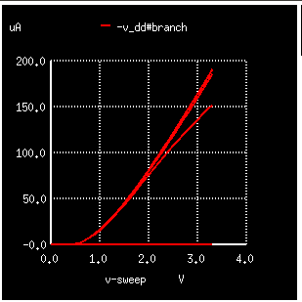

Figure 1: IDS vs VGS for varying VDS

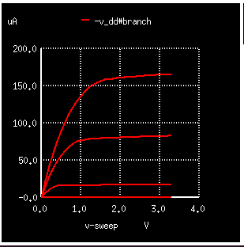

Figure 2: IDS vs VDS for varying VGS

**(b) Varying Width**

.include ./t14y_tsmc_025_level3.txt

*netlist

m1 vdd in 0 0 cmosn l=1u w=0.5u

*power sources

v_dd vdd 0 3.3

v_in in 0 3.3

.dc v_dd 0 3.3 0.1 v_in 0 3.3 1

*computing the response for various widths

.control

foreach wid 125e-9 500e-9 2500e-9

alter m1 w=$wid

run

end

.endc

*plotting the output for various widths

.control

foreach iter 1 2 3

setplot dc$iter

plot -vdd#branch

end

.endc

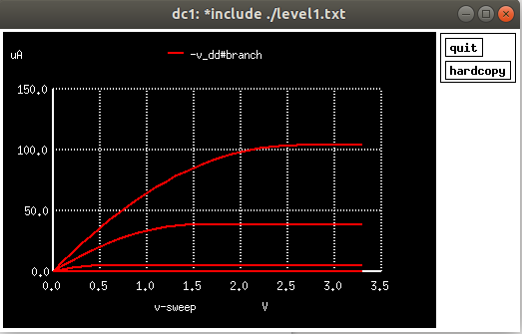

Figure 3: For width = 125n

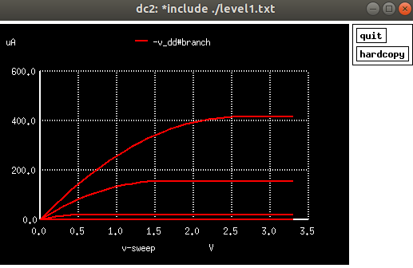

Figure 4: For width = 500n

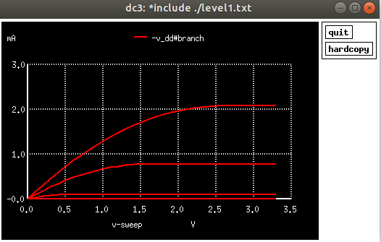

Figure 5: For width = 2500n

**Conclusion:** As seen in the VI characteristics above, with the increase in the value of width (W), the drain current (Id) increases.

**(c) Varying Length**

.include ./t14y_tsmc_025_level3.txt

*netlist

m1 vdd in 0 0 cmosn l=3u w=0.5u

*power sources

v_dd vdd 0 3.3

v_in in 0 3.3

.dc v_dd 0 3.3 0.1 v_in 0 3.3 1

*computing the response for various lengths

.control

foreach len 125e-9 500e-9 2500e-9

alter m1 l=$len

run

end

.endc

*plotting the output for various lengths

.control

foreach iter 1 2 3

setplot dc$iter

plot -v_dd#branch

end

.endc

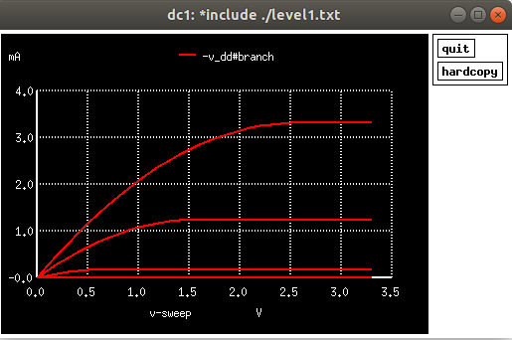

Figure 6: For length=125n

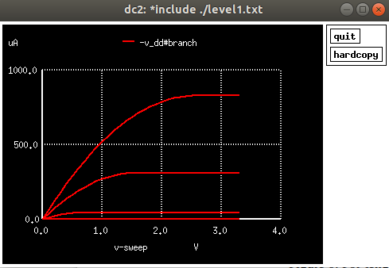

Figure 7: For length = 500n

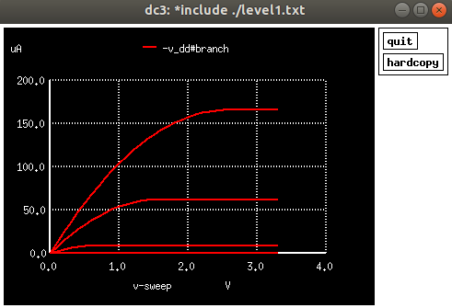

Figure 8: For length = 2500n

**Conclusion:** From the VI characteristics as seen above, with the increase in the value of length (L), the drain current (Id) decreases.

**(d) Varying VTO**

.include /home/adithi/vlsi_lab/Part1/level1.txt

.model cmosn nmos LEVEL=1 VTO=.03

m0 out in Vss 0 cmosn

*sources

Vgnd Vss 0 dc 0

vdd out 0 dc 5

*input_source

Vin in 0 dc 5

.dc Vin 0 5 .1

.control

foreach val 0.5 1 2

altermod m0 VTO = $val

run

end

.endc

.control

foreach iter 1 2 3

setplot dc$iter

end

plot dc1.vdd#branch*-1 dc2.vdd#branch*-1 dc3.vdd#branch*-1

.endc

.end

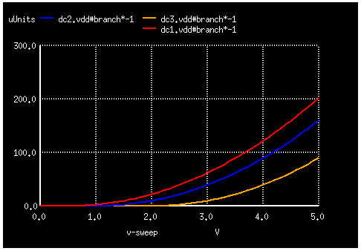

Figure 9: For Varying VTO

**Conclusion:** In the above figure for VI characteristics, as the value of VTO increases, the drain current decreases.

**(e) Varying LAMBDA**

.include /home/adithi/vlsi_lab/Part1/level1.txt

.model cmosn nmos LEVEL=1 VTO=.03

m1 vdd in 0 0 cmosn

*sources

v_dd vdd 0 3.3

v_in in 0 3.3

.dc v_dd 0 3.3 0.1 v_in 0 3.3 1

.control

foreach ld .01 .05 .09

altermod m1 LAMBDA = $ld

run

end

.endc

.control

foreach iter 1 2 3

setplot dc$iter

plot -v_dd#branch

end

.endc

.end

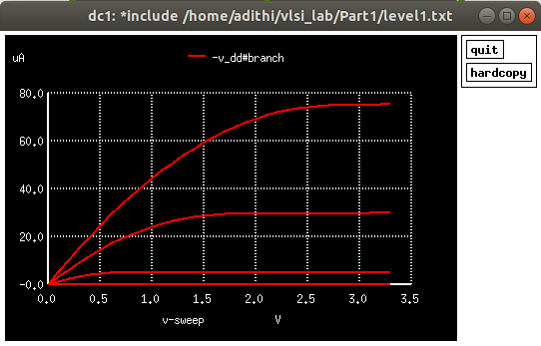

Figure 10: Id Vs Vdd for LAMBDA = 0.01

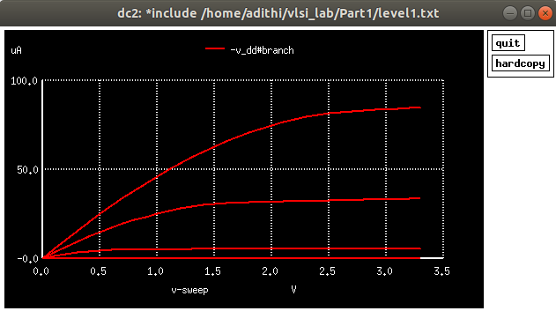

Figure 11: Id Vs Vdd for LAMBDA = 0.05

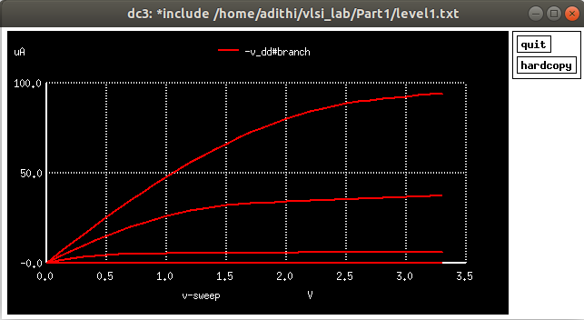

Figure 12: Id Vs Vdd for LAMBDA = 0.09

**Conclusion:** The Id vd Vdd curve is linear at first, then slowly varies in the saturation region due to channel length modulation which should otherwise be constant. As lambda is increased, the saturation region drain current also increases slightly as the drain-to-source voltage increases.

**(f) Varying VSB**

.include ./t14y_tsmc_025_level3.txt

*netlist

m1 vdd in s 0 cmosn l=1u w=0.55u

*power sources

v_dd vdd 0 5

v_in in 0 5

v_ss s 0 0

.dc v_in 0 5 0.1 v_ss 0 3 1

.control

run

setplot dc1

plot -v_dd#branch

.endc

.end

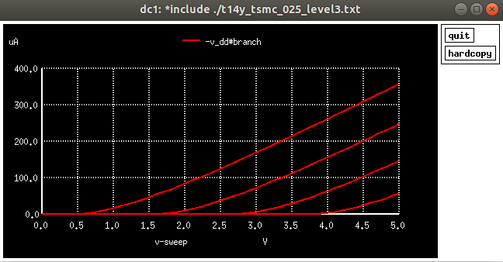

Figure 13: For varying VSB

**Conclusion:** As VSB is increased, the threshold voltage also increases due to body-effect.

**(g) Varying temperature**

.include ./t14y_tsmc_025_level3.txt

m0 out in Vss 0 cmosn TEMP=27

*sources

Vgnd Vss 0 dc 0

vdd out 0 dc 5

*input_source

Vin in 0 dc 5

.dc Vin 0 5 .1

.control

foreach t1 27 50 100

alter m0 TEMP=$t1

run

end

.endc

.control

foreach iter 1 2 3

setplot dc$iter

end

plot dc1.vdd#branch*-1 dc2.vdd#branch*-1 dc3.vdd#branch*-1

.endc

.end

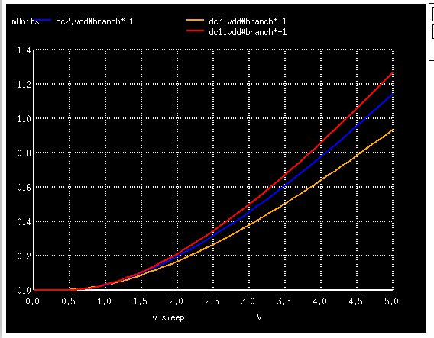

Figure 14: For varying temperature

**Conclusion:** From the VI characteristics as seen above, as temperature increases, it is observed that current (Id) decreases.

**Lab 2: Study of MOS Inverter with passive resistive load**

**Objective:** To study the transfer function, noise margin, effect on risetime, falltime, propagation delay, power and energy consumed of a MOS Inverter for various L, W of the transistor, load capacitance and rise/fall time of input.

**(a) Varying load resistance and width**

.include ./t14y_tsmc_025_level3.txt

*netlist

m0 out in 0 0 cmosn l=1.8u w=6.4u

r0 vdd out 100

*power sources

Vdd vdd 0 5

Vin in 0 dc 2.5 pulse(0 5 0.01n 0.05n 0.05n 10n 20n)

* computing the response for various load resistance values

.control

foreach res 100 1k 100k

alter r0=$res

tran 0.1ns 2n

dc Vin 0 5 0.1

end

.endc

.control

foreach iter 1 2 3

setplot dc$iter

setplot tran$iter

end

plot tran1.in tran1.out tran2.out tran3.out

plot dc1.out dc2.out dc3.out vs in

plot tran1.Vdd#branch*vdd*-1 tran2.Vdd#branch*vdd*-1 tran3.Vdd#branch*vdd*-1

.endc

.end

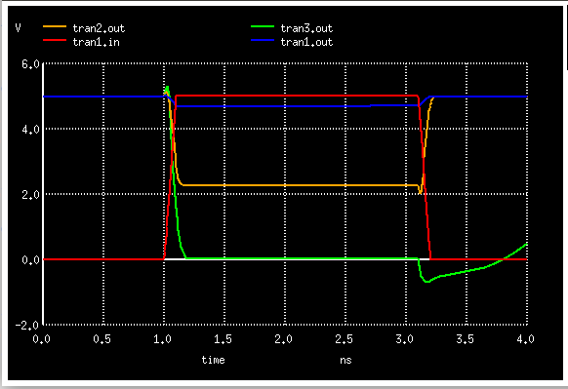

Figure 15: Transient analysis - due to varying Resistance

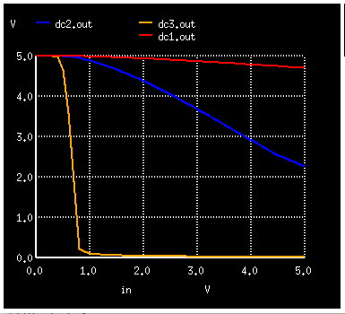

Figure 16: DC Analysis – VTC due to varying resistance ( Vout vs Vin)

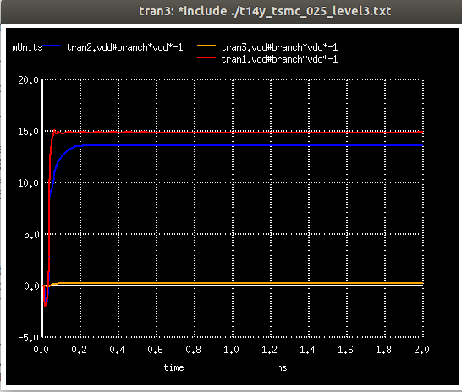

Figure : Effect on power due to varying resistance

**Conclusion:** For a given W/L ratio of driver NMOS, as load resistance (RL) increases -

* Inverter gain increases ; VTC slope increases
* VTC curve shifts left
* Power consumption decreases

**Varying width:**

.include ./t14y_tsmc_025_level3.txt

m0 out in 0 0 cmosn w=6.4u l=1.8u ad=6.84p pd=10.8u as=6.84p ps=10.8u

r0 vdd out 1k

Vdd Vdd 0 dc 5

Vin in 0 dc 2.5 pulse(0 5 0.01n 0.05n 0.05n 10n 20n)

.dc Vin 0 5 0.1

* computing the response for various widths

.control

foreach wid 125e-9 500e-9 2500e-9

alter m0 w=$wid

tran 0.1ns 2n

run

end

.endc

* plotting the output for various widths

.control

foreach iter 1 2 3

setplot dc$iter

setplot tran$iter

end

plot dc1.out dc2.out dc3.out vs in

plot tran1.Vdd#branch*vdd*-1 tran2.Vdd#branch*vdd*-1 tran3.Vdd#branch*vdd*-1

plot tran1.in tran1.out tran2.out tran3.out

.endc

.end

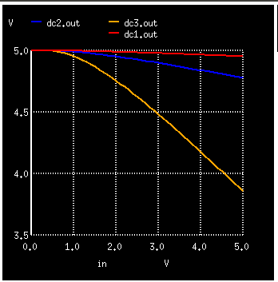

Figure : DC Analysis – VTC due to varying aspect ratio ( Vout vs Vin)

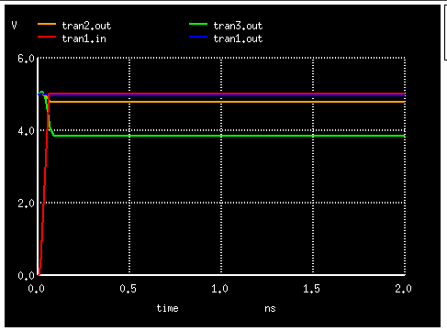

Figure : Tranient Analysis – varying aspect ratio

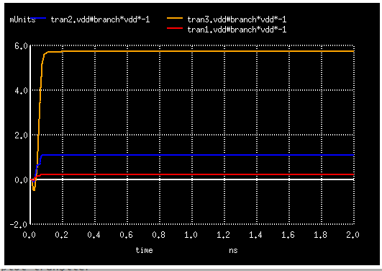

Figure : Effect on power due to varying aspect ratio

**Conclusion:** For a given load resistance (RL) , as aspect ratio (W/L) increases -

• Tplh increases and Tphl decreases

• VTC curve shifts left

• Power consumption increases

**Lab 3: Study of MOS Inverter with active load - NMOS and PMOS (pseudo NMOS load)**

**Objective:** For a MOS Inverter with active load – NMOS and PMOS (pseudo NMOS load), study the transfer function, noise margin, effect on risetime, falltime, propagation delay, power and energy consumed with variation in L and W of the pullup and pulldown transistors. Also power and energy consumed with non ideal step input.

**(a) DC Transfer characteristics**

.include ./t14y_tsmc_025_level3.txt

mnd out in 0 0 cmosn w=10u l=1u

mpl out 0 vdd vdd cmosp w=10u l=1u

Vdd vdd 0 5

Vin in 0 dc 5

.dc Vin 0 5 .001

* transfer characteristics

.control

run

plot out

end

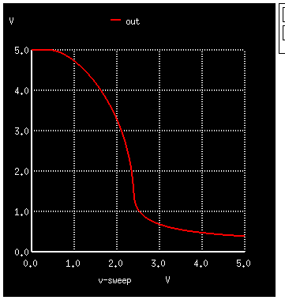.endc

Fig : Transfer characteristics

**(b) Transient Response**

.include ./t14y_tsmc_025_level3.txt

mnd out in 0 0 cmosn w=10u l=1u

mpl out 0 vdd vdd cmosp w=10u l=1u

Vdd vdd 0 5

Vin in 0 dc 2.5 pulse(0 5 0.01n 0.05n 0.05n 10n 20n)

.control

tran 0.1ns 40n

run

plot out, in

end

.endc

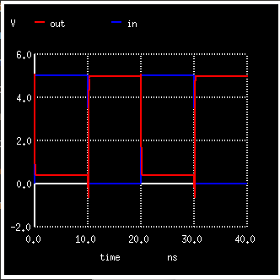

Fig: Transient response

**(c) Varying the width of load**

.include ./t14y_tsmc_025_level3.txt

mnd out in 0 0 cmosn w=10u l=1u

mpl out 0 vdd vdd cmosp w=10u l=1u

Vdd vdd 0 5

Vin in 0 dc 2.5 pulse(0 5 0.01n 0.05n 0.05n 10n 20n)

.control

foreach wid 0.5u 5u 50u

alter mpl w=$wid

tran 0.1ns 40n

dc vin 0 5 0.1

end

.endc

.control

foreach iter 1 2 3

setplot tran$iter

setplot dc$iter

end

plot tran1.in tran1.out tran2.out tran3.out

plot dc1.out dc2.out dc3.out vs in

plot tran1.Vdd#branch*vdd*-1 tran2.Vdd#branch*vdd*-1 tran3.Vdd#branch*vdd*-1

.endc

.end

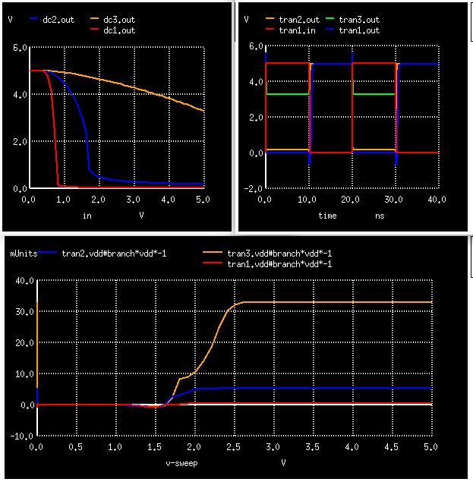

Fig: Transfer function, transient response and power variation due to variation in the width of load

**(d) Varying the width of driver**

.include ./t14y_tsmc_025_level3.txt

mnd out in 0 0 cmosn w=10u l=1u

mpl out 0 vdd vdd cmosp w=10u l=1u

Vdd vdd 0 5

Vin in 0 dc 2.5 pulse(0 5 0.01n 0.05n 0.05n 10n 20n)

.control

foreach wid 0.5u 5u 50u

alter mnd w=$wid

tran 0.1ns 40n

dc vin 0 5 0.1

end

.endc

.control

foreach iter 1 2 3

setplot tran$iter

setplot dc$iter

end

plot tran1.in tran1.out tran2.out tran3.out

plot dc1.out dc2.out dc3.out vs in

plot tran1.Vdd#branch*vdd*-1 tran2.Vdd#branch*vdd*-1 tran3.Vdd#branch*vdd*-1

.endc

.end

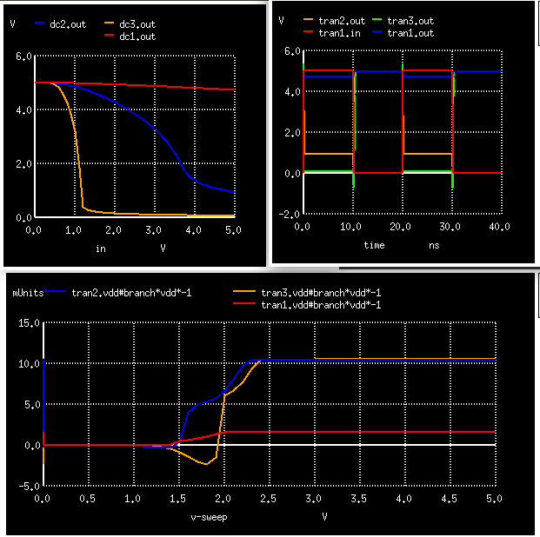

Fig:Transfer function, transient response and power variation due to variation in the width of driver

**(e) Varying the length of load**

.include ./t14y_tsmc_025_level3.txt

mnd out in 0 0 cmosn w=10u l=1u

mpl out 0 vdd vdd cmosp w=10u l=1u

Vdd vdd 0 5

Vin in 0 dc 2.5 pulse(0 5 0.01n 0.05n 0.05n 10n 20n)

.control

foreach len 0.5u 2u 5u

alter mpl l=$len

tran 0.1ns 40n

dc vin 0 5 0.1

end

.endc

.control

foreach iter 1 2 3

setplot tran$iter

setplot dc$iter

end

plot tran1.in tran1.out tran2.out tran3.out

plot dc1.out dc2.out dc3.out vs in

plot tran1.Vdd#branch*vdd*-1 tran2.Vdd#branch*vdd*-1 tran3.Vdd#branch*vdd*-1

.endc

.end

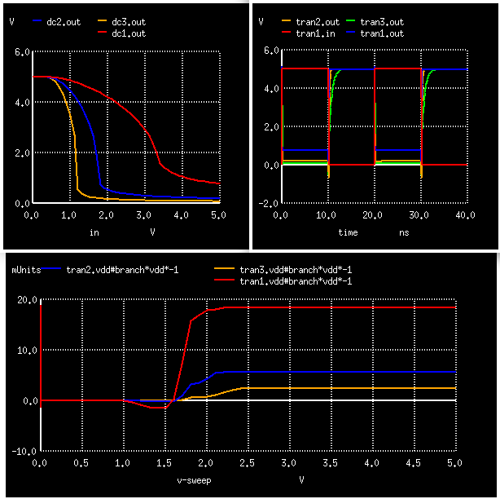

Fig:Transfer function, transient response and power variation due to variation in the length of load

**(f) Varying the length of driver**

.include ./t14y_tsmc_025_level3.txt

mnd out in 0 0 cmosn w=10u l=1u

mpl out 0 vdd vdd cmosp w=10u l=1u

Vdd vdd 0 5

Vin in 0 dc 2.5 pulse(0 5 0.01n 0.05n 0.05n 10n 20n)

.control

foreach len 0.5u 2u 5u

alter mnd l=$len

tran 0.1ns 40n

dc vin 0 5 0.1

end

.endc

.control

foreach iter 1 2 3

setplot tran$iter

setplot dc$iter

end

plot tran1.in tran1.out tran2.out tran3.out

plot dc1.out dc2.out dc3.out vs in

plot tran1.Vdd#branch*vdd*-1 tran2.Vdd#branch*vdd*-1 tran3.Vdd#branch*vdd*-1

.endc

.end

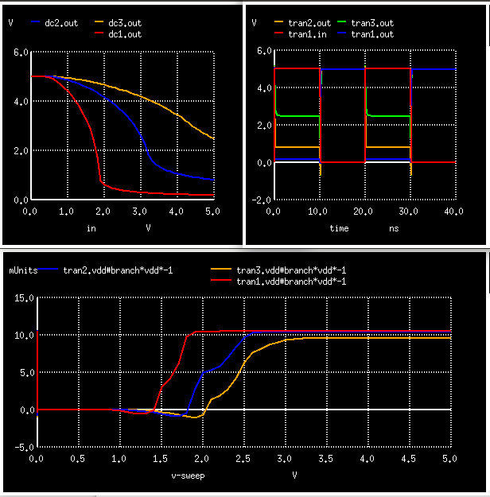

Fig:Transfer function, transient response and power variation due to variation in the length of driver

**Conclusion:**

As the aspect ratio (W/L) of driver (NMOS) increases -

1. VTC curve shifts to the left

2. Inverter gain increases

3. Tfall decreases

4. VOL decreases

5. Power dissipation and energy consumed per transition increases

As the aspect ratio (W/L) of load increases -

1. VTC curve shifts towards right

2. Inverter gain decreases

3. Trise decreases

4. VOL increases

5. Power dissipation and energy consumed per transition decreases

Upon increasing load capacitance, rise/fall time of output increases and energy consumed per transition increases.

**Lab 4: Study of CMOS Inverter**

**Objective:** To study the transfer function, noise margin, effect on risetime, falltime, propagation delay, power and energy consumed of a CMOS Inverter with variation in L and W of pull up and pull down transistors. Also power and energy consumed with non ideal step input.

**(a) Transfer function**

.include ./t14y_tsmc_025_level3.txt

m1 out in 0 0 cmosn l=1u w=1u

m2 out in vdd vdd cmosp l=1u w=2u

v_dd vdd 0 dc 5

v_in in 0 dc 5

.dc v_in 0 5 0.1

.control

run

plot out,in

.endc

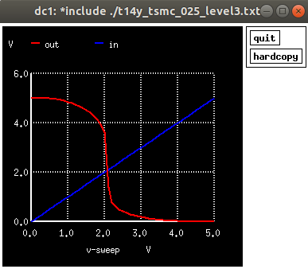.end

Figure : Transfer Function

**Tranfer function, effect on rise time, power consumed due to variation in the width of NMOS:**

.include ./t14y_tsmc_025_level3.txt

* NMOS - Driver, PMOS - Load

m0 out in vdd vdd cmosp l=1u w=.6u

m1 out in 0 0 cmosn l=1u w=.2u

v_dd vdd 0 dc 5

v_in in 0 dc 5 pulse(5 0 .01m .2m .2m .5m 1m)

.dc v_in 0 5 .01

*varying W of nmos

.control

foreach wdt .6u 2u 10u

alter m1 w=$wdt

tran .001m 1m

run

end

.endc

* plot for various w of load

.control

foreach iter 1 2 3

setplot dc$iter

setplot tran$iter

end

.endc

* case-1 dc analysis for transfer function varying with W of nmos

* case-2 tran analysis to observe the effect on rise time

* case-3 for power variation

.control

plot tran1.out tran2.out tran3.out

plot dc1.out dc2.out dc3.out

plot tran1.v_dd#branch*vdd*-1 tran2.v_dd#branch*vdd*-1 tran3.v_dd#branch*vdd*-1

.endc

.end

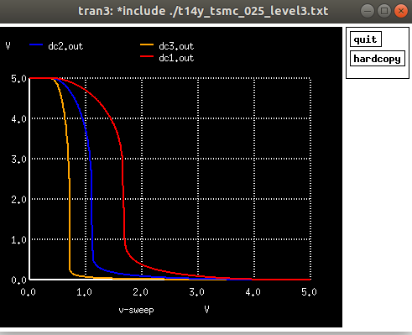

Figure :Transfer function due to varying width of NMOS

As width of NMOS (driver) increases, the VTC curve shifts towards the left.

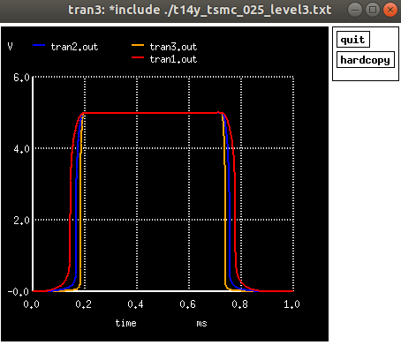

Figure : Effect on rise time due to variation in W of NMOS

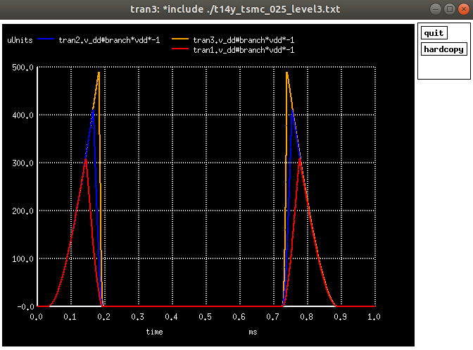Figure : Effect of varying W of NMOS on power consumed

**Tranfer function, effect on rise and fall time, power consumed due to variation in the length of NMOS:**

.include ./t14y_tsmc_025_level3.txt

* NMOS - Driver, PMOS - Load

m0 out in vdd vdd cmosp l=1u w=.6u

m1 out in 0 0 cmosn l=1u w=.2u

v_dd vdd 0 dc 5

v_in in 0 dc 5 pulse(5 0 .01m .2m .2m .5m 1m)

.dc v_in 0 5 .01

*varying W of nmos

.control

foreach len 0.5u 2u 10u

alter m1 l=$len

tran .001m 1m

run

end

.endc

* plot for various L of load

.control

foreach iter 1 2 3

setplot dc$iter

setplot tran$iter

end

.endc

* case-1 dc analysis for transfer function varying with L of nmos

* case-2 tran analysis to observe the effect on rise time

* case-3 for power variation

.control

plot tran1.out tran2.out tran3.out

plot dc1.out dc2.out dc3.out

plot tran1.v_dd#branch*vdd*-1 tran2.v_dd#branch*vdd*-1 tran3.v_dd#branch*vdd*-1

.endc

.end

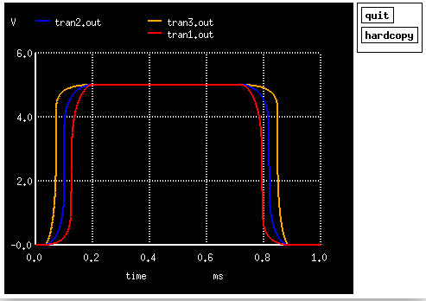

Figure : Effect on rise and fall time due to variation in L of NMOS

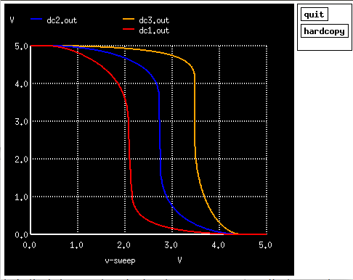

Figure :Transfer function due to varying length of NMOS

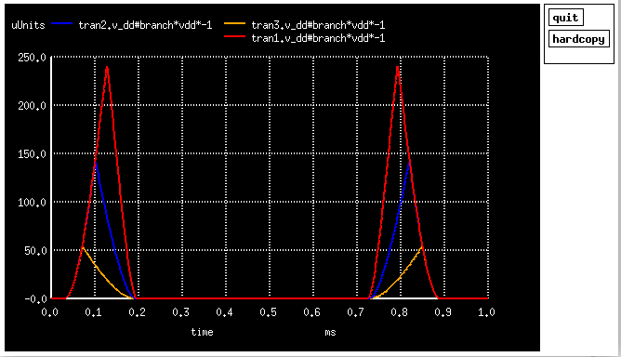Figure : Effect of varying L of NMOS on power consumed

**Variation in the length of PMOS (Load) :**

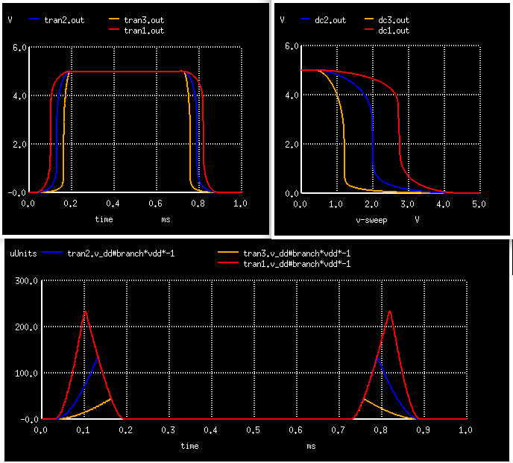

Figure : Effect on rise and fall time, transfer characteristics, and power consumed due to variation in length of load PMOS

**Variation in the width of PMOS (Load) :**

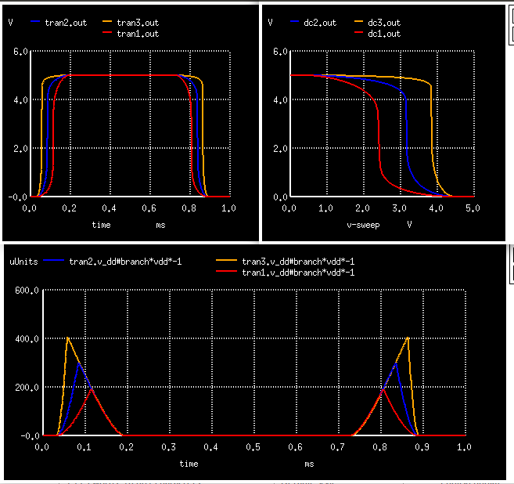

Figure : Effect on rise and fall time, transfer characteristics, and power consumed due to variation in width of load PMOS

**Conclusion:**

As W/L of load increases, for a given aspect ratio of load -

1. trise decreases

2. VTC curve shifts to the right

3. R_PUN decreases

As W/L of driver increases, for a given aspect ratio of load -

1. tfall decreases

2. VTC curve shifts to the left

3. R_PDN decreases

VOL is a perfect ‘0’ (VOL = 0V) and VOH is a perfect ‘1’ (VOH = VDD)

**Lab 5: Study of CMOS gates**

**Objective:** To study the behaviour transfer function, noise margin, effect on risetime, falltime, propagation delay, power and energy consumed of CMOS gates like NAND, NOR, functions like AOI ( 2 input AND gate, 2 input OR gate), and 2 input XOR gate.

**(a) NAND GATE**

.include ./t14y_tsmc_025_level3.txt

* F = (A.B)' NAND

m1 F A int 0 cmosn L=1u W=10u

m2 int B 0 0 cmosn L=1u W=10u

m3 F A vdd vdd cmosp L=1u W=10u

m4 F B vdd vdd cmosp L=1u W=10u

v_dd vdd 0 3.3

v_1 A 0 PULSE(0 3.3 0 0 0 8ns 16ns)

v_2 B 0 PULSE(0 3.3 0 0 0 16ns 32ns)

.control

tran 0.1ns 32ns

run

end

plot tran1.A tran1.B tran1.F

plot tran1.v_dd#branch*vdd*-1

.endc

.end

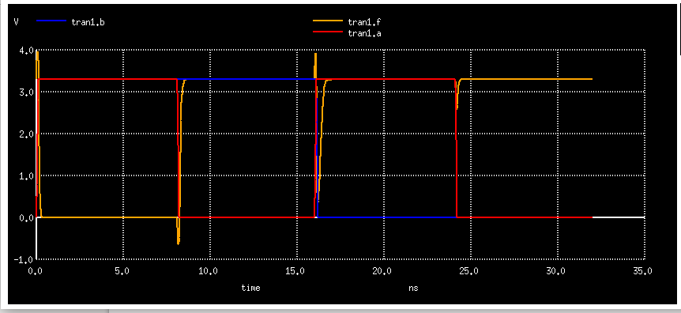

Figure : Transient response for NAND gate

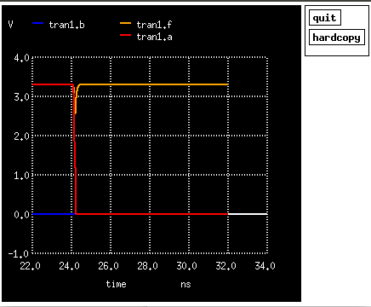

Figure : Transient response for NAND gate with inputs A=0, B=0

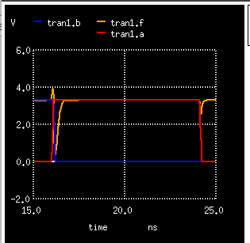

Figure : Transient response for NAND gate with inputs A=1, B=0

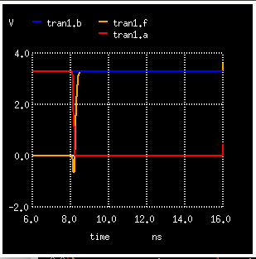

Figure : Transient response for NAND gate with inputs A=0, B=1

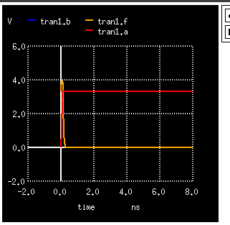

Figure : Transient response for NAND gate with inputs A=1, B=1

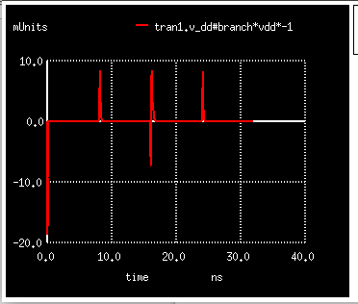

Figure: Variation in power for NAND gate

**(b) NOR gate**

.include ./t14y_tsmc_025_level3.txt

* F = (A+B)' NOR

m1 F A 0 0 cmosn L=1u W=10u

m2 F B 0 0 cmosn L=1u W=10u

m3 int A vdd vdd cmosp L=1u W=10u

m4 F B int vdd cmosp L=1u W=10u

v_dd vdd 0 3.3

v_1 A 0 PULSE(0 3.3 0 0 0 8ns 16ns)

v_2 B 0 PULSE(0 3.3 0 0 0 16ns 32ns)

.control

tran 0.1ns 32ns

run

end

plot tran1.A tran1.B tran1.F

plot tran1.v_dd#branch*vdd*-1

.endc

.end

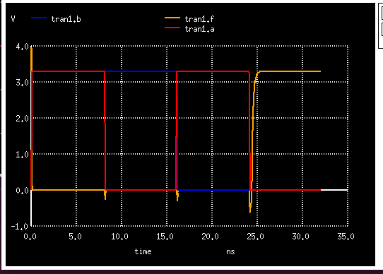

Fig: Transient response for NOR gate

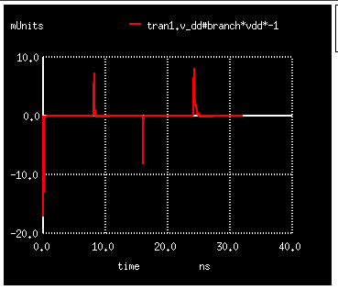

Fig: Power variation for NOR gate

**(c) AOI (A.B + C.D)'**

.include ./t14y_tsmc_025_level3.txt

* F = (A.B + C.D)' AOI

mna F A x 0 cmosn L=1u W=6u

mnb x B 0 0 cmosn L=1u W=6u

mnc F C y 0 cmosn L=1u W=6u

mnd y D 0 0 cmosn L=1u W=6u

mpa z A vdd vdd cmosp L=1u W=12u

mpb z B vdd vdd cmosp L=1u W=12u

mpc F C int3 vdd cmosp L=1u W=12u

mpd F D int3 vdd cmosp L=1u W=12u

v_dd vdd 0 3.3

v_a A 0 PULSE(0 3.3 0 0 0 2ns 4ns)

v_b B 0 PULSE(0 3.3 0 0 0 4ns 8ns)

v_c C 0 PULSE(0 3.3 0 0 0 8ns 16ns)

v_d D 0 PULSE(0 3.3 0 0 0 16ns 32ns)

.control

tran 0.1ns 32ns

run

end

plot tran1.A tran1.B tran1.C tran1.D tran1.F

plot tran1.v_dd#branch*vdd*-1

.endc

.end

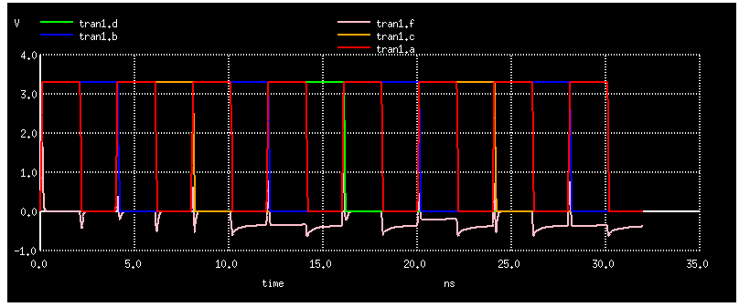

Fig: Transient response of AOI gate

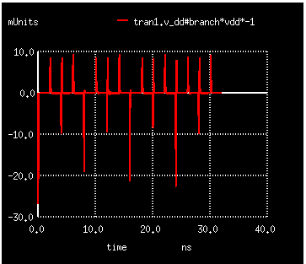

Figure: Power variation for AOI gate

**(d) XOR gate**

.include ./t14y_tsmc_025_level3.txt

* out = A XOR B

M1 out B A vdd cmosp L=3u W=6u

M2 out B x 0 cmosn L=3u W=3u

M3 out A B vdd cmosp L=3u W=6u

M4 B x out 0 cmosn L=3u W=3u

M5 x A y vdd cmosp L=3u W=6u

M6 x A 0 0 cmosn L=3u W=3u

R0 vdd y 1k

v_dd vdd 0 5

v_a A 0 PULSE(0 5 0 1ps 1ps 40ns 80ns)

v_b B 0 PULSE(0 5 0 1ps 1ps 80ns 160ns)

.control

tran 0.5ns 160ns

run

end

plot tran1.A tran1.B tran1.out

plot tran1.v_dd#branch*vdd*-1

.endc

.end

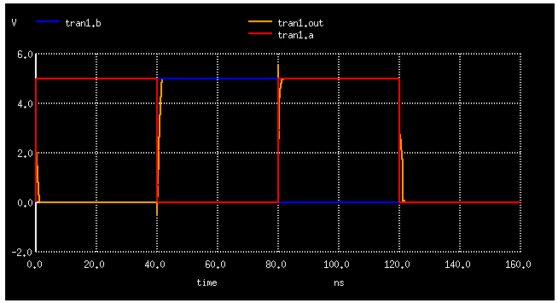 Figure: Transient response of XOR gate

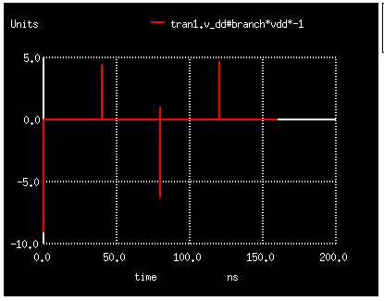

Figure: Power variation for XOR gate